MAZHARUL ISLAM
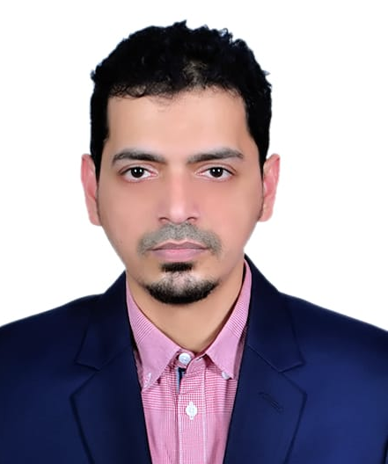
Flat # 8A, Plot # 41-45, Road # 1/1, Block # B
Kafrul, Mirpur-13, Dhaka.
Contact: 01748 928096
E-Mail: shumon_me@yahoo.com
Professional Profile
- 11+ years of experience in brand management, trade marketing, strategic planning, digital marketing, and retail sales with wide range of products in leading FMCG and building material manufacturing companies

- Strong interpersonal, written, and verbal communicator who can recommend enhancements to business processes, and maintain collaborative relationships utilizing entrepreneurial vision
Relevant Skills:

- Strategic business planning
- Business process improvement
- Brand building & development
- Corporate & marketing communication
- Retail sales & Trade marketing
- Relationship & key account management

Professional Experience
- Manager, Marketing & Communication, ANWAR GROUP OF INDUSTRIES, Dhaka.
One of the largest conglomerates in building materials in Bangladesh (October, 2018- till date)
- Contributed to gain 67% growth in 2021
- Designed major plan to get 35% additional coverage in all over Bangladesh
- Managed event & activation, different programs to get influencers like carpenters, feed dealers on board
- Conducted marketing & communication activities in coordination with Sales and other stake holder to ensure that all tasks are conducted as per set guideline and plan
- Senior Manager, Strategic Planning & Marketing at ZERO GRAVITY VENTURES LTD, Dhaka.
Leading e-commerce Company with B2B & B2C platforms (April, 2018 – September, 2018)
- Increased monthly average traffic from 80,000 to 1,000,000 by developing digital marketing strategies & restructuring customer communication models
- Contributed to 50% increase in monthly sales through new online campaign, corporate events and improved sales support
- Coordinated with different advertising agencies for improved customer communication, media buying and online as well as offline campaign management
- Consistently overseeing the implementation of newly placed policies regarding delivery & complaints management to enhance customer satisfaction

- Brand Manager at PRAN-RFL Group, Dhaka.
One of country’s largest food processing & FMCG companies (Feb, 2015 – March, 2018)
- Significantly extended the confectionery portfolio of the company. Led the team responsible for brand building & market positioning of new products such as - Koko candy, Pnut candy, Xcel & Cricket gum
- Worked closely with HOS & PMs on a regular basis on monthly trade programs. Conducted major trade programs those resulted in 50% sales growth. Developed various POMS to increase merchandising & visibility
- Repositioned one of country’s leading confectionary brands ATOM gum and launched major campaigns on ATL, BTL and Digital platforms that resulted 70% increase in sales
- Instrumental in the monthly sales growth of hard-boiled candy from 1.2 crore to 5 crores with new product development

- Area Sales Manager at GODREJ HOUSEHOLD PRODUCTS (BD) PVT LTD, Dhaka.
Leading provider of consumer products & household goods (January, 2014 – February, 2015)
- Re-structured channel sales activities by dividing into two separate channels and appointing new dealers and sales personnel which resulted in 50% sales growth
- Contributed 12% of the total national sales for last quarter with the company
- Executive – Activation & Promotion at DIMENSIONS LTD, Dhaka.
Event management, activation & brand promotion company (June, 2008 – July, 2012)
Computer Skills
Microsoft Office & Other Packages: Microsoft Office Applications (Word, Excel, Power Point, Outlook, Access), Google Analytics, IBM SPSS
Education
Master’s in Business Administration in Marketing (2014)
Institute of Business Administration (IBA), University of Dhaka
Major: Marketing
Result: CGPA 2.72 out of 4.00
Bachelor’s in Business Administration (2008)
Daffodil International University, Dhaka
Major: Marketing
Result: CGPA 2.52 out of 4.00
H.S.C. (2002) from Dhaka City College
Result: First Division (Business Studies)
S.S.C. (2000) from Monipur High School
Result: First Division (Science)
References

Mallah Omar Sharif
General Manager, Mkt & comm
Anwar Group of Industries,
Baitul Hossain building,
27 Dilkusha, Dhaka-1000.
Mobile: 01817 604059
A.K.M. Moinul Islam Moin
Executive Director- PRAN-RFL Group
PRAN-RFL Center, 105 Bir Uttam Rafiqul Islam Ave, Dhaka 1212, Bangladesh
Mobile: 01704 133742

