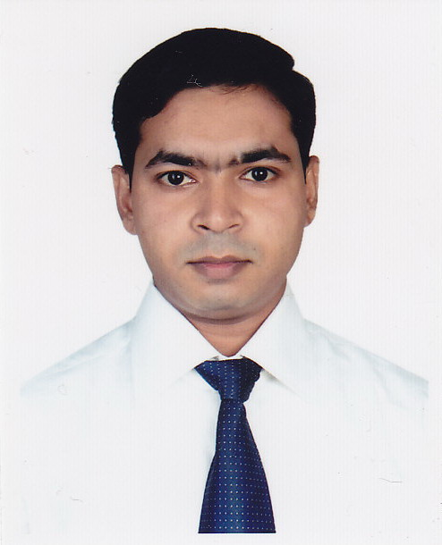
ANJAN KUMAR PAUL
{
159, Sher-e Bangla Road (4th Floor-Flat No.-E4), Rayer Bazar Dhaka-1209.
E-mail: anjanp315@gmail.com
Mobile: 01914038978, 01733633998

1. Career Objective:

To employ my knowledge and experience with the intention of securing a professional career with opportunity for challenges and career advancement, while gaining knowledge of new skills and expertise.

2. Career Profile:
- Efficient and organized professional with experience in accounting systems.
- Experienced in keeping the records of financial data.
- Expertise in transferring and calculating inter-company loan transaction.
- Highly trustworthy, discreet and ethical.
- Resourceful in the completion of reports.
- Excellent ability to sort, check and verify documents.
- Good analytical and problem solving skills.
- Good written and verbal communication skills.
- Efficient at multi-tasking.
- Smart working ability.
3. Working Experience:

- Name of Organization : Sales Promotion Service Limited
Position : Senior Executive (Finance & Accounts)
(November 01, 2017 - Continuing)
Company location : 326, Habib Khan Tower (2nd Floor)
Sontek Road, South Kazla, Section-A,
Jatrabari, Dhaka-1236.
Department : Finance & Accounts.

Job Responsibilities:

- Keeping records of daily financial transactions of different unit.
- Prepare, check & verify monthly salary, wages & other incentive sheet of different unit.
- Maintaining accounts payable & receivable ledger.
- Prepare monthly profit & loss statement.
- Assist to prepare statement of financial position.
- Calculate ROI of different unit every month.
- Preparing and maintaining bank related transactions and ensure bank reconciliation.
- Checking all bill finalization and cash payments, follow-up, monitoring.
- Maintaining stock register & reconcile the stock of different unit.
- Prepare summary sheet of income & expense, profit & loss of different unit.
- Maintain receipts and payment vouchers, cash book and different register.
- Check and verify daily sales report, dues and cash collection.
- Preparing various report regularly, weekly & monthly and submitted to the Management.
- Prepare and submit Opex & Capex data sheet every month.
- Any other task assigned by the management.

- Name of Organization : Otobi Limited
Position : Executive-Accounts Reconciliation
(November 05, 2014 to October 30, 2017.)
Company location : Otobi Centre, Plot-12 Block CWS(C)
Gulshan South Avenue, Gulshan-1, Dhaka-1212.
Department : Finance & Accounts.
Job Responsibilities:

- Collect and preserve monthly bank statement from various bank for reconciliation.
- Reconcile bank accounts ledger with bank statement and prepare monthly bank reconciliation statement.
- Reconcile credit card sales transaction and prepare various reports on credit card sales, discount and their settlement.
- Ensure the open entries are passed to the source for verification/ correction/ resolve.
- Verification of charge/interest debited/ credited by the bank and posted this voucher in SAP.
- Communicate and co-operate all branches about rectification to maintain reconciliation accuracy.
- Communicate and co-operate with bank and other section about the outstanding cheque, DD, PO.
- Assists section-in-charge to finalize the monthly Bank Reconciliation Statement file.
- Prepare various reports on Bank Statement and Reconciliation Status as per management requirement.
- Any other task assigned by the management.

4. Professional Qualification:

- ICMA. (Business Level, session- July-2018 To Continuing.)

5. Educational Qualification:

Degree | Passing Year | Institution | Subject/ Group | Result
Master of Business Administration (MBA) | 2012 | University Of Development Alternative | Finance & Accounting | 3.47 (Out of 4)
Bachelor of Business Administration (BBA) | 2011 | University Of Development Alternative | Finance | 3.46 (Out of 4)
Higher Secondary Certificate (HSC) | 2007 | New Model Degree College. | Business Studies | 3.40 (Out of 5)
Secondary School Certificate (SSC) | 2005 | Rayer Bazar High School. | Science | 3.94 (Out of 5)

6. Key Traits:

- Strengths:
- Energetic
- Hardworking
- Self-Motivated
- Confident
- Quality Decision Maker
- Good presentation ability

- Interests : Reading newer ideas and views history,
Social welfare activities, watching news,
Operating computer and doing something creative.
- Internship : Successfully completed an internship program for 03 (Three) months with Bangladesh Krishi Bank Ltd, Tajmahal Road Branch, Dhaka.

7. Computer Proficiency:

- Operating System : Windows XP, Windows 7, Windows 8, Windows 10.
- Other Packages : Microsoft Office (M/s Word, M/s Excel, PowerPoint).
(E-mail and internet browsing)
Knowledge About Accounting Software- SAP & Tally.

8. Language Proficiency:

- Bengali : Excellent in reading, writing and speaking.
- English : Good at reading, writing and speaking.

9. Personal Information:

Father’s Name : Shital Kumar Paul
Mother’s Name : Laxmi Rani Paul
Mailing Address : 159, Sher-e Bangla Road (4th Floor-Flat No.-E4), Rayer Bazar
Dhaka-1209.
Permanent Address : Shoshi Bhaban
Vill : Pathalia.
P/O : Mirzanagor.
P/S : Ashulia.
Dist : Dhaka.
Date of Birth : 30th January 1990.
Place of Birth : Gazipur.
Nationality : Bangladeshi (By birth).
Marital Status : Married.
Religion : Hindu (Sonaton).
Sex : Male.

10. Extra Curriculum Activities (Playing Tabla) :

Working as a Tabla Teacher at Bangladesh Academy of Fine Arts Ltd. (BAFA) from October 2, 2009 to till dated.
Achievement
- Won the 1st Prize in Alhaz Abdul Hashem Khan Sreety Padak-2002.
- Won the 2nd Prize in Sangeet Protijogeta-2004 by Rayer Bazar Sangeet Academy.
- Won the 2nd Prize in Janab Morhum Khandakar Sams Uddin Ahamed Sreety Padak-2006.

11. References:

- Bimal Chandra Banik  Deputy Managing Director  IBCS-PRIMAX Software (Bangladesh) Ltd.  Building # 51, Road # 10A, Dhanmondi, Dhaka-1209.  Mobile: 01713397561, 01742249409  E-mail : bcbanik@ibcs-primax.com |  | - Pankaj Kumar Paul  Govt. Service  Joint Secretary  Ministry of Shipping  Bangladesh Secretariat  Dhaka-1000.  Mobile: 01712681296  E-mail : pankajpaul1987@gmail.com


Anjan Kumar Paul

