Sanjida Rahman  Address : Flat No #323, Rajanigandha,  Rupnagar R/A (Main Road), Mirpur, Dhaka 1216  Mobile : (+88) 01720 645070  E-mail : rahman27.sanjida@gmail.com | 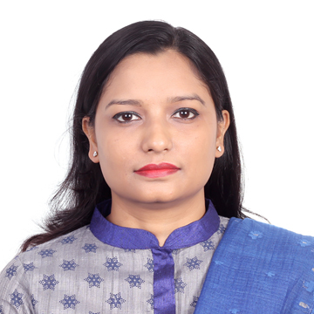

Profile Summary:

MBA with 6 years’ experience in Sales and Marketing, Business Development and Trading and Sourcing.

Professional Experience:

Swiss Singapore Overseas Enterprises Pte. Ltd. (Bulk commodity trading concern of Aditya Birla Group, India) August ‘19 - Present
Asst. Manager, Trading

Looking after the entire Beans & Pulses business in Bangladesh.
Communicating and coordinating with buyer and with the Head Office located in Dubai, UAE.
Offering price, negotiation, confirming the business deals
Issuing sales contract, proforma invoice and monitoring and collecting counter signed copy
Coordinating to the customer and desk for issuance of LC, IP, overall documentation, payment and completing the deal

BASE Technologies Limited March ‘18 – June ’18 (Due to closing of business)
Senior Specialist – Sales, Government Sales & Purchase

Worked as a sourcing officer for govt. sales and purchase department

AG Automobiles Ltd - (A concern of Anwar Group) Dec’16 – February ‘18
Consultant Sales

Visiting, communication with Govt. official specially DGDP for selling Ford vehicles, preparing tender, preparing monthly sales and tender participation report etc.

Celestial Tech Jan’15 - Nov’16 Executive - Marketing & Sales

A trading company whose main focus was to supply marine navigation, communication, firefighting and hydrographic research equipment to DGDP, Bangladesh Navy. Having experience of working with world famous companies like MAN, Kongsberg, Icom, Simrad, Furuno, Bushnell etc.

Academic Qualification:

- MBA in Marketing from Indian Institute of Social Welfare and Business Management, University of Calcutta in 2014
- BBA in Finance from Dhaka City College under National University in 2010
- HSC in Business Studies from Dhaka City College in 2004
- SSC in Humanities from St. Francis Xavier’s Girls’ High School, Dhaka in 2002

Scholastic Achievement:

Got admission in Indian Institute of Social Welfare and Business Management through an International Scholarship provided by ICCR (Indian Council for Cultural Relations), India.
Technical Skills:

- Presentation Skill: Microsoft PowerPoint
- Operating System: Windows 7/8/10
- Tools: Microsoft Word, Microsoft Excel

Key Skills:

- Excellent Communication Skill
- Excellent Negotiation, leadership and Analytical Skill
- Initiative, Creative
- Visionary, Optimist
- Flexibility, Confident
- Self-Motivated

Personal Information:
Date of Birth: 27 Nov’1985

Language:
Fluent in Bangla and English

References:

- Rajesh Chakma, Consultant in Bangladesh, International Materials LLC.
Mobile No. (+88) 01729211873, Email: rchakma@gmail.com, Relationship: Professional

- Sobhan Choudhury, Brigadier General, Bangladesh Army (Retd.)
Mobile No. (+88) 01769003127, Email: sbnchy3127@yahoo.co.uk, Relationship: Professional

“I declare that all information stated in this resume is true and complete to the best of my knowledge, I authorize the receiver of this resume to verify the information provided above”

Sincerely Yours,

Sanjida Rahman

