MD.JAYENUL KABIR
Flat 4-A, House # 37, Road #1,
Mohammadia Housing Ltd,
Mohammad Pur,Dhaka, Bangladesh
Mobile Number: +8801739500038
Email ID: jayenul.kabir@gmail.com
P R O F E S S I O N A L P R O F I L E
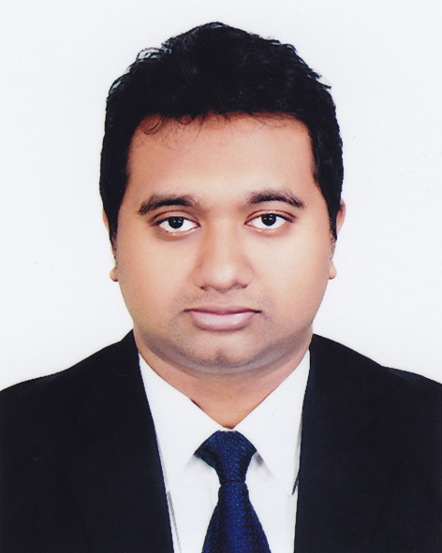
- 4+ years of work experience in corporate branding, events, premium brand activation and managing key clients.
- Successfully pulled of most prestigious events like Berger Award for Excellence in Architecture (BAEA), Berger Award Programme for the Students of Architecture BUET (BASAB), Architect Regional Council Asia (arcasia), Berger Award Programme for the students of Architecture KUET (ARCHKU),
- Trained over 30 marketing and sales representative, improving overall sales target by 24%.
- Proven record in managing product launches that increase brand awareness and sales.
- Implemented key marketing campaign by bundling products together and increased sales revenue by 13%.
- Prepared and implemented marketing campaign for 12 new Product Lines and generated BDT 500 Core annually.
EDUCATION
Qualification & Certificates | Year | Institution
MBA | Ongoing | North South University
BBA (Major in Marketing & Finance) | 2013 | Independent University, Bangladesh
A ‘Level | 2009 | Edexcel International
O ’level | 2006 | Edexcel International

EMPLOYMENT RECORD
From: (January 2018 - present)
Employer: Berger Paints Bangladesh Limited
Position Held: Senior Territory Manager – Prolinks (Avid Branding and Marketing Enthusiast)
Department: Marketing and Sales
Key Responsibilities:
- Analysis and identification of upcoming business opportunities.
- Premium product sales analysis and strategy implementation for ensuring brand profitability.
- Analyzing brand positioning and consumer insights.
- Analyzing data regarding current trends and predicting future business potential.
- Facilitating briefing session with key consumers, demonstration, buzz marketing and technical training sessions for applicators.
- Supervising corporate marketing campaign and other forms of marketing to maintain consistency in branding.
- Preparing marketing plan yearly and quarterly promotional strategy for key consumers.

From: (February 2015 - January 2018)
Employer: Berger Paints Bangladesh Limited
Position Held: Territory Manager – Prolinks
Department: Marketing & Sales
Key Responsibilities:
- Achieving volume and value target of the demarcated territory for a stipulate time period.
- Creating new business opportunity by generating sales demand for premium brand and new product.
- Enhancing brand profitability by implementing new marketing strategy.
- Preparing yearly promotional strategy, brand visibility for premium and new product to elevate business turnover.
- Analyzing competitors marketing strategy and conducting market research for understanding new business opportunity.
- Developing trade marketing promotional activity and maintaining key accounts.
- Identifying and developing business opportunity nationwide and collaborate with sales force to ensure growth attainment.
- Developing market penetration strategy and establishing new brands.

From: February 2014- December 2014
Employer: Technical Assistance Inc (Research partner of USAID)
Position Held: Research Coordinator
Department: Market research wing
Key Responsibilities:
- Assuring that all elements of the process are coordinated in a manner consistent with project objectives.
- Keeping the research manager informed of all specifics.
- Managing all of the logistics and contingencies for the sessions.
- Maintaining a high level of interest and motivation among respondents..

TRAINING AND CERTIFICATION
Topic: Key Account Management
Consultant Firm Name: Strategic Skills Development Institute (SSDI)
Key discussion points:
- Creating customer matrix.
- Identifying Focus of receptivity.
- Building relationship management strategies for key stakeholders.
- Implementing customer value pyramid.
- Handling crucial customer.
- Negotiation Styles.
- Understanding DAIPER and REED – ODPEC for creating initial bonding with key customers.
- Changing competition activity
- Competitive Analysis.
- Key account time allocation.

EXTRA CURRICULAR ACTIVITIES

- Vice president of external affairs and finance in IUB Business Club
- Winner of Business case competition 2012, Business Plan competition 2012 and Finance Quiz competition 2012
- Finalist of Master of Ideation (Business Idea generation Competition) organized by NSU in association with Mutual Trust Bank and Reckitt Benckiser (Bangladesh) Limited.
- Organizing Committee President of various National and Local Conferences, and Seminars of AIESEC.

KEY COMPETENCIES
- Hardworking, confident & determined in every working environment.
- Strong in oral and written communication, interpersonal, creative, organizational and leadership skills.
- Excel in both independent and teamwork environment.

PERSONAL SKILLS
Computer:
Experienced in Microsoft office (Word Excel and Power Point and also SPSS)
Language Proficiency:
Bangla: Mother Tongue
English: Fluent in both writing and speaking.

ADDITIONAL DETAILS
Date of Birth: February 07, 1988
Father’s Name: Late A.T.M. Aynul Kabir
Designation: Marine Engineer
Mother’s Name: Fahima Kabir

REFERENCE

Nashid Hassan
Vice President
HSBC
Shanta Western Tower
Level -4, Tejgaon Gulshan Link Road, Dhaka
Email Id: nashidhassan@hsbc.com.

Badsha Fayshal
Regional Manager
Berger Paints Bd Limited
Berger House
Sector 3, Road 2, House 8
Uttara, Dhaka
Badsha.fayshal@bergerfosroc.com

