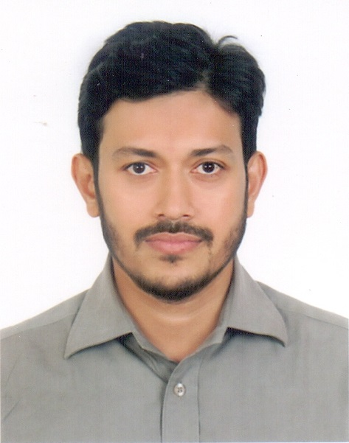

Mohammad Moniruzzaman Khan

44 New Paltan

Azimpur, Dhaka-1205
Mobile-01777763993, 01737078693
E-mail:maamunkhan@gmail.com

OBJECTIVE

To perform in a challenging position and grow as a HR professional (by making the best use of my potential and experience) which will positively affect the organization’s success and open up opportunities for career advancement.

EMPLOYMENT EXPERIENCE

Manager - Compensation & Benefits
Human Resources Department
DHL Worldwide Express (BD) Pvt. Ltd.
From 28th September, 2014 to till

Roles & Responsibilities

Compensation & Benefit:
- Assists annual salary increment process
- Assists salary survey (Mercer)
- Prepare Compensation & Benefit proposal for new Joiner / Promotion / Movement
- First contract of Regional Office as Regional Office Liaison for C&B issue
- Coordinate with Payroll Supervisor for related payroll updates (monthly)
- Assists roll out annual performance evaluation
- Administrator of online process for Competency Assessment, Goal Agreement & Achievement Process
- Monthly reporting-Payroll Journal, HR Dashboard
- Successfully completed automation process for Salary Certificate, Final Settlement, Leave encashment, Digital HR Manual (Jointly),

Recruitment & On-boarding:
- Administrator of Taleo (E-Recruitment System)
- Assist in organizational Operational Plan to ensure appropriate recruitment requirement is captured
- Prepare recruitment process cycle for different positions
- Pro-actively manage vacancies through structured process and abiding with policies
- Prepare recruitment schedule and administer the interviewing process
- Closely work with different functions as their business partner to ensure right resources are on-board on time
- Prepare new joiners action plan for all new joiners in-order to familiarize new employees in the organization

Employee Engagement and HR Transaction:
- Assist EOS survey-Kenexa (Org Mapper, Data Miner, report generate),
- Assist in employee engagement initiatives to ensure better HR visibility and upheld employee motivation
- Administrator of eHR (Express HR) tool for HRIS.
- Assists Head of HR to process EDR (Employee Development Review- Identify potentiality and succession planning)

Executive - Compensation & Benefits, Human Resources Department
Coats Bangladesh Limited
From 2nd September, 2012 to 13th September, 2014

Roles & Responsibilities
- Responsible for Payroll Process - Management, Non-Management, Junior Management, Expatriate & Intern
- Responsible for Compensation budgeting and monitoring for cost management.
- Prepare the annual statement and furnished to the Deputy Commissioner of Taxes under section 108
- Forecast budget for salary increases.
- Disbursement of Management LFA, Medical advance
- Responsible for the Final Settlement of the Employee after resignation
- Responsible for Monthly manning report
- Develop job descriptions for various positions and determine appropriate base pay
- HRIS management- Maintaining and developing personnel record systems
- Process Medical & Refreshment allowance claim &ManCom Utility bills
- Administer the Attendance & Leave management process with “Kormee”
- Facilitate new employee on boarding process
- Engaged in Payroll & HRIS implementation with SAP

Executive-Human Resources Department
Pacific Bangladesh Telecom Limited (Citycell)
From 27th November, 2010 to 31st August, 2012

Roles & Responsibilities
- Prepare & Manage monthly payroll of all the employees.
- Assist Operation in day to day issues regarding employee data that is salary or other benefits
- Maintain strict confidentiality of Employee Salaries & Responsible for all updates or changes in employee status.
- Final Settlement of the Employee after resignation
- Maintain all the functions of personal files (includes joining to exit of employees)
- Maintaining HRIS
- Administrator of Online Leave Management System.
- Keeping personnel record systems up-to-date and within present legislation.
- Head Count Report of the company

Customer Care Representative-Customer Care Division
Pacific Bangladesh Telecom Limited (Citycell)
From 08th November, 2007 to 26th November, 2010

Roles & Responsibilities
- Giving one stop solution to potential and existing customer.
- Doing Sale activities includes both service and product.
- To implement the customer service and sales policies & procedures in practice.
- Corporate Client support.
- Giving values to customer through prompt services and guarantying the delivery of company’s commitment.
- Providing IT support to the customer.
- Prepare daily, weekly, and monthly reports summarizing.
- Cash management.
- Handling Financial Report and Audit.

EDUCATIONAL QUALIFICATION

Masters of Business Administration (MBA) Appeared
Major in Human resource Management
BRAC University

Bachelor of Business Administration (BBA) 2007
Major in Finance
East West University

Higher Secondary Certificate (HSC) 2001
Dhaka Commerce College
Mirpur, Dhaka

Secondary School Certificate (SSC) 1999
BCSIR High School
Dhanmondi, Dhaka

TRAINING AND WORKSHOP

Salary Tax Calculation
Enroute Center for Develop Limited
Duration: 3 Hours

Building Great Employee Relations (BGER),
Employee Relations (ER),
Insanely Customer Centric HR (ICCHR)
DHL Express, Vietnam
Duration: 3 Days

Certified International Professional - HR
DHL Express, Srilanka
Duration: 2 Days

Management of Provident Fund, Profit Participation Fund and Gratuity Fund
Institute of Chartered Secretaries of Bangladesh (ICSB)
Duration: 2 Days

Bangladesh Labor Law 2006, Compliance and disciplinary issue
Prothom-Alo Training
Duration: 2 Days

Soft Business Skills
Rapport Bangladesh Ltd
Duration: One Day

Awareness Training on Office Safety
Pacific Bangladesh Telecom Ltd.
Duration: One Day

PERSONAL DETAILS

Father: Mohammad Sekander Ali Khan
Mother: Late Khaleda Begum
Nationality: Bangladeshi
Religion: Islam
Date of Birth: 25 August, 1984

