Resume of
MD. AL-AMIN
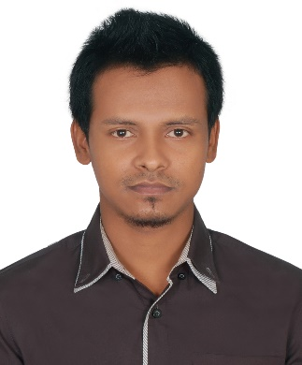
Md. Al-Amin
Address: House: 27, Road: 10, Nabinagar Housing,
Mohammedpur, Dhaka-1207, Bangladesh.
Cell no. +8801711671802, +8801722333407
E-mail: wwamins@yahoo.com

CAREER OBJECTIVES:

To work with a position where sincerity, dedication, strong communication, leadership skill and attention to details are essential to strive for excellence as well as to take the Institution to its goal.

EDUCATIONAL QUALIFICATION:
BSc Engineering
Institution : City University
Subject : EEE
Passing Year : 2019
CGPA : 3.45 (On a scale of 4)

Diploma in Engineering
Institution : Chandpur Polytechnic Institute
Subject : Electronic Technology
Board : BTEB
Passing Year : 2013
CGPA : 3.69 (On a scale of 4)

Secondary School Certificate (S.S.C.)
School : Kaduty High School
Subject : Science
Board : Cumilla
Passing Year : 2009
GPA : 4.50 (on a scale of 5.00)
Experience:
#01
Organization : Milvik Bangladesh Ltd.
12th Floor) Ambon Complex, Moakhali, Dhaka, Bangladesh.
Designation : Customer Support Representative
Period : From 1st August 2018 to 31 March 2019.

#02
Organization : Digicon Technologies Ltd.
(4th Floor) RTC, Nikunja-2, Khilkhet, Dhaka-1229, Banglasesh.
Designation : Customer Support Representative (CSR) at GP Process (Premium)
Period : From 14 May 2019 to 31 May 2021.

#03
Organization : Bangladesh Specialized Hospital Limited
21 Shyamoli, Mirpur Road, Dhaka-1207, Bangladesh.
Designation : Officer-Call Centre
Period : From 08 July 2021 to till now.

PERSONAL DETAILS:
Name : Md. Al-Amin
Father’s Name : Md. Zahangir Alam
Mother’s Name : Rowshanara Begum
Permanent Address : Vill: Tamta, Post: Kaduti Bazar, P.S: Chandina, Dist: Cumilla.
Religion : Islam
Marital Status : Unmarried
Date of Birth : 28/08/1993
Gender : Male
National Id : 6874953000
Nationality : Bangladeshi
Blood Group : A (+)

INDUSTRIAL TRAINING:

I have successfully completed 3 months training of ‘CRT & LED TV servicing from WALTON BD Ltd.

SELF-ASSESMENT:

I am hardworking, honest, devoted to duty. I believe that I can prove myself as the best productive person in any working environment.

TECHNICAL SKILLS:

- Computer OS: Windows XP, Vista, Seven & Win-8.
- Graphics: Adobe Photoshop, Video Editing.
- Others: Internet browsing, Microsoft office application (MS office word, MS Excel).

HOBBIES & INTERESTS:

Playing Football and Cricket, reading noble book, browsing internet, Listening Music, Traveling etc.

DECLARATION:

I do hereby declare that the above information is true and correct to the best of my Knowledge.

Signature: Md. Al-Amin
Date: 11/09/2021

Reference:

Name | : | Engr. Suvadra Chowdury
Organization | : | Chittagong Mohila Polytechnic In | .
Designation | : | Chief Instructor, (Tech) Electronics.
Mobile | : | 01715481530

