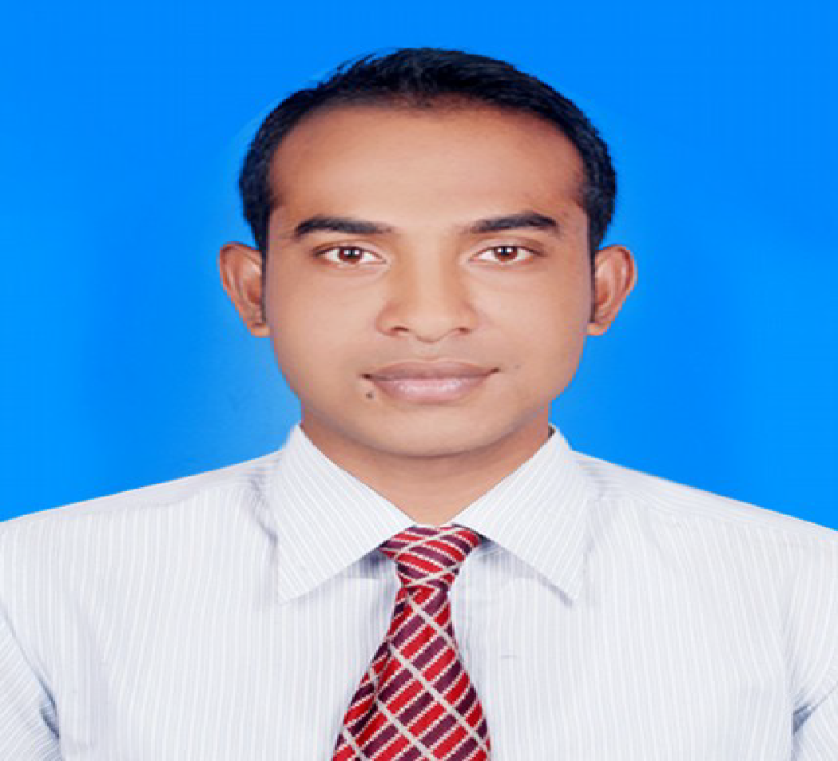

**Khan Al Sajib**

Narshindi Sadar, Dhaka



+8801719032000



[**alsajib85@gmail.com**](mailto:alsajib85@gmail.com)



**ersonal Profile:** I am a post graduate in Social Sciencefrom Government Titumir Collage.I have been working with different clubs, forums & voluntary and MNC Organizations for past couple of years. My all of this experience builds me a successful team player and gives me a good leadership, communication and convincing ability and also a good sense of responsibility.

**Post Graduation -2010               Department Masters of Social Science.**

**Result :** Second Class.

**Institution:** Government Titumir Collage.

**Graduation -2008 Department: Bachelor of Social Science.**

**Result**: Second Class

**Institution:** Lohagara Adarsha Mohavidalay.

**HSC - 2004** **Department:** Business Studies

**GPA**: 2.80.

**Institution:** Lohagara Adarsha Mohavidalay.

**SSC – 2001 Department:** Humanities.

**GPA**: 3.25

**Institution:** Lohagara Pilot High School.

**WORKING EXPERIENCE**

BCS Porickroma : BB **Working Experience : PRAN-RFL GROUP.**

Position Held : **Zonal Manager.** **(From April 2015 to Till Now)**

**MADINA GROUP.**  Position Held: **Senior Sales Executive.** (From April 2014 to March 2015)

**NILL KAMAL PADMA PLASTIC (PVT.) LTD.**

Position Held: **Area Sales Executive.**

(From August 2012 to March 2014)

**Field of Specialization: #**Analytical & problem-solving capability.

# Strong Interpersonal & convincing capability.

# Ability to work under pressure

# Maintaining deadline & Self-motivated

# Highly organized & Attention in details.

# Leadership & Team player

# Market analysis, Competitors Products analysis.

# New Dealer acquisition and keep good relationship with existing Dealers.

**Achievements:** # Win Half yearly National sales award couple of times.

**#** Achieved Yearly Nation Sales Award 2 Times.

**Co-Curricular Activities:** I am good at all kinds of indoor and outdoor games and sports.(Cricket, Football, Badminton, Carom)

**Seminars & Workshops: #** Attended RFL yearly Conference in 2015, 2016, 2017 & 2018.

# Bangladesh Youth Leadership Centre programmed in 2017

**Language Proficiency:** Bengali: Native Proficiency           English: Professional Proficiency

**Technical Knowledge:** MS Word, Power Point, MS Excel, Video Editing.

**Reference:**

>Shamsur Nahar Ratna >Md Nazmul Islam

Scientific Officer. Senior Assistant Teacher

BCS Agriculture Cadre. Senhati Govt. Secondary School (Khulna)

Contact number : 01731926952 Contact number : 01912436383

I am undersigned, hereby declare that, I will be responsible for any wrong information provides here.

**Khan Al Sajib**