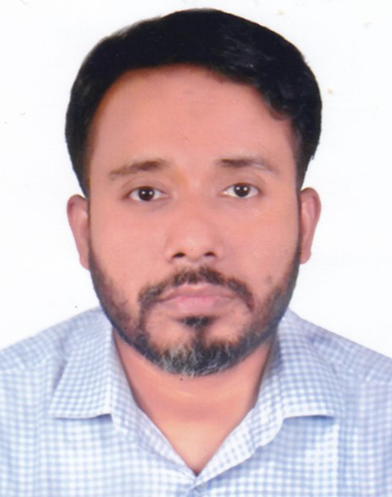

*Curriculum vitae of*

Zahir Ahmmad FCA

Contact No: 01711971340

Passport No: AA 4152347

zahir.ahmmad@gmail.com

Highly accomplished, result –driven accounting and financial management executive with more than 9 years of progressive experience in finance and operations management within start-ups and multi-million dollar organizations, Demonstrated ability to streamline business operations that drive growth and increase efficiency and bottom line profit. Strong qualifications in developing and implementing financial controls and processes in addition to productivity improvements, and change management, processes solid leadership, communication and interpersonal skills establish rapport with all level of staff and management

***Professional Skills:***

Financial Statements as per IFRS Market study & research

Financial Analysis & Decision Policy Development

Internal control Marketing

Budget Project Management

Inventory Management Operation

Business Law, Tax and VAT ERP setup

Fund Management Business Development

***Professional Experience:***

**Ha-Meem Group**

**General Manager (Finance & Accounts)**

**Responsible for Textile Division May 2016-Till Now**

Report to the Executive Director of Textile Division and as well as to the group Financial Consultant on Overall Strategic Financial Planning, Accounting and Taxation matters. Provide comptrollership functions in order to ensure finances are managed according to legislation, policies and procedures and generally accepted accounting principles

**Main Responsibilities:**

* Manage accounting and financial systems and maintain full and accurate accounting

Records

* Prepare financial Statements as per BFRS
* Contributor to annual budget process, working with various departmental heads to review historical activities, trends and future obligations
* Monthly accounts, budget variance report prepare and submit to management within a time frame with exceptional report and explanation.
* Plan, organize, direct, manage and evaluate the inventory management activities and budget of an organization
* Conduct financial analysis and prepare detailed financial reports and statements
* Ensure compliance with financial legislation, policies and procedures and adhere to

the terms of Block Funding and Contribution Agreements

* Develop and implement purchasing practices and monitor the purchasing system
* Fund management
* Establish and maintain cash controls
* Monitor department spending and recommend corrective actions as necessary
* Set up ERP under my supervision at HSML (4 module completed and three is under construction) To ensure optimum resource utilization of company

**Opex Sinha & Textile Group**

**General Manager (Finance & Accounts) July 2015-April-16**

Report to the Chairman of the group and as well as to the group CFO on Overall Strategic Financial Planning, Accounting and Taxation matters.

**Prime Responsibilities**:

* Developed a sound and effective Treasury Management for smooth running of the activities of the business.
* Contributor to annual budget process, working with various departmental heads to review historical activities, trends and future obligations.
* Developed standard operating procedures of the Financial Operation to improve internal control procedure.

**Shah Cement Industries Limited: Largest Cement Manufacturer, Distributor and seller in Bangladesh**

**Sr. Manager (Finance & Accounts) Feb2011-June 2015**

Report on overall Market activities, distribution and Credit facility. Responsible for management of all accounting & financial function of sales, Distribution and MIS. Provide formal financial planning process, tightened integration within the department so as to achieve goal of the department as well as of the company.

**Notable Achievements and Prime Responsibilities**:

* Developed a sound and effective MIS which includes to identify market gap, root cause identification and analysis then forward to management to take decision within a time

Frame to achieve the objective for the specific area,

* Inventory Management ( Including 26 Ghats Management which have been intrigued with the oracle System )
* Introduced an effective sales procedure where daily follow up the secondary sales as per person wise, reason wise, target achievement analysis and take action as per gap identification.
* Optimum Utilization of Company Resources like per person sales and cost analysis and optimum credit utilization with the line of market demand.
* Setup an effective Credit Policy as per industry’s requirement
* Contributor to annual budget process, working with various departmental heads to review historical activities, trends and future obligations
* Member of cost control team for cost reduction of project which will ultimately increase the profitability of the organization
* Monthly accounts, budget variance report prepare and submit to management within a time frame with exceptional report and explanation.

**IBRAHIM SOLAR LIMITED:** Manufacturer of Solar Wafer and Modules.

**Manager (Finance & Accounts): July 2010 to Jan 2011**

Report to the Managing Director. Oversee Strategic Financial Planning, Accounting and Taxation matters. Responsible for management of all accounting & financial function. Provide formal financial planning process, tightened integration within the department so as to achieve goal of the department as well as of the company.

**Notable Achievements and Prime Responsibilities**:

* Developed a sound and effective Treasury Management for smooth running of the activities of the business.
* Preparation of Annual Financial Statements in compliance with applicable BFRS.
* In the activity of Material Management, responsible for opening LC for importation of all goods, handling C n F agents’ activity.
* Member of cost control team for cost reduction of project which will ultimately increase the profitability of the organization.
* Contributor to annual budget process, working with various departmental heads to review historical activities, trends and future obligations.
* Determine corporate and individual tax liability.
* Developed standard operating procedures of the Financial Operation to improve internal control procedure.

***Professional Qualification:***

Qualified as a **Chartered Accountant** from the Institute of Chartered Accountants of Bangladesh in August 2010 Enrolment No- 1165

***Professional Courses:***

Completed three and half years of probation and article-ship course from June 01 2006 to November 30 2009 (vide Registration No. 14056 of 2007) from a reputed C.A firm named **Hussain Farhad & Co.** associated with **Asnaf.**

***Computer Skills:***

**Diploma in Information & System Management (DISM)**

Operating Software: MS Word, MS Excel, MS Power point

Accounting Software: Tally and other customized software

**ERP Software: Oracle, DremApps, Navision**

***Academic Qualification:***

|  |  |  |  |
| --- | --- | --- | --- |
| **Year** | **Title** | **Institution/ Board** | **Group/ Discipline** |
| 2006 | MBS | Jagannath University | Accounting |
| 2004 | B. Com(Pass) | Dhaka City College  (National University) | Commerce |
| 2001 | H.S.C | Chaumuhani S. A College  (Comilla Board) | Science |
| 1999 | S.S.C | Nateswar Abul Khair High School  (Comilla Board) | Science |

***Training Program:***

**APM Training** - 50 hours training received on **Audit Practice Manual (APM)** under supervision of Partner **Mr. M Farhad Hussain FCA** and APM specialist hired from **World Bank** under Twining Project**.**

**IFRS/ IAS/ BAS Training** - 40 hours training received on various **IFRS/ IAS/ BAS** under supervision of **Partner M Farhad Hussain FCA.**

**Leadership Development Program:** 8 hours training received on leadership development program which was supervised by HR specialist **Md. Abdullah**, Brand Icon in Bangladesh Md. Naushad Karim Chawdory and Ferdous Kabir Chawdory FCA

**Focus on** Traditional management, modern management, and situational management.

***Personal Information:***

Father’s Name : Zalal Ahmmad

Mother’s Name : Amena Khaton

Date of Birth : January 01 1984

Known by other name : Kiron

Religion : Islam (Sunni)

Marital Status : Married

Language Proficiency : Bangla Excellent

English Standard

Hobby : Traveling

**Address:**

**Present Address Permanent Address**

Flat # G-9, 6/3 (Excelsia Park) Vill & P.O- Nateswar

Segunbagicha, Dhaka p/s- Sonaimuri,

Mobile: 01711-971340 Dist- Noakhali

**Reference:**

**M Farhad Hussain FCA**

Partner

**Hussain Farhad & Co.**

Chartered Accountants

House # 15, Road # 12

Niketon, Dhaka.

Mobile: 01713-001022

I hereby declare that information provided in this application form is true to the best of my knowledge.

**Zahir Ahmmad**