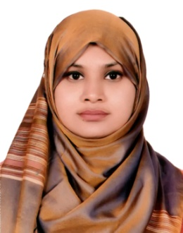Farhana Ferdous

Address: KA-137/A South Badda, Dhaka-1212

Mobile: 01902123010

E-mail: [farhanaferdous60@gmail.com](mailto:farhanaferdous60@gmail.com)

**Career Objective**

To secure a challenging position in a reputable organization to expand my learning’s, knowledge and skills.

**Work Experience**

**Audit Associate**

**MABS & J Partners,** Chartered Accountants

July 2019 – March 2020

**Accounting Service:**

* Prepare Cash book and Bank Book based on number of monthly transactions.
* Prepare Voucher and posting in ledger of each transaction.
* Maintain proper documentation with preparing voucher.

**Payroll Service:**

* Calculate payroll and prepare payroll report.
* Prepare pay slip for individual employees.

**Cash Incentive:**

* Perform the task of Cash Incentive.

**Education:**

Cost and Management Accountant (CMA),

**The Institute of Cost and Management Accountants of Bangladesh**, (January, 2020-Present)

**Business and Operational Level**

Bachelor of Business Administration (BBA), **East West University**, (2014-2018)

**Major in Finance**; CGPA 3.49

Higher Secondary Certificate (H.S.C), **BAF Shaheen College, Dhaka**

**Business Studies**; GPA 5.00

Secondary School Certificate (S.S.C), **Badda Alatunnessa High School**

**Science**; GPA 4.94

**Project Work:**

* Performance analysis of banking companies through Price/Earnings ratio, Market Capitalization, Market Turnover and Beta Co-efficient.
* Different types of graphical presentation.

**Technical Skills:**

* **Operating System:** Microsoft excel, Microsoft Word, Power Point, SPSS
* **Skills in Excel:** Payroll, Compensation Module, Tax Calculation, PMT Calculation

**Key Competencies and Desirable Traits:**

* Good knowledge over English and Bangla language.
* Ability to work in a team
* Strong leadership skill
* Highly motivated to achieve goal

**Achievements:**

* In 2016 got MedhaLalon Scholarship
* In 2017 got MedhaLalon Scholarship

**Personal Profile:**

1. **Name : Farhana Ferdous**
2. **Place of Birth : Dhaka**
3. **Permanent Address : KA-137/A South Badda, Badda, Dhaka-1212**
4. **Marital status: Single**
5. **Religion : Islam**
6. **Gender : Female**
7. **Nationality : Bangladeshi by birth**

**References:**

**Mr. Omar Faruq MS. Quazi Sagota Samina**

Assistant Professor, East West University Assistant Professor, East West University

Cell: 09666775577 (Ext-168) Cell: 09666775577 (Ext- 163)

Email: omar@ewubd.edu Email: qss@ewubd.edu