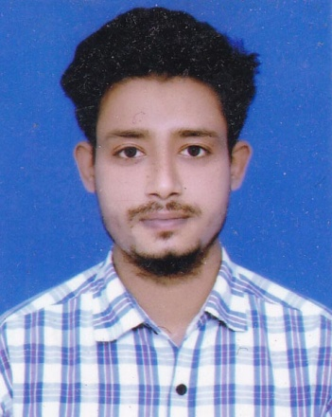

*Md. Mushfikur Rahman*

Vill : Ramnagor, Post : Betgari-5410

Upzila : Gangachara, Dist : Rangpur,

Contact No : +8801761531887

E-mail : musfiqur4u@gmail.com

***C a r e er O b j e c t i v e:***

Make an excellent career as an Engineer. I would like to build an excellent career. Having a challenging position with a company that is rapidly expanding and offers good advancement potential.

***A c a d e m i c Q u a l i f i c a t i o n:***

***Diploma in Engineering:***

Name of Institute : Image Polytechnic Institute,Rangpur.

Name of Board : Bangladesh Technical Education Board.

Group : Mechanical Technology.

Year : 2018

Result : Appeard

***Secondary School Certificate Examination (S.S.C/Dhakil)***

Name of Institute : Pakuria Sharif dhakil Madrasah.

Name of Board : Madrasah Board

Group : Scince

Year : 2014

Result : GPA # 3.7 (Out of 5.00)

***L a n g u a g e P r o f i c i e n c y:***

Bangla:

Proficient in writing, reading, listening and speaking.

English:

Competent in writing, reading, listening and speaking.

***S k i l l s:***

.

● Computer Skill On Microsoft Office (Good Typing Speed Bangla, English), MS Excel, MS Power Point, Photoshop, Illustrator, Internet Browsing etc.

***T r a i n i n g:***

● Bangladesh Machine Tools factory . Shimul Toli Gagipur From 02.02.2018 to 22.05.2018

***P e r s o n a l I n f o r m a t i o n:***

|  |  |  |  |  |
| --- | --- | --- | --- | --- |
| Name | | : | MD: Mushfikur Rahman Shaown | |
| Father's Name | | : | Md.Shafiqul Alam | |
| Mother's Name | | : | Most. Shuli Begum | |
| Date of Birth | | : | 01.09.1999 | |
| Religion  Gender | | :  : | Islam (Sunni)  Male | |
| Marital Status | | : | Unmarried | |
| Nationality | : | Bangladeshi | |
| Mobile No. | : | +8801761531887 | |
| National ID No. | : | No | |
| Height | : | 5΄-4˝ | |
| Blood Group | : | (B+) | |

***C o n t a c t A d d r e s s:***

● **Present Address** : Vill : Ramnagor, Post : Betgari-5410

Upzila : Gangachara, Dist : Rangpur.

**● Permanent Address** : Vill : Ramnagor, Post : Betgari-5410

Upzila : Gangachara, Dist : Rangpur.