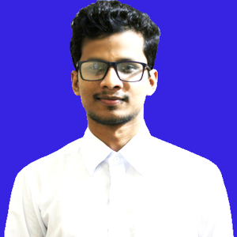**MD. ASHIKUR RAHMAN**

Address : Nobinagor, Savar, Dhaka

Contact : +8801743297489

E-mail : emonrahmanashik@gmail.com

LinkedIn: www.linkedin.com/in/ashikur-rahman-497397184

**Objective:**

I want to develop my career in a reputed organization. Seeking a quality environment where my knowledge and skills can be share. I always wish to work with the potential of myself. So I want Place Where I can contrivance my energy as well as thought and knowledge.

|  |  |
| --- | --- |
| **Academic Qualification:** |  |
| **Bachelor of Science (B.Sc.) Honors**  Subject | : Computer Science & Engineering |
| Institute | : Gono Bishwabidyalay |
| Year | : 2019 |
| Result | : 3.30 Out of 4.00 |
| **Higher Secondary Certificate (H.S.C)**  Group | : Science |
| Institute | : Savar Model College |
| Year | : 2014 |
| Result | : 4.50 Out of 5.00 |
| **Secondary School Certificate (S.S.C)**  Group | : Science |
| Institute | : Daudpur Pallimilon High School |
| Year | : 2011 |
| Result | : 4.63 Out of 5.00 |
| **Computer Proficiency:** |  |

* I have knowledge on MS. Office (MS-Word, MS-Excel, MS-PowerPoint) E-mailing and browsing etc.
* Web Research, Data mining etc.

**Work Experience:**

* EI Technology ( As a Freelancer )
* KASH IT Corporation (EXECUTIVE- ICT)

**Extra Curriculum Activities & Projects:**

* Food Delivery App • E-commerce site.
* **Special Skill:**
* I have good communication & organization skill.
* I am able to work both individually & in a team.

**Language**

Excellent communication capabilities both verbal and writing in: English Reading, Writing, Listening & Speaking High

**Trainings and Seminars Attended:**

* Web Application Development-PHP(BITM)
* Freelancing Career in Web Design & Development 2018(Seminars)
* Bangladesh Digital Social Innovation in Dhaka(Seminars)
* Firefox new feature Test Day, Dhaka(Seminars)

|  |  |
| --- | --- |
| **Personal Information:** |  |
| Name | : MD. ASHIKUR RAHMAN |
| Father’s Name | : MD. MIJANUR RAHMAN |
| Mother’s Name | : NAJMA BEGUM |
| Permanent Address | : Nobinagor, Savar, Dhaka |
| Date of Birth | : 20/03/1996 |
| Marital Status | : Unmarried |
| Religion | : Islam |
| Nationality | : Bangladeshi |
| Blood Group | : A+ |
| **References:** |  |

|  |  |
| --- | --- |
| Professor Dr. Molla Amir Hossen  Chairman  Board of Intermediate and Secondary Education, Jessore  Phone: 01711140859  Email: amir.hossen1964@gmail.com | o Md. Faisal Khan  Chairman  EI Technology  Phone: 01917019025  Email: eitechbd18@gmail.com |

**Declaration**

I am Md. Ashikur Rahman certify that to the best of my knowledge and belief, these data correctly describe my qualification.

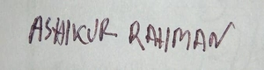

MD. ASHIKUR RAHMAN