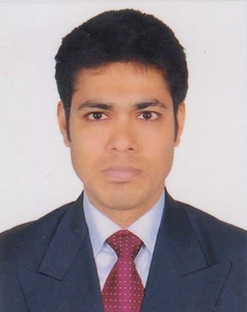

**Resume of**

**Md. Asadul Haque**

**01922-316817**

asadhaqueg@gmail.com

**Present Address:**

Md. Quddus(Teacher)

Dingadoba,Bank Colony,

Rajshahi City,

Rajshahi.6000

**Career Objective**

Looking for a term association with a people oriented organization where individual talent, skills, honesty and hard work are acknowledged and conductive work culture is provided. Seeking professional knowledge and utilizing my skills and abilities to their fullest extant to make distinct position in job. I aspire to obtain in an organization where my skills and abilities will be challenged to achieve result.

**Experience**

01 .Organization : **KY Steel Mills Ltd.**

255, Nasirabad I/A, Chittagong-4211, Bangladesh.

Job Title : Sr. Sales Executive

Period : 4th May 2019 at Rajshahi & Natore to Continuing.

02. Organization : **LafargeHolcim Cement (Bangladesh) Ltd**.

Ninakabbo level-2, Tajgoan , Gulshan link Road, Dhaka

Job Title : Sales Promotion Officer.

Period : 1st March 2016 at Madaripur & Shariatpur to 30 April 2019.

03. Organization : **Partex Plastics PVC Group.**

74, Bir Uttam A.K. Khandaker Sarak, Mohakhali C/A.

Job Title : Sales Executive

Period : 2nd March 2015 at Mirpur, Dhaka to 16 February 2016.

04. Organization : **Marketing Resource Bureau of Bangladesh ( M.R.B).**

Kalabagan, Bus Stand Road, House no-5, Dhaka.

Job Title : Supervisor.

Period. : 12 February 2013 to 31 January 2015.

**Academic Qualification**

|  |  |  |  |  |
| --- | --- | --- | --- | --- |
| **Course** | **Institution** | **Board** | **Place** | **Year of passing** |
| Master of Social Science (MSS) | M.M. College,  Jessore | National University of Bangladesh | Second class | 2009 |
| Bachelor of Social Science (BSS) | Cantonment College, Jessore | National University of Bangladesh | Second class | 2008 |
| H.S.C | Satkhira, govt  College | Jessore | GPA 2.30 | 2003 |
| S.S.C | P.N. High School, Satkhira | Jessore | GPA 2.88 | 2001 |

**Special Qualification**

Certificate Basic Computer Training under Shomaj Sheba from Satkhira Branch.

**Professional Qualification**

Computer Literacy **:-** MS-office, Excel, Internet, Photoshop.

**:-**  Typing Speed**>**Bangla 30,English 25 per minute.

**Achievements**

3000 sacks of Holcim cement sales in Shariatpur from 0 volume.

**Personal Details**

**Father’s Name :** Late Mozammel Haque.

**Mother’s Name :** Asia Khatun.

**Religion :** Islam

**Date of Birth :** 6th August, 1984.

**Nationality :** Bangladeshi

**Marital Status :** Married

**Height :** 6’0”

**Strong Points :** Hard working & Positive Attitude.

**Declaration**

I thereby declare that the information furnished above is true to the best of my knowledge and if given a chance, I will do my best.

**Permanent Address**

Late MozammelHaque[music teacher]

Sultanpur(palpara)

Ayub Ali Bishwas Sarony,

Satkhira.9400

**References:**

(1) **Khan Jafar Altaf** (2) **Md. Alauddin**

Area Sales Manager (South Bengal) Join Director, (L/C Branch)

Lafargeholcim Cement (Bangladesh) Limited. Bangladesh Bank,

NinaKabbo, Level-7, Bir Uttam Mir- Motijhil Branch,

Shawkat Sarak, Tejgaon, Dhaka. Motijhil, Dhaka-1000.

Mobile : 01708-124642 Mobile: 01818-475977

Email: jafar.altaf@lafargeholcim.com Email: md.alauddin346.bb.org.bd

**Md. Asadul Haque**

