**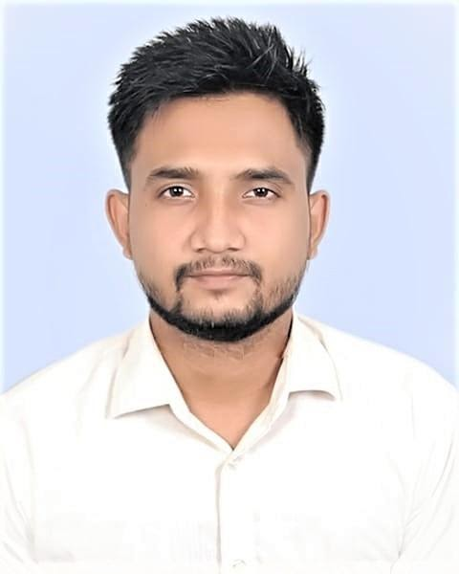       Curriculum Vitae**

**NASIM PARVEJ**

**C/O :  Assaduzzaman**

**Contact no. :  +88 01772-567880**

**Mail ID :  nasimparvez8@gmail.com**

***Career Objective:***

I am a confident, motivated, reliable and hard-working person with a flexible approach to work and keen to learn new skills. I have the ability to work on my own initiative or as a part of a team, with a commitment to succeed. Basically, I want to build up my career in a successive way to achieve my competencies and skill, nevertheless any kind of challenging work draws my interest.

***Academic Qualification:***

**Started from most recent degree:**

* **Name of Degree: B.Sc Engineering in Electrical & Electronic Engineering**

Name of Institution : Southern University

  (**79 Credit transferred from Daffodil International University)**

University : Dhaka & Chittagong.

Group/Subject : Electrical & Electronic Engineering

Result : **CGPA- 3.57 (Out of 4)**

Passing Year : 2017

* **Name of Degree: Higher Secondary Certificate (H.S.C)**

Name of Institution : Ghataile Cantonment Public School &College

Board : Dhaka.

Group : Science

Result : **GPA- 3.30 (Out of 5)**

Passing Year : 2012

* **Name of Degree: Secondary School Certificate (S.S.C)**

Name of Institution : Daxmin Mainam High School, Naogaon

Board : Rajshahi

Group : Science

Result : **GPA- 5.00 (Out of 5)**

Passing Year : 2010

**Strength**

* Creative thinking, dedication and hard working.
* Self motivated and strong concern for career.
* Good leadership skill.

**Computer Knowledge**

* Ms- Word, Ms- Excel, Ms- Access, Ms- Power Point & Internet Browsing.

**Job Experience**

1. Company Name : Banglalink Digital (response Ltd.)

   Designation : Sales & Service Executive

   Duration : 11th May 2019 to till now.

   Gross Salary : 10000+KPI+Mobile Bill 3000 Taka.

   Operation : Monobrand & Device. Location- Dinajpur.

2. Company Name : Banglalink Digital (Genex Infosys Ltd.)

   Designation : CCR (Call Center Representative)

   Duration : 01st November 2018 to 31st April 2019

   Gross Salary : 12000+KPI+Mobile Bill 2000 Taka.

   Operation : Investigations and Resolutions. Location- Dhaka.

3. Company Name : Banglalink Digital (response Ltd.)

   Designation : CCR (Call Center Representative)

   Duration : 19th October 2017 to 30th October 2018

   Gross Salary : 10000+KPI+Mobile Bill 3000 Taka.

   Operation : Call Center Agent. Location- Gazipur.

4. Company Name : Wakia Education

   Designation : Consultant

   Duration : 01st October 2016 to 30th May 2017

   Gross Salary : 10000+KPI

   Operation : Counseling. Location- Dhaka.

**Job Responsibilities:**

* Obtains client information by answering telephone calls; interviewing clients; verifying information.
* Determines eligibility by comparing client information to requirements.
* Establishes policies by entering client information; confirming pricing.
* Informs clients by explaining procedures; answering questions; providing information.
* Maintains communication equipment by reporting problems.
* Maintains and improves quality results by adhering to standards and guidelines; recommending improved procedures.
* Updates job knowledge by studying new product descriptions; participating in educational opportunities.
* Accomplishes sales and organization mission by completing related results as needed.
* Manage large amounts of incoming calls
* Generate sales leads
* Identify and assess customers’ needs to achieve satisfaction
* Build sustainable relationships and trust with customer accounts through open and interactive communication
* Provide accurate, valid and complete information by using the right methods/tools
* Meet personal/customer service team sales targets and call handling quotas
* Handle customer complaints, provide appropriate solutions and alternatives within the time limits; follow up to ensure resolution
* Keep records of customer interactions, process customer accounts and file documents
* Follow communication procedures, guidelines and policies
* Take the extra mile to engage customers

**Language** **Skills**

* Bengali    : Mother Tongue
* English    : Reading, Writing and speaking fluently.

**Interest/ Hobby**

* Reading Newspaper, Reading Book, Traveling etc.

**Personal Information**

* Name : Nasim Parvej
* Father’s Name : Assaduzzaman
* Mother’s Name : Nasima Begum
* Permanent Address : Vill : Mainam, P.O. : Mainam -6500,

                                                             P.S : Manda, Dist : Naogaon.

* Present Address : Vill : Roysahebbari, P.O. : Dinajpur-5200,

                                                             P.S : Dinajpur Sadar, Dist : Dinajpur.

* Date of Birth : 26th October 1994
* Sex : Male
* Nationality : Bangladeshi
* National Id Number : 2402773085
* Home District : Naogaon
* Blood Group : B+ (ve)
* Marital Status : Single
* Religion : Islam

**Reference**

**1. Mr. Jahangir Alam**

   Agent of Printex Industries

   Laxmi Bazar, Dhaka.

   Mobile No: +88 01716-136244

   Relationship: Uncle.

2. **Abu Sadat Muhiuddin**

   Sr. Excutive at Banglalink Digital

   Sadar, Dinajpur.

   Mobile No: +88 01962-400239

   Relationship: Current Line Manager

**Declaration**

I hereby declare that, the above information in the resume is true and correct to the best of my knowledge and behalf.

**Signature:**



**(Nasim Parvej)**

**Date: 15/11/2020**