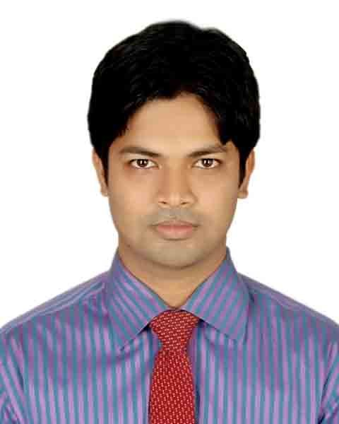MD. ALI AKBAR PALASH

Address: House:25, Road:12, Sector: 14, Uttara 1230, Dhaka

⚫ Phone: +8801753648481

⚫e-mail: a.palashkhan999@gmail.com

Mission

Seeking a position in any Department of an organization where I will be able to contribute my skill and academic knowledge to achieve the goal of the organization as well as I can develop my career.

**Personal Strength-Qualitative Attributes**

|  |  |
| --- | --- |
| * Positive and professional attitude * Hard working, dynamic and can work under pressure * Self-motivated and dedicated for getting the job done rightly | * Strong sense of responsibility and capable of quick service delivery * Strong communication skill * Capable of working in team at various levels |

**Job Experience: total 5 Year(s)**

1. **Sr. Executive: Sales & Business Development**

**Intertek Bangladesh (Sep, 2019 - Continuing)**

**Duties/Responsibilities:**

* Managing portfolio of accounts (Buyer H&M)
* Explore for opportunity to achieve sales targets with pre-sales team.
* Ensure good understanding of customer requirements & current market information.
* Build and maintain strong, long-lasting customer relationships.
* Ensure the timely and successful delivery of our solutions according to customer needs.
* Responsible for credit collection with the finance team
* Make daily field visits to customers to retain existing business, increase volume and pursue new customers.
* Preparing monthly basis report and presentation.
* To prepare invoice of received test order & to prepare test cost estimation for client.
* To coordinate with the lab personnel to submit the order for test.
* To send the test report to customer through email and upload the same to the specific customer web portal / account, if necessary.
* To provide information as required by the department Heads & perform any task assigned by Managements.

1. **Executive: Marketing**

**YKK Bangladesh PTE Ltd, (Feb, 2017 - Sep, 2019)**

**Duties/Responsibilities:**

* Managing portfolio of accounts (Buyer: C&A, Next, Intersport, Terranova, Academy, etc.)
* Collect market information & make a report
* Identify and grow opportunities within the assigned market
* Forecast and track key account metrics.
* Achieve periodical, individual and group sales target
* Arrange sample and confirm order offering price, meeting with buyer and coordinate sample issue
* To ensure timely sample log-in and to organize the sample pick-up and delivery on time to customer.

1. **Officer: Customer Service**

**UL VS Bangladesh Ltd, (Jan,2016-Dec,2017)**

**Duties/Responsibilities:**

* Answer calls coming into the helpdesk
* Serve as the first point of contact for customers seeking technical assistance over the phone or email
* Direct the customer to articulate the suspected fault through carefully designed questions
* Identify the issue encountered by the customer and open the right support ticket in the system
* Determine the solution based on the issue and details provided by customers
* Arrange appointment with the client for follow up
* Record events and problems and their resolution in logs

**Academic Qualification**

|  |  |  |  |  |  |
| --- | --- | --- | --- | --- | --- |
| **Exam Title** | **Concentration /Major** | **Institute** | **Board/ University** | **Result** | **Passing Year** |
| MBA | Marketing & Finance | Institute of Business Administration | Jahangirnagar University | **CGPA:3.05**  Out of 4 | 2018 |
| BBA | Marketing | Bachelor of Business Administration. | Khulna University | **CGPA:3.03**  out of 4 | 2014 |
| HSC | Science | Khulna Public college | Jashore Board | **CGPA:4.40** out of 5 | 2007 |
| SSC | Science | Boyra Dak Bivagiyo High School, Khulna | Jashore Board | **CGPA:4.94** out of 5 | 2005 |

**Training Summary**

|  |  |  |  |
| --- | --- | --- | --- |
| **Training Title** | **Topic** | **Institute** | **Year** |
| **Operations Based Sales** | Leverage the skills and client’s relationship of Ops-based Sales to generate sales leads through inbound and outbound calls | INTERTEK Bangladesh | 2021 |
| **Marketing and Sales** | A disciplined process targeting best leads, opportunities and overall sales performance | INTERTEK Bangladesh | 2021 |
| **ATIC Selling** | To learn innovation toolkits that will help teams to gain greater insight into the organization across all business lines, globally and locally | INTERTEK Bangladesh | 2021 |
| **Information Security Awareness: Malware, Email, Password** | Total Security about using digital equipment | INTERTEK Bangladesh | 2020 |
| **Code of Ethics Training** | Corporate ethics, value, role and responsibility | INTERTEK Bangladesh | 2020 |
| **Building Resilience** | Mindfulness = maintaining awareness of the "now" - tuning into this helps manage stress. Resilience = ability to bounce back and come back together stronger from them. | INTERTEK Bangladesh | 2020 |
| **Customer Segmentation** | Identify the priority segment, Clarify the opportunity, take necessary steps | INTERTEK Bangladesh | 2020 |
| **Contract Negotiations, Pricing** | Setting ourselves up to win | INTERTEK Bangladesh | 2020 |
| **Customer Wiring** | Being wired into your customer knowing them, their purpose and their needs | INTERTEK Bangladesh | 2020 |
| **Project Management for Business** | How to arrange and complete project | IBA, JU | 2018 |
| **Branding** | Importance of branding in Marketing | IBA, JU | 2018 |
| **Business Equity** | Business culture and equity | Khulna University | 2014 |
| **Basic Computer** | Computer basic application | Khulna University | 2010 |

**Personal Profile:**

|  |  |  |
| --- | --- | --- |
| **Father’s Name** | **:** | Md. Yousuf Ali Khan |
| **Mother’s Name** | **:** | Nurjahan Begum |
| **Date of Birth** | **:** | 20th March,1990 |
| **Permanent Address** | **:** | Khan Vila, 88/B, R/A KDA, Boyra, Mosgunni,  GPO:9000, Khulna. |
| **Nationality** | **:** | Bangladeshi |
| **Religion** | **:** | Muslim |
| **Blood Group** | **:** | B+ |
| **National Id No.** | : | 5966635301 |

**Technological Experience:**

|  |  |
| --- | --- |
| MS Office (Word, Access, Excel, PowerPoint). |  |

**Reference:**

|  |  |  |  |  |  |
| --- | --- | --- | --- | --- | --- |
| Name | : | Md. Jasim Uddin khan | Name | : | Md. Refat Ahmed |
| Organization | : | Bangladesh Police | Organization | : | Tex Zipper (BD) Limited |
| Designation | : | Inspector | Designation | : | Assistant Manager |
| Mobile | : | +8801913540253 | Mobile | : | +88 01894800231 |
| E-Mail | : | jasimkhan980@gmail.com | E-Mail | : | refat.ahmed@texzipperbd.com |
| Relationship | : | Brother | Relationship | : | Official |

**I do hereby confirm that the information mentioned above is true to the best of my knowledge.**

**Sincerely,**

Md. Ali Akbar Palash