**REAL-TIME CRIMINAL IDENTIFICATION SYSTEM**

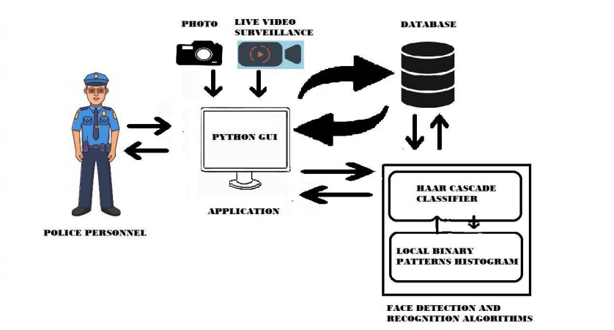

**Face Detection:**

The system uses Haar cascade classifiers to detect faces in images. Haar cascade classifiers are machine learning based algorithms that are trained to detect specific object classes in images. The classifiers are trained using a large number of positive and negative images. The positive images contain the object to be detected, while the negative images do not contain the object. The classifiers are then used to detect the object in new images.

**Face Recognition:**

The system uses the Local Binary Patterns Histograms (LBPH) algorithm for face recognition. LBPH is a texture based feature extraction method. It works by first converting the image into grayscale. Then, it computes the intensity values of the image pixels at various points on a grid. These intensity values are used to create a histogram of the image. The histograms are then used to compare the similarity between two images. The more similar the histograms, the more likely the two images are of the same person.

**Database Management:**

The system uses a database to store the criminal data. The database is organized in such a way that each criminal has a unique identifier. The criminal data includes the criminal's name, age, gender, and a set of images of the criminal's face.

**User Interface:**

The system provides a user interface for the police personnel to interact with. The user interface allows the police personnel to search for criminals by providing their name or identifier. The system then retrieves the criminal data from the database and displays it on the screen. The user interface also allows the police personnel to add new criminals to the database.

**Live CCTV Surveillance:**

The system seamlessly integrates with live CCTV surveillance, detecting faces in real-time. It also allows manual upload of suspect images for comparison. Both live video and uploaded images are matched against a criminal database using LBPH algorithm. Upon a match, relevant criminal data is displayed for swift action by law enforcement.