LW_02 answers

Q1

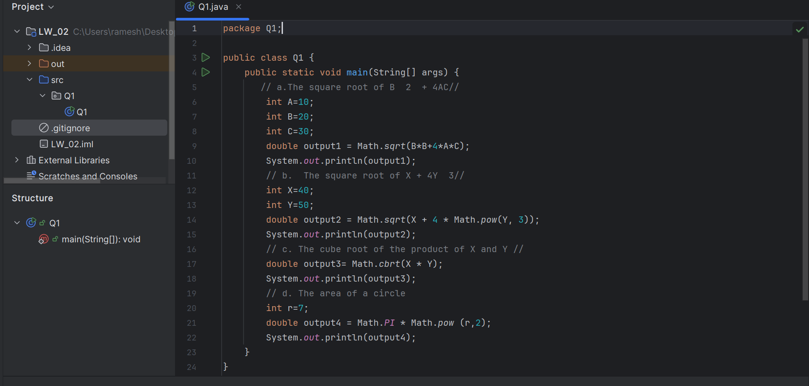

OUTPUT

Q2

OUTPUT

Q3

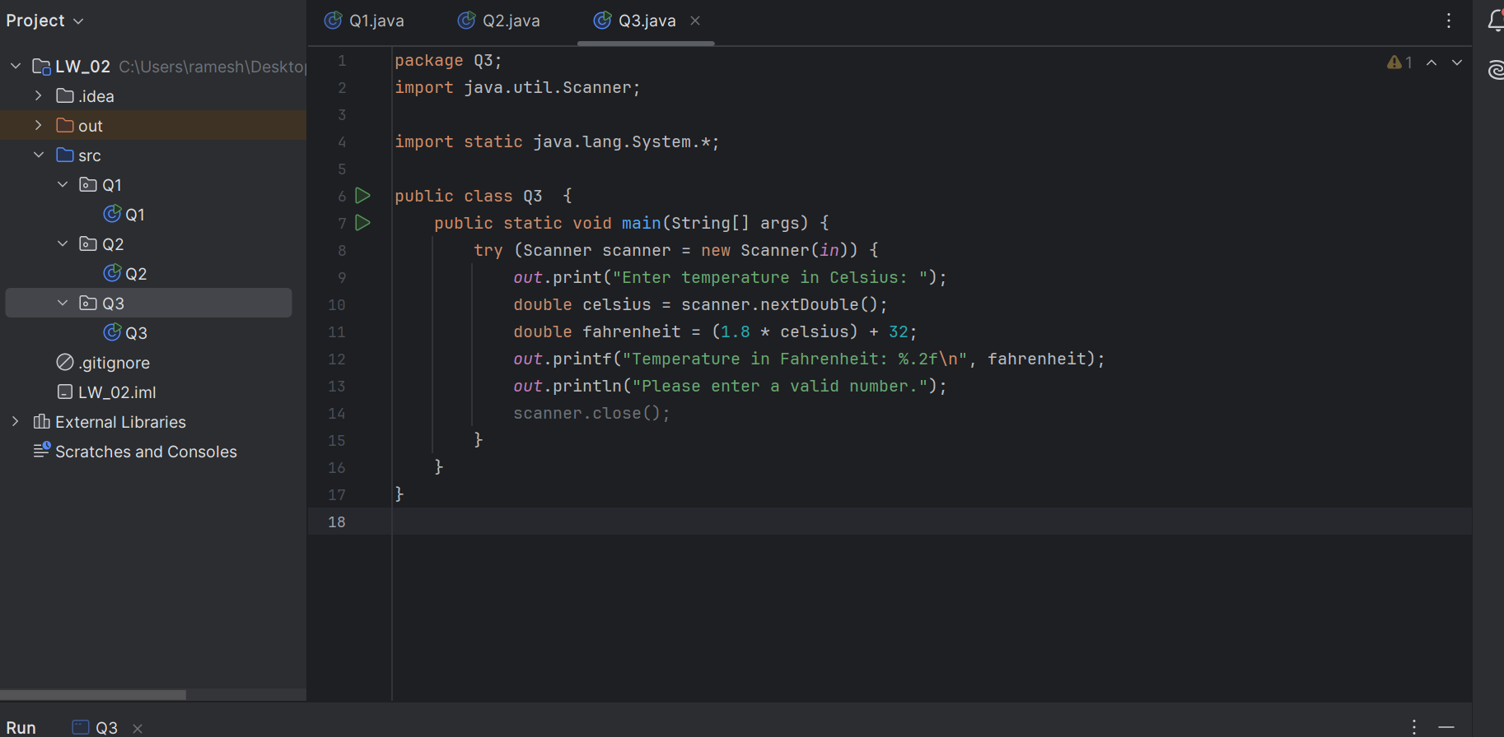

OUTPUT

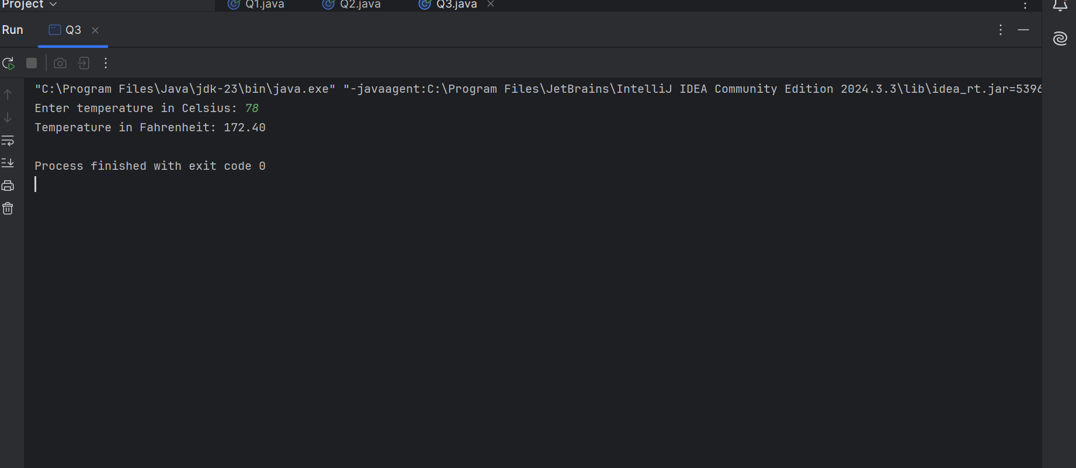

Q4

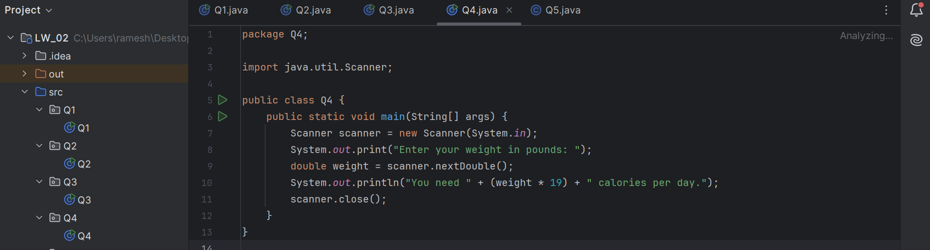

OUTPUT

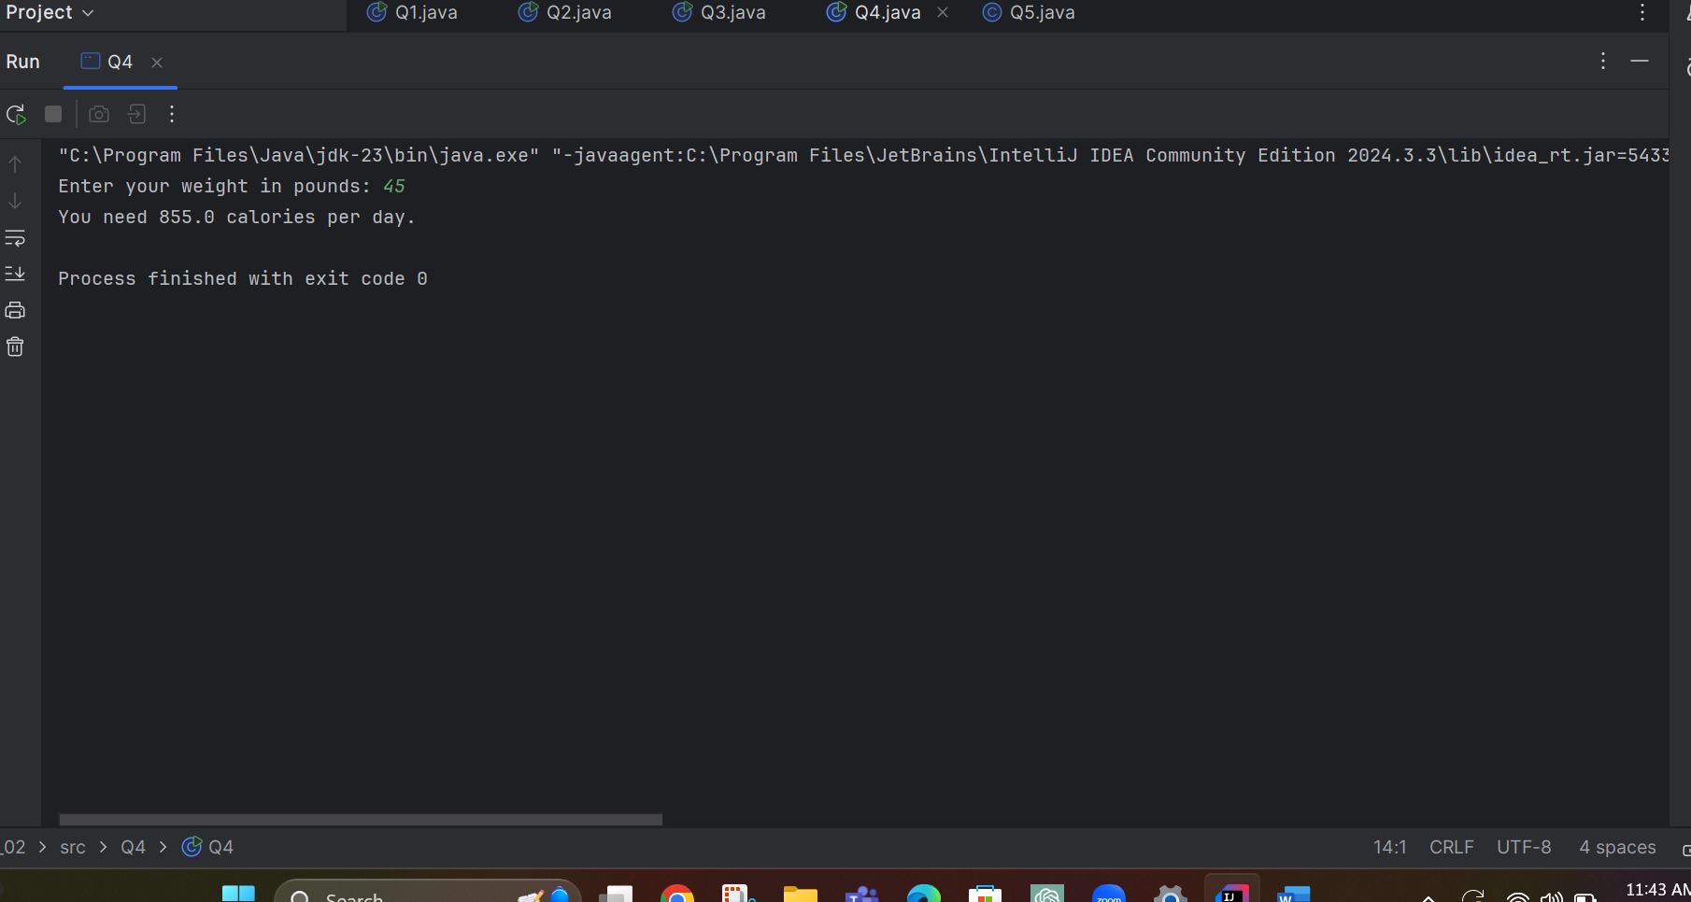

Q5

OUTPUT

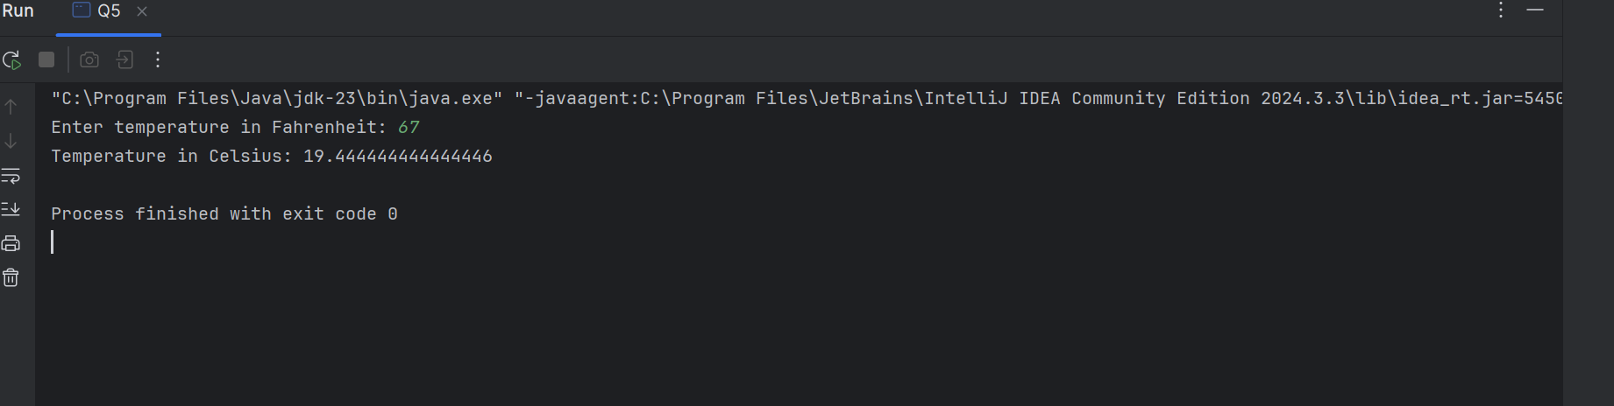

Q6

OUTPUT

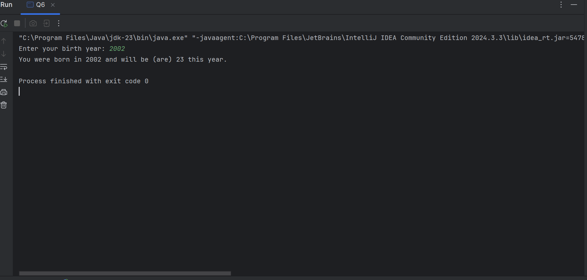

Q7

Q8

OUTPUT

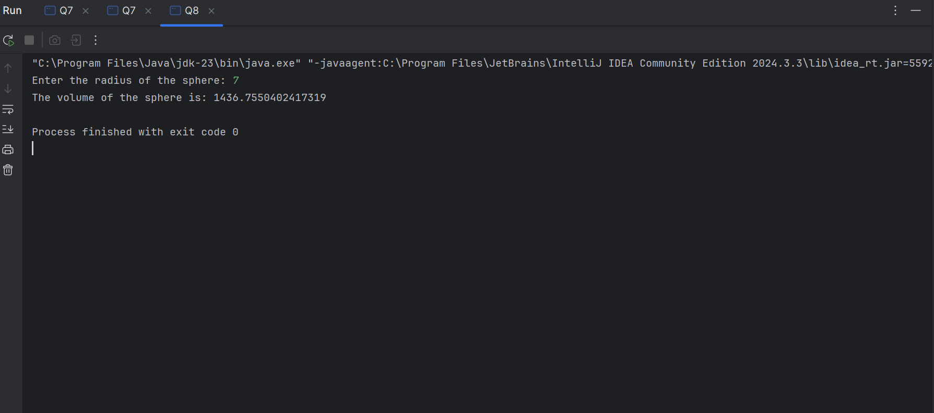

Q9

OUTPUT

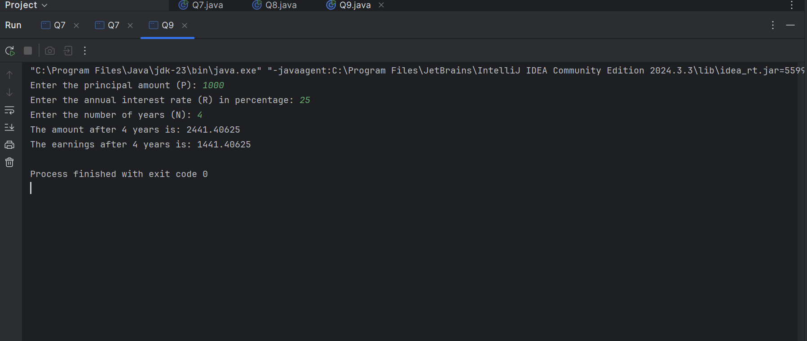

Q10

OUTPUT

