**CTEC 22043 -Object Oriented Programming**

**LAB WORKSHEET -03**

QUESTION-01

package Q_01;  
  
import java.util.Scanner;  
  
 public class Q_01 {  
 public static void main(String[] args) {  
 Scanner input=new Scanner(System.*in*);  
 System.*out*.println("Enter temperature in celsius");  
 double celsiusInput=input.nextDouble();  
 Temperature temperature=new Temperature(celsiusInput);  
 System.*out*.println("Equivalent temperature in fahrenheit:"+temperature.toFahrenheit());  
 System.*out*.println("Enter temperature in F to convert back to c");  
 double fahrenheitInput=input.nextDouble();  
 temperature.setFahrenheit(fahrenheitInput);  
 System.*out*.println("convert back to c:"+temperature.toCelsius());  
 input.close();  
 }  
}

package Q_01;  
  
public class Temperature {  
 private double celsius;  
 public Temperature(){  
 celsius=0.0;  
  
 }  
 public Temperature(double celsius){  
 this.celsius=celsius;  
  
 }  
 public double toFahrenheit(){  
 return (celsius*9/5)+32;  
 }  
 public double toCelsius(){  
 return celsius;  
 }  
 public void setCelsius(double celsius){  
 this.celsius=celsius;  
 }  
 public void setFahrenheit(double fahrenheit){  
 this.celsius=(fahrenheit-32)*5/9;  
 }  
}

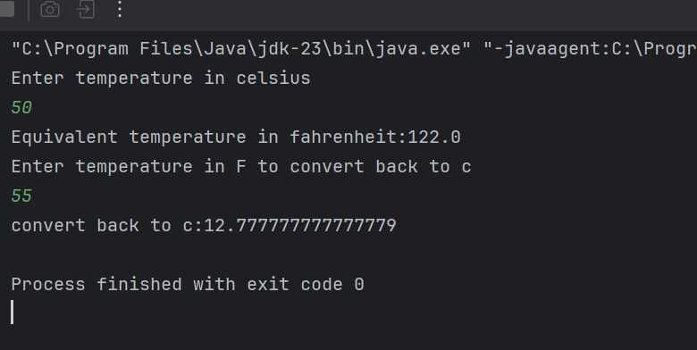

QUESTION- 02

package Q_02;  
  
import java.util.Scanner;  
  
public class Q_02 {  
 public static void main(String[] args) {  
 Scanner input = new Scanner(System.*in*);  
  
 System.*out*.print("Enter temperature in Fahrenheit: ");  
 double fahrenheit = input.nextDouble();  
  
 Temperature temp = new Temperature();  
 temp.setFahrenheit(fahrenheit);  
  
 System.*out*.println("Equivalent temperature in Celsius: " + temp.getCelsius());  
  
 input.close();  
 }  
}

package Q_02;  
  
public class Temperature {  
 private double fahrenheit;  
  
 public void setFahrenheit(double fahrenheit) {  
 this.fahrenheit = fahrenheit;  
 }  
  
 public double getCelsius() {  
 return (fahrenheit - 32) * 5 / 9;  
 }  
}

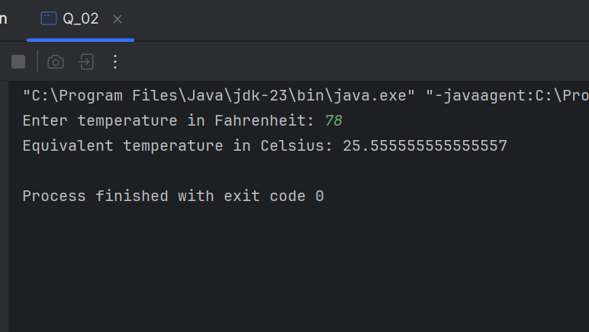

QUESTION-03

package Q_03;  
  
import java.util.Scanner;  
  
public class Q_03 {  
 public static void main(String[] args) {  
 Scanner input=new Scanner(System.*in*);  
 System.*out*.println("Enter the inner radius of the circle:");  
 double innerRadius=input.nextDouble();  
 System.*out*.println("Enter the outer radius of the circle:");  
 double outerRadius=input.nextDouble();  
  
 if(innerRadius>outerRadius) {  
 System.*out*.println("Inner radius connot be greater than outer radius. ");  
  
 }  
 else {  
 Circle outerCircle=new Circle(outerRadius);  
 Circle innerCircle=new Circle(innerRadius);  
  
 double Area=outerCircle.computeArea()-innerCircle.computeArea();  
 System.*out*.println("The area is: "+Area);  
 }  
 }  
}

package Q_03;  
  
public class Circle {  
 private double radius;  
 public Circle(double radius){  
 this.radius=radius;  
 }  
 public void setRadius(double radius) {  
 this.radius = radius;  
 }  
 public double computeArea(){  
 return Math.*PI*\*radius*radius;  
 }  
 public double computeCircumference(){  
 return 2*Math.*PI*\*radius;  
 }  
}

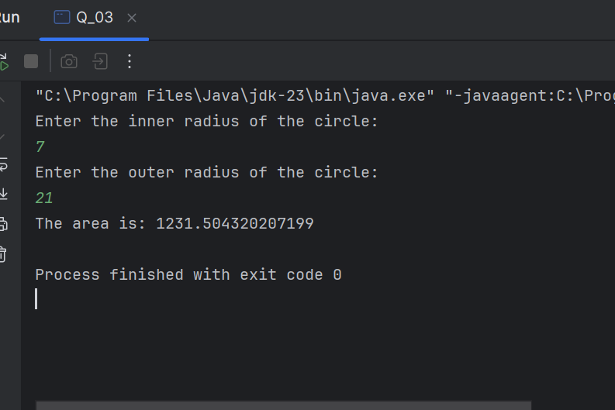

QUESTION-04

package Q_04;  
  
public class Q_04 {  
  
 public static void main(String[] args) {  
 Owner owner = new Owner("John Doe", "123-456-7890");  
  
  
 Bicycle bike = new Bicycle("Giant", 21, owner);  
  
 bike.displayDetails();  
 }  
}

package Q_04;  
  
public class Bicycle {  
 private String brand;  
 private int gearCount;  
 private Owner owner; // Owner object instead of separate name and phoneNo  
  
 // Constructor  
 public Bicycle(String brand, int gearCount, Owner owner) {  
 this.brand = brand;  
 this.gearCount = gearCount;  
 this.owner = owner;  
 }  
  
 // Getters  
 public String getBrand() {  
 return brand;  
 }  
  
 public int getGearCount() {  
 return gearCount;  
 }  
  
 public Owner getOwner() {  
 return owner;  
 }  
  
 // Display bicycle details  
 public void displayDetails() {  
 System.*out*.println("Bicycle Brand: " + brand);  
 System.*out*.println("Gear Count: " + gearCount);  
 System.*out*.println(owner);  
 }  
}

package Q_04;  
  
public class Owner {  
 private String ownerName;  
 private String phoneNo;  
  
 public Owner(String ownerName, String phoneNo) {  
 this.ownerName = ownerName;  
 this.phoneNo = phoneNo;  
 }  
  
 public String getOwnerName() {  
 return ownerName;  
 }  
  
 public String getPhoneNo() {  
 return phoneNo;  
 }  
  
 @Override  
 public String toString() {  
 return "Owner: " + ownerName + ", Phone: " + phoneNo;  
 }  
}

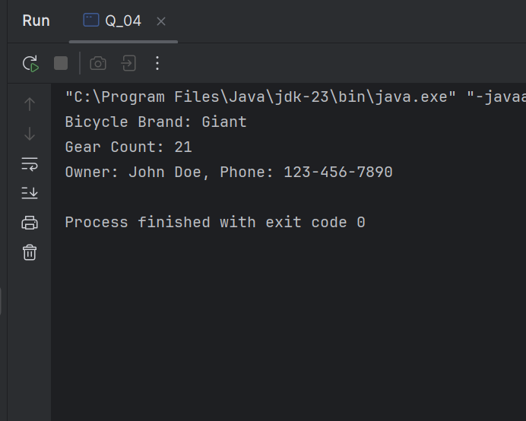

QUESTION-05

package Q_05;  
  
public class Q_05 {  
 public static void main(String[] args) {  
 Lecturer lecturer = new Lecturer("Mr.Kesavan", "Object-Oriented Programming");  
  
 Course course = new Course("Object-Oriented Programming", "CTEC 22043", lecturer);  
  
  
 Student student = new Student("Rishani", "Information Communication Technology", "CTEC 22043");  
  
 System.*out*.println("Course: " + course.getCourseName() + " (" + course.getCourseCode() + ")");  
 System.*out*.println("Lecturer: " + course.getLecturer().getLecturerName());  
 System.*out*.println("Student: " + student.getStudentName() + " - " + student.getDegreeName());  
  
 }  
}

package Q_05;  
  
public class Lecturer {  
 private String lecturerName;  
 private String courseTeaching;  
  
 public Lecturer(String lecturerName, String courseTeaching) {  
 this.lecturerName = lecturerName;  
 this.courseTeaching = courseTeaching;  
 }  
  
 public String getLecturerName() {  
 return lecturerName;  
 }  
  
 public void setLecturerName(String lecturerName) {  
 this.lecturerName = lecturerName;  
 }  
  
 public String getCourseTeaching() {  
 return courseTeaching;  
 }  
  
 public void setCourseTeaching(String courseTeaching) {  
 this.courseTeaching = courseTeaching;  
 }  
}

package Q_05;  
  
public class Course {  
 private String courseName;  
 private String courseCode;  
 private Lecturer lecturer; // Lecturer object  
  
 public Course(String courseName, String courseCode, Lecturer lecturer) {  
 this.courseName = courseName;  
 this.courseCode = courseCode;  
 this.lecturer = lecturer;  
 }  
  
 public String getCourseName() {  
 return courseName;  
 }  
  
 public void setCourseName(String courseName) {  
 this.courseName = courseName;  
 }  
  
 public String getCourseCode() {  
 return courseCode;  
 }  
  
 public void setCourseCode(String courseCode) {  
 this.courseCode = courseCode;  
 }  
  
 public Lecturer getLecturer() {  
 return lecturer;  
 }  
  
 public void setLecturer(Lecturer lecturer) {  
 this.lecturer = lecturer;  
 }  
}

package Q_05;  
  
public class Student {  
  
 private String studentName;  
 private String degreeName;  
 private String courseFollowing;  
  
 // Constructor  
 public Student(String studentName, String degreeName, String courseFollowing) {  
 this.studentName = studentName;  
 this.degreeName = degreeName;  
 this.courseFollowing = courseFollowing;  
 }  
  
 public String getStudentName() {  
 return studentName;  
 }  
  
 public void setStudentName(String studentName) {  
 this.studentName = studentName;  
 }  
  
 public String getDegreeName() {  
 return degreeName;  
 }  
 public void setDegreeName(String degreeName) {  
 this.degreeName = degreeName;  
 }  
 public String getCourseFollowing() {  
 return courseFollowing;  
 }  
 public void setCourseFollowing(String courseFollowing) {  
 this.courseFollowing = courseFollowing;  
 }  
