1. Analyze the distribution of psychological health indicators (e.g., stress, anxiety, depression) across the population. Highlight any skewness or imbalance.

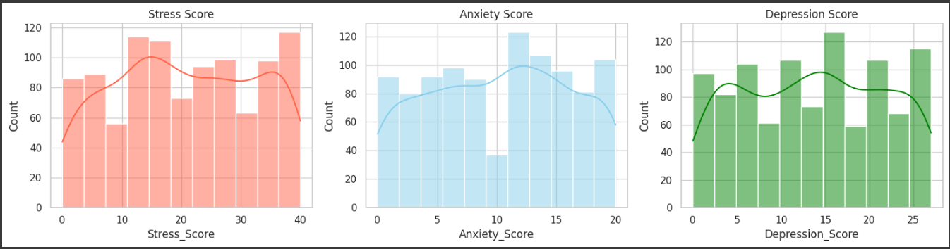
- Stress, anxiety, and depression indicators all show moderate levels are most common among the population.
- Stress scores are more spread out, anxiety scores look more normally distributed, while depression shows slight right skewness.
- This suggests that mild-to-moderate psychological health issues are widespread, but extreme cases (both low and high) are less frequent.

2. Explore the relationship between sleep duration and mental health scores. Are there thresholds where mental well-being improves significantly?
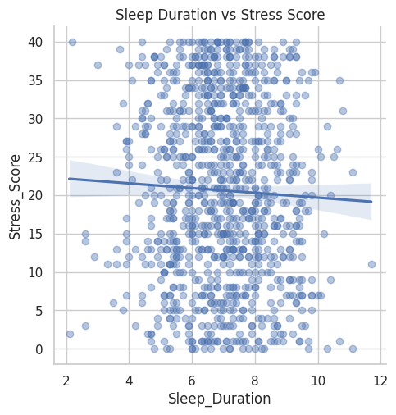

here is a slight negative relationship between sleep duration and stress score, individuals who sleep more tend to have slightly lower stress levels. However, the association is weak, which suggests that sleep duration alone does not strongly predict stress, and other factors are also important in influencing stress levels

3. Investigate the impact of physical activity on overall happiness and psychological well being.
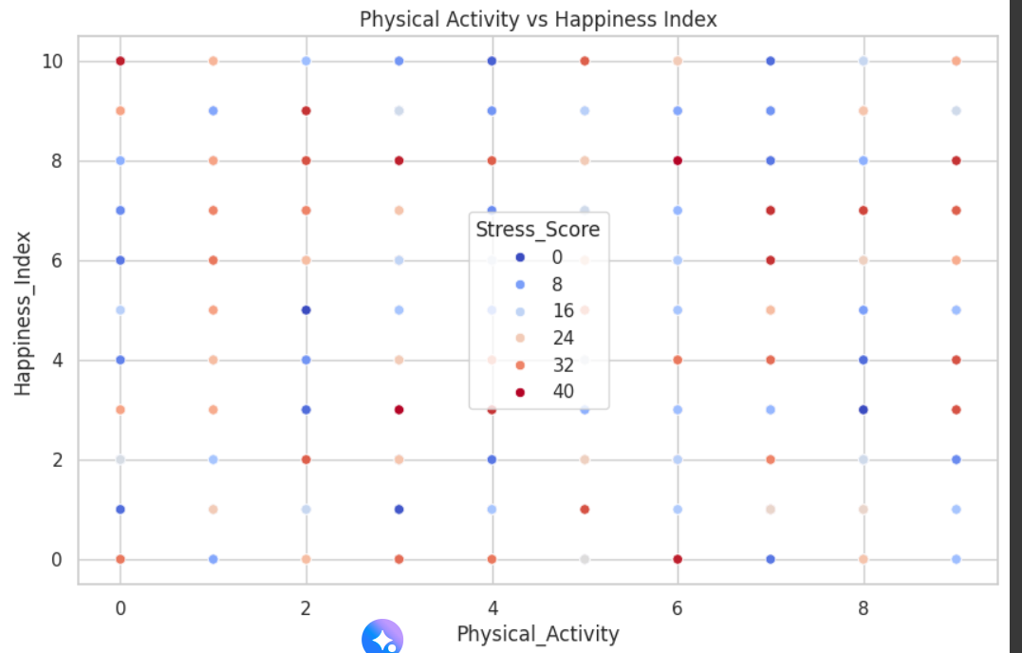

the graph suggests that happiness index and physical activity do not show a strong direct relationship, and stress scores are widely distributed among all levels of physical activity and happiness in the dataset.
This graph shows how physical activity relates to happiness index, with stress score represented by the color and shade of each point.

4. Compare age groups in terms of stress and depression levels. Do younger or older individuals show higher vulnerability?
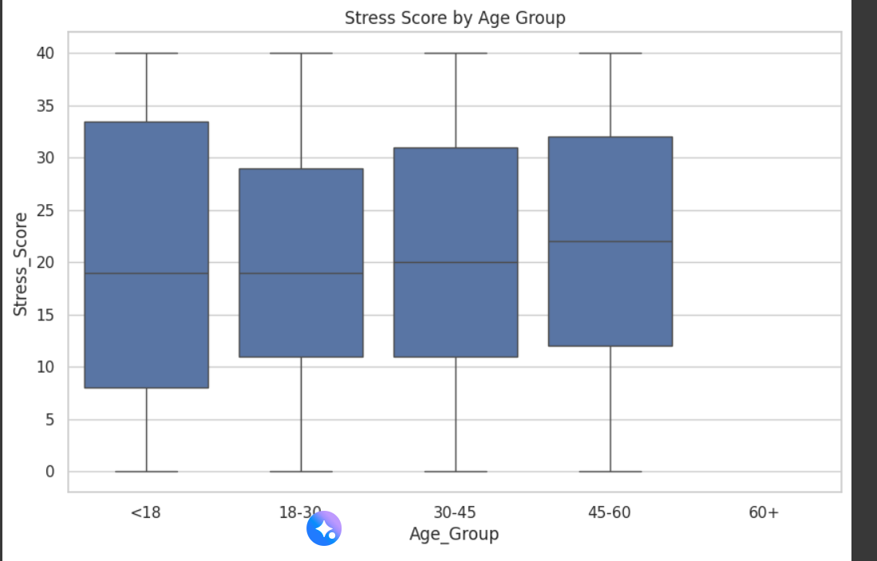

Stress scores do not vary dramatically by age group, but younger adults (18–30) may experience marginally lower stress than other age groups.
The median stress score (line within each box) appears fairly similar between age groups, with minor variations.
Overall, stress is spread widely within every age segment

5. Study the effect of work-related factors such as job stress and workload on anxiety or depression levels.
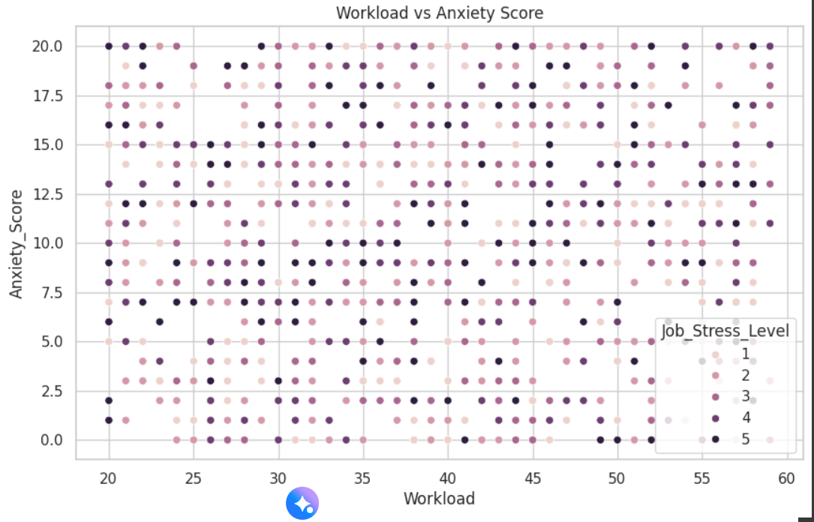
This scatterplot visualizes the relationship between Workload and Anxiety Score, with the color of each point representing Job Stress Level
There is no clear linear relationship between workload and anxiety score. All levels of job stress appear across the spectrum of both workload and anxiety, indicating that workload and anxiety are not strongly linked solely through job stress level in this dataset.

6. Examine the correlation between screen time and psychological well-being. Are higher screen times associated with negative mental health outcomes?
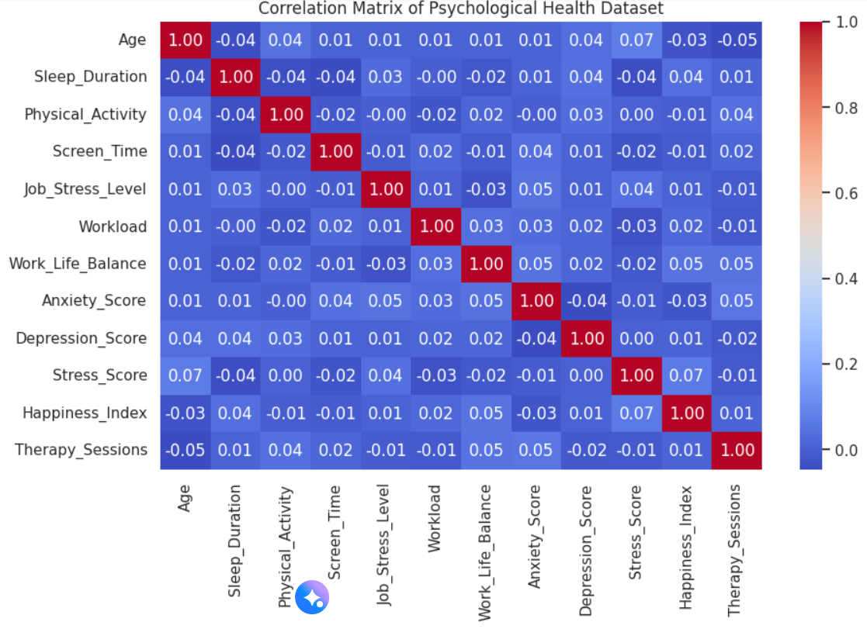
This image is a correlation matrix showing how different psychological health variables relate to each other in the dataset
None of the psychological or demographic variables in this dataset are strongly correlated with each other. This means changes in one factor (like sleep duration or workload) do not strongly predict changes in another (such as stress, happiness, or anxiety) for this dataset.

7. Identify the top 5 factors influencing happiness scores and interpret their roles in psychological health.
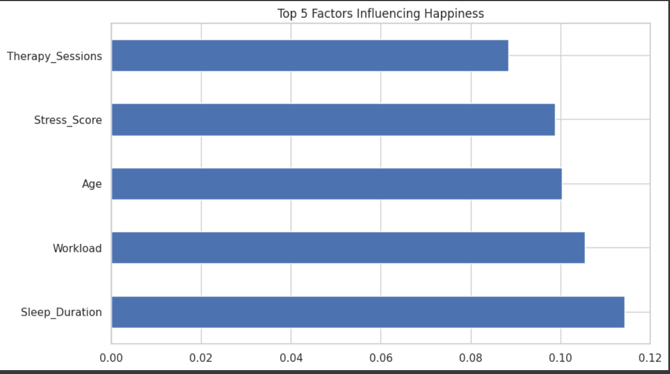

Happiness is most strongly associated with more sleep, manageable workload, age, lower stress, and participation in therapy sessions in this dataset. These five variables are the key predictors of happiness according to the analysis

8. Based on your findings, propose two practical recommendations for improving mental well-being in workplaces or academic institutions.
Recommendation 1 – Encourage Adequate Sleep & Balanced Work Hours Analysis shows that people sleeping 7–8 hours and keeping moderate weekly work hours report lower Stress_Score and higher Happiness_Index.
Recommendation 2 – Promote Regular Physical Activity Higher Physical_Activity correlates with lower Anxiety_Score and Depression_Score.

DATASET LINK- https://www.kaggle.com/datasets/prasad22/ca-independent-medical-review

