# Software Requirement Specification

**Virtual Classroom**

## Team Members:

Rishank Pratik

Department of Computer Science and Engineering, Vellore Institute of Technology, Chennai Campus

**Contents**

|  |  |
| --- | --- |
| **Title** | **Page No.** |
| 1. **Introduction**    1. Purpose    2. Document Conventions    3. Users of the System    4. Product Scope    5. References | **2**  2  2  2  2  2 |
| 1. **Overall Description**    1. Product Description    2. Use Case Diagram    3. Design and Interface    4. Implementation    5. Activity Diagram    6. Sequence Diagram | **3**  3  4  4  5  5  6 |
| 1. **External Interface Requirements**    1. User Interface    2. Software Requirements    3. Hardware Requirements | **7**  7  7  7 |
| 1. **Other Non-Functional Requirements**    1. Performance requirements    2. Security Requirements    3. Safety Requirements    4. Software Quality Attributes | **7**  7  7  7  7 |

1. **Introduction**
   1. **Purpose**

During the current corona virus outbreak, it has become increasingly important to maintain social distancing and minimize contact. Covid-19 has brought the education system, particularly classroom teaching to a standstill, while the students in rural India were hit the maximum. Not every educational institution apart from well-established colleges and universities have access to online teaching portal. They still use methods like Video calling or chatting through WhatsApp. Popular applications like Google Meet and Zoom are designed to conduct meeting and not classes, hence they lack proper system for storage and access to study materials, quiz section. Hence, we aim to design a simple, cost friendly and an efficient system to facilitate a classroom learning environment by improving makespan, cost and using limited yet proper resources.

## Document Conventions

Standard IEEE Software Requirement Specification format was thoroughly followed while writing this document.

## Users of the system

1. Students - To access learning materials, take assignments and quizzes and interact with the system
2. Faculties - To teach students online through various modes, give assignments and quizzes, record student details and evaluate answer scripts.
3. Administrator – It has control over the entire system.

## Product Scope

This product definitely has a lot of scope in future. With the advent of technology and current corona virus scenario it has become increasingly important to adopt online teaching through efficient platforms.

## References

* + - AlAwadhi, S., et al. "Virtual reality application for interactive and informative learning." *2017 2nd International Conference on Bio-engineering for Smart Technologies (BioSMART)*. IEEE, 2017.
    - Hakami, Mohssen. "Utilization of Virtual Classroom System in Traditional Teaching: Benefits and Challenges." *International Journal of Education, Learning and Development* 5.3 (2017): 21-29.
    - Sunasee, Rajesh. "Challenges of Teaching Organic Chemistry during COVID-19 Pandemic at a Primarily Undergraduate Institution." *Journal of Chemical Education* (2020).
    - Jang, H.Y.; Kim, H.J. A Meta-Analysis of the Cognitive, Affective, and Interpersonal Outcomes of Flipped Classrooms in Higher Education. *Educ. Sci.* 2020
    - Cloete, Anita L. "Technology and education: Challenges and opportunities." *HTS Theological Studies* 73.4 (2017): 1-7.
    - Reynolds, Kate, and Linda Flynn-Wilson. "Student perception of the quality of discussion in a synchronous virtual classroom environment." *EdMedia+ Innovate Learning*. Association for the Advancement of Computing in Education (AACE), 2018.
    - Rekha Asmara. (2020). TEACHING ENGLISH IN A VIRTUAL CLASSROOM USING WHATSAPP DURING COVID-19 PANDEMIC. *Language and Education Journal*, *5*(1), 16-27.
    - Hofmann, Jennifer. "Solutions to the top 10 challenges of blended learning." *United states: InSync Training, LLC* (June 2020).

## Overall Description

* 1. **Product Functions**

### Login function

When learner or lecturer wants to enter in the classroom, they have to login with correct username and password. Only logged-in users are allowed to use shared objects or resources.

### Whiteboard/ Simulation function

The purpose of using this function is to provide a collaborative environment for learners and lecturers. They can write message in text format and draw line on the shared whiteboard environment in real time. When they want a message or line, they must select tools by dragging and dropping them on the whiteboard. They can also delete objects by pressing delete key on the keyboard. Learners can write or erase any items at any time they want. They are equally authorized in this classroom. Same goes with the simulation application.

### Presentation function

This function allows creating a presentation in SWF format. Lecturer can fully control the presentation. Learners can see the same frame simultaneously. Learners are not allowed to control the presentation that the lecturer has corresponded. The presentation function requires SWF presentation files.

### Chat function

This function supports lecturer and learners for chatting in regular text format. They can send message to other people in the same classroom. Text can be selected in different styles.

### List of learners

This function displays lecturer and learners name that login the classroom. All usernames appear on the list in the classroom that is used to identify who they are.

### Audio/Video presentation function

This allows the lecturer and the learner to facilitate audio and video sharing/ streaming

## Use case Diagram

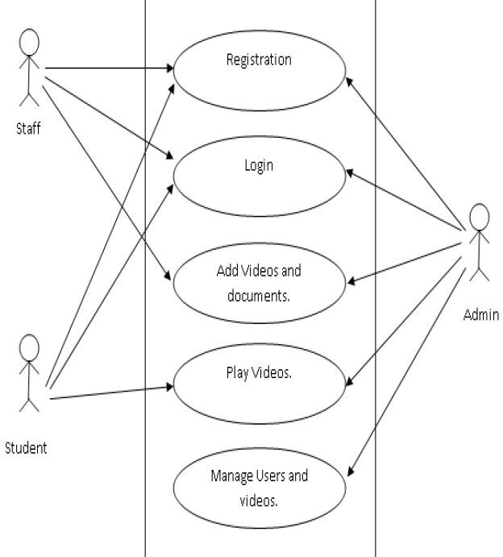

* 1. **Design and Interface**

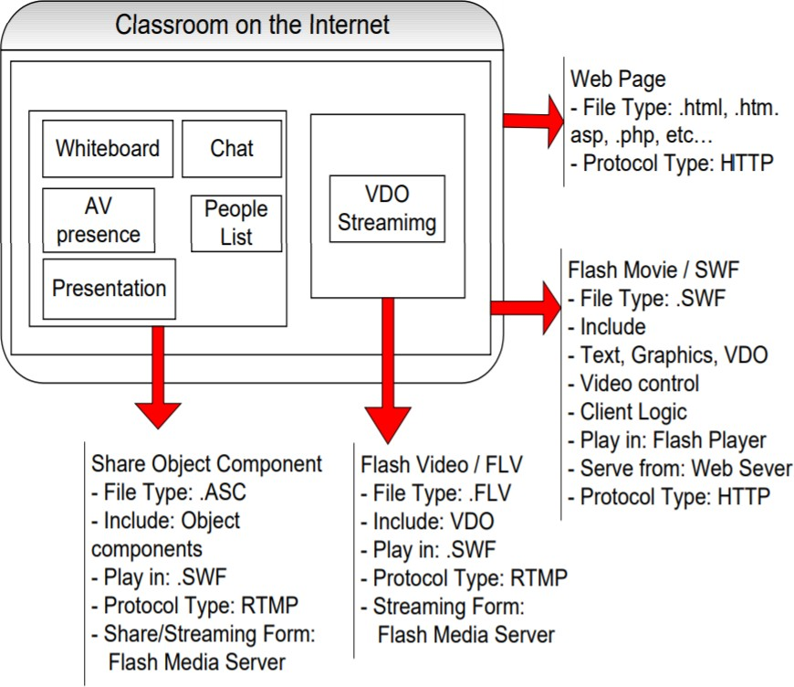

* 1. **Implementation**

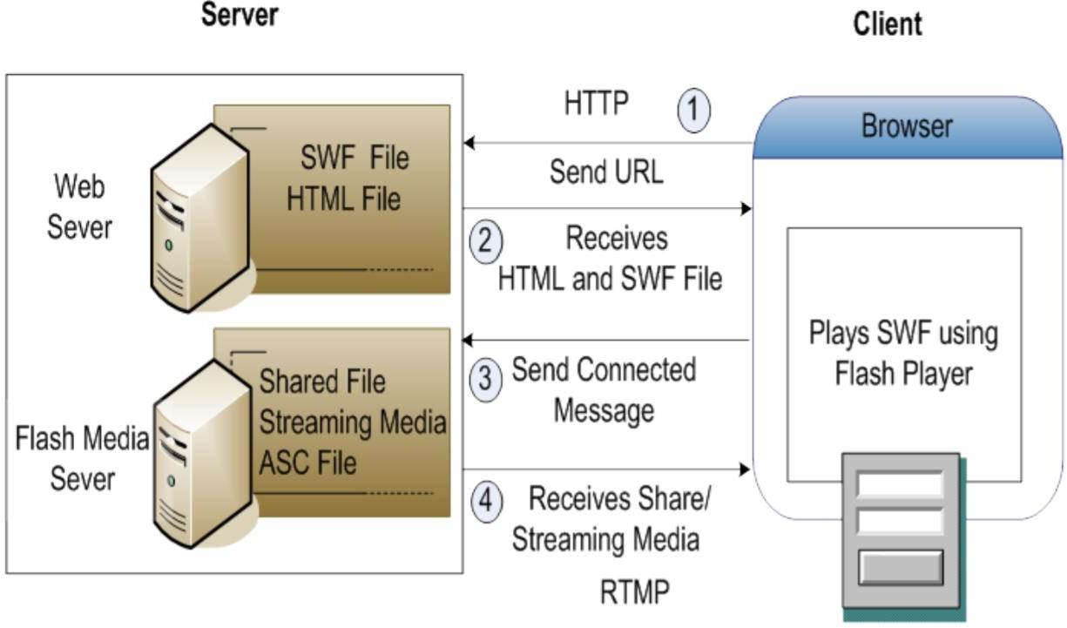

* 1. **Activity Diagram**

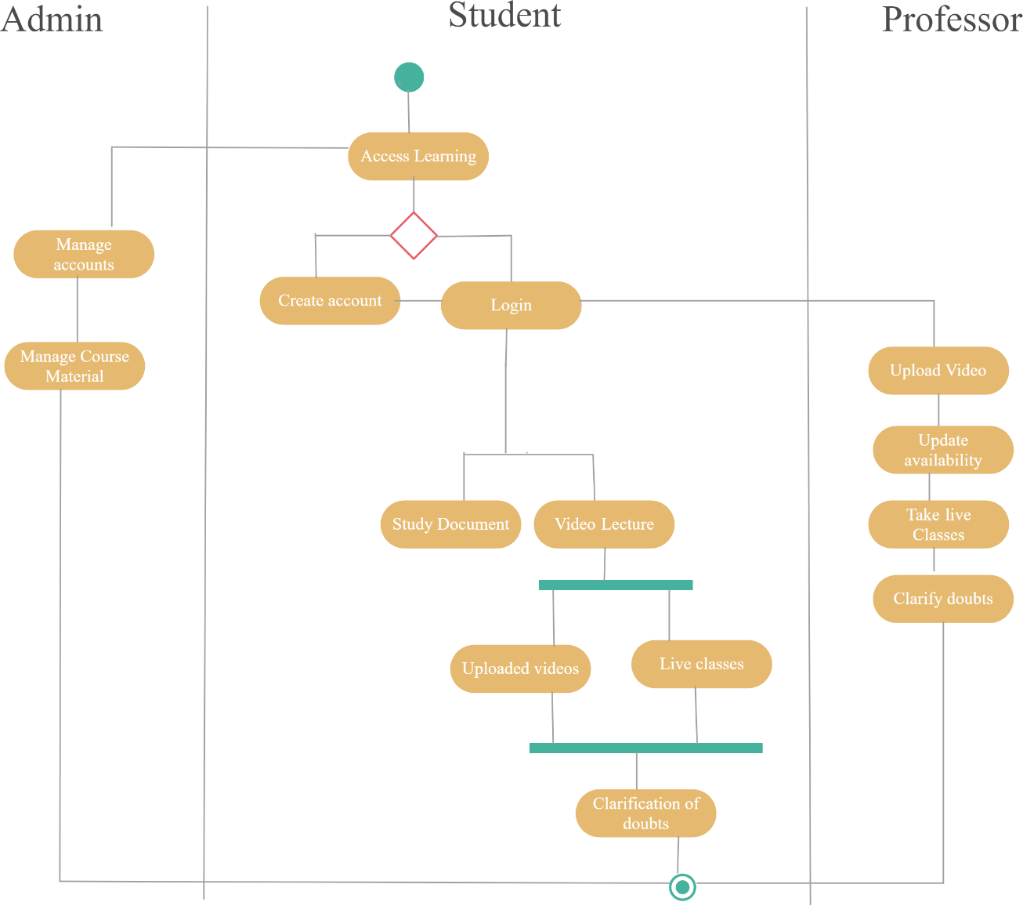

* 1. **Sequence Diagram**

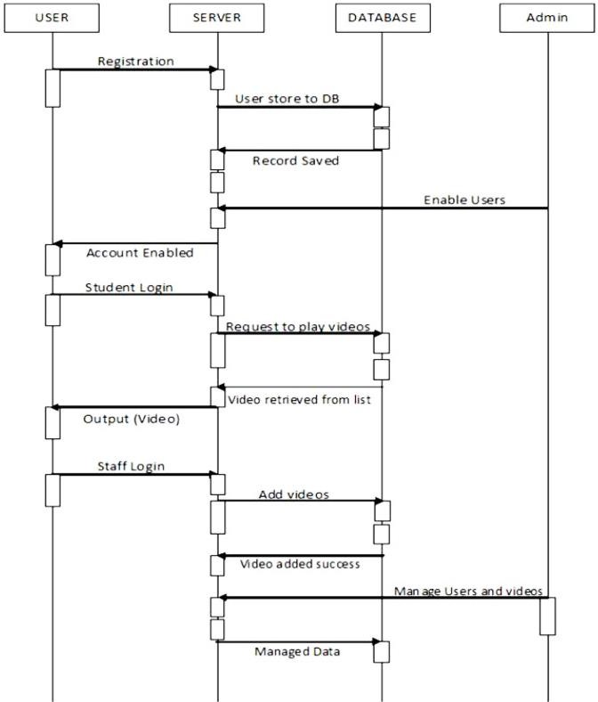

1. **External Interface Requirements**
   1. **User Interface**

A login screen for entering the username and password, so that the authorized user can have an access without any problems. After that the lecturer and learner can present audio and video and proceed with the class. Lecturers can upload exam and assignments and evaluate them after learner is done with it.

## Software Requirements

The minimum software requirement is a Microsoft Windows 2000, Web Browser, Active Server Page (ASP), JAVA Script, HTML, Microsoft SQL Server 2000, Shockwave player and flash player

## Hardware Requirements

The hardware requirement consists of CPU Intel Pentium IIII 3.0 GHz or higher, memory (RAM) 1 GB or higher, Hard disk 80 GB or higher, Controller Support, Graphics Card, Network Interface Card. Monitor screen, mouse and a keyboard.

## Other Non-Functional Requirements

* 1. **Performance requirements**

1. It is expected that the database would perform functionally all the requirements that are specified.
2. The system should be easy to handle.
3. System should give expected performance results.
4. The response time should be small.

## Security Requirements

We are going to develop a secured database. There are different categories of users namely Administrator, Students, Restricted users who will be viewing either all or some specific information from the database.

Depending upon the category of user the access rights are decided. It means if the user is an administrator then he can be able to modify the data, append etc. All other users only have the rights to retrieve the information about database.

## Safety Requirements

The database may get crashed at any certain time due to virus or operating system failure. Therefore, it is required to take the database backup.

## Software Quality Attributes

1. The application is easy to interact and communicate with user.
2. This application provides better user interface for ease of working.

