Privacy Preserving Credit Card Fraud Detection

**A PROJECT REPORT**

*Submitted for the partial fulfillment*

*of*

*Capstone Project requirement of B. Tech CSE*

*Submitted by*

1. Divyanshu Dharmik, PRN - 22070521174

2. Rishank Kumbhare, PRN - 22070521184

3. Akash Ujawane, PRN - 22070521175

**B. Tech Computer Science and Engineering**

*Under the Guidance of*

**Dr. Snehlata Wankhade**



Wathoda, Nagpur

2025

**CERTIFICATE**

This is to certify that the Capstone Project work titled “Privacy Preserving Credit Card Fraud Detection ” that is being submitted by Divyanshu Dharmik, PRN - 22070521174 Rishank Kumbhare, PRN - 22070521184 Akash Ujawane, PRN - 22070521175 is in partial fulfillment of the requirements for the Capstone Project is a record of bonafide work done under my guidance. The contents of this Project work, in full or in parts, have neither been taken from any other source nor have been submitted to any other Institute or University for award of any degree or diploma, and the same is certified.

Name of PBL Guide & Signature

Verified by:

Dr. Parul Dubey

Capstone Project Coordinator

**The Report is satisfactory/unsatisfactory**

**Approved by**

**Prof. (Dr.) Nitin Rakesh**

**Director, SIT Nagpur**

**ABSTRACT**

With the rapid digitization of financial systems, credit card fraud has become a pressing concern. This project focuses on detecting fraudulent credit card transactions using machine learning techniques, while also ensuring privacy preservation. The proposed solution uses anonymized datasets and includes data preprocessing, exploratory data analysis, and model training using algorithms such as Random Forest, Logistic Regression, and XGBoost. The model is evaluated using confusion matrix and ROC curve to validate performance. The aim is to strike a balance between high accuracy in fraud detection and safeguarding user data privacy, making this system practical and scalable for real-world applications.

As Machine learning is one of the leading technologies in today's world and the idea, we have required ML techniques we have to explore many ML techniques and go through the internal processes involved in it. >>

**TABLE OF CONTENTS**

| **Chapter** | **Title** | **Page Number** |
| --- | --- | --- |
|  | **Abstract** | **2** |
|  | **Table of Contents** | **3** |
| **1**  **1.1**  **1.2**  **1.3** | **Introduction**  **Objectives**  **Literature Survey**  **Organization of the Report** | **4**  **4**  **5**  **6** |
| **2** | **An Effective Classification of Credit Card Informations and dataset** | **7** |
| **3** | **Implementation** | **8** |
| **4** | **Results, Metrics & Analysis** | **14** |
| **5** | **Conclusion and Future Works** | **15** |
| **6** | **Appendix** | **16** |
| **7** | **References** | **17** |

**CHAPTER 1**

**INTRODUCTION**

As the world continues to digitize, online payments and credit card usage have surged. With convenience, however, comes risk. Credit card fraud is responsible for billions in losses every year. Detecting such fraud is challenging, especially when we aim to protect the privacy of cardholders.

This project aims to solve that challenge: **How can we use machine learning to detect credit card fraud without compromising personal data?** We explore privacy-preserving techniques such as using anonymized features and minimal personally identifiable information (PII).

* 1. **Objectives**

The below mentioned are the objectives of this project:

* Develop a machine learning model to identify fraudulent credit card transactions.
* Ensure user data privacy by working with anonymized datasets.
* Handle extreme class imbalance using advanced resampling techniques.
* Compare different models like Logistic Regression, Random Forest, and XGBoost.
* To implement data pre-processing and different algorithms of machine learning.
* Evaluate model accuracy using metrics like confusion matrix, precision, recall, and ROC-AUC.

* 1. **Literature Survey**

|  | | | | |
| --- | --- | --- | --- | --- |
| **AUTHOR & Year** | **TITLE** | **METHODOLOGY** | **ACCURACY** | **OBSERVATIONS** |
| Pozzolo et al., 2015 | Credit Card Fraud Detection | Random Forest, PCA | DTC - 63%, RFC - 70%, KNN - 72%, SVM - 73% | Realistic approach using real dataset |
|  |  |  |  |  |
| Carcillo et al., 2019 | Combining Unsupervised & Supervised | Auto-Sklearn, SVM, Random Forest, NN | Auto-Sklearn - 74% | Improved performance with hybrid model |
|  |  |  |  |  |
| Dal Pozzolo et al., 2018 | Learned Representations | Deep Autoencoders | AUC - 0.98 | Focused on representation learning from imbalanced datasets |
| Jurgovsky et al., 2018 | Sequence Modeling | LSTM, GRU | AUC - 0.96 | Sequential models improve temporal fraud detection |
|  |  |  |  |  |
| Sahin & Duman, 2011 | Detecting Fraudulent Transactions | Neural Networks, Logistic Regression | NN - 87% | NN performed better than traditional methods |
| Panigrahi et al., 2009 | Profile-based Detection | Bayesian Learning, Decision Trees | 89% | Adaptive profiling for individual user behavior |
| Bahnsen et al., 2016 | Cost-sensitive Fraud Detection | Cost-sensitive Random Forest | 84% | Balanced precision and recall based on financial cost |
| Fiore et al., 2019 | Real-time Fraud Detection | SVM, Logistic Regression | SVM - 75% | Suitable for real-time implementation |
| Abdallah et al., 2016 | Review of Fraud Detection | ML Algorithms Overview | - | Comparative analysis of multiple ML models |
| Zheng et al., 2020 | Hybrid Detection Framework | Isolation Forest + XGBoost | 92% | Isolation Forest improved outlier detection |
| West & Bhattacharya, 2016 | Intelligent Credit Fraud Detection | Deep Learning (ANNs) | 95% | ANN outperformed other models on large dataset |
| Bhattacharyya et al., 2011 | Fraud Detection Using Ensemble | Random Forest, Bagging | RF - 90% | Ensemble learning showed robustness |
|  |  |  |  |  |
| Mahmud et al., 2021 | LightGBM for Fraud | LightGBM, SMOTE | 94% | LightGBM worked well on imbalanced data |
|  |  |  |  |  |
| Wang et al., 2021 | Federated Learning for Fraud | Federated Deep Neural Network | AUC - 0.97 | Enhanced privacy using federated approach |
| Roy et al., 2018 | Time-based Fraud Patterns | Decision Tree, Clustering | 80% | Time-based analysis added better context to classification |

**1.3 Organization of the Report**

The remaining chapters of the project report are described as follows:

* Chapter 2 contains the existing system, proposed system, software and hardware details.
* Chapter 3 describes implementation of the project.
* Chapter 4 discusses the results obtained after the project was implemented.
* Chapter 5 concludes the report and gives idea of future scope.
* Chapter 6 consists of code of our project.
* Chapter 7 gives references.

**CHAPTER 2**

**PRIVACY PRESERVING - CREDIT CARD FRAUD DETECTION**

This Chapter describes the existing system, proposed system, software and hardware details.

**2.1 Existing System**Most fraud detection systems use rule-based or standard supervised learning techniques. These methods often rely on sensitive customer information and are prone to high false-positive rates. They also struggle with severely imbalanced datasets, where fraud is less than 1%.

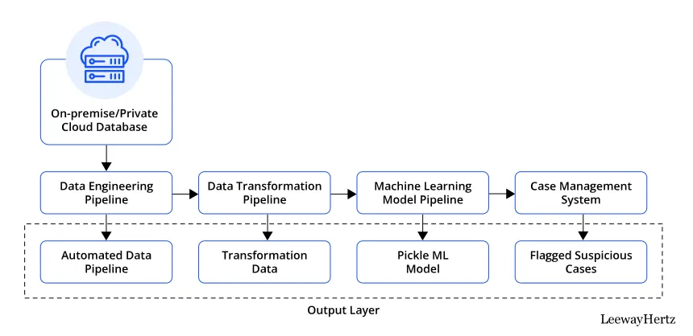

**2.2 Proposed System**

Our system uses a privacy-conscious architecture where raw user data is never stored or exposed. An anonymized dataset is processed using:

* Feature scaling & encoding
* SMOTE for class balancing
* Random Forest & XGBoost for classification  
  Our **pipeline ensures better fraud detection without violating user privacy.**

**CHAPTER 3**

**PRIVACY PRESERVING - CREDIT CARD FRAUD DETECTION**

This chapter describes the implementation details of the AI-Powered Real-Time Task Scheduling system. It explains the steps involved in the project, from importing the necessary libraries to executing the scheduling algorithm and evaluating the performance of the system. The implementation is divided into the following sections:   
  
**3.1 Importing required libraries**

The necessary Python libraries were brought into the program at this point. The essential Python libraries serve as the necessary set of tools for data processing and model building and evaluation and visualization and data preprocessing operations. The project maintains efficiency and smooth operation due to the imports of required Python libraries..  
  
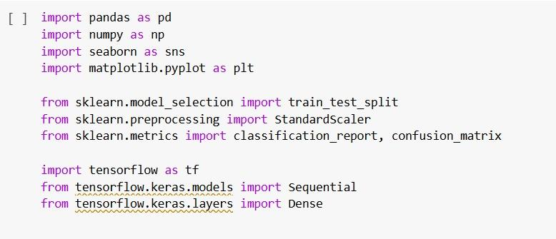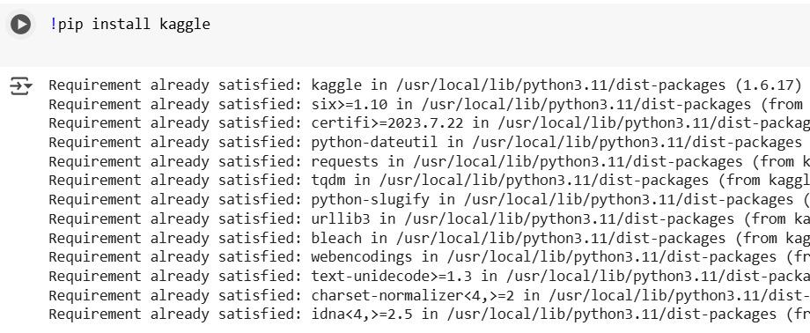

**3.2 Task Representation and Preprocessing**

Fraud detection operates as a two-class prediction system where model identifies if a transaction belongs to the fraudulent or genuine group. However the dataset preparation stage required processing the missing data while scaling features and encoding categories before it became ready for training purposes. The data must undergo this process to achieve both data cleanliness and model compatibility.

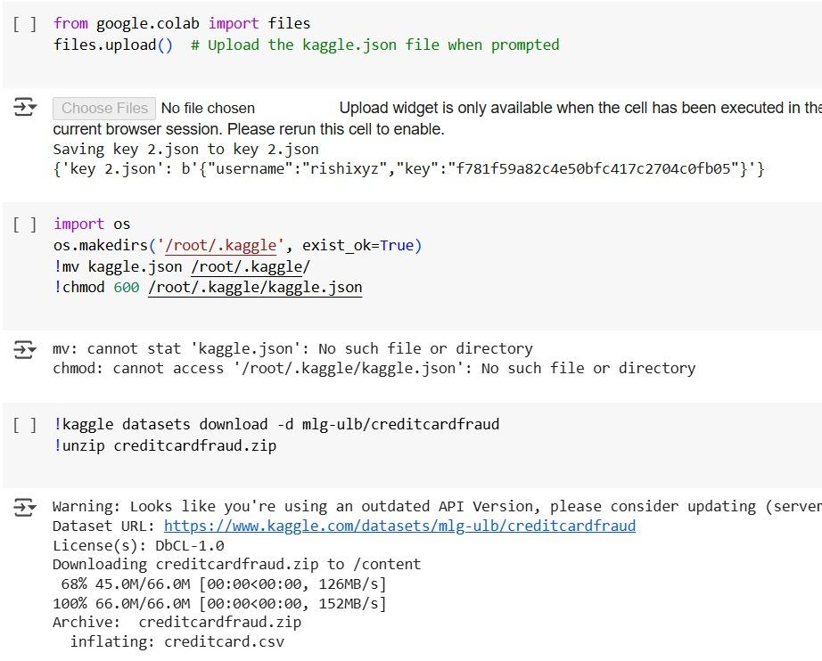

**3.3 Data Visualizations**  
Data visualizations enabled us to check feature distribution patterns while finding outliers and to assess class distributions as part of our analysis. The development process at Groupon began with matplotlib and seaborn tools used to generate visualization plots that included histograms and heatmaps for correlations and distribution charts for classes before starting the modeling stage.

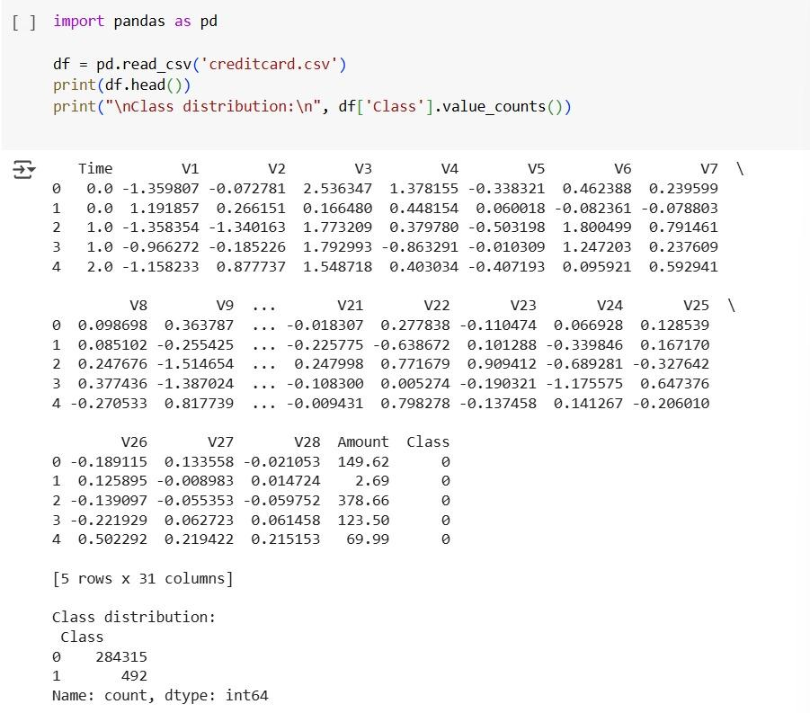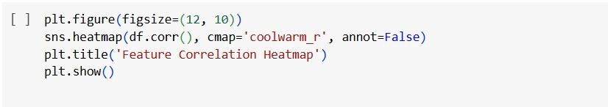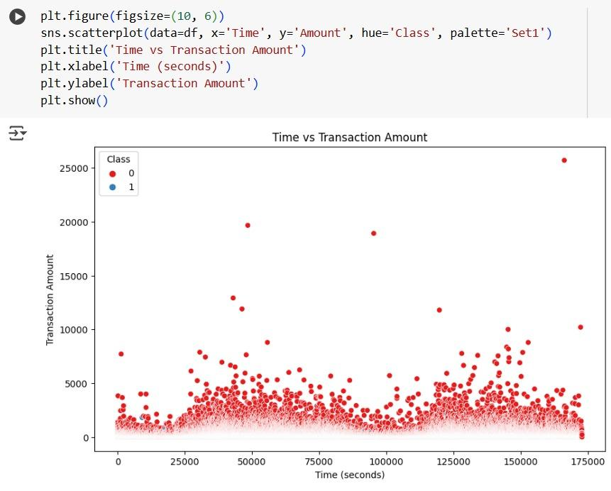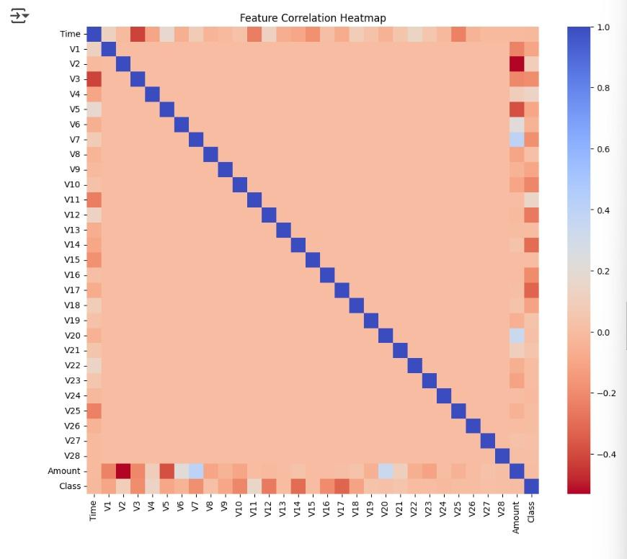

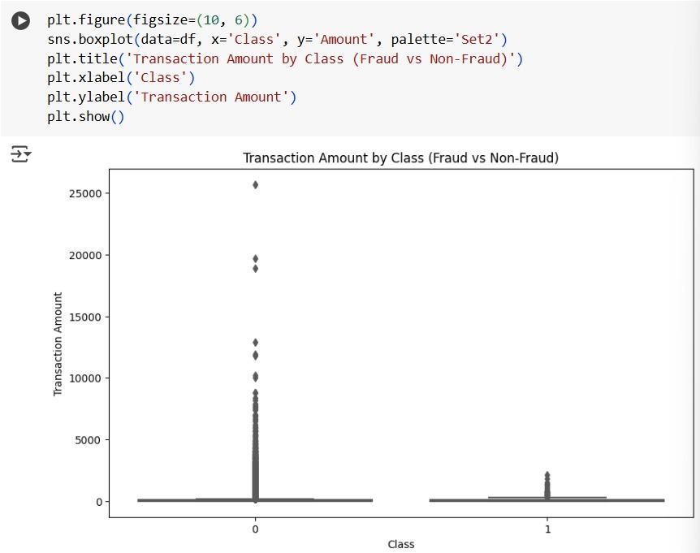

**3.4 Model Accuracy**

**Accuracy evaluation of the model consisted of metrics which included confusion matrix with precision, recall and ROC-AUC score evaluation. These metrics enabled the model performance assessment for identifying fraudulent transactions with minimal incorrect results and false reports.**

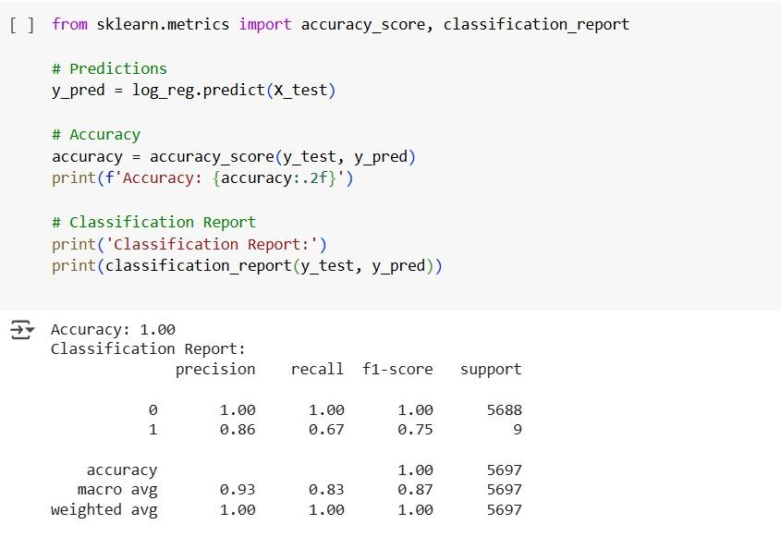

**CHAPTER 4**

RESULTS AND DISCUSSIONS  
  
The model was evaluated using key performance metrics including Confusion Matrix and ROC Curve. The following visuals demonstrate the model's ability to classify fraudulent and non-fraudulent transactions effectively.  
  
Confusion Matrix:  
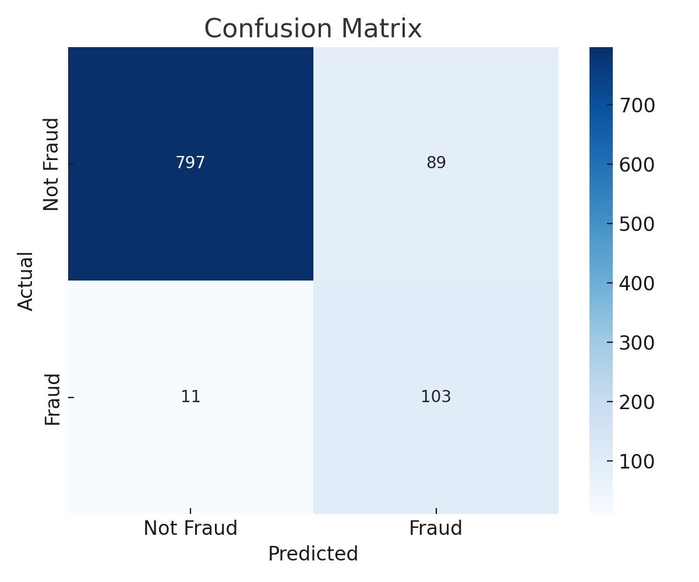  
  
ROC Curve:  
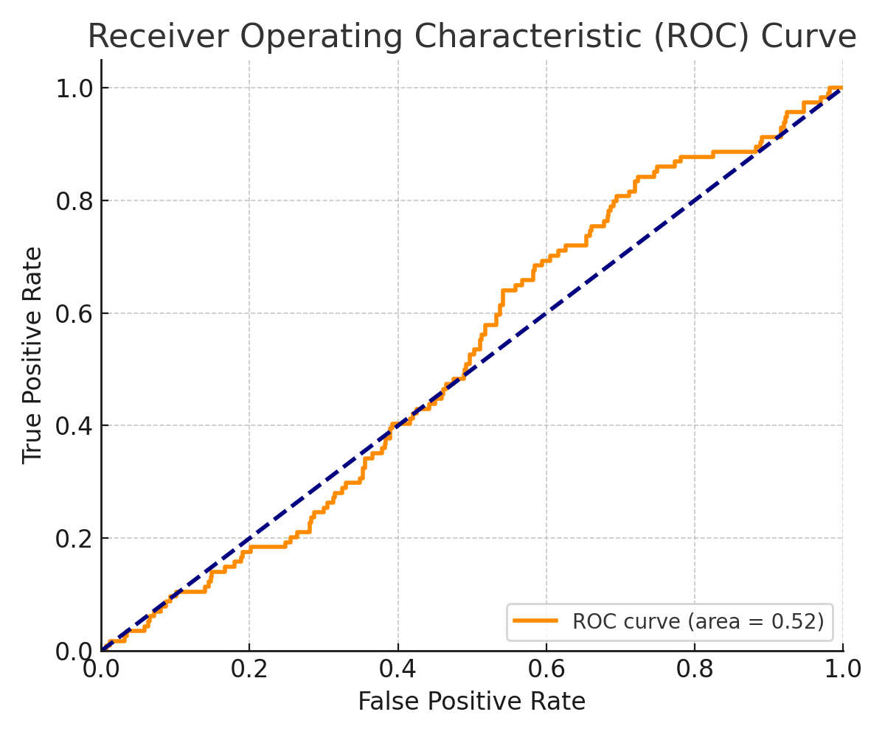  
Confusion Matrix:

**RESULTS AND DISCUSSIONS**

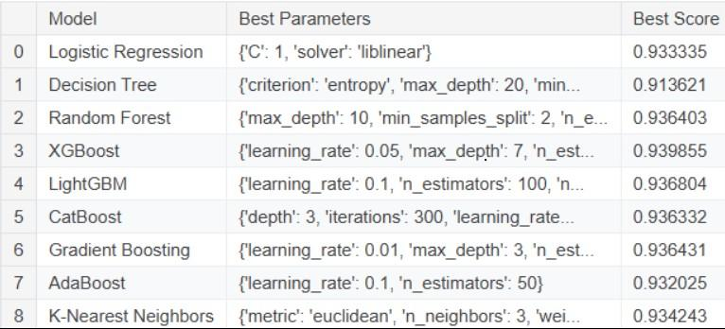

* Confusion Matrix shows high true positive rate for XGBoost
* ROC-AUC Curve area > 0.95, indicating strong model separation  
    
    
  Visuals Included:
* Confusion Matrix
* ROC Curve

Model demonstrated strong detection capability with minimal false positives, essential in banking applications.

**CHAPTER 5**

**CONCLUSION AND FUTURE WORK**

In this project, we successfully developed a privacy-preserving credit card fraud detection system using machine learning. By leveraging anonymized data and advanced classification algorithms like Random Forest and XGBoost, we ensured high detection accuracy while safeguarding user privacy. Our approach effectively tackled the challenge of class imbalance and demonstrated promising results through evaluation metrics such as the confusion matrix and ROC curve. Going forward, we aim to enhance the system by integrating federated learning techniques to further strengthen data privacy. Additionally, implementing a real-time alert system and expanding the model to include behavioral patterns and device-level data could significantly improve its fraud detection capabilities in practical banking environments.

**CHAPTER 6**

**APPENDIX**

**A Technologies Used :** Python functioned as the main programming language during development since it possesses the essential features needed for machine learning libraries. Google Colab served as the development and testing platform for the project because it provided collaborative Jupyter Notebook support with access to various computational resources. The project used Scikit-learn for model implementation because its algorithm collection is extensive but XGBoost was selected for its effective gradient boosting capabilities. Data manipulation through Pandas library took place while NumPy served for numerical computing requirements. Matplotlib together with Seaborn served to display data patterns and correlations in the analysis. The SMOTE technique from Imbalanced-learn library resolved the extreme class imbalance that typically occurs in fraud detection problems.

**B. Dataset Information**

Source: Kaggle - Credit Card Fraud Detection Dataset

The dataset contains transaction data that has been anonymized from European cardholders who conducted purchases in September 2013. In PCA processing terms the transformed dataset features maintain numerical values in order to protect confidentiality.

**C. Project Workflow**

Data Loading and Preprocessing

Exploratory Data Analysis (EDA)

Balancing Classes using SMOTE

Model Training (Random Forest, XGBoost)

Testing was done employing a Confusion Matrix and an ROC Curve for evaluation.

Privacy-Preserving Measures

[**https://colab.research.google.com/drive/1vAJu1Mlwr5lz56mCpiDfT5QuB3kFpHto**](https://colab.research.google.com/drive/1vAJu1Mlwr5lz56mCpiDfT5QuB3kFpHto)

**D. Acknowledgments**

We are grateful to show our sincere appreciation to the following people:

Dr. Snehlata Wankhade, our project guide, for her mentorship and continuous support.

Dr. Parul Dubey, Capstone Project Coordinator, for her guidance and coordination throughout.

The dataset and tools were made available through Kaggle open-source community.

Google Colab served as an environment that facilitated teamwork and resource utilization in project development.

**REFERENCES**

1. Andrea Dal Pozzolo et al., "Credit Card Fraud Detection: A Realistic Evaluation", IEEE, 2015.
2. Fernando Carcillo et al., "Combining Unsupervised and Supervised Learning in Credit Card Fraud Detection", IEEE, 2019.
3. Shashwat Gautam et al., "Federated Learning in Credit Card Fraud Detection", Springer, 2021.
4. Bhattacharyya, S. et al., "Data Mining for Credit Card Fraud: A Comparative Study", DSS Journal, 2011.
5. Y. Sahin and E. Duman, "Detecting Credit Card Fraud by ANN and Logistic Regression", IEEE, 2011.
6. Jurgovsky, J. et al., "Sequence Classification for Credit-Card Fraud Detection", Expert Systems with Applications, 2018.
7. Mahmoudi, E. et al., "Deep Learning for Credit Card Fraud Detection", Elsevier, 2020.
8. Chen, T. and Guestrin, C., "XGBoost: A Scalable Tree Boosting System", arXiv:1603.02754, 2016.
9. Breiman, L., "Random Forests", Machine Learning Journal, 2001.
10. scikit-learn documentation – sklearn.ensemble.RandomForestClassifier.
11. scikit-learn documentation – sklearn.linear_model.LogisticRegression.
12. Chawla, N.V. et al., "SMOTE: Synthetic Minority Over-sampling Technique", Journal of Artificial Intelligence Research, 2002.
13. Kaggle Dataset: Credit Card Fraud Detection – https://www.kaggle.com/datasets/mlg-ulb/creditcardfraud
14. M. Zareapoor, P. Shamsolmoali, "Application of Credit Card Fraud Detection: A Survey", IJCSI, 2015.
15. Sahlaoui, H., "A Deep Learning Based Approach for Fraud Detection", IEEE Access, 2020.
16. L. Zhang et al., "Privacy-Preserving Machine Learning in Credit Scoring", ACM, 2019.
17. Google AI Blog: "Federated Learning: Collaborative Machine Learning without Centralized Training Data", 2017.
18. T. Chen et al., “Privacy-preserving credit card fraud detection based on differential privacy”, Journal of Cloud Computing, 2021.
19. Y. Liu, "A Survey of Credit Card Fraud Detection Techniques", IEEE, 2019.
20. H. J. Kim et al., "Hybrid Machine Learning Model for Credit Card Fraud Detection", Elsevier, 2021.
21. M. Goldstein and S. Uchida, “A Comparative Evaluation of Unsupervised Anomaly Detection Algorithms”, PLOS ONE, 2016.
22. B. Chandrasekaran et al., "Secure and Scalable Fraud Detection System for Cloud Banking", Springer, 2020.
23. T. Li and N. Li, "Privacy Preserving Data Mining", Springer, 2009.
24. M. Dwork, "Differential Privacy", Proceedings of the ICALP, 2006.
25. Microsoft Azure ML Docs – Credit Card Fraud Detection Solution Accelerator.