Instructions

1. Download and install anaconda3 from given link

- link : <https://www.filehorse.com/download-anaconda-64/download/>

- At the stage given in the image below check both checkboxes

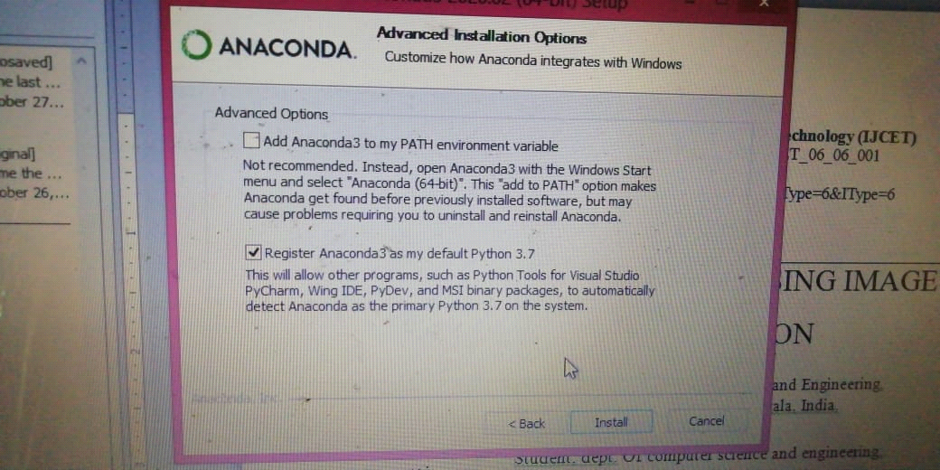

1. extract the ‘ml_env’ folder and paste it to the anaconda3’s **envs** folder
2. Extract the ‘Runway_30%’ folder
3. Download dataset from this link

<https://1drv.ms/u/s!AmgKYzARBl5ca3HNaHIlzp_IXjs>

1. Open anaconda prompt
2. In prompt(cd) Navigate to ‘Runway_30%’ folder
3. Run command : conda activate ml_env
4. Run command : python pre2.py