**SENTIMENTAL ANALYSIS of EMOTIONS and EXPRESSIONS for HUMAN FACE**

**System Requirement Specification (SRS)**

Project work Phase 1 (EAI753)

Degree

**BACHELOR OF TECHNOLOGY – CSE(AI+ML+DL)**

|  |  |
| --- | --- |
| PROJECT GUIDE:  **Mr. Ashish Bishnoi**  **Dr. Saurabh Pathak** | SUBMITTED BY:  **RISHANT RAJPOOT (TCA1959009)**  **AKSHAT JAIN (TCA1959038)** |

December- 2022



**FACULTY OF ENGINEERING & COMPUTING SCIENCES**

**TEERTHANKER MAHAVEER UNIVERSITY, MORADABAD**

**TableofContents**

1 Introduction 3

1.1 Problem Statement 4

1.2 Scopeofthe project 5

1.3 Definitions,Acronyms,andAbbreviations 6

1.4 References 3

2 Project Description 7

2.1 Scope of the work 8

2.2 Project Modules 9

2.3 UserCharacteristics 10

2.4 Constraints of project 11

2.5 AssumptionsandDependencies 11

3 SpecificRequirements 12

3.1 ExternalInterfaces 12

3.2 Functions 13

3.3 PerformanceRequirements 14

3.5 DesignConstraints 14

3.6 StandardsCompliance(diagram) 15

3.7 Softwareand Hardware Requirements 16

# Introduction

Sentimental Analysis of Emotions and Expressions for Human Face

What is sentiment analysis?

Sentiment analysis is the task of classifying the category of a given image/text. For an instance, a image can be categorized into different categories like –Happy, Sad, Excited, angry, Stressed etc. Given the images and the accompanying labels, a model can be trained to predict the correct sentiment as per the target labels. Sentiment analysis techniques can be categorized into machine learning approaches, lexicon-based approaches, and even hybrid methods.

Sentiment analysis is a powerful text analysis tool that automatically mines unstructured data (social media, emails, customer service tickets, and more) for opinion and emotion, and can be performed using machine learning and deep learning algorithms. Deep learning (DL) is considered an evolution of machine learning. Sentiment analysis is the classification of emotions (positive, negative, and neutral) within data using text analysis techniques. Harnessing the power of deep learning, sentiment analysis models can be trained to understand text beyond simple definitions, read for context

## Problem Statement

To develop a model of Deep Learning which will be able to analyze the facial expressions of image and will give the output as the face in the image is Happy, Sad, Angry and excited etc. The main problems that exist with the current techniques are: inability to perform well in different domains, inadequate accuracy and performance in sentiment analysis based on insufficient labeled data, incapability to deal with complex and blurry images or may be complex text, that require more than sentiment words and simple analyzing. Sentiment analysis tools are essential to detect and understand customer feelings. The objective of sentiment analysis is to accurately extract people's opinions from a large number of unlabeled images or wrongly labeled data and classifying them into sentiment classes.

This project addresses the problem of sentimental analysis or opinion mining in social media like Facebook and Twitter, that is classifying the tweets or people opinions according to the sentiment expressed in them : positive, negative, neutral.

## Scopeofthe project

The scope of the sentimental analyser model is –

* examining and evaluating customer sentiments with such tools, brands can gain a drastic support in understanding of consumer behaviors and, as a result, better serve to their audiences with the products, services, and experiences they offer.
* Doctors may also use this model to analyze the behavior of the patient from anywhere to give better suggestions for mood adjustment and to counter the physiatrist problem easily.

The future of sentiment analysis is going to continue to dig deeper, far past the surface of the number of likes, comments and shares, and aim to reach, and truly understand, the significance of social media interactions and what they tell us about the consumers behind the screens. This forecast also predicts broader applications for sentiment analysis – brands will continue to leverage this tool, but so will individuals in the public eye, governments, nonprofits, education centres and many other organizations.

## References

* <https://www.tutorialspoint.com/opencv/opencv_overview.htm>
* <https://www.tutorialspoint.com/keras/index.htm>
* [OpenCV - Overview - GeeksforGeeks](https://www.geeksforgeeks.org/opencv-overview/)
* [Compliance Diagram For Sentiment Analysis Project - Search Images (bing.com)](https://www.bing.com/images/search?view=detailV2&ccid=GURtHcJm&id=B28D76195C11E4193F163F7BEE439209EF50DF4F&thid=OIP.GURtHcJmHV8xyQggfAQqIAHaMR&mediaurl=https%3a%2f%2fermodelexample.com%2fwp-content%2fuploads%2f2020%2f10%2ffigure-2-2-from-sentiment-analysis-of-customers-using.png&exph=1156&expw=698&q=Compliance+Diagram+For+Sentiment+Analysis+Project&simid=608048755383868091&FORM=IRPRST&ck=F0914391AFA0EB90F30BFE99F8D1A1F1&selectedIndex=0&ajaxhist=0&ajaxserp=0)
* Synopsis - “Sentimental analysis of emotions and expressions for human face”

# Project Description

Sentimental Analysis – The main aim of this project is to analyze facial expression to analyze the emotions in the moving pictures. This project will be able to identify the mood of the person present in the image whether the person is Happy, sad, excited, stressed etc. This project will be based on different libraries of Python to enhance the performance of the model that will be deployed. The different libraries of python that will be used are:

* OpenCV
* Keras

This model will create a frame using openCV and capture the image from Camera and tokenizing of image will be done.

Deep neural network model will be developed using keras and the model will be trained on different imaged that are prelabelled. To improve the accuracy of model prediction data number of hidden layers will be added. The most common use cases we see sentiment analysis applied to is on social media, customer service, movie live review and market research. Social media is a common area where sentiment analysis is used to monitor how people are perceiving and speaking of a brand or product. Sentiment analysis tools are essential to detect and understand customer feelings. Companies that use these tools to understand how customers feel can use it to improve its market strategies. Sentiment analysis tools generate insights into how companies can enhance the customer experience and improve customer service

## Scope of the work

The scope of the sentimental analyser model is –

* examining and evaluating customer sentiments with such tools, brands can gain a drastic support in understanding of consumer behaviors and, as a result, better serve to their audiences with the products, services, and experiences they offer.
* Doctors may also use this model to analyze the behavior of the patient from anywhere to give better suggestions for mood adjustment and to counter the physiatrist problem easily.

The future of sentiment analysis is going to continue to dig deeper, far past the surface of the number of likes, comments and shares, and aim to reach, and truly understand, the significance of social media interactions and what they tell us about the consumers behind the screens. This forecast also predicts broader applications for sentiment analysis – brands will continue to leverage this tool, but so will individuals in the public eye, governments, nonprofits, education centres and many other organizations.

## Project Modules

Face

Classifier module

Tokenizer module

Pre-processing module

Training image data

* OpenCV frame-

The image in the frame will be tokenized and will be analyzed for different labels.

What is OpenCV frame?

OpenCV is a library containing predefined functions for real-time computer vision tasks like object detection, processing of images captured, etc.

A frame is an image that forms a single instance of a video. A video consists of a lot of frames running per second (also known as frames per second). For example, a video streaming at 30 fps means that it displays 30 images in a second.

Steps for OpenCV Frame?

* + Import CV2
  + vidcap = cv2.VideoCapture(0)
  + if vidcap.isOpened():  
     #do something  
    else:  
     print("Cannot open camera")

## UserCharacteristics

There are 2 types of users for this module:

* Administrators or normal person:thisisthegroupofusersthat theycan perform task:
  + Identify their mood
  + Identify their reviews
* Doctors:
  + View all hospitals’ information including status of patient review .
  + Will be able to suggest more pattern and medicines for the patient.
* Hospital Staff: this is the group of people working in the same hospital. They can:
  + View all hospitals’ information including status.
  + Get to know the complete analysis of patient.

## Constraints of project

This project “Sentimental analysis of emotions and expression for human face” should identify the face of human and should not identify and predict the s entiments of other living being.

## AssumptionsandDependencies

Themodule doesnotdependonanyexternalservices.

# SpecificRequirements

## ExternalInterfaces

OpenCV is an independent frame which is a window showing the image captured by the camera.

OpenCV is the huge open-source library for the computer vision, machine learning, and image processing and now it plays a major role in real-time operation which is very important in today’s systems. By using it, one can process images and videos to identify objects, faces, or even handwriting of a human. When it integrated with various libraries, such as NumPy, python is capable of processing the OpenCV array structure for analysis. To Identify image pattern and its various features we use vector space and perform mathematical operations on these features.

The first OpenCV version was 1.0. OpenCV is released under a BSD license and hence it’s free for both academic and commercial use. It has C++, C, Python and Java interfaces and supports Windows, Linux, Mac OS, iOS and Android. When OpenCV was designed the main focus was real-time applications for computational efficiency. All things are written in optimized C/C++ to take advantage of multi-core processing.

## Functions

|  |  |
| --- | --- |
| **Main window frame:** | |
| **Input** | Image captured by the camera will be visible on the main window. |
| **Action** | Image will be tokenized using keras tokenization algorithms into different parts i.e.: eyes, nose, mouth, forehead and chin. |
| **Output** | The algo applied to the image will identify the reviews of image as per the training data classification. |
| **Notes** |  |
| **Priority** | All the image data for training must have a large size and variety of faces and the testing data are of the persons that are living around. |

## PerformanceRequirements

None identified.

## DesignConstraints

## A design constraints is an integrated Modelling Language- is a sort of communication diagram that shows procedures work with each other and in what request. Sequence diagrams are also called as occasion follow diagrams, occasion situations, and timing diagram. Sequence diagrams are utilized to formalize the conduct of the framework and to picture the correspondence framework among the articles. They are valuable for recognizing extra questions that takes part in the utilization cases. A sequence diagram speaks to the associations that happen among these articles.

## StandardsCompliance(diagrams)

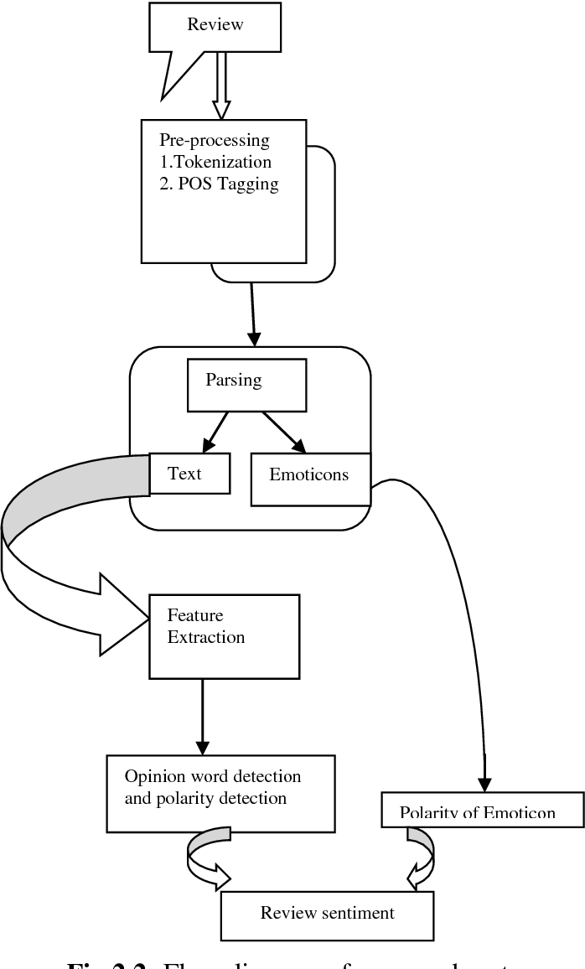

## Softwareand Hardware Requirements

## Software Platform

1. **Front-end**

* Python
* Jupyter Notebook

The Jupyter Notebook is an open source web application that you can use to create and share documents that contain live code, equations, visualizations, and text. Jupyter Notebook is maintained by the people at Project Jupyter. Jupyter Notebooks are a spin-off project from the IPython project, which used to have an IPython Notebook project itself.

* + Google Colab

1. **Back-end**

* Flask API
* Google Cloud

## Hardware Platform

* RAM

It stands for Random Access Memory, is a hardware device generally located on the motherboard of a computer and acts as an internal memory of the CPU. It allows CPU store data, program, and program results when you switch on the computer. It is the read and write memory of a computer, which means the information can be written to it as well as read from it. RAM is a volatile memory, which means it does not store data or instructions permanently.

* SSD
* GPU (min 8GB)
* Windows (10 and upper)
* Camera