**SENTIMENTAL ANALYSIS of EMOTIONS and EXPRESSIONS for HUMAN FACE**

**Project Synopsis**

Project Work Phase-I ML (EAI753)

**BACHELOR OF TECHNOLOGY - CSE (AI+ML+DL)**

|  |  |
| --- | --- |
| PROJECT GUIDE: | SUBMITTED BY:  **RISHANT RAJPOOT (TCA1959009)**  **AKSHAT JAIN (TCA1959038)** |

OCTOBER-2022



**FACULTY OF ENGINEERING & COMPUTING SCIENCES**

**TEERTHANKER MAHAVEER UNIVERSITY, MORADABAD**

Table of Contents

1 Project Title 3

2 Domain 3

3 Problem Statement 3

4 Project Description 3

4.1 Scope of the Work 3

4.2 Project Modules 3

5 Implementation Methodology 3

6 Technologies to be used 4

6.1 Software Platform 4

6.2 Hardware Platform 4

6.3 Tools 4

7 Advantages of this Project 4

8 Future Scope and further enhancement of the Project 4

9 Team Details 4

10 Conclusion 5

11 References 5

# Project Title

Sentimental Analysis of Emotions and Expressions for Human Face

What is sentiment analysis?

Sentiment analysis is the task of classifying the category of a given image/text. For an instance, a image can be categorized into different categories like –Happy, Sad, Excited, angry, Stressed etc. Given the images and the accompanying labels, a model can be trained to predict the correct sentiment as per the target labels. Sentiment analysis techniques can be categorized into machine learning approaches, lexicon-based approaches, and even hybrid methods.

# Domain

Artificial Intelligence (Deep Learning)

What is Artificial Intelligence?

Artificial Intelligence is an approach to make a machine learn or we can say make machine intelligent which can behave like humans upto some extent.

AI have different sub domains – Machine Learning and Deep Learning.

# Problem Statement

To develop a model of Deep Learning which will be able to analyze the facial expressions of image and will give the output as the face in the image is Happy, Sad, Angry and excited etc. The main problems that exist with the current techniques are: inability to perform well in different domains, inadequate accuracy and performance in sentiment analysis based on insufficient labeled data, incapability to deal with complex and blurry images or may be complex text, that require more than sentiment words and simple analyzing. Sentiment analysis tools are essential to detect and understand customer feelings. The objective of sentiment analysis is to accurately extract people's opinions from a large number of unlabeled images or wrongly labeled data and classifying them into sentiment classes.

# Project Description

Sentimental Analysis – The main aim of this project is to analyze facial expression to analyze the emotions in the moving pictures. This project will be able to identify the mood of the person present in the image whether the person is Happy, sad, excited, stressed etc. This project will be based on different libraries of Python to enhance the performance of the model that will be deployed. The different libraries of python that will be used are:

* OpenCV
* Keras

This model will create a frame using openCV and capture the image from Camera and tokenizing of image will be done.

Deep neural network model will be developed using keras and the model will be trained on different imaged that are prelabelled. To improve the accuracy of model prediction data number of hidden layers will be added. The most common use cases we see sentiment analysis applied to is on social media, customer service, movie live review and market research. Social media is a common area where sentiment analysis is used to monitor how people are perceiving and speaking of a brand or product. Sentiment analysis tools are essential to detect and understand customer feelings. Companies that use these tools to understand how customers feel can use it to improve its market strategies. Sentiment analysis tools generate insights into how companies can enhance the customer experience and improve customer service

## Scope of the Work

The scope of the sentimental analyser model is –

* examining and evaluating customer sentiments with such tools, brands can gain a drastic support in understanding of consumer behaviors and, as a result, better serve to their audiences with the products, services, and experiences they offer.
* Doctors may also use this model to analyze the behavior of the patient from anywhere to give better suggestions for mood adjustment and to counter the physiatrist problem easily.

The future of sentiment analysis is going to continue to dig deeper, far past the surface of the number of likes, comments and shares, and aim to reach, and truly understand, the significance of social media interactions and what they tell us about the consumers behind the screens. This forecast also predicts broader applications for sentiment analysis – brands will continue to leverage this tool, but so will individuals in the public eye, governments, nonprofits, education centres and many other organizations.

## Project Modules

* OpenCV frame-

The image in the frame will be tokenized and will be analyzed for different labels.

# Implementation Methodology

The frame generated using openCV, the image will be tokenized and matched with the trained model to predict the labels or the mood of the face present in the image.

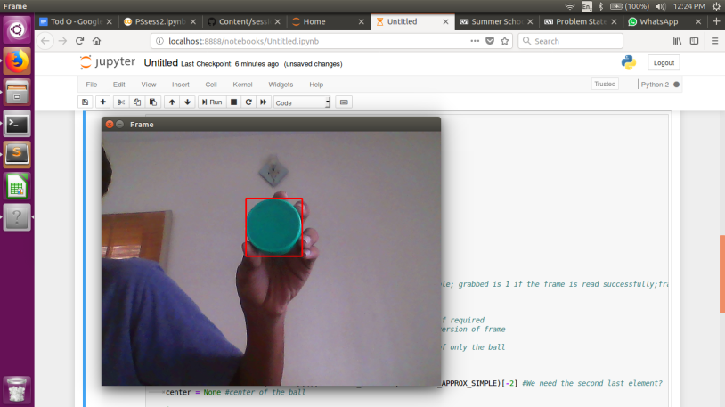

Emoji faces{

Happy

Sad

Angry

Excited }

# Technologies to be used

## Software Platform

1. **Front-end**

* **Python**
* **Jupyter Notebook**
* **Google Colab**

1. **Back-end**

* **Flask API**
* **Google Cloud**

## Hardware Platform

* RAM
* SSD
* GPU (min 8GB)
* Windows (10 and upper)

## Tools

* Python
* Jupyter Notebook
* Google Colab
* Keras ( CNN )
* OpenCV

# Advantages of this Project

* Competitor insights are one of the most useful benefits of sentiment analysis. Through analyzing sentiment in publically available data you can find out why competitor products are more successful than yours, and why people prefer certain products from you but go to your competitors for others.
* This model will be able to use easily and to find the customer reviews by their face expressions whether the customer is interested with the service or like it or may be other expression.

# Future Scope and further enhancement of the Project

The future of sentiment analysis is going to continue to dig deeper, far past the surface of the number of likes, comments and shares, and aim to reach, and truly understand, the significance of social media interactions and what they tell us about the consumers behind the screens. This forecast also predicts broader applications for sentiment analysis – brands will continue to leverage this tool, but so will individuals in the public eye, governments, nonprofits, education centers and many other organizations. Other private forms can also use this model to increase the sales of the product or to improve the service provided by the company to there customers.

The movie’s trailer review can also be analyzed so what to add or what to removed from the movie and there the different fields where it can be used.

* Up selling opportunities. Happy customers are more likely to be receptive to up selling.
* Agent monitoring. You no doubt monitor agent efficiency.
* Training chat bots.
* Identifying key emotional triggers.
* Handling multiple customers.
* Adaptive customer service.
* Live insights.
* Quick escalations.

# Team Details

| **Project Name & ID** | **Course Name** | **Student ID** | **Student Name** | **Role** |
| --- | --- | --- | --- | --- |
| Sentimental Analysis  (FACIAL) | B.Tech CSE  (AI+ML+DL) | TCA1959009 | Rishant Rajpoot | Designer,  Developer |
| TCA1959038 | Akshat Jain | Tester |

# Conclusion

Sentiment analysis is a uniquely powerful tool for businesses that are looking to measure attitudes, feelings and emotions regarding their brand. To date, the majority of sentiment analysis projects have been conducted almost exclusively by companies and brands through the use of social media data, survey responses and other hubs of user-generated content. By investigating and analyzing customer sentiments, these brands are able to get an inside look at consumer behaviors and, ultimately, better serve their audiences with the products, services and experiences they offer.

# References

* <https://www.tutorialspoint.com/opencv/opencv_overview.htm>
* <https://www.tutorialspoint.com/keras/index.htm>