**RESUME**

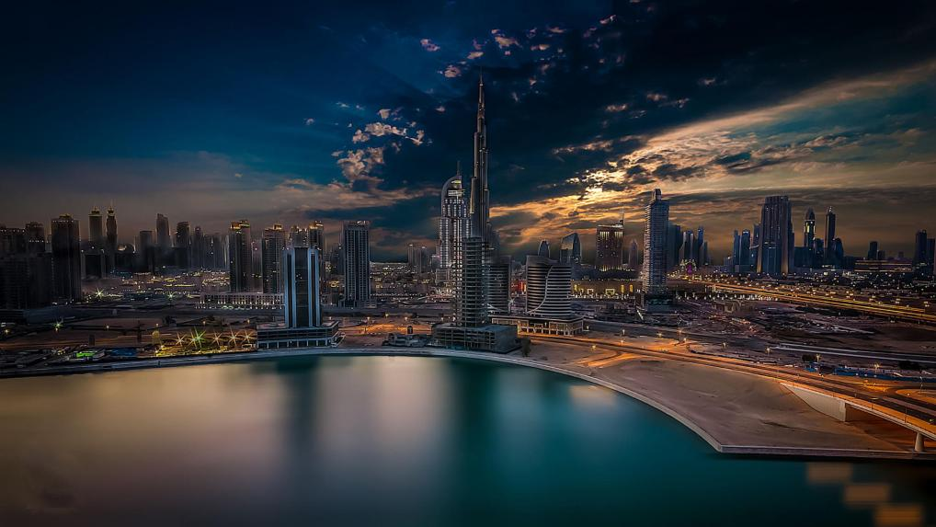

Name : Rishav Dey

Age : 19

From : Ambala Cantt, Haryana

Education :

* DAV Public School

(https://davambalacantt.com)

* Chitkara Institute of Engineering and Technology (CUIET) , Punjab (2025)

( <https://www.chitkara.edu.in)>

**RESEARCH INTERESTS**