**System Requirements**

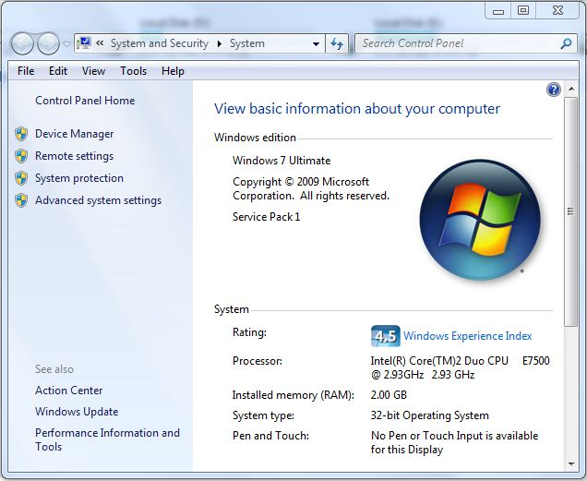

**NOTE : The executable file(.exe) provided does not work in Windows 7 but works properly in Windows XP. I tried running it in several computers having Windows 7 and Windows XP, but it worked only in Windows XP. The problem is with the graphics and I think it is not been supported by Windows 7.**

**Files Used**

* **Acc.txt - It stores the account numbers of all the accounts. It is been used for creating new account numbers.**
* **Player.txt - It stores all the information of all the players – Name, Year of Birth, Account Number, Password and Money. Any change during the game is reflected here immediately.**

**Introduction**

**My project is set of four games entitled – “Games – Rishav Agarwal”.**

**The four games are as follows -**

**1. Number Racing.**

**2. Ball Shooting.**

**3. Tic Tac Toe.**

**4. Spin for Luck.**

**I have tried to make the games interesting as much as possible. I have also made an effort to make the interface user friendly by providing instructions at each place where possible.**

**Basic graphics has been used to accomplish the project since, games without graphics is worthless. I have used it for proper background, font style, size, and animations, which ultimately makes the project more beautiful, attractive and enjoyable.**

**File Handling has also been used for making player’s game account by which, he/she can login in future and enjoy the game. A player gets Rs. 1,00,000 on creating a account which, he/she bets in the games and the gain or loss is deducted from the total and stored permanently using files.**

**The following page provides the instructions for using the game.**

**Instructions**

**Although the user is guided throughout the game, here are some instructions for the user to play and understand the games easily.**

1. **The game starts with a fake loading just for the sake of introduction to the game and me.**
2. **Then, the user needs to provide the game password to continue. The password is “GamesRish”. Before entering the password, the user can press the “Esc” button any time to exit.**
3. **The user now has three choices:**
4. **Create New Account.**
5. **Login.**
6. **Exit.**
7. **If the user chooses to create new account, a new screen appears which demands user’s name and year of birth. Then, the user is provided his/her account number and is demanded a password for his account, which is been used by him/her in future to login.**
8. **If the user chooses to exit, the program simply terminates.**
9. **If the user chooses to login, he is requested to provide his account number and password. Correct account number and password allows him/her to enjoy the games. On entering wrong account number, it says – “No such account exists!” On entering correct account number but wrong password, it says – “Wrong Password!”**
10. **After login, the user has five options, four of which are games and the fifth being an option to log out.**

* **Number Racing.**
* **Ball Shooting.**
* **Tic Tac Toe.**
* **Spin for Luck.**
* **Log Out.**

1. **If the user wishes to log out, he/she can select 5 and log out.**
2. **If the user selects any of the other four options (game), he plays the game returns to the logged in page.**

**Following are the description of each of the games.**

1. **Number Racing.**

**First, the user needs to select an amount to bet and a number to bet on. Then, the user sees five numbers (numbered 1-5) at the extreme left, the starting line towards the left and the end line towards the right of the screen. As soon as the user presses a key, the race between starts. The numbers take random movement at each step (ranging from 1-4) until a number reaches the end line. The number selected by the user is been shown below the racing track. It is highly possible that a number (say 1) moves 1 step ahead at each chance while another number (say 2) moves 4 step ahead at each chance resulting in this time of awkward condition which is never a case in a racing :**

**1**

**2**

**So, the racing has programmed in such way that this awkward situation is never been reached and it looks like a real race and the user enjoys it. If the user wins, he/she gets five the amount bet else he loses his/her money.**

1. **Ball Shooting.**

**This game is very simple and most of us have played it. There are five levels in each set. The details and the mode of game are displayed at the top of the screen. The current level is displayed at the bottom. From the right bottom, a ball comes upwards and the user has an arrow to control. The controls are: ‘w’ to go up, ‘s’ to go down and “space” to shoot the arrow. When the game starts, the user needs to choose from four modes of play:**

* **Limited Time. – Limited Shots.**
* **Limited Misses. – Free Play.**

**In Limited Time, the user needs to shoot as much as balls in small interval of time. The level ends as soon as the time ends.**

**In Limited Shots, the user gets few arrows using that, he/she needs to shoot the balls. The level ends as soon as shot limit is reached.**

**In Limited Misses, the user can miss only few arrows. The level ends as soon as the miss limit is reached.**

**In above three cases, the user is eligible to play next level only when the score until that level is greater than or equal to the number of attempts until that level, else, the game ends.**

**In the Free Play mode, the user has unlimited time, shots and misses. This can played to practice the game. In this mode, there is no condition for levelling up. The user can simply press ‘+’ to level up and ‘-‘ to level down. This is also shown at the bottom in the Free Play mode.**

**The money is given according to the following formula:**

**(score – misses)*10**

1. **Tic Tac Toe.**

**This game is very simple and interesting. The user plays against the CPU. I have made some effort to provide some intelligence that works in most cases. With help of the provided intelligence, the can only resist winning of user and play in a manner to win. It does not make any plans or uses any tricks to defeat the opponent. Very basic intelligence is used. In this game, the user needs to make his/her three consecutive marks by provided the number of the space. As soon as a three consecutive mark is made, the game ends else, it is a draw. If the user wins, he/she gets Rs. 1000 else if he loses, Rs. 500 is deducted from total else no gain, no lose.**

1. **Spin for Luck.**

**First, the user needs to select an amount to bet and a number to bet on. Then, spin wheel appears. As soon as the user presses a key, the game starts. Towards the left of the screen, it shows the number selected. I have made some effort to make it look like a spinning wheel spinning upwards. It spins for ten seconds and then stops. If the number in between matches with the number selected by the user, he/she gets ten times the money he bet else he/she loses his/her money.**

**Variable Description**

|  |  |  |
| --- | --- | --- |
| VARIABLE | DATA TYPE | DESCRIPTION |
| name | **char[]** | **Stores the name of current user. Used in structure.** |
| yob | **char[]** | **Stores year of birth of current user. Used in structure.** |
| acc | **char[]** | **Stores account number of the current user. Used in structure.** |
| pass | **char[]** | **Stores password of the current user. Used in structure.** |
| money | **unsigned long** | **Stores money of the current user. Used in structure.** |
| pla | **Player** | **It is an object of the structure – Player.** |
| p | **char** | **Used for accepting values such as – name, amount, account number, password, etc.** |
| num | **int** | **Stores user’s choice of number in the game – Number Racing and Spin for Luck.** |
| b, l, l1, h, h1, f, score, att, shot, five, two, one, miss, time, level | **int** | **Used in the game – Ball Shooting for movement of arrow, score, attempts, successful attempts, ones, twos, fives, misses, time and current level.** |
| square | **char[]** | **Used for the numbers, ‘X’ & ‘O’ in the game (Tic Tac Toe) board.** |

**Variable Description**

|  |  |  |
| --- | --- | --- |
| Variable | Data type | description |
| player | **int** | **Used in the game – Tic Tac Toe. It tells the which player will play next.** |
| a | **int[][]** | **It stores the three displaying numbers in the game – Spin for Luck.** |
| s | **clock_t** | **It stores the time of start of the game – Spin for Luck.** |

**Modular Description**

1. **void intro()**

**This function is the beginning of the program. It introduces the user to Game and me.**

1. **void pass()**

**This function is the second part of the program. It asks the user for password to continue playing Game.**

1. **Void login()**

**This function is the third part of the program which asks the user for three options –**

* **Login using account no. and password.**
* **Create new account.**
* **Exit.**

1. **Void new()**

**This function works when the user wants to create a new account for the game. The user is required to give his/her name and date of birth. Then an account no. is given to the user and the user needs to provide a password for his/her account.**

1. **Void sign()**

**This function works if the user wants to login into his/her account. The user needs to provide his/her account no. and password to log in.**

1. **Void choice()**

**When the user has logged in or created new account he/she has five options out of which, the fifth option is to log out from account and the rest four are games. The games are –**

* **Number Racing.**
* **Ball Shooting.**
* **Tic Tac Toe.**
* **Spin for Luck.**

1. **Void race()**

**If the user selects the game – Number Racing, then this function works. Then, the game proceeds as given in Instructions.**

1. **Void sh_ch()**

**If the user selects the game – Ball Shooting, then this function works. This function asks the user for the mode of play of the game – Ball Shooting. The following are available –**

* **Limited Time.**
* **Limited Shots.**
* **Limited Misses.**
* **Free Play.**

1. **Void report()**

**This function works at the end of each round and at the end of Ball Shooting game. It shows the Score, Attempts and Time Taken in a round.**

1. **Void shoot()**

**This function works after asking the user’s choice in the game – Ball Shooting. It is the main part of the game and proceeds as given in Instructions.**

1. **Void tic_tac_toe()**

**This function works when the user selects the game – Tic Tac Toe. Then, the game proceeds as given in Instructions.**

1. **Void CPU()**

**This function returns position for CPU’s turn. I have tried to provide some intelligence but it is not working properly.**

1. **Void checkwin()**

**This function checks whether the game is over or not. If yes, it checks whether someone (Player or CPU) has won or it is a draw.**

1. **Void board()**

**This function prints the board of the game – Tic Tac Toe.**

1. **Void race()**

**This function works if the user selects the game – Spin for Luck. Then, the game proceeds as given in Instructions.**

**Source Code**

**#include <dos.h> // for delay() .**

**#include <time.h> // for clock(), clock_t, CLK_TCK .**

**#include <conio.h> // for kbhit(), getch(), clrscr() .**

**#include <stdio.h> // for printf() .**

**#include <stdlib.h> // for randomize(), random(), rand() .**

**#include <string.h> // for strcmp(), strlen(), strcpy() .**

**#include <fstream.h> // for fstream(), ifstream() and qualifier ios .**

**#include <graphics.h> // to initialize and use graphics in program, for**

**setbkcolor(), setcolor(), settextstyle(), outtextxy(),**

**line(), circle(), outtext(), setfillstyle(), bar(), getmaxx(),**

**getmaxy(), cleardevice(), moveto(), floodfill(),**

**initgraph(), graphresult(), grapherrormsg() .**

**void main(void);**

**int checkwin(void);**

**void board(void);**

**int CPU(void);**

**struct Player // Structure for player**

**{**

**char name[100];**

**char yob[5];**

**char acc[4];**

**char pass[50];**

**unsigned long money;**

**}pla;**

**int t=0;**

**/\*\*\*\*\*\*\*\*\*\*\*\*\*\*\*\*\*\*\*\*\*\*\*\*\*\*\*\*\*\*\*\*\*\*\*\*\*\*\*\*\*\*\*\*\*\*\*\*\*\*\*\*\*\*\*\*\***

**function to introduce user to Games and**

**Me.**

**\*\*\*\*\*\*\*\*\*\*\*\*\*\*\*\*\*\*\*\*\*\*\*\*\*\*\*\*\*\*\*\*\*\*\*\*\*\*\*\*\*\*\*\*\*\*\*\*\*\*\*\*\*\*\*\*\*\*/**

**void intro()**

**{**

**setbkcolor(14);**

**setcolor(3);**

**settextstyle(4,0,4);**

**outtextxy(200,5,"GAMES");**

**setcolor(12);**

**settextstyle(3,0,2);**

**outtextxy(220,40,"- Rishav Agarwal");**

**setcolor(13);**

**settextstyle(2,0,7);**

**outtextxy(200,130,"Welcome!");**

**outtextxy(200,150,"GAMES");**

**outtextxy(200,170,"By-");**

**outtextxy(200,190,"Rishav Agarwal");**

**outtextxy(200,210,"Birla High School.");**

**setcolor(9);**

**line(190,2,410,2);**

**line(190,235,410,235);**

**line(190,2,190,235);**

**line(410,2,410,235);**

**settextstyle(5,0,2);**

**setcolor(4);**

**outtextxy(5,280,"Loading...");**

**int c=0;**

**for(int i=0;i<getmaxx();++i)**

**{**

**setfillstyle(11,5);**

**bar(0,320,i,340);**

**delay(2);**

**if(kbhit())**

**c=getch();**

**if(c==27)**

**exit(0);**

**}**

**}**

**/\*\*\*\*\*\*\*\*\*\*\*\*\*\*\*\*\*\*\*\*\*\*\*\*\*\*\*\*\*\*\*\*\*\*\*\*\*\*\*\*\*\*\*\*\*\*\*\*\*\*\*\*\*\*\*\***

**function to ask user for Password to**

**Continue.**

**\*\*\*\*\*\*\*\*\*\*\*\*\*\*\*\*\*\*\*\*\*\*\*\*\*\*\*\*\*\*\*\*\*\*\*\*\*\*\*\*\*\*\*\*\*\*\*\*\*\*\*\*\*\*\*\*/**

**void pass()**

**{**

**char pass[10],p;**

**pass[0]='\0';**

**int i;**

**do**

**{**

**cleardevice();**

**i=0;**

**setcolor(14);**

**setbkcolor(4);**

**settextstyle(3,0,1);**

**outtextxy(100,200,"Enter Password :");**

**setcolor(11);**

**while(1)**

**{**

**p=getch();**

**if(p==13)**

**{**

**pass[i]='\0';**

**break;**

**}**

**else if(p==27)**

**exit(0);**

**else if(p==8)**

**{**

**if(i>0)**

**{**

**setcolor(4);**

**outtextxy(250+i*10,205,"*");**

**pass[--i]='\0';**

**setcolor(11);**

**}**

**}**

**else**

**{**

**pass[i++]=p;**

**pass[i]='\0';**

**outtextxy(250+i*10,205,"*");**

**}**

**}**

**}**

**while(strcmp("GamesRish",pass));**

**setbkcolor(14);**

**}**

**/\*\*\*\*\*\*\*\*\*\*\*\*\*\*\*\*\*\*\*\*\*\*\*\*\*\*\*\*\*\*\*\*\*\*\*\*\*\*\*\*\*\*\*\*\*\*\*\*\*\*\*\*\*\*\*\*\***

**function to ask user’s choice –**

1. **Create new account.**
2. **Sign in.**
3. **Exit.**

**\*\*\*\*\*\*\*\*\*\*\*\*\*\*\*\*\*\*\*\*\*\*\*\*\*\*\*\*\*\*\*\*\*\*\*\*\*\*\*\*\*\*\*\*\*\*\*\*\*\*\*\*\*\*\*\*\*/**

**int login()**

**{**

**cleardevice();**

**setcolor(4);**

**int ch;**

**settextstyle(1,0,2);**

**outtextxy(150,100,"Enter your choice :");**

**outtextxy(150,140,"1. Create new player account.");**

**outtextxy(150,170,"2. Login.");**

**outtextxy(150,200,"3. Exit.");**

**ch=getch()-48;**

**if(ch==27)**

**exit(0);**

**if(ch<1 || ch>3)**

**ch=login();**

**return ch;**

**}**

**/\*\*\*\*\*\*\*\*\*\*\*\*\*\*\*\*\*\*\*\*\*\*\*\*\*\*\*\*\*\*\*\*\*\*\*\*\*\*\*\*\*\*\*\*\*\*\*\*\*\*\*\*\*\*\*\*\*\***

**Function to create new Account.**

**\*\*\*\*\*\*\*\*\*\*\*\*\*\*\*\*\*\*\*\*\*\*\*\*\*\*\*\*\*\*\*\*\*\*\*\*\*\*\*\*\*\*\*\*\*\*\*\*\*\*\*\*\*\*\*\*\*\*/**

**void New()**

**{**

**cleardevice();**

**settextstyle(3,0,1);**

**outtextxy(100,100,"Enter Name : ");**

**outtextxy(100,150,"Enter Year of Birth : ");**

**setcolor(9);**

**settextstyle(0,0,1);**

**int i=0;**

**char nm[100],p;**

**nm[0]='\0';**

**while(1)**

**{**

**outtextxy(250+i*8,112,"_");**

**p=getch();**

**if(p==13)**

**{**

**setcolor(14);**

**outtextxy(250+i*8,112,"_");**

**setcolor(9);**

**nm[i]='\0';**

**break;**

**}**

**else if(p==27)**

**{**

**t=1;**

**main();**

**}**

**else if(p==8)**

**{**

**if(i>0)**

**{**

**setcolor(14);**

**outtextxy(250+i*8,112,"_");**

**char w[1];**

**w[0]=nm[--i];**

**outtextxy(250+i*8,112,w);**

**nm[i]='\0';**

**setcolor(9);**

**}**

**}**

**else**

**{**

**setcolor(14);**

**outtextxy(250+i*8,112,"_");**

**setcolor(9);**

**nm[i++]=p;**

**nm[i]='\0';**

**outtextxy(250,112,nm);**

**}**

**}**

**strcpy(pla.name,nm);**

**setcolor(9);**

**i=0;**

**char yob[4];**

**yob[0]='\0';**

**while(1)**

**{**

**outtextxy(310+i*8,162,"_");**

**p=getch();**

**if(p==13)**

**{**

**setcolor(14);**

**outtextxy(310+i*8,162,"_");**

**setcolor(9);**

**yob[i]='\0';**

**break;**

**}**

**else if(p==27)**

**{**

**t=1;**

**main();**

**}**

**else if(p==8)**

**{**

**if(i>0)**

**{**

**setcolor(14);**

**outtextxy(310+i*8,162,"_");**

**char w[1];**

**w[0]=yob[--i];**

**outtextxy(310+i*8,162,w);**

**yob[i]='\0';**

**setcolor(9);**

**}**

**}**

**else**

**{**

**setcolor(14);**

**outtextxy(310+i*8,162,"_");**

**setcolor(9);**

**yob[i++]=p;**

**yob[i]='\0';**

**outtextxy(310,162,yob);**

**}**

**}**

**strcpy(pla.yob,yob);**

**char ac[]="000";**

**fstream fs("Acc.txt", ios::in | ios::out | ios::ate);**

**if(fs.tellg()==0){}**

**else**

**{**

**fs.seekg(-3, ios::end);**

**fs>>ac;**

**for(int z=0;z<3;++z)**

**{**

**if(ac[z]==57)**

**ac[z]=65;**

**else if(ac[z]==90)**

**ac[z]=97;**

**else if(ac[z]==122)**

**{**

**ac[z]=48;**

**ac[z-1]=0;**

**}**

**else if(z==2)**

**++ac[z];**

**}**

**}**

**strcpy(pla.acc,ac);**

**setcolor(4);**

**settextstyle(3,0,1);**

**outtextxy(100,200,"Your Account Number : ");**

**outtextxy(100,250,"Enter Password : ");**

**setcolor(9);**

**settextstyle(0,0,1);**

**outtextxy(320,212,ac);**

**i=0;**

**char pass[50];**

**pass[0]='\0';**

**while(1)**

**{**

**outtextxy(260+i*10,262,"_");**

**p=getch();**

**if(p==13)**

**{**

**setcolor(14);**

**outtextxy(260+i*8,262,"_");**

**setcolor(9);**

**pass[i]='\0';**

**break;**

**}**

**else if(p==8)**

**{**

**if(i>0)**

**{**

**setcolor(14);**

**outtextxy(260+i*10,262,"_");**

**outtextxy(260+(--i)*10,262,"*");**

**pass[i]='\0';**

**setcolor(9);**

**}**

**}**

**else**

**{**

**setcolor(14);**

**outtextxy(260+i*10,262,"_");**

**setcolor(9);**

**outtextxy(260+i*10,262,"*");**

**pass[i++]=p;**

**pass[i]='\0';**

**}**

**}**

**strcpy(pla.pass,pass);**

**pla.money=100000;**

**fs<<ac;**

**fs.close();**

**ofstream ofs("Player.txt", ios::app);**

**ofs.write((char *)&pla ,sizeof pla);**

**ofs.close();**

**}**

**/\*\*\*\*\*\*\*\*\*\*\*\*\*\*\*\*\*\*\*\*\*\*\*\*\*\*\*\*\*\*\*\*\*\*\*\*\*\*\*\*\*\*\*\*\*\*\*\*\*\*\*\*\*\*\*\*\*\***

**function to Sign in using Account number**

**and Password.**

**\*\*\*\*\*\*\*\*\*\*\*\*\*\*\*\*\*\*\*\*\*\*\*\*\*\*\*\*\*\*\*\*\*\*\*\*\*\*\*\*\*\*\*\*\*\*\*\*\*\*\*\*\*\*\*\*\*\*\*/**

**void sign()**

**{**

**cleardevice();**

**char acc[4],pass[50];**

**outtextxy(100,100,"Enter Account No. : ");**

**outtextxy(100,150,"Enter Password : ");**

**setcolor(9);**

**settextstyle(0,0,1);**

**int i=0;**

**char p;**

**acc[0]='\0';**

**while(1)**

**{**

**outtextxy(320+i*8,112,"_");**

**p=getch();**

**if(p==13)**

**{**

**setcolor(14);**

**outtextxy(320+i*8,112,"_");**

**setcolor(9);**

**acc[i]='\0';**

**break;**

**}**

**else if(p==27)**

**{**

**t=1;**

**main();**

**}**

**else if(p==8)**

**{**

**if(i>0)**

**{**

**setcolor(14);**

**outtextxy(320+i*8,112,"_");**

**char w[1];**

**w[0]=acc[--i];**

**outtextxy(320+i*8,112,w);**

**acc[i]='\0';**

**setcolor(9);**

**}**

**}**

**else if(i<3)**

**{**

**if((p>=48 && p<=57) || (p>=65 && p<=90) || (p>=97 && p<=122) )**

**{**

**setcolor(14);**

**outtextxy(320+i*8,112,"_");**

**setcolor(9);**

**acc[i++]=p;**

**acc[i]='\0';**

**outtextxy(320,112,acc);**

**}**

**}**

**else{}**

**}**

**i=0;**

**pass[0]='\0';**

**while(1)**

**{**

**outtextxy(280+i*10,162,"_");**

**p=getch();**

**if(p==13)**

**{**

**setcolor(14);**

**outtextxy(280+i*8,162,"_");**

**setcolor(9);**

**pass[i]='\0';**

**break;**

**}**

**else if(p==27)**

**{**

**t=1;**

**main();**

**}**

**else if(p==8)**

**{**

**if(i>0)**

**{**

**setcolor(14);**

**outtextxy(280+i*10,162,"_");**

**outtextxy(280+(--i)*10,162,"*");**

**pass[i]='\0';**

**setcolor(9);**

**}**

**}**

**else**

**{**

**setcolor(14);**

**outtextxy(280+i*10,162,"_");**

**setcolor(9);**

**outtextxy(280+i*10,162,"*");**

**pass[i++]=p;**

**pass[i]='\0';**

**}**

**}**

**ifstream ifs("Player.txt");**

**if(!ifs)**

**{**

**outtextxy(100,200,"No such account exists !!!");**

**getch();**

**t=1;**

**main();**

**}**

**ifs.seekg(0);**

**int flag=0;**

**while(1)**

**{**

**ifs.read((char *)&pla, sizeof pla);**

**if(ifs.eof())**

**break;**

**if(!strcmp(acc,pla.acc))**

**{**

**if(!strcmp(pass,pla.pass))**

**{**

**settextstyle(4,0,1);**

**outtextxy(100,250,"Login Succesful !");**

**settextstyle(0,0,1);**

**flag=1;**

**ifs.close();**

**break;**

**}**

**else**

**{**

**outtextxy(100,200,"Wrong Password !");**

**getch();**

**ifs.close();**

**t=1;**

**main();**

**}**

**}**

**}**

**if(!flag)**

**{**

**outtextxy(100,200,"No such account exists !");**

**getch();**

**ifs.close();**

**t=1;**

**main();**

**}**

**}**

**/\*\*\*\*\*\*\*\*\*\*\*\*\*\*\*\*\*\*\*\*\*\*\*\*\*\*\*\*\*\*\*\*\*\*\*\*\*\*\*\*\*\*\*\*\*\*\*\*\*\*\*\*\*\*\*\*\***

**Function to ask Signed in user for**

**Following choices –**

1. **Number Racing.**
2. **Ball Shooting.**
3. **Tic Tac Toe.**
4. **Spin for Luck.**
5. **Log Out.**

**\*\*\*\*\*\*\*\*\*\*\*\*\*\*\*\*\*\*\*\*\*\*\*\*\*\*\*\*\*\*\*\*\*\*\*\*\*\*\*\*\*\*\*\*\*\*\*\*\*\*\*\*\*\*\*\*\*\*/**

**int choice()**

**{**

**cleardevice();**

**setcolor(9);**

**settextstyle(2,0,4);**

**moveto(5,5);**

**outtext(pla.name);**

**outtext(" - ");**

**outtext(pla.acc);**

**unsigned long num=pla.money;**

**char mon[11];**

**mon[0]='\0';**

**int i=0,t;**

**while(num)**

**{**

**mon[i++]=(num%10)+48;**

**mon[i]='\0';**

**num/=10;**

**}**

**for(int j=0;j<i/2;++j)**

**{**

**t=mon[j];**

**mon[j]=mon[i-1-j];**

**mon[i-1-j]=t;**

**}**

**outtextxy(5,15,mon);**

**setcolor(4);**

**settextstyle(3,0,1);**

**outtextxy(200,100,"Enter your choice :");**

**settextstyle(0,0,1);**

**outtextxy(200,140,"1. Number Racing.");**

**outtextxy(200,160,"2. Ball Shooting.");**

**outtextxy(200,180,"3. Tic Tac Toe.");**

**outtextxy(200,200,"4. Spin for Luck.");**

**outtextxy(200,220,"5. Log Out.");**

**int ch=getch();**

**return (ch-48);**

**}**

**/\*\*\*\*\*\*\*\*\*\*\*\*\*\*\*\*\*\*\*\*\*\*\*\*\*\*\*\*\*\*\*\*\*\*\*\*\*\*\*\*\*\*\*\*\*\*\*\*\*\*\*\*\*\*\*\*\***

**Function for the Game – Number Racing.**

**\*\*\*\*\*\*\*\*\*\*\*\*\*\*\*\*\*\*\*\*\*\*\*\*\*\*\*\*\*\*\*\*\*\*\*\*\*\*\*\*\*\*\*\*\*\*\*\*\*\*\*\*\*\*\*\*\*\*/**

**void race()**

**{**

**ra:**

**cleardevice();**

**setcolor(4);**

**settextstyle(0,0,1);**

**char am[20],nm[2];**

**int num,n;**

**unsigned long amo=0;**

**outtextxy(200,150,"Enter amount to bet:");**

**setcolor(9);**

**int p,i=0;**

**while(1)**

**{**

**p=getch();**

**if(!( (p>=48 && p<=57) || p==8 || p==13) )**

**continue;**

**if(p==13)**

**{**

**am[i]='\0';**

**break;**

**}**

**else if(p==8)**

**{**

**amo/=10;**

**setcolor(14);**

**char w[1];**

**w[0]=am[--i];**

**outtextxy(200+i*8,180,w);**

**setcolor(9);**

**}**

**else**

**{**

**amo=amo*10+p-48;**

**am[i++]=p;**

**am[i]='\0';**

**outtextxy(200,180,am);**

**}**

**}**

**if(amo>pla.money)**

**{**

**settextstyle(2,0,5);**

**outtextxy(200,250,"You dont have enough money");**

**getch();**

**goto ra;**

**}**

**setcolor(4);**

**outtextxy(200,200,"Enter number to bet on(1-5):");**

**do**

**{**

**num=getch()-48;**

**}**

**while(num<1 || num>5);**

**nm[0]=num+48;**

**nm[1]='\0';**

**int j;**

**cleardevice();**

**int pos[]={0,0,0,0,0};**

**char pl[5][2];**

**for(int k=0;k<5;++k)**

**{**

**pl[k][0]=k+49;**

**pl[k][1]='\0';**

**}**

**int f=0;**

**for(k=0;k<5;++k)**

**outtextxy(0,k*50+50,pl[k]);**

**setcolor(9);**

**line(5,5,5,getmaxy()-5);**

**line(getmaxx()-5,5,getmaxx()-5,getmaxy()-5);**

**getch();**

**randomize();**

**while(1)**

**{**

**delay(25);**

**cleardevice();**

**moveto(50,300);**

**outtext("Number Selected : ");**

**setcolor(9);**

**outtext(nm);**

**line(5,5,5,getmaxy()-5);**

**line(getmaxx()-5,5,getmaxx()-5,getmaxy()-5);**

**setcolor(4);**

**for(j=0;j<5;++j)**

**{**

**outtextxy(pos[j]=pos[j]+random(3)+1,j*50+50,pl[j]);**

**if(pos[j]>=getmaxx()-5)**

**{**

**cleardevice();**

**n=j+1;**

**f=1;**

**break;**

**}**

**}**

**if(f)**

**break;**

**}**

**char w[1];**

**w[0]=n+48;**

**w[1]='\0';**

**settextstyle(8,0,3);**

**setcolor(9);**

**moveto(250,120);**

**outtext(w);**

**outtext(" WINS!");**

**moveto(250,150);**

**outtext("YOU ");**

**if(n==num)**

**{**

**pla.money = pla.money + amo*5;**

**outtext("WIN!");**

**}**

**else**

**{**

**pla.money = pla.money - amo;**

**outtext("LOSE!");**

**}**

**getch();**

**}**

**/\*\*\*\*\*\*\*\*\*\*\*\*\*\*\*\*\*\*\*\*\*\*\*\*\*\*\*\*\*\*\*\*\*\*\*\*\*\*\*\*\*\*\*\*\*\*\*\*\*\*\*\*\*\*\*\***

**Function for the Game – Ball Shooting.**

* **It asks for the mode of play.**

**\*\*\*\*\*\*\*\*\*\*\*\*\*\*\*\*\*\*\*\*\*\*\*\*\*\*\*\*\*\*\*\*\*\*\*\*\*\*\*\*\*\*\*\*\*\*\*\*\*\*\*\*\*\*\*\*\*\*/**

**int sh_ch()**

**{**

**cleardevice();**

**setcolor(4);**

**int ch;**

**outtextxy(200,100,"How do you want to play?");**

**outtextxy(200,130,"1. Limited Time.");**

**outtextxy(200,150,"2. Limited Shots.");**

**outtextxy(200,170,"3. Limited Misses.");**

**outtextxy(200,190,"4. Free Play.");**

**ch=getch()-48;**

**if(ch<1 || ch>4)**

**ch=sh_ch();**

**return ch;**

**}**

**/\*\*\*\*\*\*\*\*\*\*\*\*\*\*\*\*\*\*\*\*\*\*\*\*\*\*\*\*\*\*\*\*\*\*\*\*\*\*\*\*\*\*\*\*\*\*\*\*\*\*\*\*\*\*\*\*\*\***

**Function to print result at the end of**

**each round / game.**

**\*\*\*\*\*\*\*\*\*\*\*\*\*\*\*\*\*\*\*\*\*\*\*\*\*\*\*\*\*\*\*\*\*\*\*\*\*\*\*\*\*\*\*\*\*\*\*\*\*\*\*\*\*\*\*\*\*\*/**

**void report(char sc[],char at[],char ti[])**

**{**

**settextstyle(7,0,1);**

**moveto(200,150);**

**setcolor(4);**

**outtext("SCORE : ");**

**setcolor(9);**

**outtext(sc);**

**moveto(200,200);**

**setcolor(4);**

**outtext("ATTEMPTS : ");**

**setcolor(9);**

**outtext(at);**

**moveto(200,250);**

**setcolor(4);**

**outtext("TIME TAKEN : ");**

**setcolor(9);**

**outtext(ti);**

**setcolor(4);**

**settextstyle(0,0,1);**

**}**

**/\*\*\*\*\*\*\*\*\*\*\*\*\*\*\*\*\*\*\*\*\*\*\*\*\*\*\*\*\*\*\*\*\*\*\*\*\*\*\*\*\*\*\*\*\*\*\*\*\*\*\*\*\*\*\*\*\***

**Function for the Game – Ball Shooting.**

**\*\*\*\*\*\*\*\*\*\*\*\*\*\*\*\*\*\*\*\*\*\*\*\*\*\*\*\*\*\*\*\*\*\*\*\*\*\*\*\*\*\*\*\*\*\*\*\*\*\*\*\*\*\*\*\*\*\*/**

**void shoot()**

**{**

**int ch=sh_ch();**

**st:**

**int choice,cc[9];**

**cleardevice();**

**if(ch==1)**

**{**

**outtextxy(200,100,"Select time :");**

**outtextxy(200,130,"1. 30 seconds.");**

**outtextxy(200,150,"2. 60 seconds.");**

**outtextxy(200,170,"3. 90 seconds.");**

**outtextxy(200,190,"4. 120 seconds.");**

**outtextxy(200,210,"5. 150 seconds.");**

**outtextxy(200,230,"6. 180 seconds.");**

**outtextxy(200,250,"7. 300 seconds.");**

**choice=getch()-48;**

**if(choice<1 ||choice>7)**

**goto st;**

**cc[1]=30;**

**cc[2]=60;**

**cc[3]=90;**

**cc[4]=120;**

**cc[5]=150;**

**cc[6]=180;**

**cc[7]=300;**

**}**

**else if(ch==2)**

**{**

**outtextxy(200,100,"Select shots :");**

**outtextxy(200,130,"1. 10 shots.");**

**outtextxy(200,150,"2. 20 shots.");**

**outtextxy(200,170,"3. 30 shots.");**

**outtextxy(200,190,"4. 50 shots.");**

**outtextxy(200,210,"5. 75 shots.");**

**outtextxy(200,230,"6. 100 shots.");**

**outtextxy(200,250,"7. 150 shots.");**

**outtextxy(200,270,"8. 200 shots.");**

**choice=getch()-48;**

**if(choice<1 || choice>8)**

**goto st;**

**cc[1]=10;**

**cc[2]=20;**

**cc[3]=30;**

**cc[4]=50;**

**cc[5]=75;**

**cc[6]=100;**

**cc[7]=150;**

**cc[8]=200;**

**}**

**else if(ch==3)**

**{**

**outtextxy(200,100,"Select misses :");**

**outtextxy(200,130,"1. 5 misses.");**

**outtextxy(200,150,"2. 10 misses.");**

**outtextxy(200,170,"3. 20 misses.");**

**outtextxy(200,190,"4. 25 misses.");**

**outtextxy(200,210,"5. 30 misses.");**

**outtextxy(200,230,"6. 50 misses.");**

**choice=getch()-48;**

**if(choice<1 || choice>6)**

**goto st;**

**cc[1]=5;**

**cc[2]=10;**

**cc[3]=20;**

**cc[4]=25;**

**cc[5]=30;**

**cc[6]=50;**

**}**

**cleardevice();**

**setfillstyle(1,12);**

**int b, l=20, l1=20, h=50, h1=50, f=0, score=0, att=0, shot=0, five=0, two=0,**

**one=0, miss=0, time=0;**

**char sc[5], at[5], sh[5], fi[5], tw[5], on[5], mi[5], ti[4];**

**sc[0]='0'; at[0]='0'; sh[0]='0'; fi[0]='0'; tw[0]='0'; on[0]='0'; mi[0]='0';**

**ti[0]='0';**

**sc[1]='\0'; at[1]='\0'; sh[1]='\0'; fi[1]='\0'; tw[1]='\0'; on[1]='\0'; mi[1]='\0';**

**ti[1]='\0';**

**int level=1;**

**char lev[2];**

**lev[0]='1';**

**lev[1]='\0';**

**int k=getmaxy();**

**clock_t st;**

**st=clock();**

**for(int i=getmaxy();;--i)**

**{**

**cleardevice();**

**line(0,40,getmaxx(),40);**

**line(l1,h1,l1+30,h1);**

**setcolor(4);**

**circle(getmaxx()-15,k,10);**

**floodfill(getmaxx()-15,k,4);**

**moveto(15,5);**

**outtext("Score : ");**

**setcolor(9);**

**outtext(sc);**

**setcolor(4);**

**if(ch==2)**

**{**

**outtext(" | Attempts : ");**

**setcolor(9);**

**outtext(at);**

**outtextxy(300,5,"LIMITED SHOTS");**

**}**

**else if(ch==3)**

**{**

**outtext(" | Misses : ");**

**setcolor(9);**

**outtext(mi);**

**outtextxy(300,5,"LIMITED MISSES");**

**}**

**else if(ch==1)**

**{**

**outtext(" | Time : ");**

**setcolor(9);**

**outtext(ti);**

**outtextxy(300,5,"LIMITED TIME");**

**setcolor(4);**

**outtext(" seconds");**

**}**

**else**

**{**

**setcolor(9);**

**outtextxy(300,5,"FREE PLAY");**

**outtextxy(100,getmaxy()-50,"Press '+' to level up and '-' to level down.");**

**}**

**setcolor(4);**

**moveto(15,20);**

**outtext("Five : ");**

**setcolor(9);**

**outtext(fi);**

**setcolor(4);**

**outtext(" | Two : ");**

**setcolor(9);**

**outtext(tw);**

**setcolor(4);**

**outtext(" | One : ");**

**setcolor(9);**

**outtext(on);**

**setcolor(4);**

**moveto(200,getmaxy()-15);**

**outtext("LEVEL : ");**

**setcolor(9);**

**outtext(lev);**

**int flag=0;**

**if(ch==1 && time>=cc[choice])**

**{**

**flag=1;**

**outtextxy(200,100,"TIME UP !");**

**}**

**if(ch==2 && att==cc[choice]*level && !f)**

**{**

**flag=1;**

**outtextxy(200,100,"SHOTS FINISHED !");**

**}**

**if(ch==3 && miss==cc[choice])**

**{**

**flag=1;**

**outtextxy(200,100,"MISSES LIMIT REACHED !");**

**}**

**int l1=level,temp=0;**

**while(l1)**

**{**

**lev[temp++]=(l1%10)+48;**

**lev[temp]='\0';**

**l1/=10;**

**}**

**for(int j=0;j<strlen(lev)/2;++j)**

**{**

**temp=lev[j];**

**lev[j]=lev[strlen(lev)-j-1];**

**lev[strlen(lev)-j-1]=temp;**

**}**

**if(flag)**

**{**

**getch();**

**report(sc,at,ti);**

**getch();**

**if(level==5)**

**{**

**pla.money+=(score-miss)*10;**

**break;**

**}**

**else**

**{**

**setcolor(9);**

**if(score>=att)**

**{**

**outtextxy(200,300,"Level Passed !");**

**++level;**

**if(ch==1)**

**st=clock();**

**if(ch==3)**

**miss=0;**

**getch();**

**}**

**else**

**{**

**outtextxy(200,300,"Level Failed !");**

**getch();**

**break;**

**}**

**setcolor(4);**

**}**

**}**

**if(f)**

**{**

**line(l,h,l+30,h);**

**l=l+5;**

**if(l>=getmaxx()-25)**

**{**

**--f;**

**l=20;**

**++miss;**

**int temp=0,m=miss;**

**while(m)**

**{**

**mi[temp++]=(m%10)+48;**

**mi[temp]='\0';**

**m/=10;**

**}**

**for(int j=0;j<strlen(mi)/2;++j)**

**{**

**temp=mi[j];**

**mi[j]=mi[strlen(mi)-j-1];**

**mi[strlen(mi)-j-1]=temp;**

**}**

**}**

**}**

**time=(clock()-st)/CLK_TCK;**

**int t1=time;**

**temp=0;**

**while(t1)**

**{**

**ti[temp++]=(t1%10)+48;**

**ti[temp]='\0';**

**t1/=10;**

**}**

**for(j=0;j<strlen(ti)/2;++j)**

**{**

**temp=ti[j];**

**ti[j]=ti[strlen(ti)-j-1];**

**ti[strlen(ti)-j-1]=temp;**

**}**

**k-=level;**

**if(k<=50)**

**k=getmaxy();**

**if(h1<=40)**

**h1=getmaxy()-1;**

**if(h1>=getmaxy())**

**h1=41;**

**if(kbhit())**

**{**

**b=getch();**

**if(b==32)**

**{**

**h=h1;**

**if(!f)**

**{**

**++f;**

**++att;**

**int temp=0,a=att;**

**while(a)**

**{**

**at[temp++]=(a%10)+48;**

**at[temp]='\0';**

**a/=10;**

**}**

**for(int j=0;j<strlen(at)/2;++j)**

**{**

**temp=at[j];**

**at[j]=at[strlen(at)-j-1];**

**at[strlen(at)-j-1]=temp;**

**}**

**}**

**}**

**else if(b==115)**

**{**

**h1=h1+5;**

**}**

**else if(b==119)**

**{**

**h1=h1-5;**

**}**

**else if(b==13)**

**{**

**pla.money+=(score-miss)*10;**

**getch();**

**report(sc,at,ti);**

**getch();**

**break;**

**}**

**if(ch==4)**

**{**

**if(b==43 && level!=5)**

**++level;**

**else if(b==45 && level !=1)**

**--level;**

**}**

**}**

**if(l>=getmaxx()-55 && l<=getmaxx()-5 && h>=k-10 && h<=k+10)**

**{**

**--f;**

**l=20;**

**if(h>=k-(level-1)/2 && h<=k+(level-1)/2)**

**{**

**score+=5;**

**++five;**

**}**

**else if(h>=k-3-(level-1)/2 && h<=k+3-(level-1)/2)**

**{**

**score+=2;**

**++two;**

**}**

**else**

**{**

**++score;**

**++one;**

**}**

**++shot;**

**k=getmaxy();**

**}**

**temp=0;**

**int s=score,sho=shot,f1=five,o1=one;**

**t1=two;**

**while(s)**

**{**

**sc[temp++]=(s%10)+48;**

**sc[temp]='\0';**

**s/=10;**

**}**

**temp=0;**

**while(sho)**

**{**

**sh[temp++]=(sho%10)+48;**

**sh[temp]='\0';**

**sho/=10;**

**}**

**temp=0;**

**while(f1)**

**{**

**fi[temp++]=(f1%10)+48;**

**fi[temp]='\0';**

**f1/=10;**

**}**

**temp=0;**

**while(t1)**

**{**

**tw[temp++]=(t1%10)+48;**

**tw[temp]='\0';**

**t1/=10;**

**}**

**temp=0;**

**while(o1)**

**{**

**on[temp++]=(o1%10)+48;**

**on[temp]='\0';**

**o1/=10;**

**}**

**for(j=0;j<strlen(sc)/2;++j)**

**{**

**temp=sc[j];**

**sc[j]=sc[strlen(sc)-j-1];**

**sc[strlen(sc)-j-1]=temp;**

**}**

**for(j=0;j<strlen(sh)/2;++j)**

**{**

**temp=sh[j];**

**sh[j]=sh[strlen(sh)-j-1];**

**sh[strlen(sh)-j-1]=temp;**

**}**

**for(j=0;j<strlen(fi)/2;++j)**

**{**

**temp=fi[j];**

**fi[j]=fi[strlen(fi)-j-1];**

**fi[strlen(fi)-j-1]=temp;**

**}**

**for(j=0;j<strlen(tw)/2;++j)**

**{**

**temp=tw[j];**

**tw[j]=tw[strlen(tw)-j-1];**

**tw[strlen(tw)-j-1]=temp;**

**}**

**for(j=0;j<strlen(on)/2;++j)**

**{**

**temp=on[j];**

**on[j]=on[strlen(on)-j-1];**

**on[strlen(on)-j-1]=temp;**

**}**

**delay(10);**

**}**

**}**

**/\*\*\*\*\*\*\*\*\*\*\*\*\*\*\*\*\*\*\*\*\*\*\*\*\*\*\*\*\*\*\*\*\*\*\*\*\*\*\*\*\*\*\*\*\*\*\*\*\*\*\*\*\*\*\*\*\*\***

**Function for the Game – TIC TAC TOE.**

**\*\*\*\*\*\*\*\*\*\*\*\*\*\*\*\*\*\*\*\*\*\*\*\*\*\*\*\*\*\*\*\*\*\*\*\*\*\*\*\*\*\*\*\*\*\*\*\*\*\*\*\*\*\*\*\*\*\*/**

**char square[10],n[2][100];**

**void tic_tac_toe()**

**{**

**for(int z=1;z<=9;++z)**

**{**

**square[z]=z+48;**

**}**

**cleardevice();**

**strcpy(n[1],pla.name);**

**strcpy(n[2],"CPU");**

**int player=1,ch;**

**int i=-1;**

**board();**

**outtextxy(200,350,"Press any key to continue.");**

**getch();**

**do**

**{**

**board();**

**if(player==1)**

**{**

**outtextxy(200,350,"Enter a number.");**

**ch=getch()-48;**

**if(ch<1 || ch>9 || square[ch]=='X' || square[ch]=='0')**

**continue;**

**square[ch]='X';**

**board();**

**player=2;**

**}**

**else if(player==2)**

**{**

**board();**

**moveto(200,380);**

**outtext("CPU enters at :");**

**char pos[2];**

**pos[0]=CPU()+48;**

**pos[1]='\0';**

**outtext(pos);**

**square[pos[0]-48]='0';**

**player=1;**

**getch();**

**}**

**i=checkwin();**

**}**

**while(i==-1);**

**board();**

**if(i==0)**

**{**

**outtextxy(200,350,"Press any key to continue.");**

**getch();**

**cleardevice();**

**outtextxy(200,100,"GAME DRAW!");**

**}**

**else**

**{**

**int n[3];**

**n[0]=i/100;**

**n[1]=(i/10)%10;**

**n[2]=i%10;**

**line(210+((n[0]-1)%3)*60,190+((n[0]-1)/3)*60,210+((n[1]-**

**1)%3)*60,190+((n[1]-1)/3)*60);**

**line(210+((n[1]-1)%3)*60,190+((n[1]-1)/3)*60,210+((n[2]-**

**1)%3)*60,190+((n[2]-1)/3)*60);**

**getch();**

**cleardevice();**

**if(player==2 && i!=0)**

**{**

**pla.money+=1000;**

**outtextxy(200,200,"CONGRATULATIONS! YOU WIN!");**

**}**

**else if(player==1 && i!=0)**

**{**

**pla.money-=500;**

**outtextxy(200,200,"BAD LUCK! CPU WINS!");**

**}**

**}**

**getch();**

**}**

**/\*\*\*\*\*\*\*\*\*\*\*\*\*\*\*\*\*\*\*\*\*\*\*\*\*\*\*\*\*\*\*\*\*\*\*\*\*\*\*\*\*\*\*\*\*\*\*\*\*\*\*\*\*\*\*\*\*\***

**Function for CPU’s turn.**

**\*\*\*\*\*\*\*\*\*\*\*\*\*\*\*\*\*\*\*\*\*\*\*\*\*\*\*\*\*\*\*\*\*\*\*\*\*\*\*\*\*\*\*\*\*\*\*\*\*\*\*\*\*\*\*\*\*\*/**

**int CPU()**

**{**

**int c=1,ch=c,flag=0,i,j,k,l;**

**int p[8]={321,654,987,741,852,963,951,753};**

**int a[3]={3,2,1};**

**for(i=0;i<8;++i)**

**{**

**if(flag==1)**

**break;**

**a[0]=p[i]/100;**

**a[1]=(p[i]%100)/10;**

**a[2]=p[i]%10;**

**for(j=0;j<3;++j)**

**{**

**if(flag==1)**

**break;**

**for(k=j+1;k<3;++k)**

**{**

**for(l=0;l<3;++l)**

**if(l!=k && l!=j)**

**c=a[l];**

**if(square[a[j]]==square[a[k]] && square[a[j]]=='X' && square[c]!='0' && square[c]!='X')**

**{**

**flag=1;**

**ch=c;**

**break;**

**}**

**}**

**}**

**}**

**for(i=0;i<8;++i)**

**{**

**if(flag==2)**

**break;**

**a[0]=p[i]/100;**

**a[1]=(p[i]%100)/10;**

**a[2]=p[i]%10;**

**for(j=0;j<3;++j)**

**{**

**if(flag==2)**

**break;**

**for(k=j+1;k<3;++k)**

**{**

**for(l=0;l<3;++l)**

**if(l!=k && l!=j)**

**c=a[l];**

**if(square[a[j]]==square[a[k]] && square[a[j]]=='0' && square[c]!='X'**

**&& square[c]!='0')**

**{**

**flag=2;**

**ch=c;**

**break;**

**}**

**}**

**}**

**}**

**if(!flag)**

**{**

**randomize();**

**do**

**{**

**ch = (rand()%9)+1;**

**}**

**while(square[ch]=='X' || square[ch]=='0');**

**}**

**return ch;**

**}**

**/\*\*\*\*\*\*\*\*\*\*\*\*\*\*\*\*\*\*\*\*\*\*\*\*\*\*\*\*\*\*\*\*\*\*\*\*\*\*\*\*\*\*\*\*\*\*\*\*\*\*\*\*\*\*\*\***

**Function which returns -**

**1 for Game is Over with Result**

**-1 for Game is in Progress**

**O for Game is Over with Draw**

**\*\*\*\*\*\*\*\*\*\*\*\*\*\*\*\*\*\*\*\*\*\*\*\*\*\*\*\*\*\*\*\*\*\*\*\*\*\*\*\*\*\*\*\*\*\*\*\*\*\*\*\*\*\*\*\*\*\*/**

**int checkwin()**

**{**

**if (square[1] == square[2] && square[2] == square[3])**

**return 123;**

**else if (square[4] == square[5] && square[5] == square[6])**

**return 456;**

**else if (square[7] == square[8] && square[8] == square[9])**

**return 789;**

**else if (square[1] == square[4] && square[4] == square[7])**

**return 147;**

**else if (square[2] == square[5] && square[5] == square[8])**

**return 258;**

**else if (square[3] == square[6] && square[6] == square[9])**

**return 369;**

**else if (square[1] == square[5] && square[5] == square[9])**

**return 159;**

**else if (square[3] == square[5] && square[5] == square[7])**

**return 357;**

**else if (square[1] != '1' && square[2] != '2' && square[3] != '3' &&**

**square[4] != '4' && square[5] != '5' && square[6] != '6' &&**

**square[7] != '7' && square[8] != '8' && square[9] != '9')**

**return 0;**

**else**

**return -1;**

**}**

**/\*\*\*\*\*\*\*\*\*\*\*\*\*\*\*\*\*\*\*\*\*\*\*\*\*\*\*\*\*\*\*\*\*\*\*\*\*\*\*\*\*\*\*\*\*\*\*\*\*\*\*\*\*\*\*\*\*\*\***

**Function which prints board of Game when**

**required.**

**\*\*\*\*\*\*\*\*\*\*\*\*\*\*\*\*\*\*\*\*\*\*\*\*\*\*\*\*\*\*\*\*\*\*\*\*\*\*\*\*\*\*\*\*\*\*\*\*\*\*\*\*\*\*\*\*\*\*/**

**void board()**

**{**

**cleardevice();**

**setcolor(4);**

**settextstyle(1,0,2);**

**line(180,220,360,220);**

**line(180,280,360,280);**

**line(240,160,240,350);**

**line(300,160,300,350);**

**outtextxy(100,10,"TIC TAC TOE - by - RISHAV AGARWAL.");**

**moveto(180,120);**

**outtext(n[1]);**

**outtext(" (X) - ");**

**outtext(n[2]);**

**outtext(" (0)");**

**char sq[10][2];**

**for(int rt=1;rt<10;++rt)**

**sq[rt][0]=square[rt];**

**for(rt=0;rt<10;++rt)**

**sq[rt][1]='\0';**

**int cou=1,rt1;**

**for(rt=180;rt<=300;rt+=60)**

**for(rt1=200;rt1<=320;rt1+=60)**

**outtextxy(rt1,rt,sq[cou++]);**

**}**

**/\*\*\*\*\*\*\*\*\*\*\*\*\*\*\*\*\*\*\*\*\*\*\*\*\*\*\*\*\*\*\*\*\*\*\*\*\*\*\*\*\*\*\*\*\*\*\*\*\*\*\*\*\*\*\*\*\*\***

**Function for the Game – Spin for Luck.**

**\*\*\*\*\*\*\*\*\*\*\*\*\*\*\*\*\*\*\*\*\*\*\*\*\*\*\*\*\*\*\*\*\*\*\*\*\*\*\*\*\*\*\*\*\*\*\*\*\*\*\*\*\*\*\*\*\*\*/**

**void spin()**

**{**

**sp:**

**cleardevice();**

**char am[20];**

**int num,n;**

**setcolor(4);**

**outtextxy(200,150,"Enter amount to bet:");**

**setcolor(9);**

**int p,i=0;**

**unsigned long amo=0;**

**while(1)**

**{**

**p=getch();**

**if(!( (p>=48 && p<=57) || p==8 || p==13) )**

**continue;**

**if(p==13)**

**{**

**am[i]='\0';**

**break;**

**}**

**else if(p==8)**

**{**

**amo/=10;**

**setcolor(14);**

**char w[1];**

**w[0]=am[--i];**

**outtextxy(200+i*8,180,w);**

**setcolor(9);**

**}**

**else**

**{**

**amo=amo*10+p-48;**

**am[i++]=p;**

**am[i]='\0';**

**outtextxy(200,180,am);**

**}**

**}**

**if(amo>pla.money)**

**{**

**settextstyle(2,0,5);**

**outtextxy(200,300,"You dont have enough money");**

**getch();**

**goto sp;**

**}**

**setcolor(4);**

**outtextxy(200,200,"Enter number to bet on(0-9):");**

**do**

**{**

**num=getch()-48;**

**}**

**while(num<0 || num>9);**

**char a[3][2];**

**for(i=0;i<3;++i)**

**{**

**a[i][0]=i+48;**

**a[i][1]='\0';**

**}**

**cleardevice();**

**outtextxy(300,150,"0");**

**settextstyle(0,0,2);**

**outtextxy(300,170,"1");**

**settextstyle(0,0,1);**

**outtextxy(300,200,"2");**

**setcolor(9);**

**line(290,130,320,130);**

**line(290,160,320,160);**

**line(290,190,320,190);**

**line(290,220,320,220);**

**line(290,130,290,220);**

**line(320,130,320,220);**

**getch();**

**setcolor(4);**

**int h,z;**

**clock_t s;**

**randomize();**

**z=random(10);**

**s=clock();**

**while(1)**

**{**

**cleardevice();**

**setcolor(9);**

**line(290,130,320,130);**

**line(290,160,320,160);**

**line(290,190,320,190);**

**line(290,220,320,220);**

**line(290,130,290,220);**

**line(320,130,320,220);**

**setcolor(4);**

**outtextxy(100,150,"Number selected:");**

**char w[1];**

**w[0]=num+48;**

**w[1]='\0';**

**setcolor(9);**

**outtextxy(100,170,w);**

**setcolor(4);**

**for(int i=0;i<3;++i)**

**{**

**if(i==1)**

**settextstyle(0,0,2);**

**if(i==2)**

**outtextxy(300,200,a[i]);**

**else**

**outtextxy(300,150+i*20,a[i]);**

**a[i][0]+=1;**

**delay(30);**

**if(a[i][0]>57)**

**a[i][0]-=10;**

**settextstyle(0,0,1);**

**}**

**if(a[1][0]==z+49 && (clock()-s)/CLK_TCK>=10)**

**break;**

**}**

**settextstyle(3,0,2);**

**if(num==z)**

**{**

**pla.money+=amo*10;**

**outtextxy(400,150,"YOU WIN!");**

**}**

**else**

**{**

**pla.money-=amo;**

**outtextxy(400,150,"YOU LOSE!");**

**}**

**getch();**

**}**

**/\*\*\*\*\*\*\*\*\*\*\*\*\*\*\*\*\*\*\*\*\*\*\*\*\*\*\*\*\*\*\*\*\*\*\*\*\*\*\*\*\*\*\*\*\*\*\*\*\*\*\*\*\*\*\*\***

**The main() function.**

**\*\*\*\*\*\*\*\*\*\*\*\*\*\*\*\*\*\*\*\*\*\*\*\*\*\*\*\*\*\*\*\*\*\*\*\*\*\*\*\*\*\*\*\*\*\*\*\*\*\*\*\*\*\*\*\*\*/**

**void main()**

**{**

**if(!t)**

**{**

**clrscr();**

**int gdriver = DETECT, gmode, errorcode;**

**initgraph(&gdriver, &gmode, "");**

**errorcode = graphresult();**

**if (errorcode != grOk)**

**{**

**printf("Graphics error: %s\n", grapherrormsg(errorcode));**

**printf("Press any key to halt:");**

**getch();**

**exit(1);**

**}**

**intro();**

**getch();**

**pass();**

**}**

**int ch=login();**

**if(ch==1)**

**New();**

**else if(ch==2)**

**sign();**

**else**

**{**

**closegraph();**

**exit(0);**

**}**

**while(1)**

**{**

**int ch=choice();**

**if(ch==1)**

**race();**

**else if(ch==2)**

**shoot();**

**else if(ch==3)**

**tic_tac_toe();**

**else if(ch==4)**

**spin();**

**else if(ch==5)**

**{**

**cleardevice();**

**settextstyle(4,0,1);**

**setcolor(9);**

**outtextxy(100,150,"You are Logged Out !");**

**setcolor(4);**

**getch();**

**t=1;**

**main();**

**}**

**fstream fs("Player.txt", ios::in | ios::out | ios::ate);**

**fs.seekg(0);**

**Player play;**

**int pos=0;**

**while(1)**

**{**

**pos=fs.tellg();**

**fs.read((char *)&play, sizeof play);**

**if(fs.eof())**

**break;**

**if(!strcmp(play.acc,pla.acc))**

**{**

**fs.seekg(pos);**

**fs.write((char *)&pla, sizeof pla);**

**break;**

**}**

**}**

**fs.close();**

**}**

**}**

**Output**

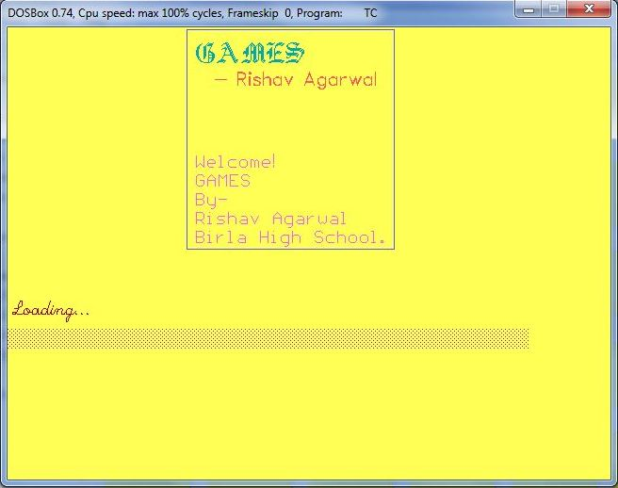

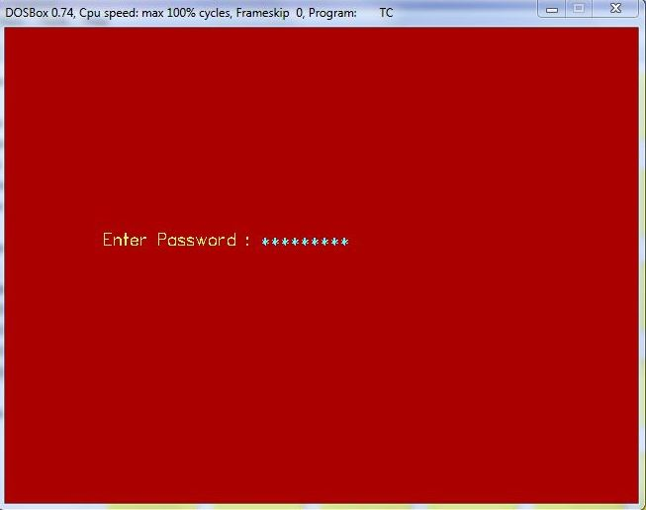

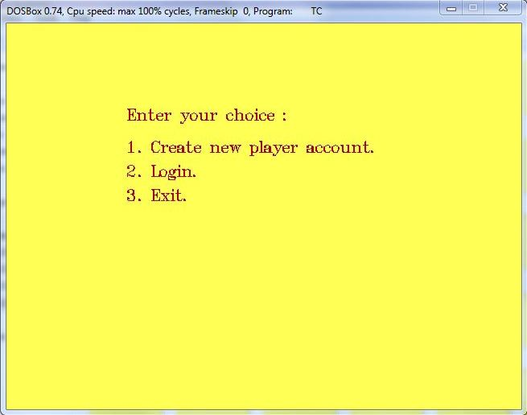

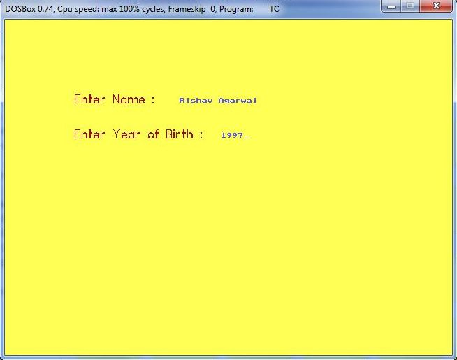

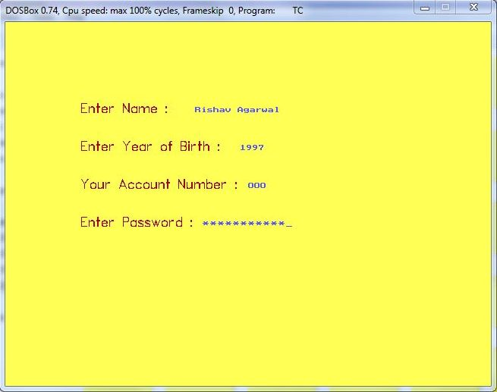

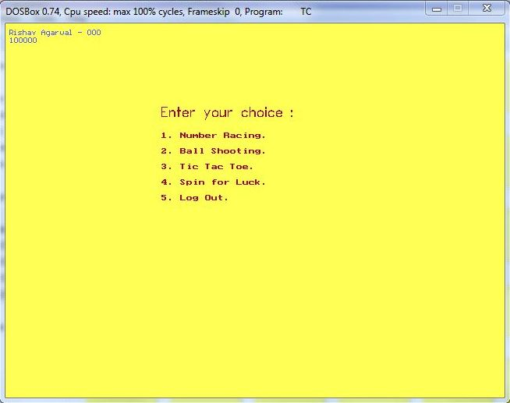

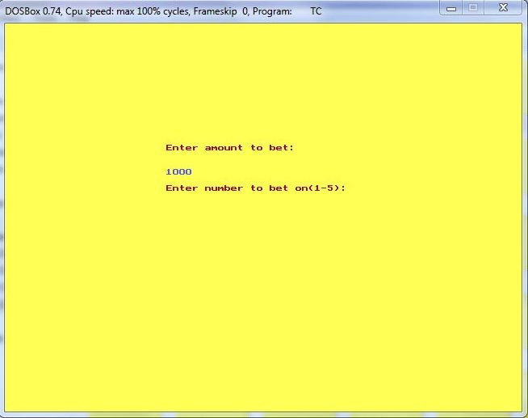

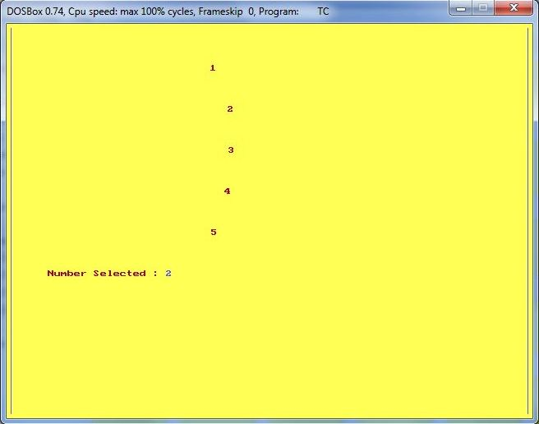

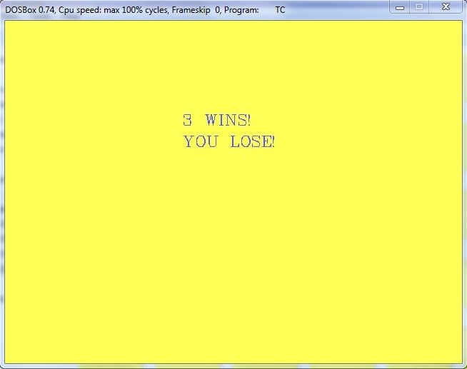

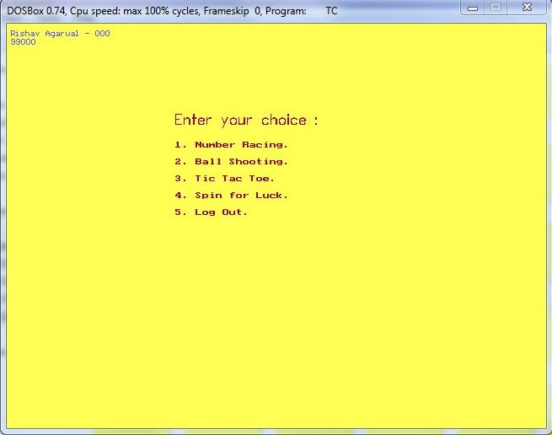

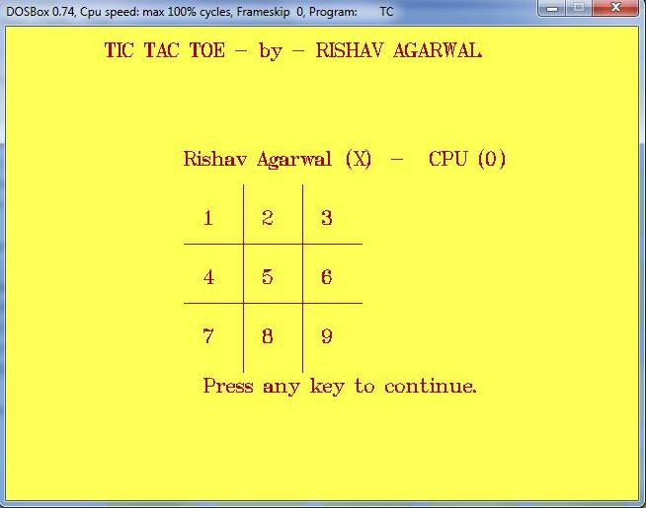

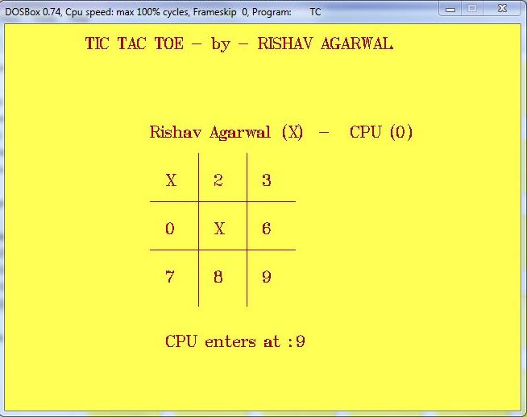

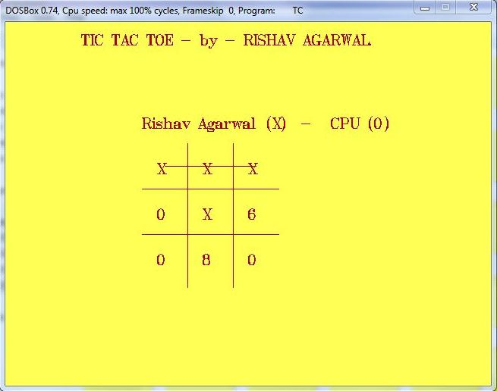

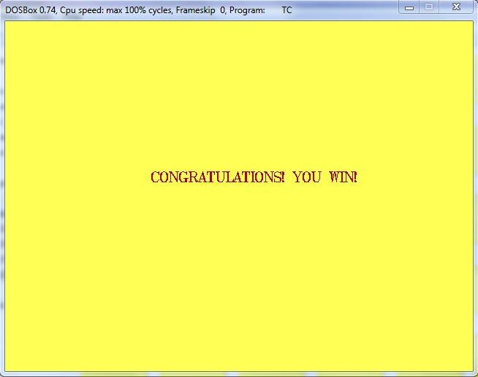

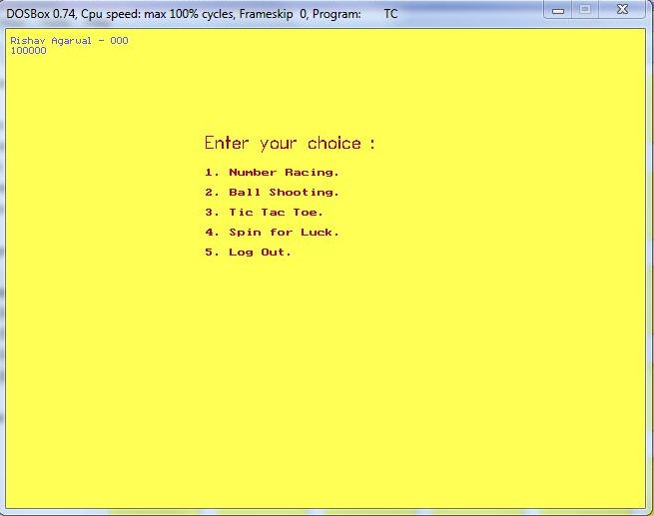

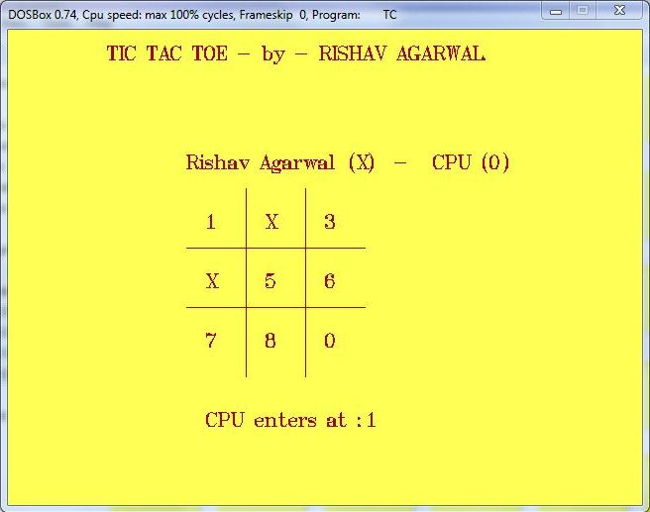

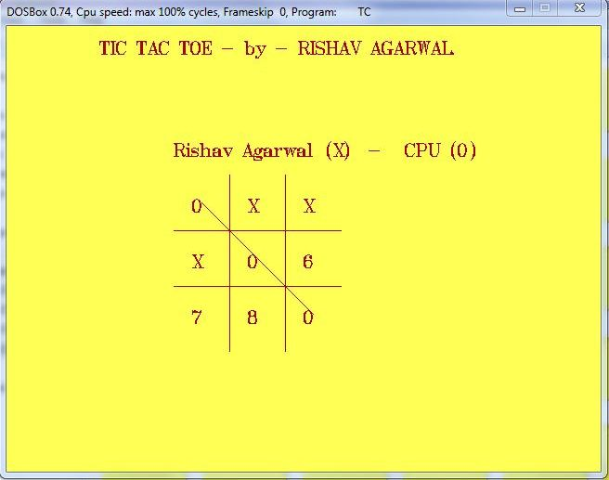

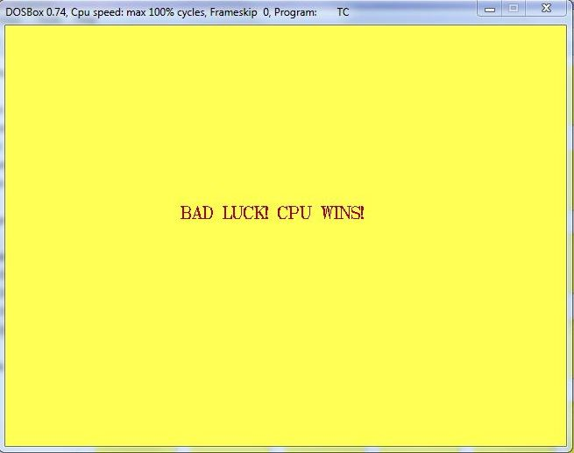

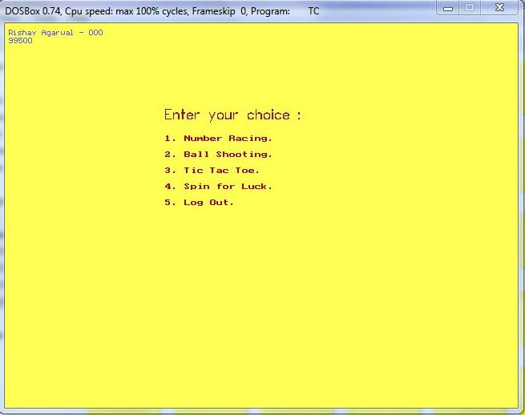

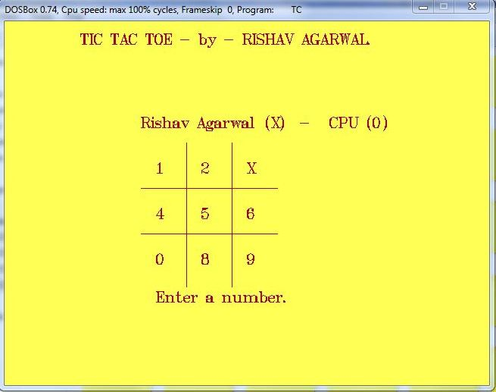

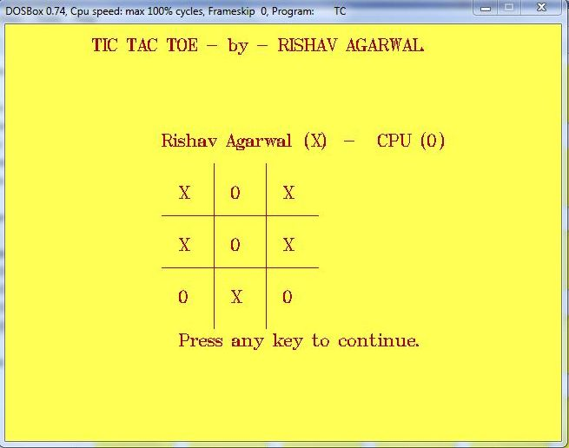

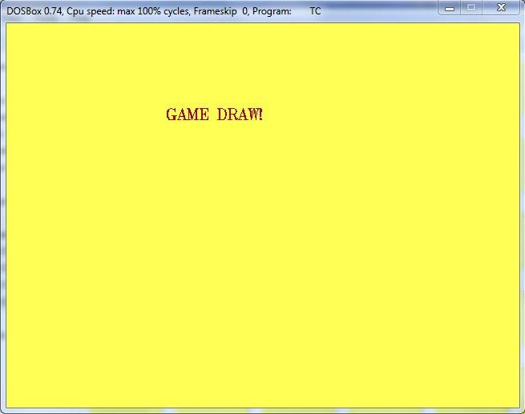

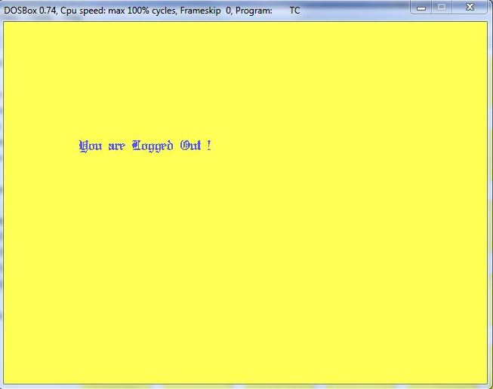

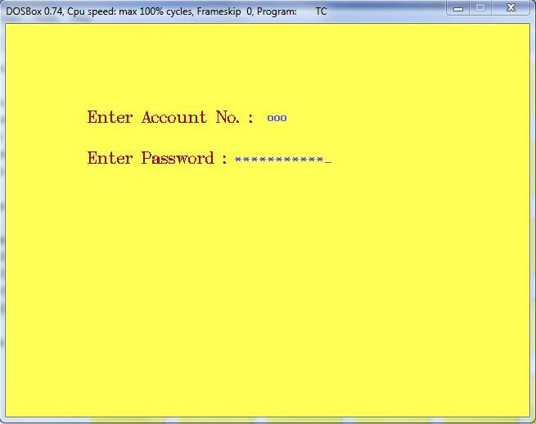

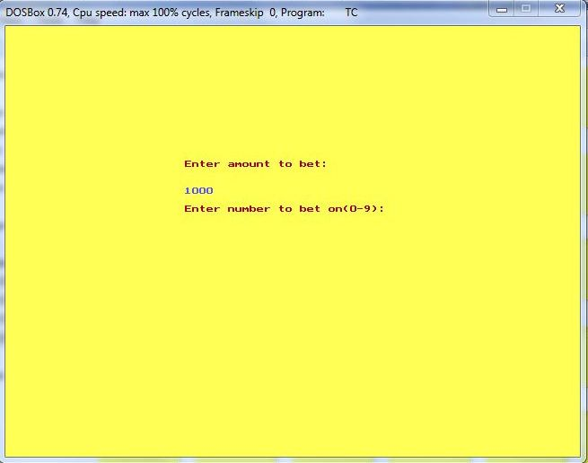

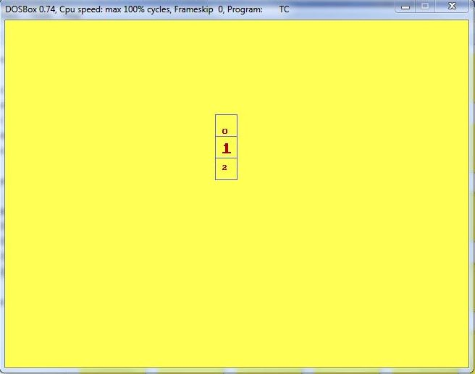

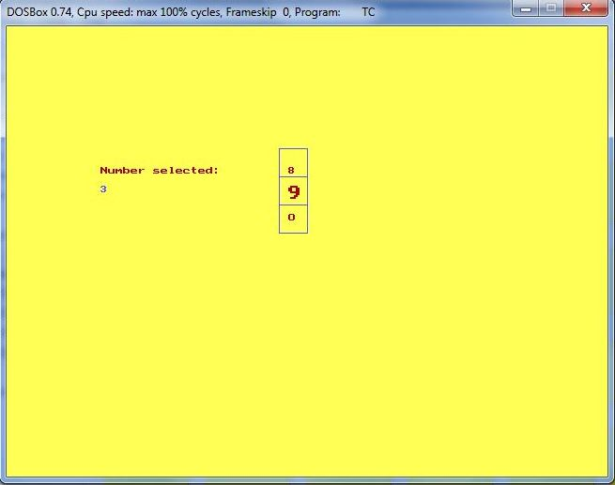

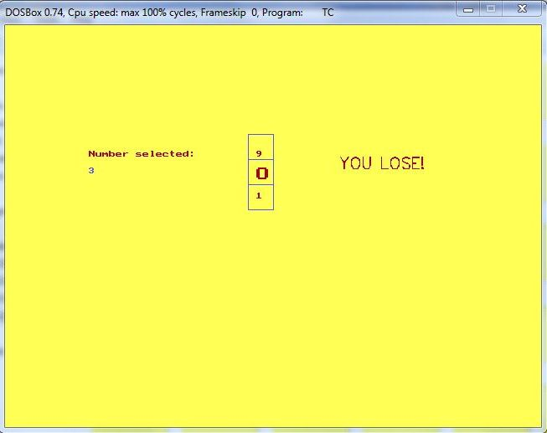

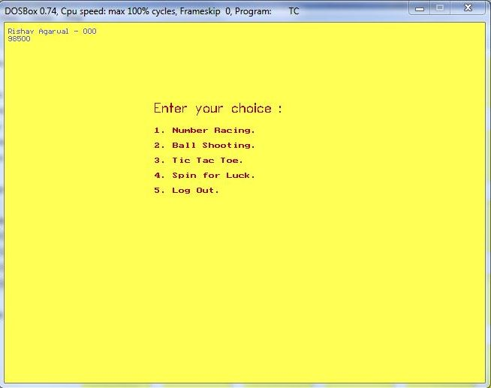

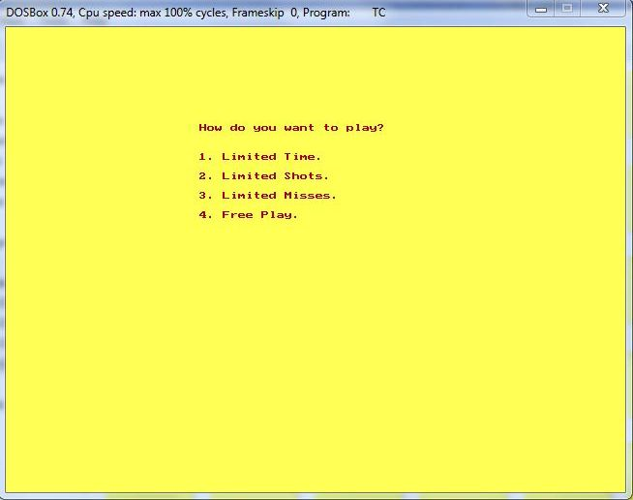

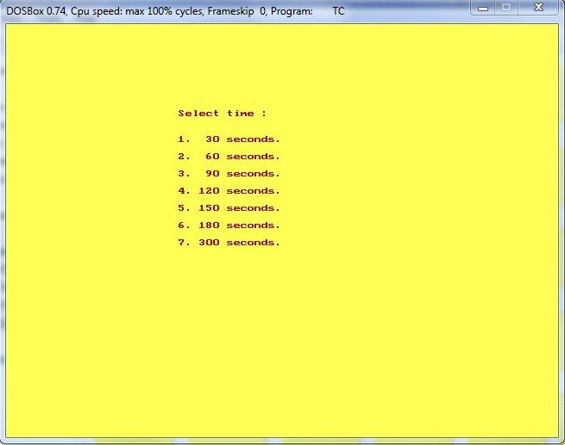

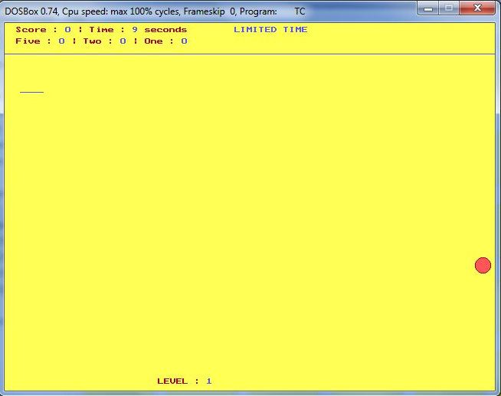

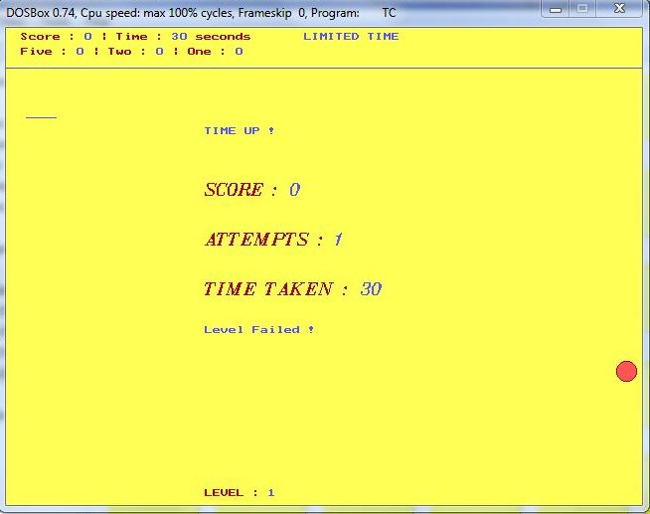

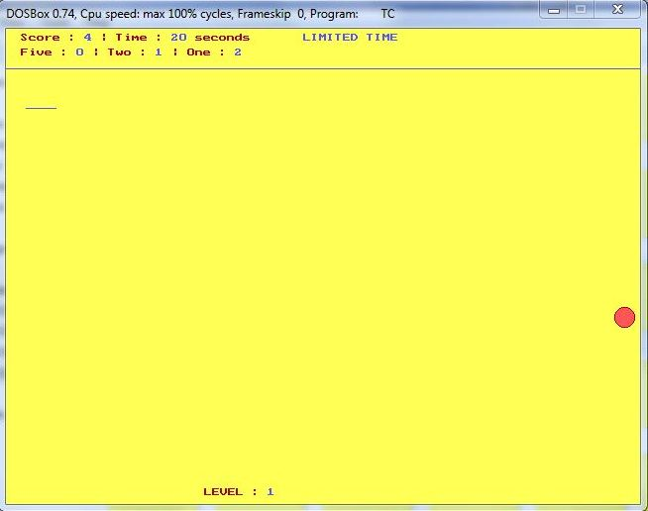

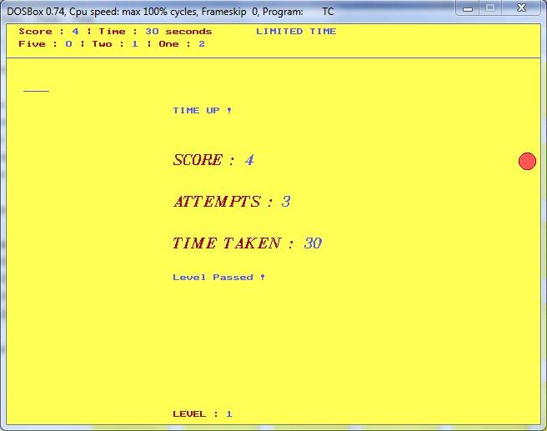

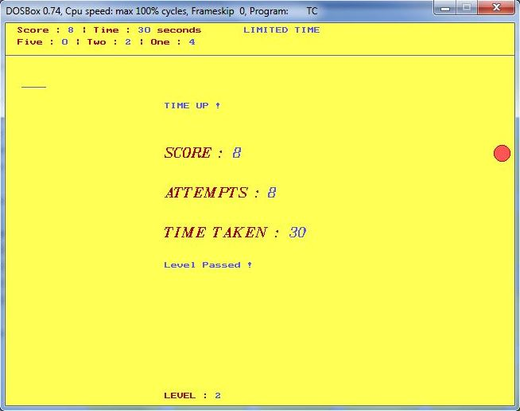

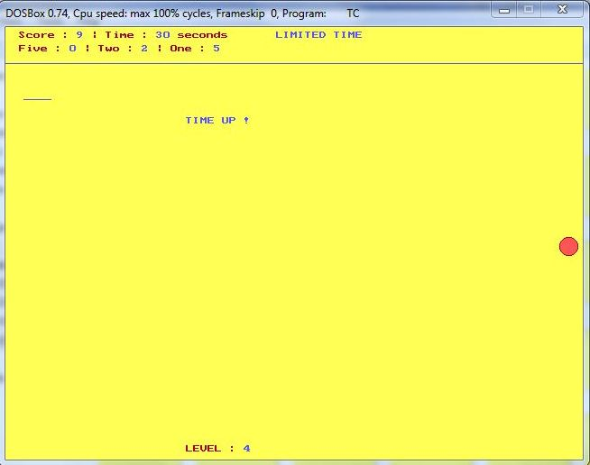

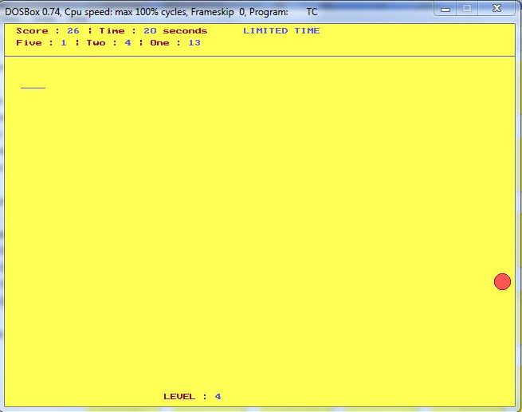

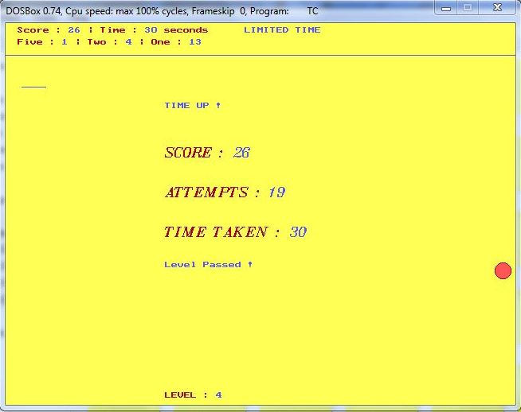

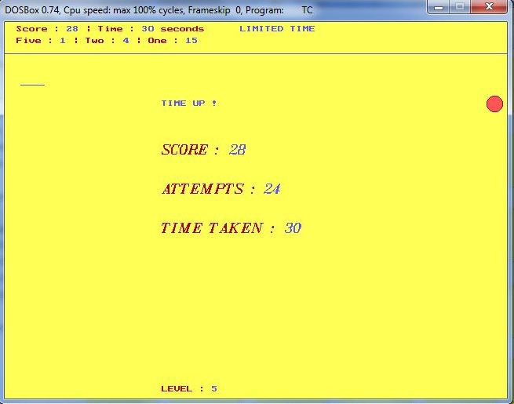

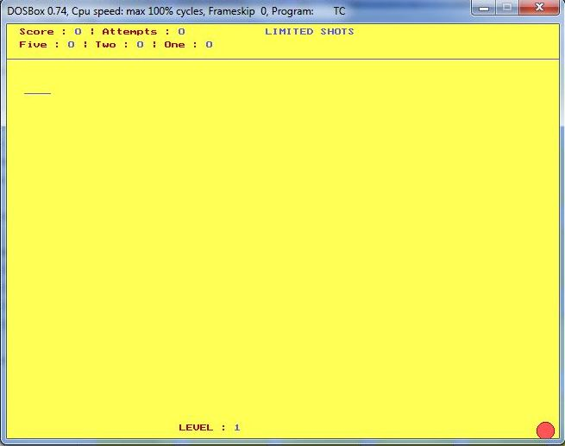

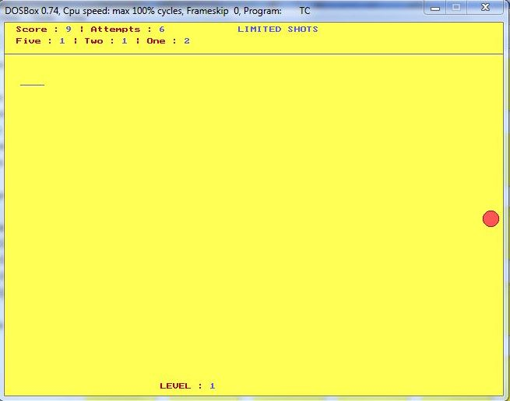

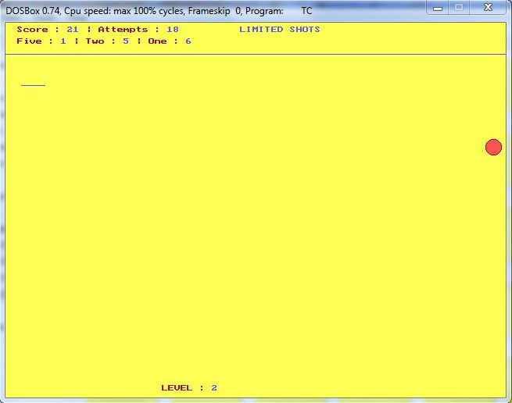

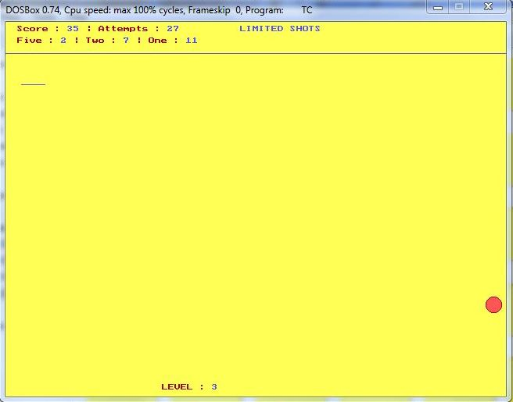

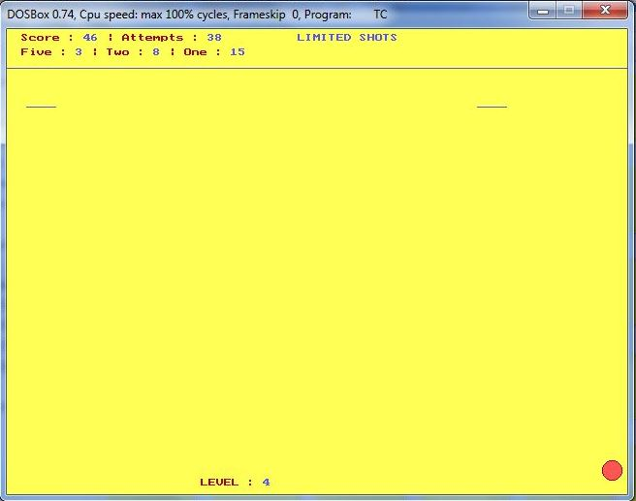

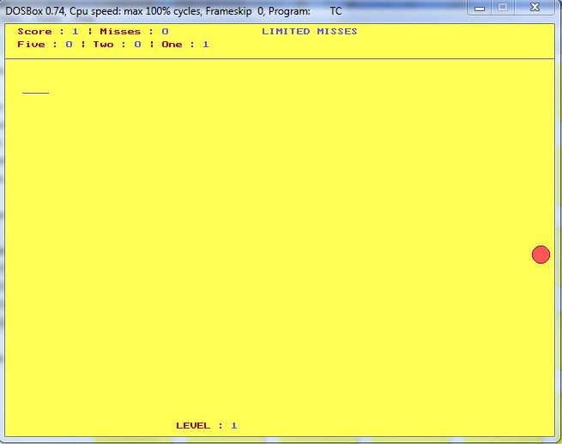

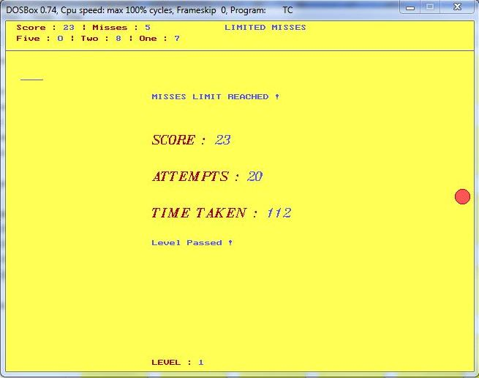

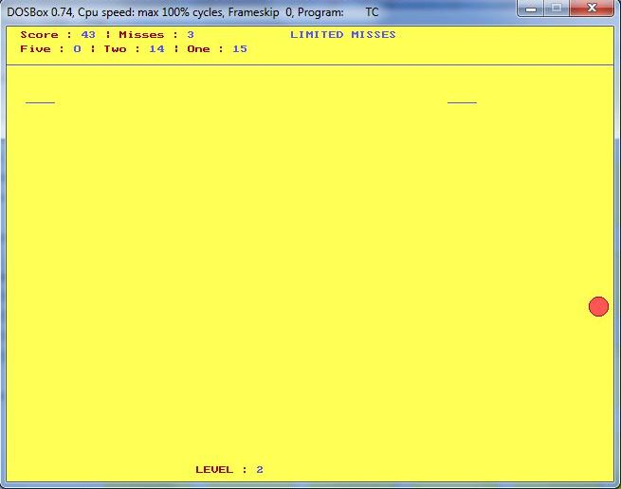

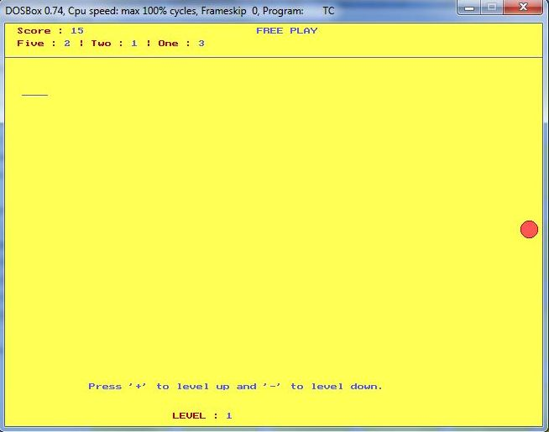

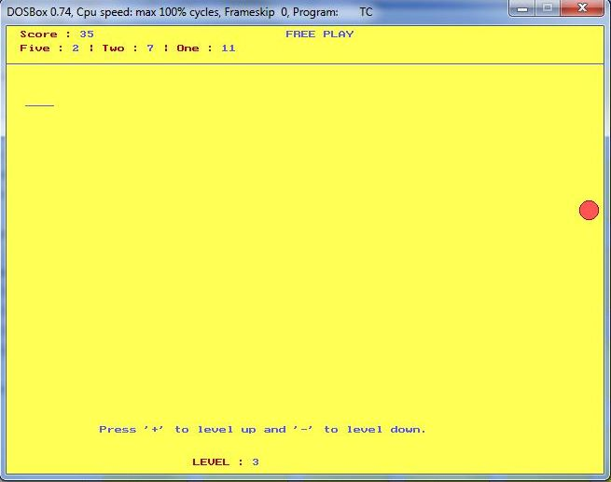

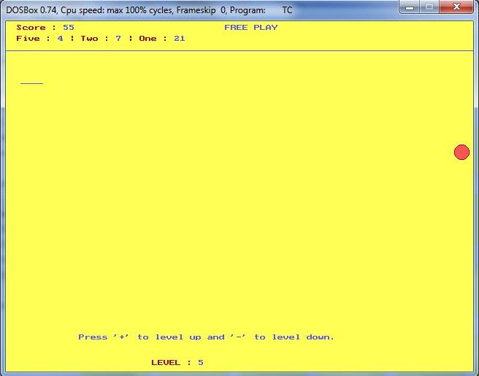

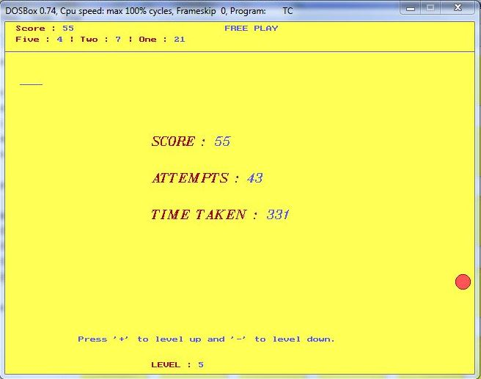

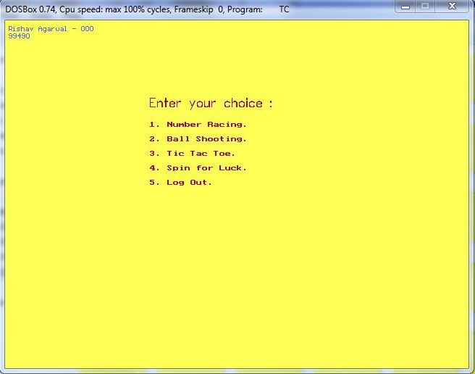

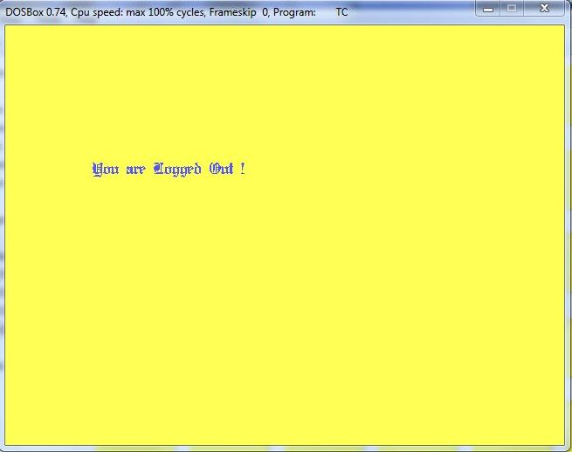

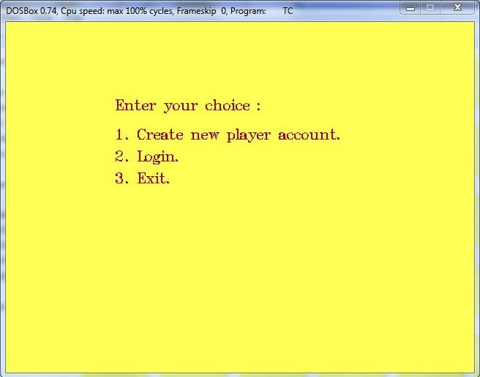

**Certificate**

This is to certify that **Rishav Agarwal** studying

in standard **XII – Sc. A** in **Birla High School**

has successfully completed his project entitled -

**Games – Rishav Agarwal.**

**External Examiner**

**Internal Examiner**