Cloud-Based Business Data Analytics and Decision Support System
Project Report
Submitted by: Baisakhi Bhaduri
Roll Number: O2BCA110280
Programme: BCA, Semester 5
Chandigarh University

Abstract
This project develops a practical business analytics and decision-support solution for cloud-service performance. It analyses a client dataset labelled DataServe India and compares it with Competitor Alpha and Competitor Beta. The supplied data contains 1,600 client records and 1,100 records for each competitor, with fields covering cloud service model, data volume, query activity, query time, cloud cost, uptime, dashboard usage, data quality, conversion, satisfaction, optimisation, storage utilisation and decision effectiveness. Python and Pandas are used for KPI calculations, while Streamlit provides an interactive dashboard for filters, comparison tables and grouped visualisations.

1. Introduction
Organisations use cloud platforms to store and process business data. Decision makers need clear metrics to understand whether their cloud services are fast, reliable, cost-efficient and useful for business decisions. Raw spreadsheets are difficult to compare at scale, so this project converts the supplied datasets into summary indicators, visualisations and actionable recommendations.

2. Problem Statement
The project addresses the need for a consistent, evidence-based view of cloud business analytics performance. The client needs to identify performance gaps against two competitors, understand variation across months, regions, mining segments and service models, and prioritise improvements using measurable KPIs.

3. Objectives
- Inspect and summarise the three supplied datasets.
- Calculate comparable company-level KPIs using consistent definitions.
- Analyse client performance by month, region, mining segment and cloud service model.
- Build an interactive dashboard that supports filtering and CSV export.
- Translate observed KPI gaps into practical recommendations and proposed targets.

4. Scope
The project covers descriptive analytics for the supplied records. It does not connect to live cloud infrastructure, perform predictive modelling, or prove causal relationships. All results depend on the supplied data and its field definitions.

5. Dataset Description
Dataset | Records | Fields | Role
DataServe India (client) | 1600 | 20 | Primary dataset for detailed analysis
Competitor Alpha | 1100 | 20 | Benchmark dataset
Competitor Beta | 1100 | 20 | Benchmark dataset
Common fields include Month, Region, Business_Unit, Customer_Segment, Cloud_Service_Model, Data_Volume_GB, Query_Count, Avg_Query_Time_Sec, Cloud_Cost_INR, Uptime_Pct, Dashboard_Users, Dashboard_Views, Data_Quality_Score, Mining_Segment, Conversion_Rate_Pct, Customer_Satisfaction_Score, Optimization_Score, Storage_Utilization_Pct and Decision_Effectiveness_Score.

6. Methodology
- Load the three Excel datasets and preserve their supplied field names.
- Check row counts, missing cells, duplicate record IDs and category coverage.
- Calculate average KPI scores and times using arithmetic means.
- Calculate cost per GB as total Cloud_Cost_INR divided by total Data_Volume_GB.
- Group the client dataset by Month, Region, Mining_Segment and Cloud_Service_Model.
- Create charts and a Streamlit dashboard for interactive review.
- Interpret differences as descriptive evidence and state limitations explicitly.

7. System Design and Technology
Component | Technology | Purpose
Data processing | Python, Pandas, NumPy | Load, validate, aggregate and compare datasets
Dashboard | Streamlit | Interactive filters, KPI cards, charts, tables and CSV download
Visualisation | Matplotlib and Streamlit charts | Display company comparisons and client breakdowns
Input data | Provided Excel workbooks converted to CSV | Portable local datasets bundled with the project

8. KPI Definitions
KPI | Calculation | Interpretation
Average query time | Mean of Avg_Query_Time_Sec | Lower is generally faster
Average uptime | Mean of Uptime_Pct | Higher indicates greater recorded availability
Cost per GB | Sum(Cloud_Cost_INR) / Sum(Data_Volume_GB) | Lower recorded cost per data volume, subject to workload comparability
Data quality | Mean of Data_Quality_Score | Higher supplied score is better, assuming same score definition
Conversion rate | Mean of Conversion_Rate_Pct | Descriptive conversion indicator
Decision effectiveness | Mean of Decision_Effectiveness_Score | Higher supplied score suggests better decision effectiveness

9. Company Benchmark Results
Company | Records | Query time (s) | Uptime (%) | Cost/GB | Data quality | Conversion (%) | Decision effectiveness
DataServe India | 1600 | 3.40 | 97.39 | ₹308.63 | 74.78 | 11.89 | 74.30
Competitor Alpha | 1100 | 2.50 | 98.52 | ₹284.63 | 83.19 | 15.02 | 85.60
Competitor Beta | 1100 | 2.94 | 98.97 | ₹265.16 | 80.43 | 13.52 | 82.78
DataServe India averages 3.40 seconds query time, 97.39% uptime, ₹308.63 per GB, data quality 74.78, and decision effectiveness 74.30. Alpha has the fastest average query time at 2.50 seconds. Beta has the highest average uptime at 98.97% and lowest cost per GB at ₹265.16.

10. DataServe India Detailed Analysis
The dashboard includes monthly query-time and conversion trends, regional cloud cost totals, mining-segment conversion averages, and service-model summaries. These breakdowns help analysts locate differences that may be obscured by company-wide averages.
Month | Records | Avg Query Time (s) | Avg Cloud Cost (₹) | Avg Data Quality | Avg Conversion (%)
Jan | 124 | 3.39 | 55451.10 | 75.13 | 11.66
Feb | 136 | 3.46 | 56949.19 | 74.69 | 11.72
Mar | 136 | 3.33 | 54421.81 | 74.49 | 12.26
Apr | 123 | 3.52 | 54110.88 | 73.59 | 11.37
May | 121 | 3.31 | 55577.94 | 76.20 | 11.88
Jun | 147 | 3.33 | 56227.41 | 73.89 | 11.90
Jul | 127 | 3.46 | 56230.61 | 74.78 | 11.82
Aug | 141 | 3.30 | 55968.01 | 75.28 | 11.87
Sep | 135 | 3.39 | 54421.40 | 74.43 | 11.76
Oct | 131 | 3.36 | 54482.80 | 76.08 | 11.97
Nov | 128 | 3.49 | 56181.02 | 74.56 | 12.06
Dec | 151 | 3.43 | 55054.93 | 74.46 | 12.34
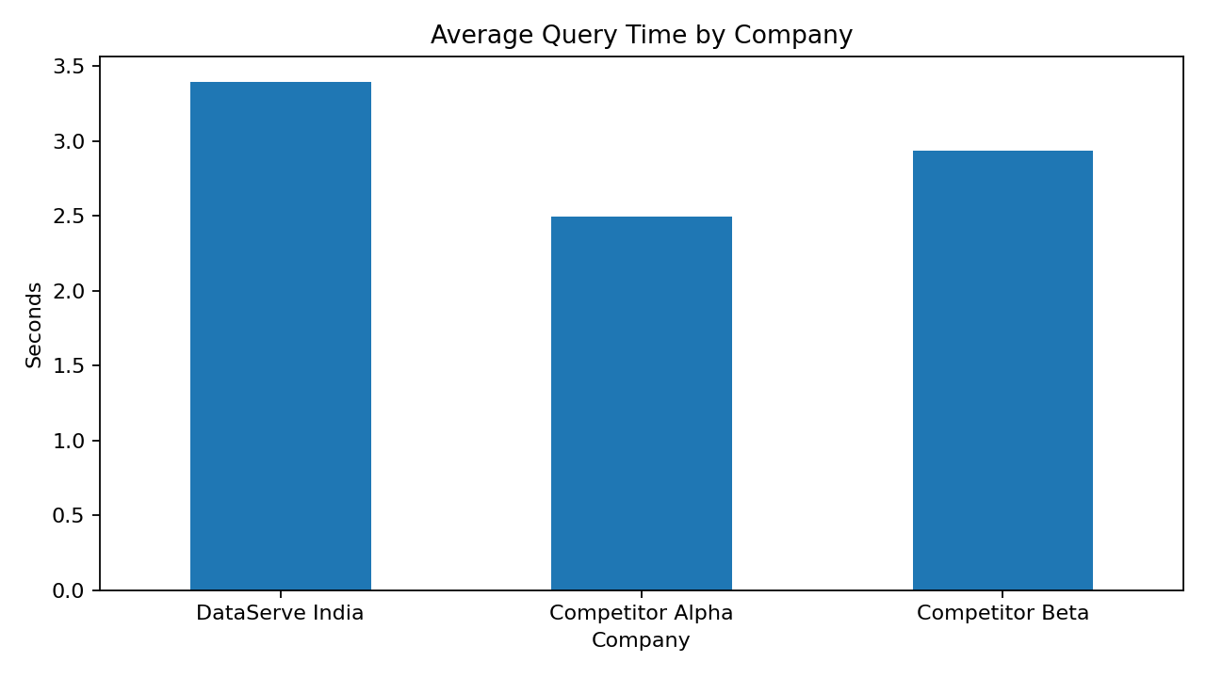
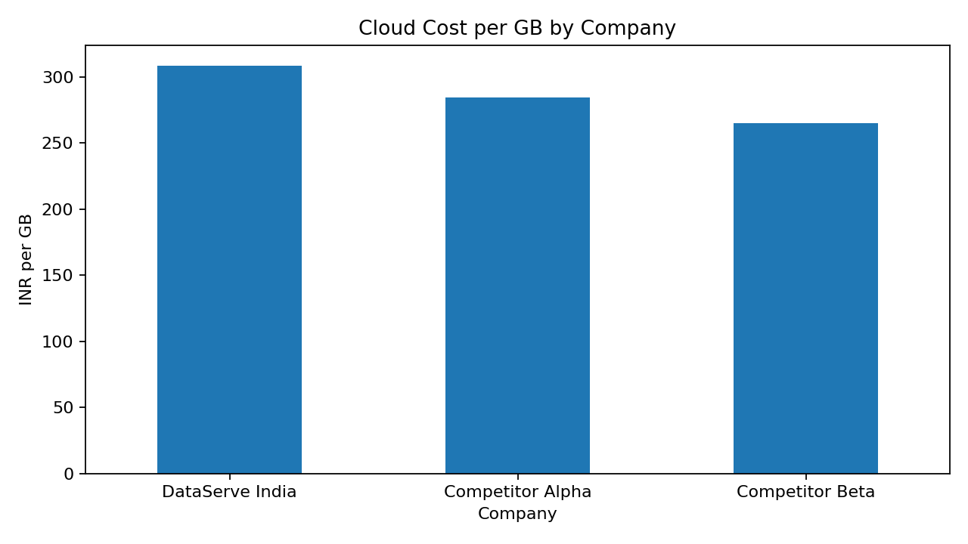
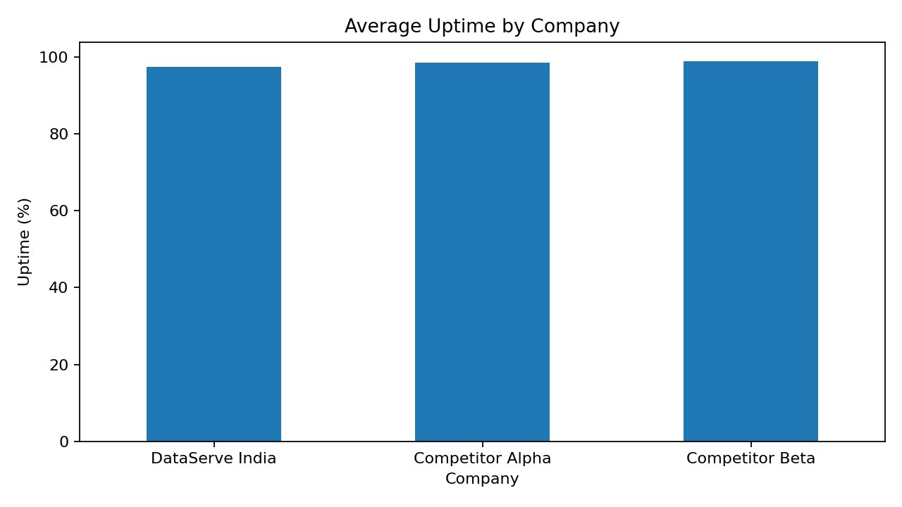
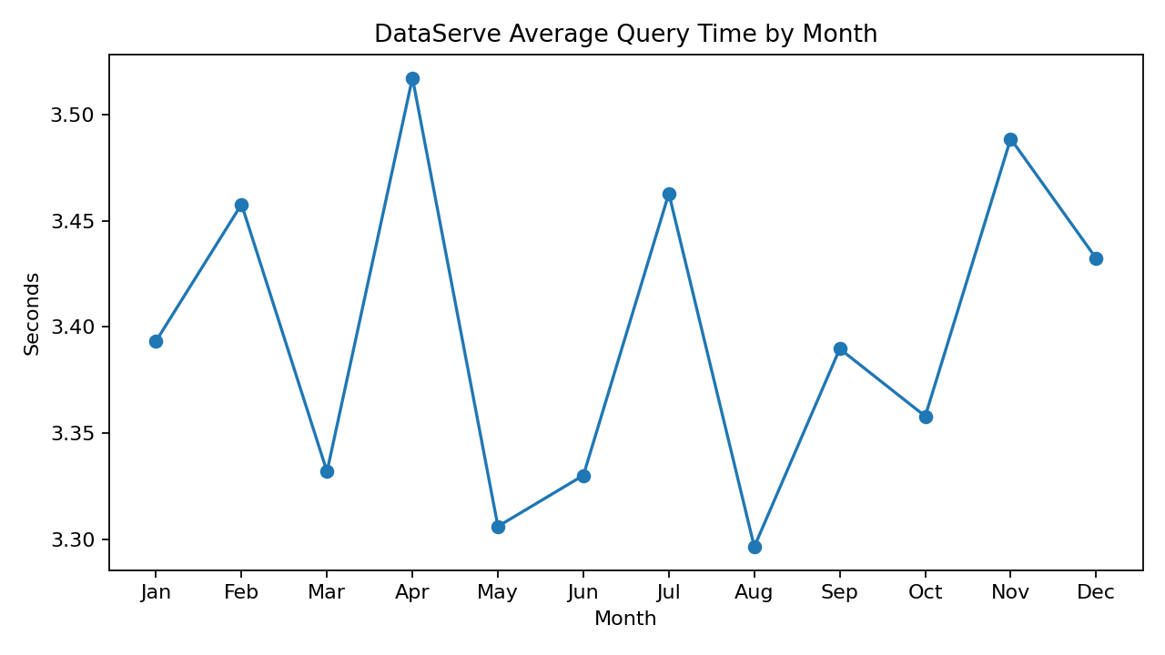
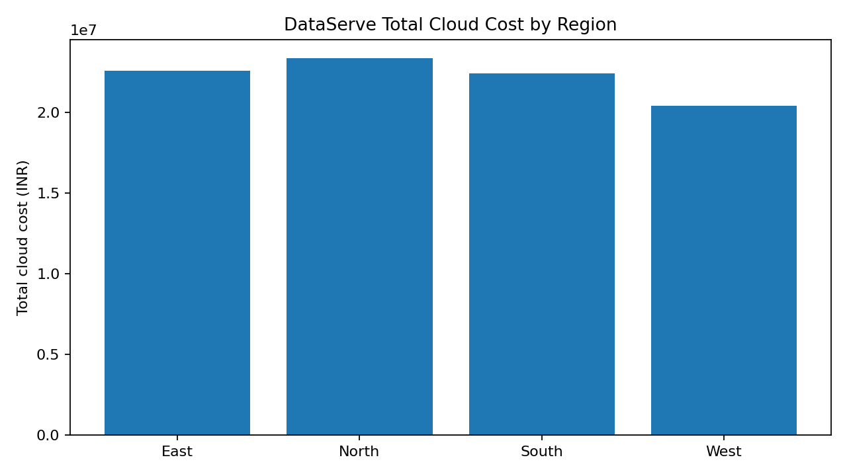
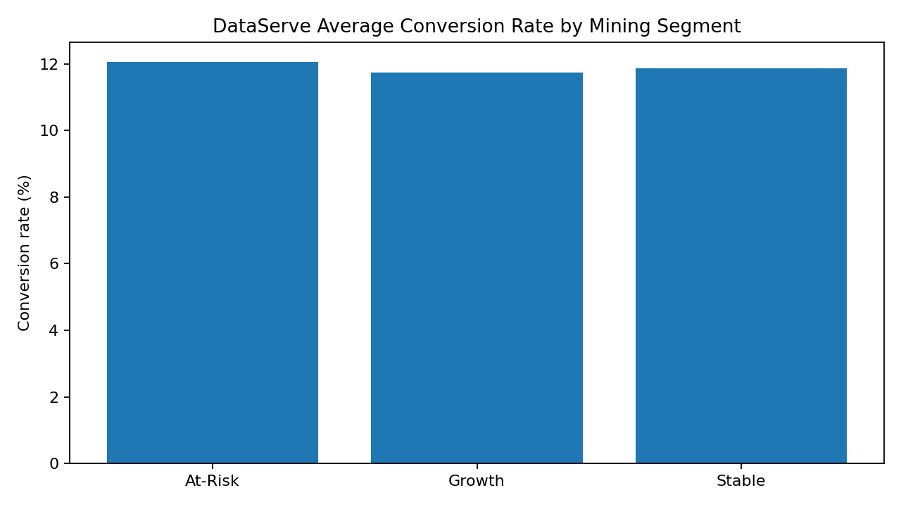

11. Data Quality Review
Dataset | Rows | Fields | Duplicate Record IDs | Missing Cells | Distinct Months | Distinct Regions
DataServe India | 1600 | 20 | 0 | 0 | 12 | 4
Competitor Alpha | 1100 | 20 | 0 | 0 | 12 | 4
Competitor Beta | 1100 | 20 | 0 | 0 | 12 | 4
The audit output is saved as data_quality_audit.csv. A zero count for missing cells or duplicate IDs only describes the inspected file; it does not establish that every field value is semantically correct. Validate categories, score ranges and source definitions before operational decisions.

12. Findings
- Query performance gap: DataServe averages 3.40 seconds, slower than Alpha (2.50 seconds) and Beta (2.94 seconds).
- Cost efficiency gap: DataServe's cost per GB is ₹308.63, compared with Alpha ₹284.63 and Beta ₹265.16.
- Reliability gap: DataServe averages 97.39% uptime, below Alpha (98.52%) and Beta (98.97%).
- Data quality gap: DataServe's average score is 74.78, below Alpha (83.19) and Beta (80.43).
- Decision effectiveness: DataServe averages 74.30, below Alpha (85.60) and Beta (82.78).

13. Recommendations and Proposed Targets
Priority | Recommendation | Proposed target / measure
1. Query performance | Profile slow queries; test indexing, caching, query simplification and workload scheduling. | Reduce average query time from 3.40 s toward ≤2.80 s; validate against representative workload.
2. Cloud cost | Review idle compute, storage tiering, capacity allocation and cost by workload/region. | Move cost per GB toward ≤₹284.63 (Alpha reference) while monitoring service quality.
3. Reliability | Review incidents, availability patterns, resilience and recovery procedures. | Improve average uptime toward ≥98.5%, with a clear measurement window.
4. Data quality | Introduce validation rules, duplicate detection, ownership and routine quality dashboards. | Raise average data-quality score toward ≥80.
5. Decision support | Use dashboard filters and segment analysis in monthly performance reviews. | Track decision effectiveness and conversion changes over time.
These are proposed targets for future measurement, not achievements already obtained. Pilot changes first and check that workload mix and data definitions are comparable before attributing improvements to a specific intervention.

14. Limitations
- The three datasets have different record counts and may represent different workload mixes.
- Cost per GB is calculated as total cost divided by total data volume; it is not a full cost-efficiency model.
- Arithmetic averages can hide outliers and distribution differences.
- The data is observational; associations do not establish cause and effect.
- The project uses supplied data and does not validate live cloud billing or infrastructure telemetry.

15. Conclusion
The project demonstrates how a consistent KPI layer and an interactive dashboard can make cloud analytics performance easier to compare. In the supplied data, DataServe India has higher average query time and cost per GB, and lower average uptime, data quality and decision effectiveness than both competitors. The dashboard allows users to explore monthly, regional, segment and service-model patterns, while the recommendations convert those gaps into measurable improvement goals. Future work could add anomaly detection, forecasting, role-based access and live data connectors.

16. References
- Microsoft Power BI documentation: https://learn.microsoft.com/en-us/power-bi/
- Google Cloud Architecture Framework: https://cloud.google.com/architecture/framework
- Microsoft Learn, Data mining concepts: https://learn.microsoft.com/en-us/analysis-services/data-mining/data-mining-concepts

