Flow Diagram :

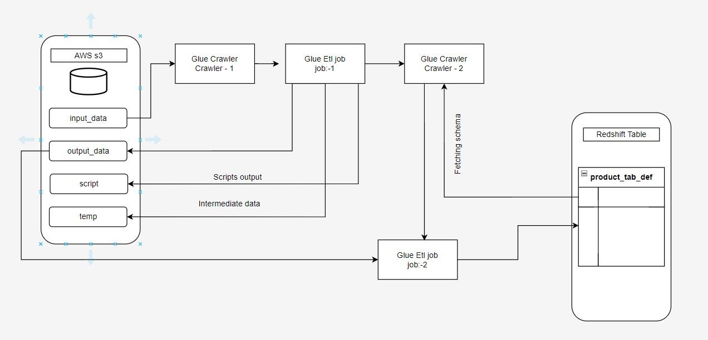

Execution of Jobs :

**Workflow (Orchestration): -**

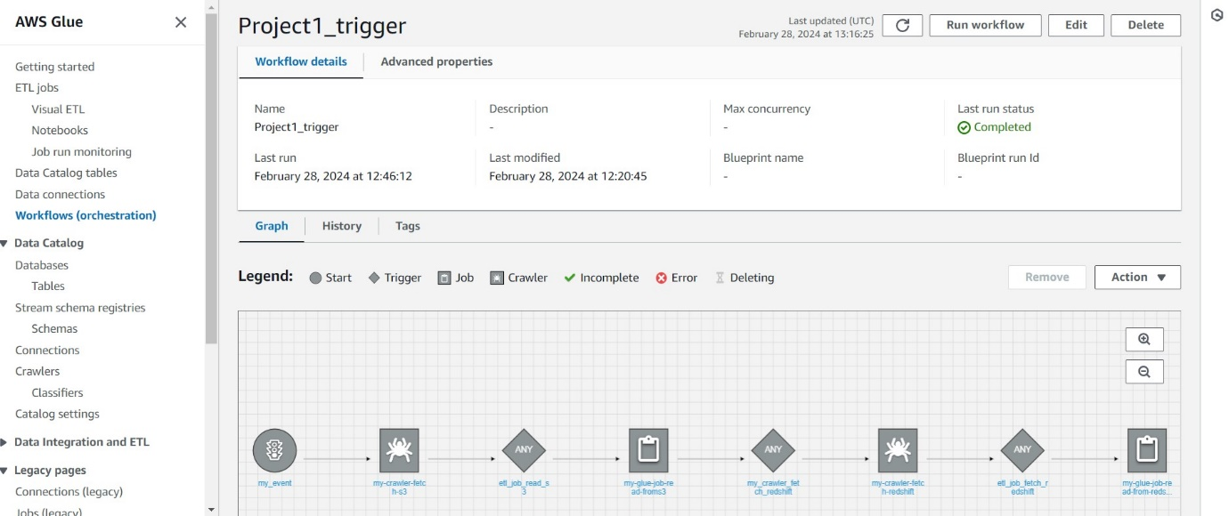

**Crawler1 got executed to read the csv file from s3 bucket and create metadata in datalog:-**

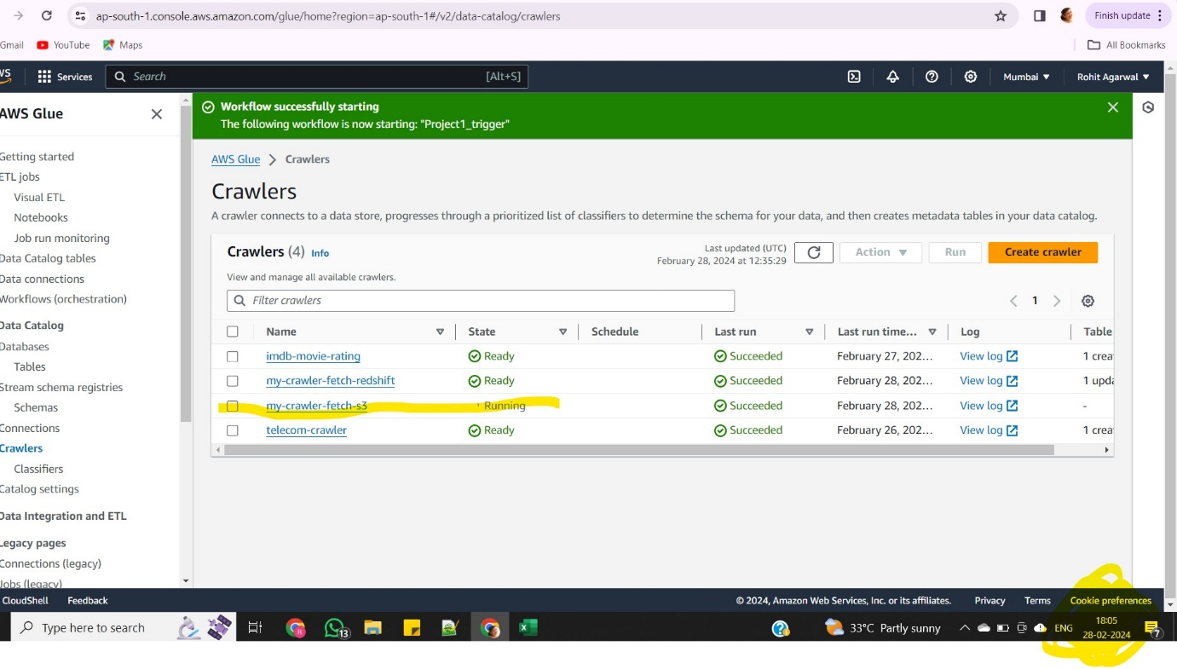

**Job:1 got executed to extract data transform it and pushed back to output folder in s3 bucket**

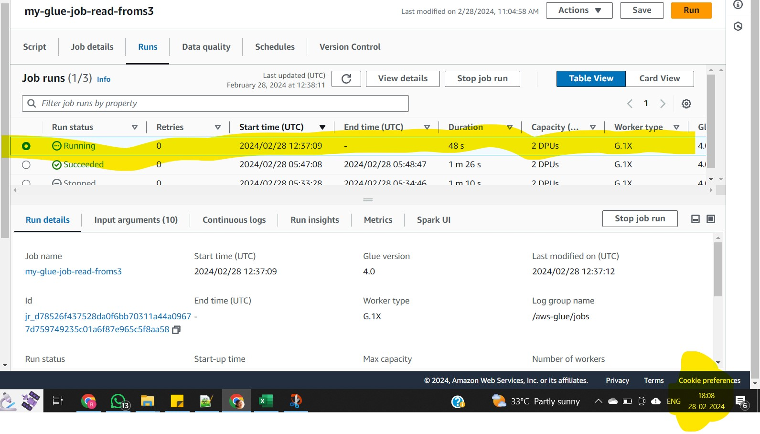

**Crawler2 got executed to read the Redshift table from Redshift and create metadata in datalog:-**

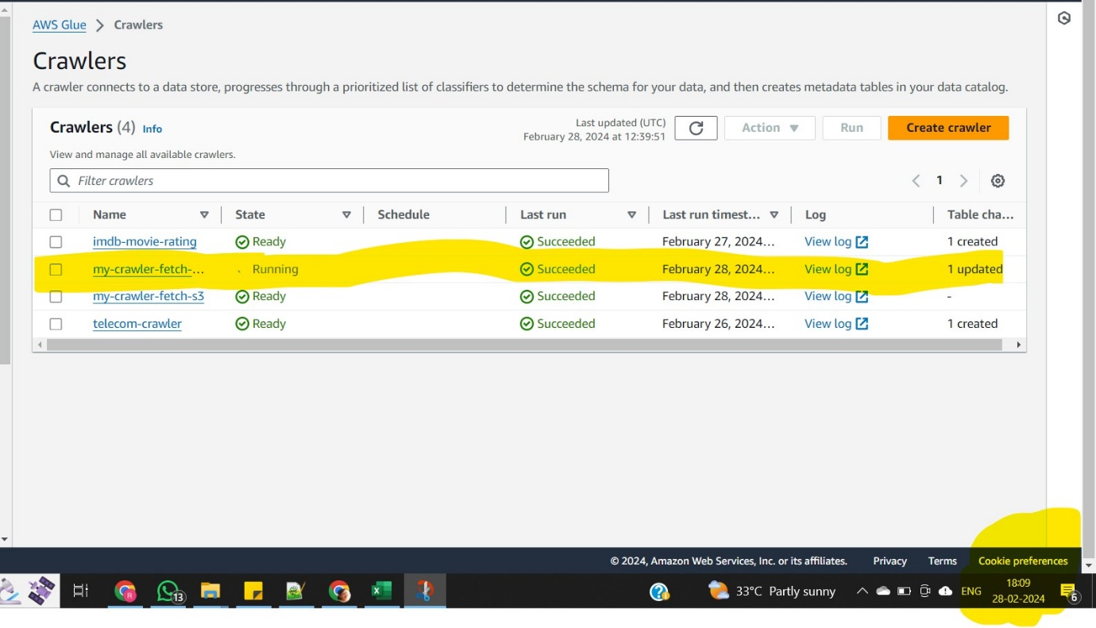

**Job:2 got executed to extract data from s3 output folder and pushed to Redshift table**

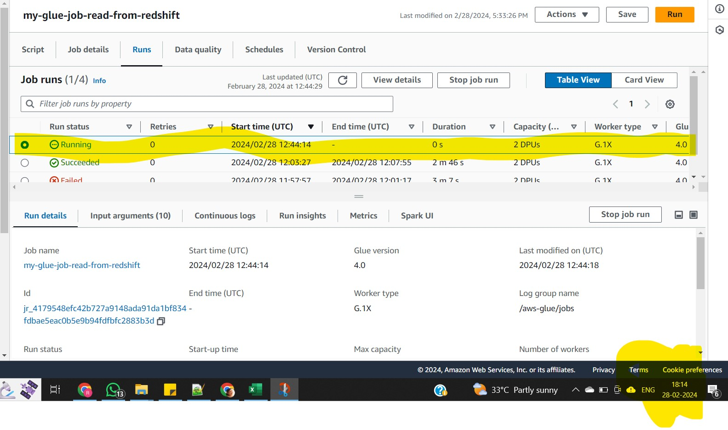

**Result of year wise quantity sale out**

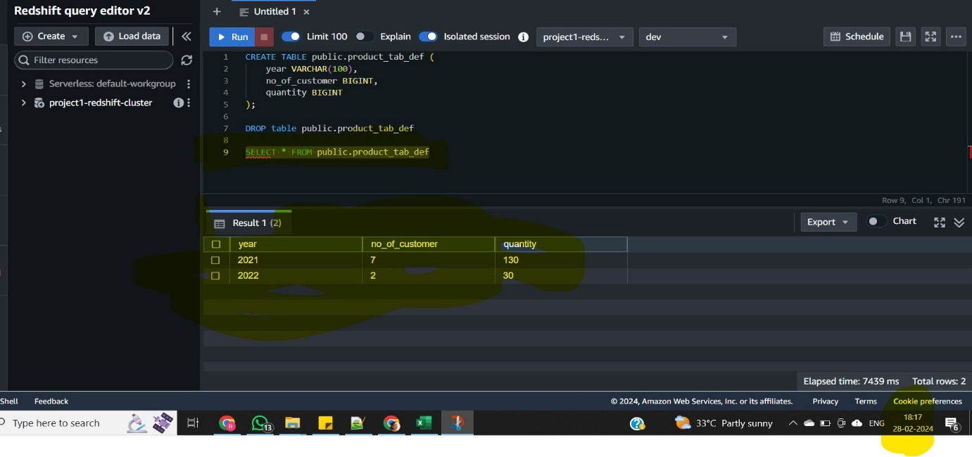

**Successful pipeline execution status**

