**Real time streaming data using DynamoDb and Kinesis in AWS**

1. Pushing Data to DynamoDb using mock generator Data from local using AWS CLI.

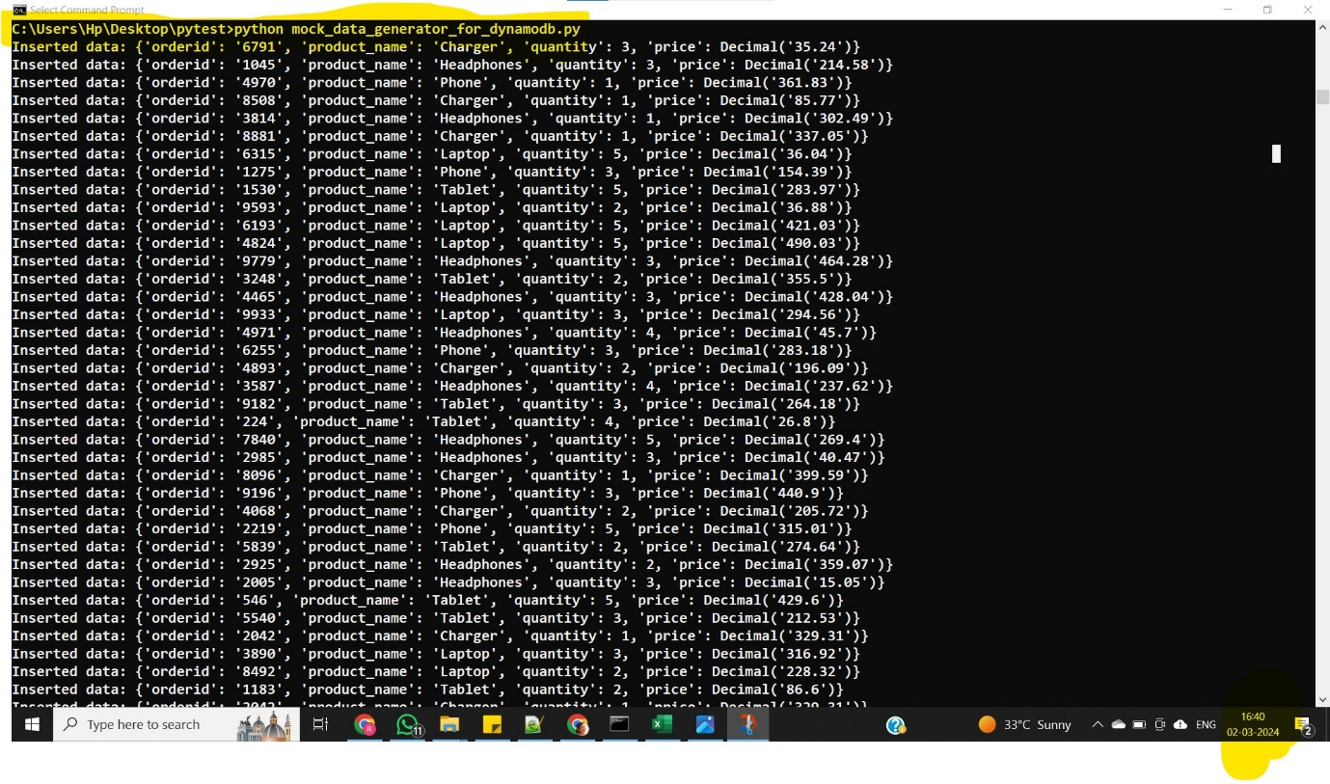

2.Data getting appended in dynamoDb table in AWS

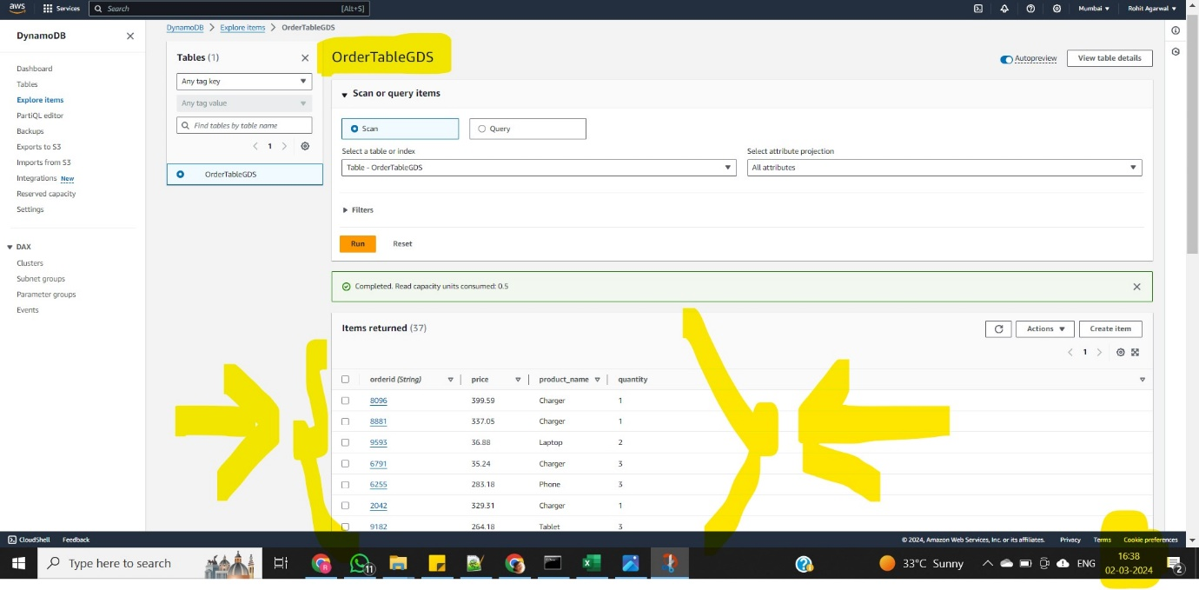

3.Creating Event bridge to connect DynamoDb stream with Kinsesis stream and KinesisFirehose

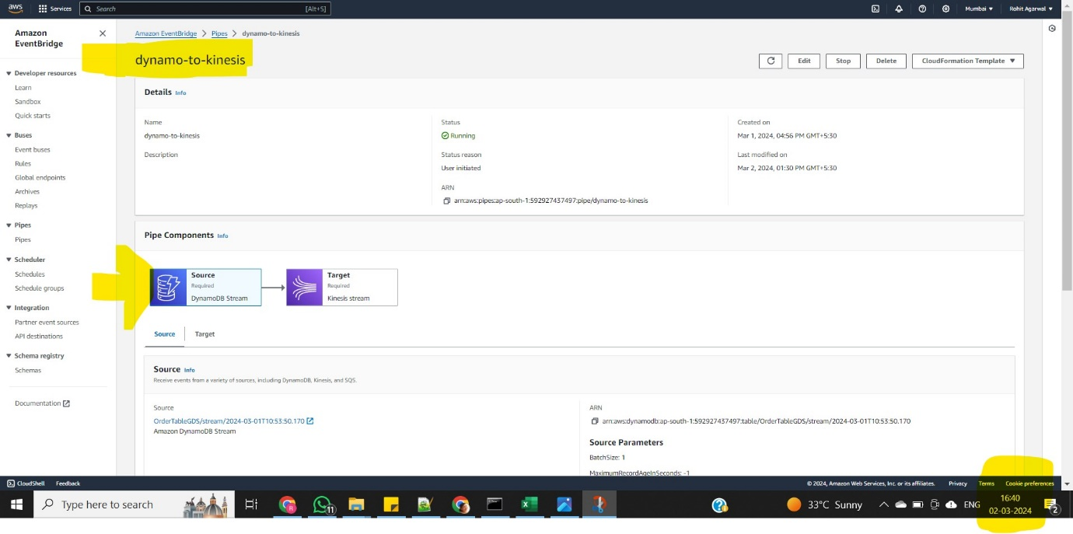

4.Graph is the evidence to show receiving data

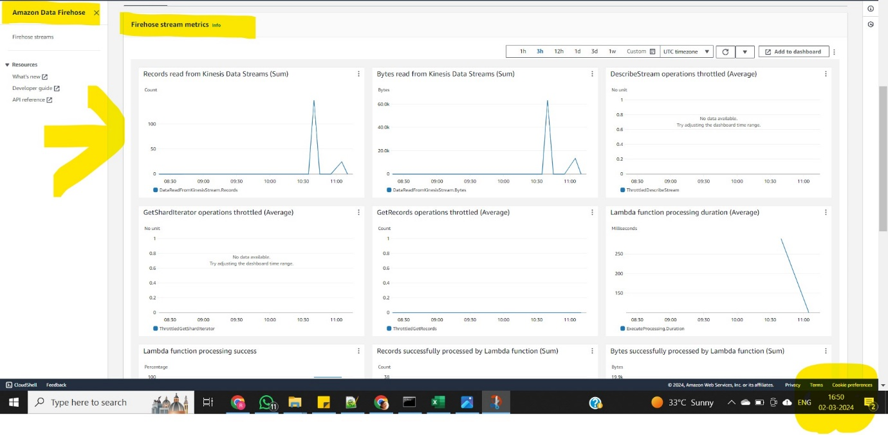

5.Lambda function is triggered to filter out the data

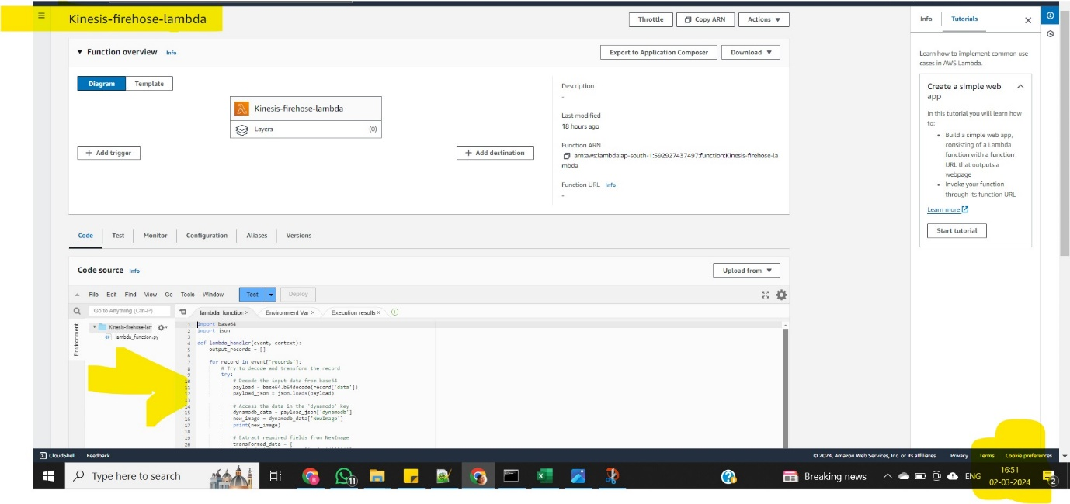

6.Data getting stored in S3 bucket

failprocessing-failed/ - this directory containing failed data

success2024/ - this directory is containing success data

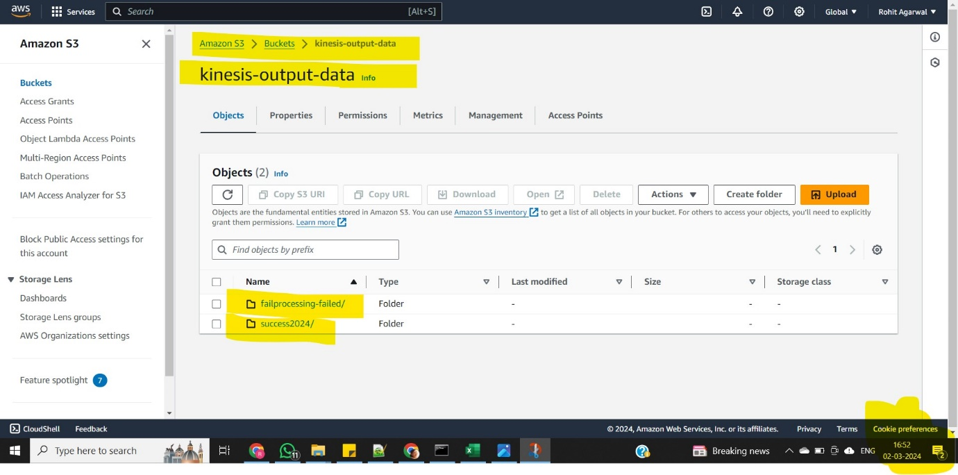

7. Crawler got executed to crawl files from output folder

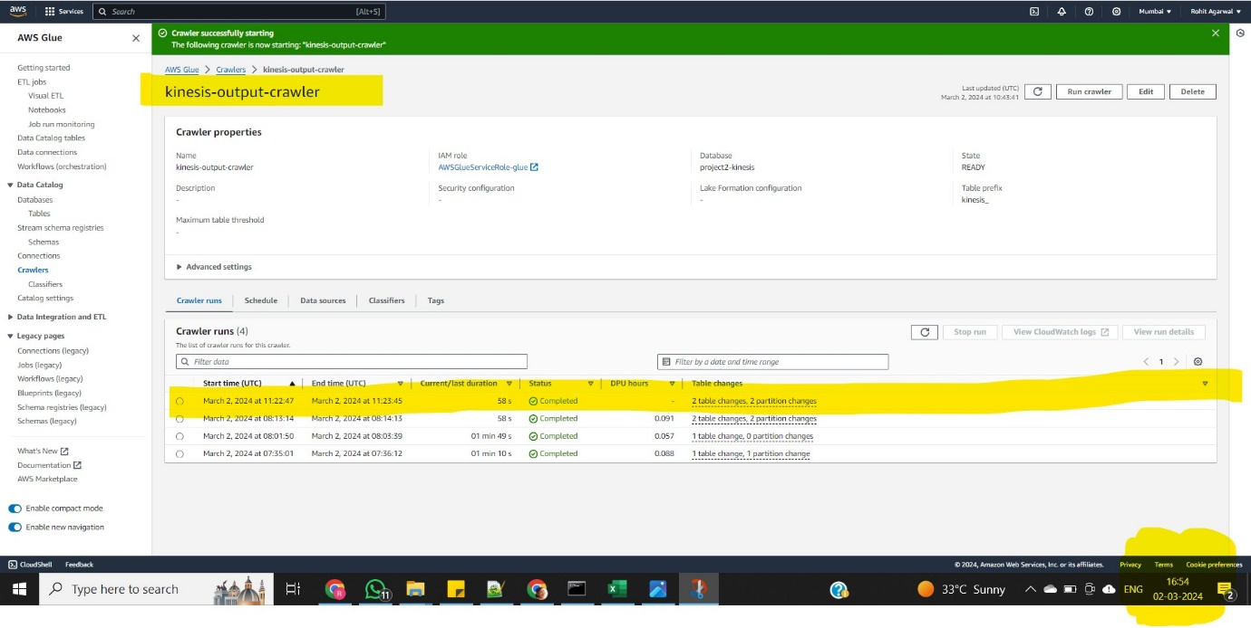

8.Metadata Tables got created

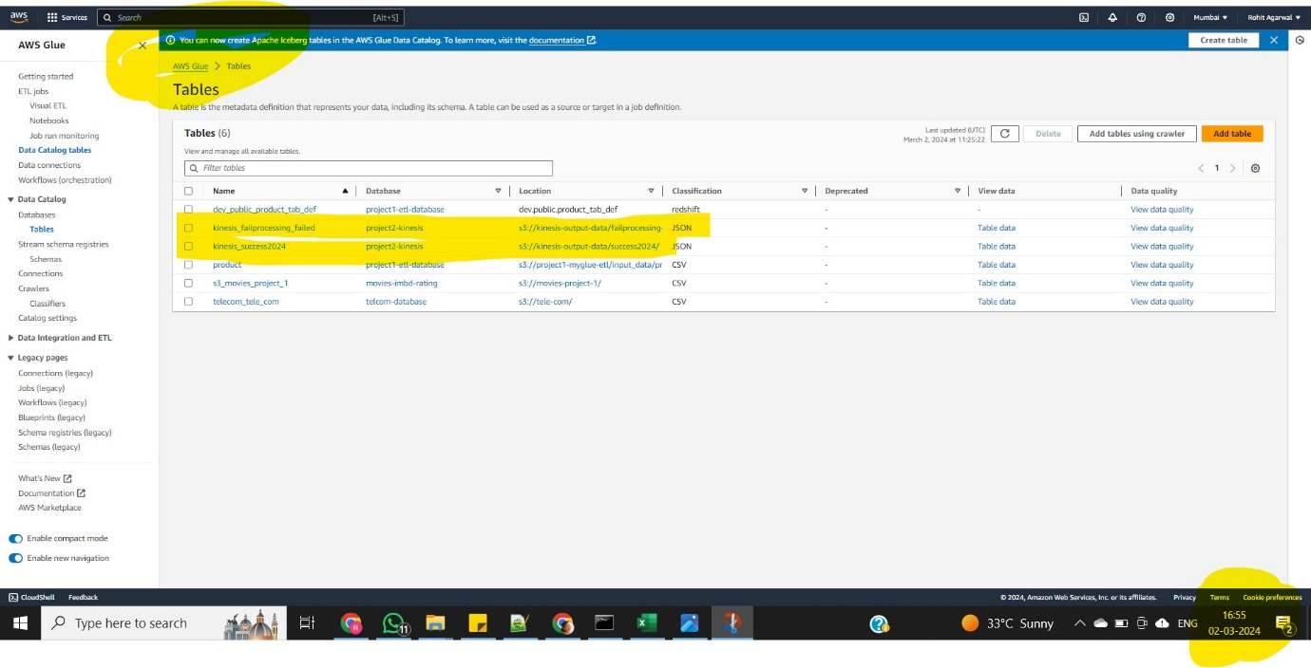

9.Executing query on Athena for Analysis

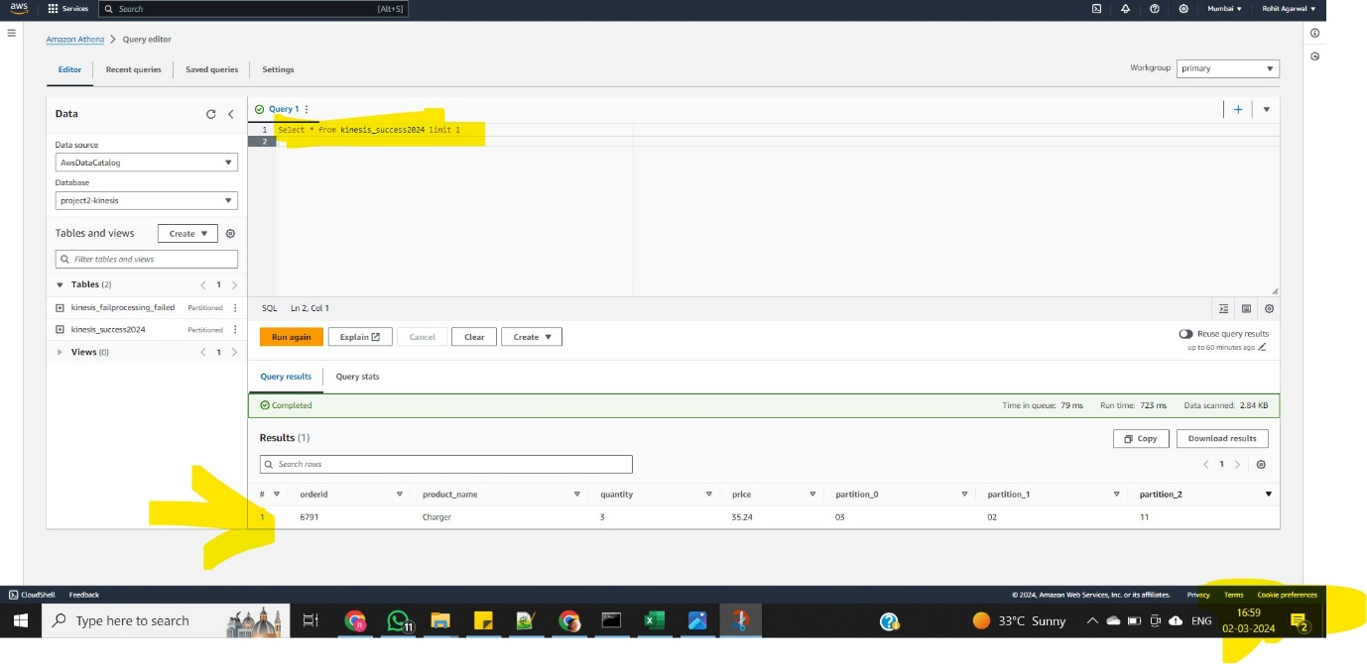

**This is end to end flow how we are fetching live data which is generated by mockdata generator and we are using it for Analysis part!!!**