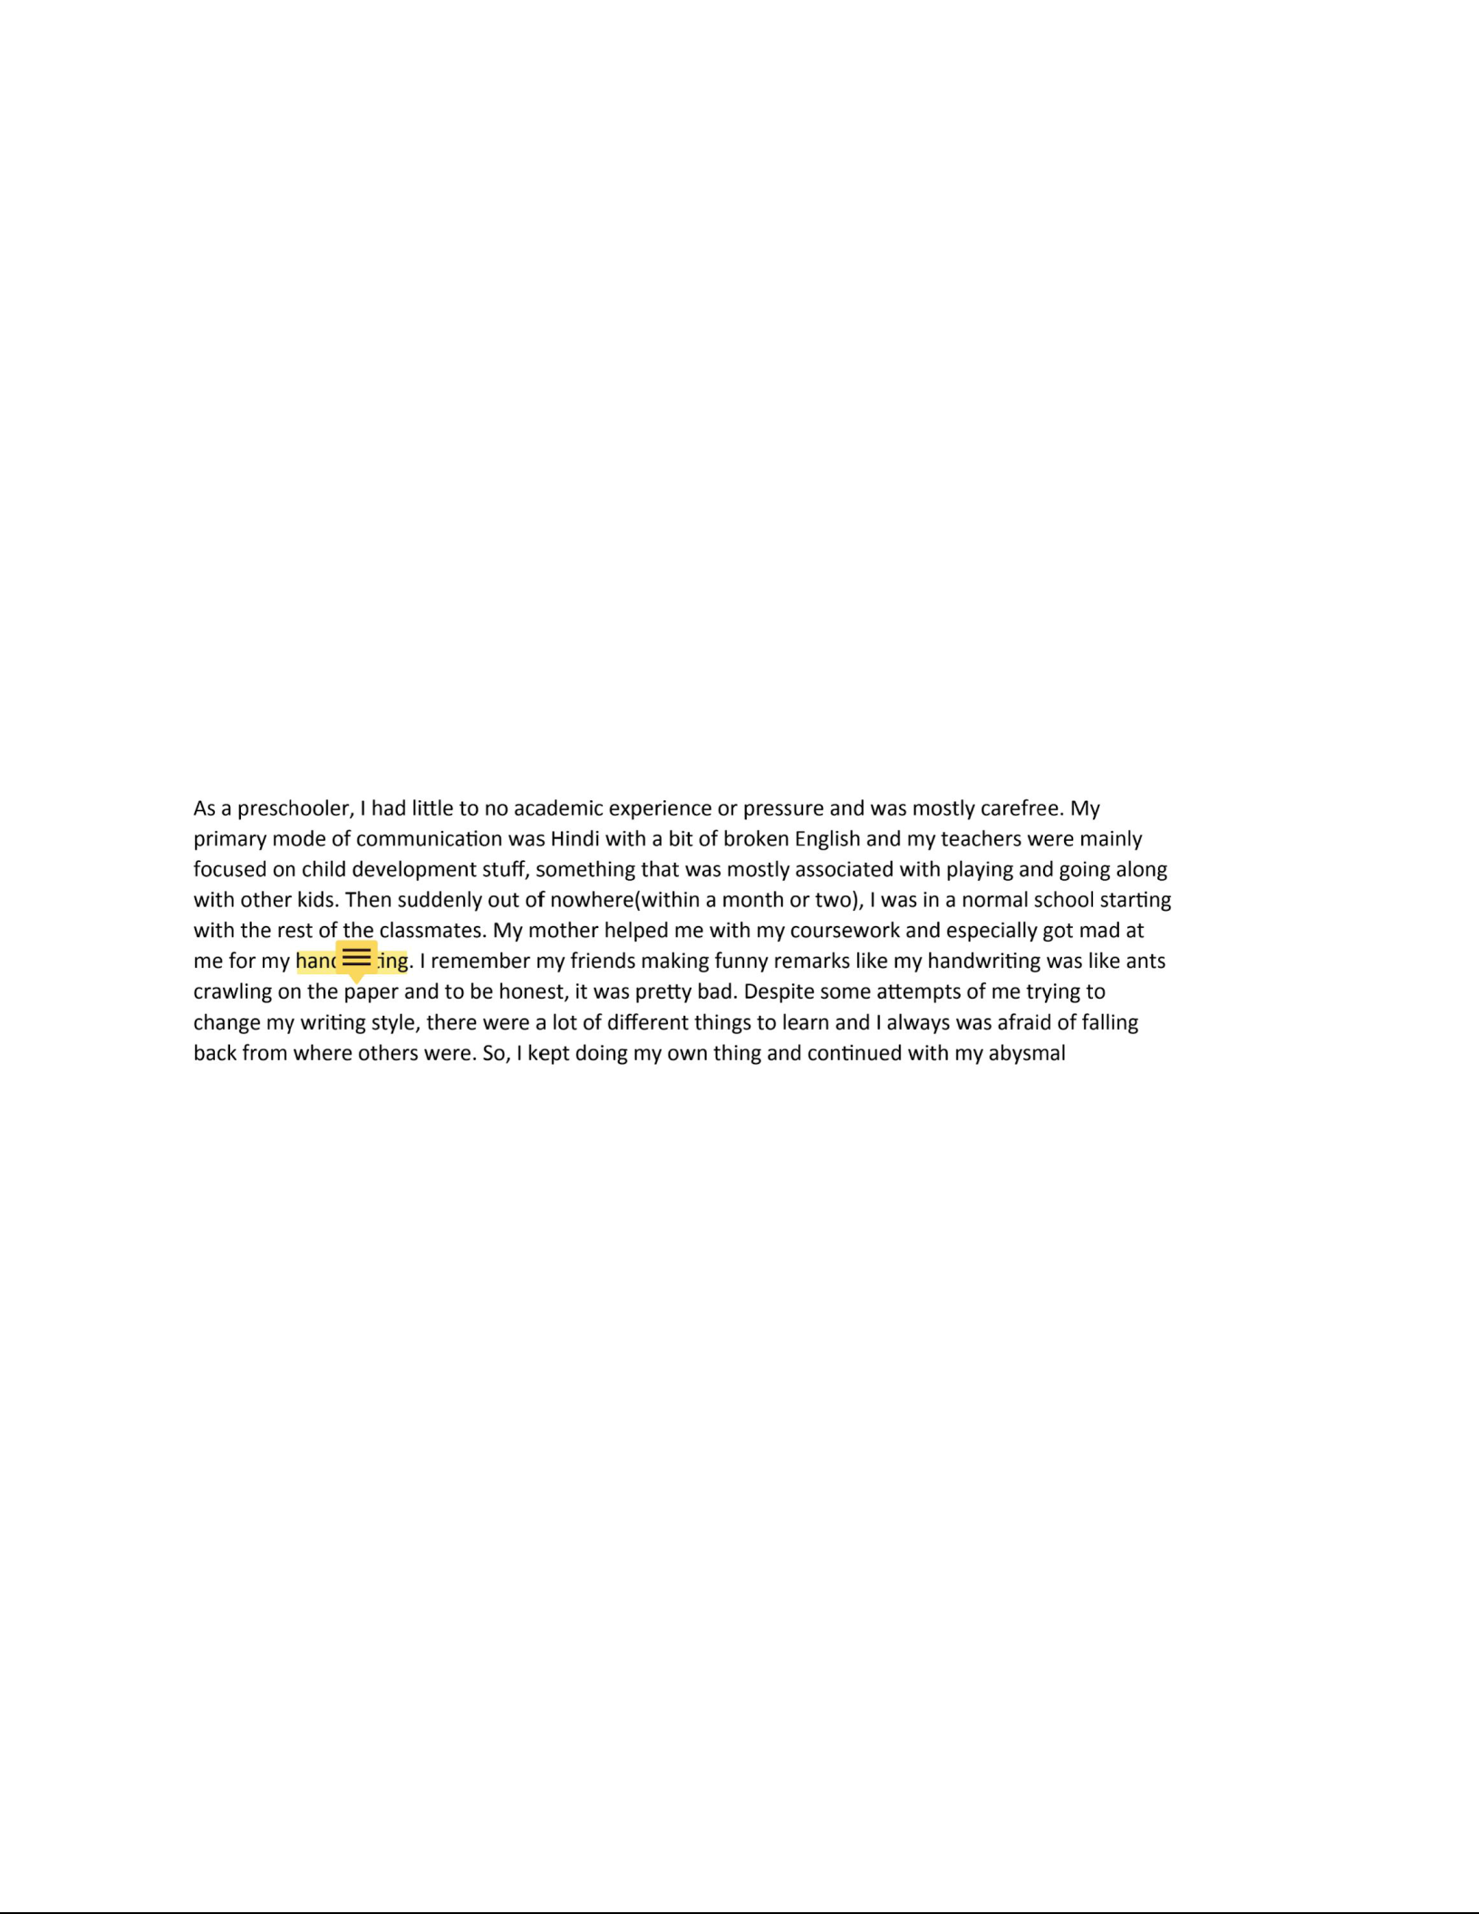
As an academic writer, I often struggle with many elements of writing. There are times where I struggle with explaining ideas that I envision, and I always seemed to miss out on those crucial supporting details that would give a comprehensive outlay to the readers of my writing pieces. Evidently, at the start of the ENGL 107 course, I lacked the skills necessary to generate clear opening sentences that gave out a clear idea of what the reader should expect from the given piece of writing. Erratic sentences plagued my essays and ambiguous connotations prevented me from letting me get my ideas across, throwing up a barrier between me and my audience.

While working on my Language Narrative in Project 1 of ENGL 107, I had some significant doubts about my language experience. Even as I look backward on my graded project 1 final paper, I find the writing to have a very divided focus, which gives the reader a very unclear idea of what the paper is trying to mean. When I was starting, I did not even understand the usage of a language narrative. A screenshot of the starting lines:

My writing style and quality of a Language Narrative felt unnatural - I had little idea of how a language narrative looked like and why somebody would write one. Writing is a process that involves creating multiple ideas and thoughts, then converting the thoughts into actual paragraphs that tell a story in enough detail to grip the attention of the reader. This might sound easy on paper but in reality, it is difficult to generate those “writable” ideas itself, let alone simultaneously converting them to paper. I would say that this is a skill that I learned with experience, by rewriting each idea giving the ideas the time and maturity to develop into well-reasoned arguments and exquisitely expressed thoughts.

However, with a plethora of peer feedback and communication with our instructor, Ms. Gou, and peers alike, I began to have a clearer idea about my next essay structure and what the core elements comprising a proper language narrative is. For example, in the peer review short task, Bahaa suggested that the first paragraph seemed a bit lost and the use of dialogues might improve the readability of the paper and give it a more clear outlook. A screenshot of his feedback:
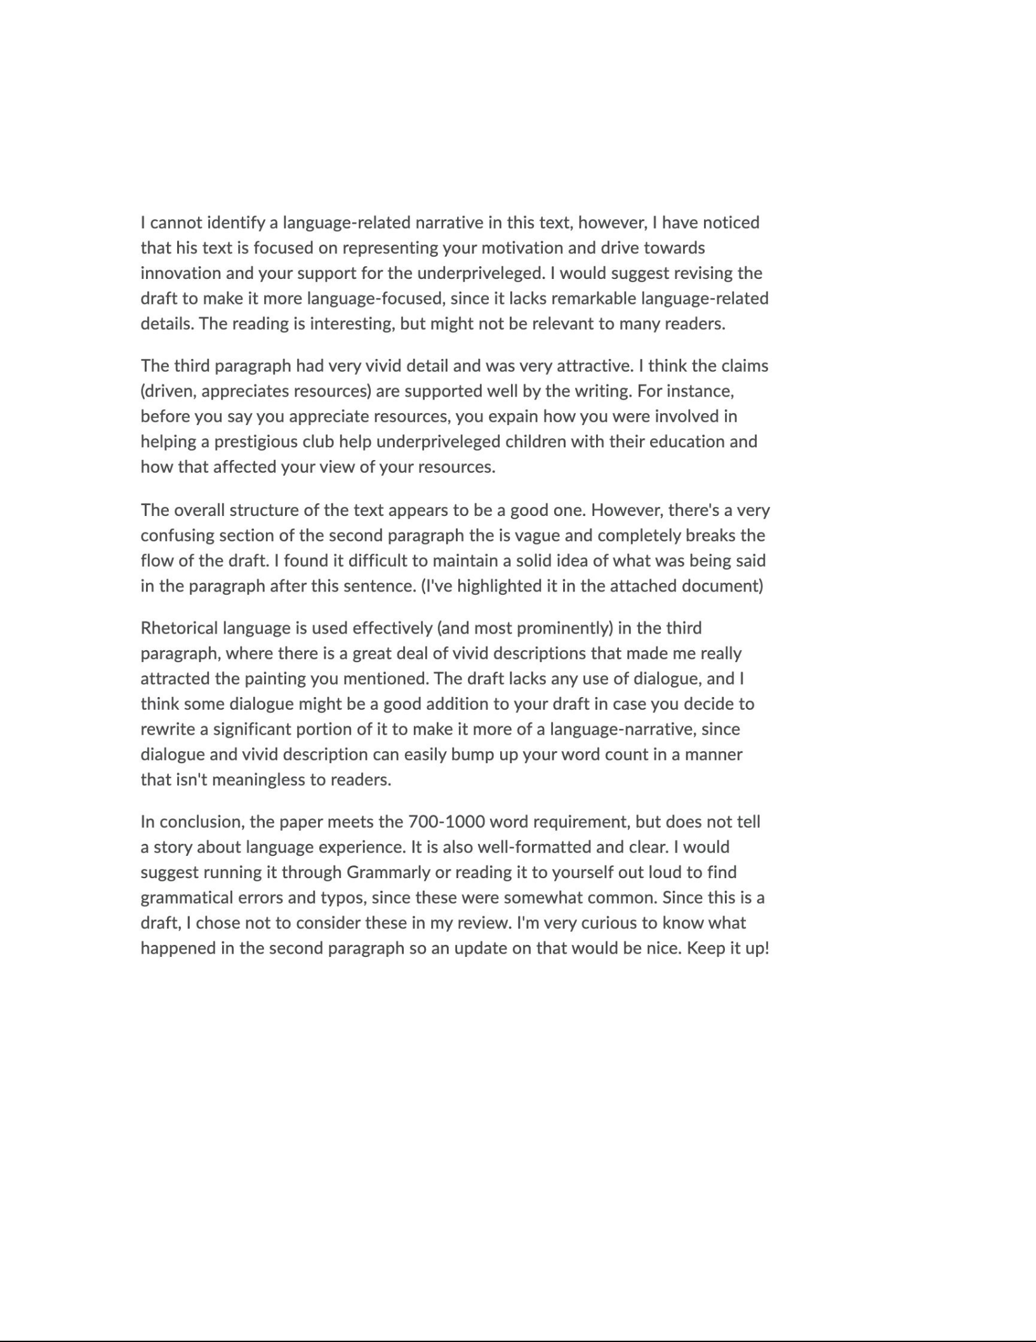

I restructured my initial draft to include dialogues and personal experiences to give a more clear and in-depth vision to the reader. Relating to someone’s feedback and communicating it back was a really immersive experience that I was glad to be a part of. I also tried to include some language experience according to his feedback while trying to accommodate the given word limit.

While personal writings such as Project 1, the language narrative, do not require sources or

quotations (maybe some dialogues), writing about different things, for example, Project 3 or the news article, requires extensive use of different kinds of sources(after all who is going the read your news article if it only contains your limited/biased perspective). While finding many reliable quotations might not be a problem, giving credit to those writings is a must and I honestly felt quite confused while working on individual MLA/APA citations because on my first look it made no sense and to my untrained eye, I felt normal citations would work out just fine. I especially felt this sentiment while working on project two. However, when I started to work on project three, I realized that when working with multiple citations, the proper organization that is brought by MLA/APA citations allowed me to recollect my ideas and regain my train of thought instantly, something which would have been lost in my mind, had I used normal translations. Plus the academic credibility and ease of recollecting sources from the user’s point of view amplified the efforts.

Another problem I had while writing projects 2 and 3 was limiting expressing myself to the word count. Project 2 or the Genre Analysis and Profile report are articles that require a lot of sources so the readers can depend on the article itself. This meant that referring to those articles became a major part of the article itself. My writing process consisted of writing freely for initial drafts, rereading and restructuring the drafts by removing extraneous or irrelevant information, hence trimming it down to the needed word limit. However, in this process of aimless free writing and consequent and aggressive trimming, the quality of my ideas that cut was sub-par. From this experience, I learned that wilful and powerful writing is something I should practice- every word written should be purposeful, have meaning and intention behind it. Practicing this in all my projects in this class I have tried to overcome my aimless writing impulses so that everything I write is purposeful and deliberate. I often used to include the less significant part of lines while removing the more descriptive lines and I should account for taking those decisions on a whim.

Now I have started to write in a controlled fashion, actively consulting the proposed idea which I thought of initially and trying to create a structure of paragraphs that give a descriptive vision to the paragraph. I still have not perfected this skill and only time would tell how experienced I would be later.

In conclusion, I feel that the writing experience that I learned in ENGL 107 contributes to my skill as a writer while helping me gain those analysis skills that help contribute descriptive feedback to my colleagues.

