Report
Of
Airline Ticket Price Prediction

Submitted
To
School of Computer Science and Engineering
IILM University, Greater Noida, U.P.

In partial fulfilment of the requirement of degree of
B.Tech CSE


By
Roll Number of Student: CS-2341537
Name of Student: Rishav Rai
Batch: 2023–27

2026-27

CANDIDATE’S DECLARATION
I, Rishav Rai, do hereby declare that the internship report titled “Airline Ticket Price Prediction” has been completed by me to fulfil the requirement for the award of the degree of Bachelor of Technology in CSE. All the references have been quoted and I have not taken as such any material from any other source. I affirm to you that this report is my own and has not been submitted to any other institute for any degree/diploma requirement and further I shall be solely responsible for any kind of copyright violation in this regard.
Signature
Student Name: Rishav Rai
Roll No.: CS-2341537

ACKNOWLEDGEMENT
I am using this opportunity to express my gratitude to everyone who supported me throughout this internship. I am especially thankful to Naviotech Solution Pvt. Ltd. and its Academic Team for giving me the opportunity to work on this project and for the clear guidelines they provided for its completion and submission.
I would also like to thank my faculty at IILM University, Greater Noida, for their support and direction while I was preparing this report.
I express my gratitude to my parents for their blessings.
Signature
Student Name: Rishav Rai
Roll No.: CS-2341537
INTERNSHIP COMPLETION CERTIFICATE

TABLE OF CONTENTS
Chapter No. | Chapter Name | Page Nos.
 | Cover Page | ----
1. | Candidate’s Declaration | i
2. | Acknowledgement | ii
3. | Internship Completion Certificate | iii
4. | Project Description  4.1 Introduction  4.2 Organization Profile  4.3 Problem Statement  4.4 Project Objectives  4.5 Scope of the Project  4.6 Technologies and Tools Used  4.7 System Architecture  4.8 Methodology  4.9 Expected Outcomes  4.10 Certificates of Completion and Other Communication Mail Proof | 1  1  2  2  3  3  4  5  8  10
5. | Bibliography/References | 11

4. PROJECT DESCRIPTION
4.1 Introduction
Industry-based training is a core part of the curriculum at IILM University, giving students a chance to apply classroom concepts to a real, evaluated project rather than a simulated one. As part of this requirement, I completed an internship project with Naviotech Solution Pvt. Ltd., an education-technology company that offers certified internships to students. The company assigned me the project “Airline Ticket Price Prediction using Machine Learning”, a project in the regression category, which I designed, built and documented as a complete system.
This report documents that project — the organization I worked with, the problem the project addressed, how it was designed and built, the results it produced, and what I learned from it. As required by the company, the finished work is submitted as a project report, a PowerPoint presentation of at least ten slides, and a GitHub repository containing documentation, a README file and all necessary code and files.
Table 4.1: Internship Particulars
Organization | Naviotech Solution Pvt. Ltd.
Position | Intern (project-based internship)
Project Title | Airline Ticket Price Prediction using Machine Learning
Project Category | Regression (Machine Learning)
Submitted By | Rishav Rai, B.Tech CSE, IILM University (Roll No. CS-2341537)
Deliverables | Project report, PowerPoint presentation (minimum 10 slides), GitHub repository with README
Evaluation | Academic Team, Naviotech Solution Pvt. Ltd.
Outcome | Internship Completion Certificate, issued on successful evaluation
Project Repository | github.com/Rishavv75/Airline-Ticket-Prediction
4.2 Organization Profile
Naviotech Solution Pvt. Ltd. is an education-technology company that provides certified internships, skill-based training programs and career-oriented mentorship to students and young professionals across India. Its programs cover domains such as Data Science, Artificial Intelligence, Cyber Security and Web Development, with an emphasis on practical training and real-time project exposure. Interns are assigned a project in one of these domains. After completing it, the intern submits the project by email, uploads it to GitHub, and shares the repository link. The company’s Academic Team then reviews the work, and an Internship Completion Certificate is issued after a successful evaluation.
Table 4.2: Organization Profile at a Glance
Company Name | Naviotech Solution Pvt. Ltd.
Business Activity | Internship training, skill development and mentorship programs (EdTech)
Program Domains | Data Science, Artificial Intelligence, Cyber Security, Web Development and others
Website | www.naviotechsolution.com
Contact | info@naviotechsolution.com (project submission), support@naviotechsolution.com (queries)
Project Review | Academic Team, headed by the Academic Head
4.3 Problem Statement
Airline ticket prices are not fixed. The fare for the same seat changes with the airline, the route, the number of stops, the date of travel, the time of day and the class of service. A traveller looking at a quoted fare therefore has no easy way to judge whether it is reasonable, and planning a trip around price becomes guesswork.
The problem I worked on was to learn these patterns from historical flight data and use them to estimate the price of a new flight from details such as airline, source, destination, route, journey date, departure and arrival time, duration, number of stops and additional information. I aimed for more than a notebook experiment: the solution had to include a reproducible machine learning pipeline, a prediction service, and an interactive user interface that anyone could use without touching the code.
4.4 Project Objectives
- To build an end-to-end airline ticket price prediction system.
- To clean the raw flight data and engineer useful features from dates, times and durations.
- To train and compare multiple regression models on the same data.
- To evaluate the models using MAE, RMSE and R², together with cross-validation.
- To analyse feature importance and prediction errors.
- To package the final model and serve it through a FastAPI backend with a React frontend.
4.5 Scope of the Project
Within the internship, the scope of my work covered the complete pipeline: understanding and cleaning the dataset, engineering features, training and comparing Random Forest and XGBoost regressors, evaluating them, packaging the final model, and building the FastAPI backend and React frontend around it. I also prepared the documentation, the README file, the presentation and this report.
The system is trained on a historical dataset of Indian domestic flights covering 12 airline categories, five source cities and six destination labels, and it returns a single estimated fare in Indian Rupees (INR). It is an estimation tool for learning and demonstration. It is not connected to live airline inventory, it does not perform bookings, and its accuracy is limited to the range of flights present in the training data.
4.6 Technologies and Tools Used
The project was built with a Python-based machine learning stack, a FastAPI service for inference and a React application for the interface. Table 4.3 lists the main tools and technologies I used, with the versions pinned in the project’s requirements.txt and package.json files.
Table 4.3: Technologies and Tools Used
Programming Languages | Python, JavaScript (React)
Machine Learning | scikit-learn 1.9.1, XGBoost 3.4.1
Data Handling | pandas 3.0.6, NumPy 2.5.3, openpyxl 3.1.5
Visualisation and Notebook | Matplotlib, Seaborn, JupyterLab
Backend | FastAPI 0.141.1, Uvicorn 0.53.0, Pydantic 2.13.5
Frontend | React 19, Vite, Tailwind CSS
Model Storage | Joblib, Git LFS
Data Access | kagglehub (dataset download)
Version Control | Git and GitHub
4.7 System Architecture
The application is organized into three layers, shown in Figure 4.1. The React frontend collects flight details and sends them to the FastAPI backend as JSON. The backend converts the request into the same raw format as the training data, applies the same feature engineering functions, and passes the result to the saved machine learning pipeline. The predicted price is returned to the frontend and displayed to the user.
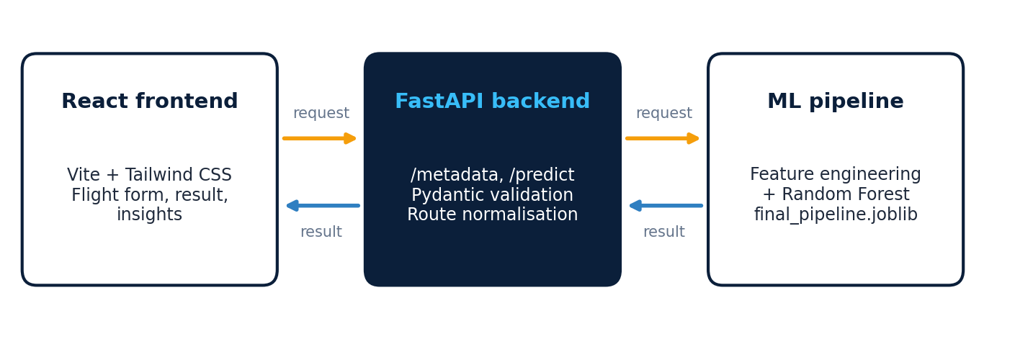
Figure 4.1: System Architecture of the Airline Ticket Price Prediction Application
The backend is implemented in backend/main.py, with request and response models in backend/schemas.py and the model loading and prediction logic in backend/services/predictor.py. The trained pipeline is loaded once when the server starts, and prediction reuses the same feature engineering function used in training, which avoids any mismatch between training and serving. The API exposes four endpoints, listed in Table 4.4, and FastAPI generates interactive documentation for them automatically (Figure 4.2).
Table 4.4: API Endpoints
Method | Endpoint | Description
GET | / | Root message showing that the API is running
GET | /health | Health check returning the service status
GET | /metadata | Valid airlines, cities, stop options and additional-information values for the form
POST | /predict | Accepts flight details and returns the predicted price

The /predict endpoint takes ten required text fields (airline, date of journey, source, destination, route, departure time, arrival time, duration, total stops and additional information), validated with Pydantic. The response contains the predicted price, the currency (INR), the model name and the model version. The route is normalised so that a typed “BLR->DEL” matches the “BLR → DEL” format used in training, and cross-origin access is enabled for the local frontend.
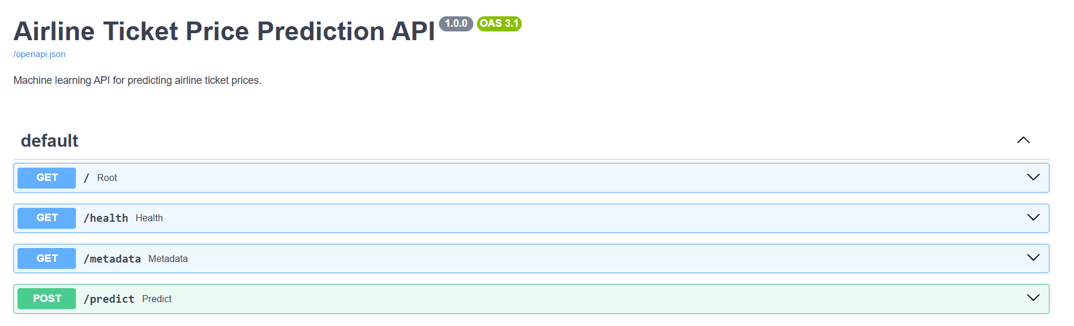
Figure 4.2: Interactive API Documentation Generated by FastAPI (Swagger UI)
The frontend is a React 19 application built with Vite and styled with Tailwind CSS. When it starts, it calls the /metadata endpoint to fill the dropdown lists, so a user can only choose values the model knows. It is organized into components for the flight form, the prediction result, model insights, a model comparison table and a short “how it works” section. Figure 4.3 shows a sample prediction: for an Air India non-stop flight from Bangalore to Delhi lasting 4h 00m, the application estimates a fare of ₹6,227 using the Random Forest model.
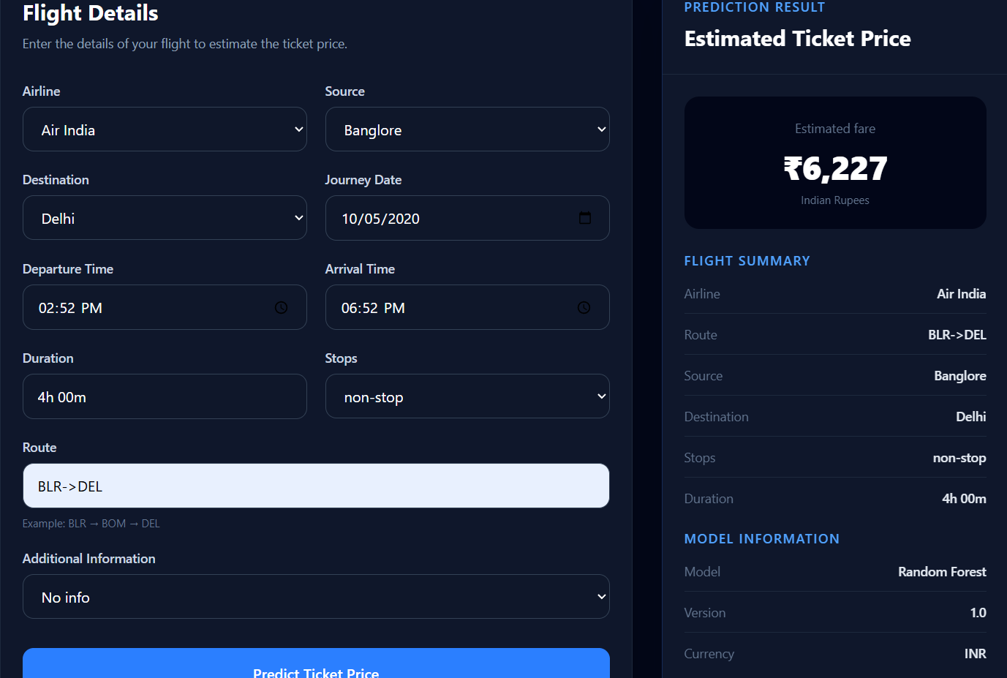
Figure 4.3: Flight Details Form and Prediction Result in the Web Application
4.8 Methodology
- Understanding the dataset — its columns, data types, missing values, duplicates and price distribution.
- Cleaning the data — handling missing values and converting text dates, times and durations into usable formats.
- Engineering features — extracting day, month, weekday, hour and minute values, duration in minutes, and four derived features.
- Preprocessing — one-hot encoding the categorical columns inside a scikit-learn pipeline.
- Training Random Forest and XGBoost regressors on an 80% training split.
- Evaluating both models on the held-out 20% test set with MAE, RMSE and R², and analysing feature importance and errors.
- Packaging the final pipeline with Joblib and serving it through the FastAPI backend and React frontend.

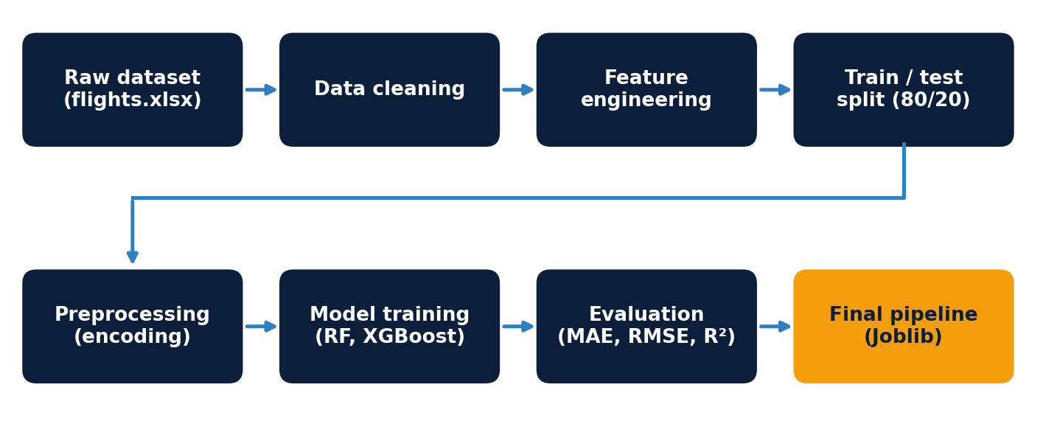
Figure 4.4: Machine Learning Pipeline of the Project
Dataset. I used the public Kaggle dataset “plane-ticket-price”, downloaded with the kagglehub library and stored as flights.xlsx. It contains 10,683 flight records with 11 columns: Airline, Date_of_Journey, Source, Destination, Route, Dep_Time, Arrival_Time, Duration, Total_Stops, Additional_Info and the target column Price (in INR). Prices range from ₹1,759 to ₹79,512, with a median of ₹8,372 and a mean of ₹9,087, which shows a right-skewed distribution with a few very expensive tickets. Jet Airways is the largest carrier (3,849 records), followed by IndiGo (2,053) and Air India (1,752), and one-stop flights are the most common (5,625 records).
Data cleaning. Exploration showed one record with no Route and no Total_Stops value, 220 exact duplicate rows, and inconsistent labels such as “No info” and “No Info”. The row with missing values was removed, since route information is critical to price, and missing Additional_Info values are filled with “Unknown”. The journey date was parsed day-first, arrival times were parsed with a pattern that also handles values like “09:25 07 May”, duration strings such as “2h 50m” were converted to minutes, and Total_Stops was converted to an ordinal number from 0 to 4.
Feature engineering and preprocessing. The models use 13 numerical features and 5 categorical features (Table 4.5). Four of the numerical features are derived: departure and arrival time expressed in minutes since midnight, a weekend indicator, and a night-flight indicator. A ColumnTransformer one-hot encodes the categorical columns, ignoring unknown categories at prediction time, and passes the numerical features through unchanged. Tree-based models do not need feature scaling, so no scaler is used.
Table 4.5: Features Used by the Models
Categorical (5) | Airline, Source, Destination, Route, Additional_Info
Date features (3) | Journey_Day, Journey_Month, Journey_Weekday
Time features (4) | Departure_Hour, Departure_Minute, Arrival_Hour, Arrival_Minute
Flight features (2) | Total_Stops, Duration_Minutes
Derived features (4) | Departure_Time_Minutes, Arrival_Time_Minutes, Is_Weekend, Is_Night_Flight

Model training. The cleaned data was split 80% for training and 20% for testing with a fixed random seed (42), so every model is evaluated on the same unseen records. I trained two tree-based ensemble models. Random Forest averages many independent decision trees to reduce variance, while XGBoost builds trees one after another, each correcting the errors of the earlier ones. Their main settings are given in Table 4.6. The final Random Forest was packaged as a single scikit-learn Pipeline (preprocessing plus a 300-tree model) and saved with Joblib; because the file is about 125 MB, it is stored in the repository through Git LFS.
Table 4.6: Model Configurations
Setting | Random Forest (baseline) | XGBoost
Number of trees | 200 | 500
Learning rate | not applicable | 0.05
Maximum depth | default (unlimited) | 6
Row / column sampling | bootstrap (default) | 0.8 / 0.8
Objective | squared error | reg:squarederror
Random seed | 42 | 42

Evaluation. Model quality is measured with Mean Absolute Error (MAE), the average error in rupees; Root Mean Squared Error (RMSE), which penalises large errors more strongly; and R², the share of price variation explained by the model. The project also includes a 5-fold cross-validation script, a feature-importance script, and scripts that list the largest prediction errors and evaluate errors by price range.
4.9 Expected Outcomes
The project was expected to deliver a working system that could estimate ticket prices with useful accuracy and let a user try it through a simple interface, rather than a set of disconnected experiments. The comparison of the two models on the test set is given in Table 4.7 and Figure 4.5.
Table 4.7: Test-Set Performance of the Two Models
Model | MAE (₹) | RMSE (₹) | R²
Random Forest | 569.76 | 1,451.92 | 0.9022
XGBoost | 746.99 | 1,289.40 | 0.9229

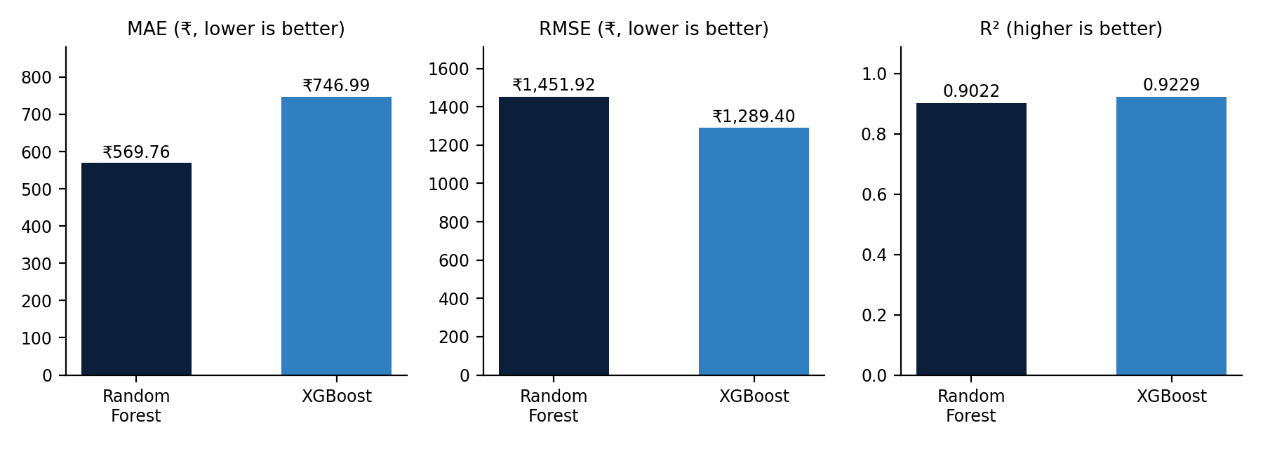
Figure 4.5: Comparison of Random Forest and XGBoost
Both models explain more than 90% of the variation in ticket prices. Random Forest achieved the lower MAE, about ₹177 less than XGBoost, so its typical prediction is closer to the true fare. XGBoost achieved the lower RMSE and the higher R², which suggests it makes fewer very large errors on expensive tickets. Relative to the average ticket price of ₹9,087, the Random Forest MAE is roughly 6.3%. The Random Forest pipeline was selected as the final model and is the one served by the application.
The model insights panel of the application reports the most influential features of the deployed model (Figure 4.6): the premium Jet Airways Business category and the number of stops carry the largest importance, followed by flight duration, the Jet Airways carrier and the absence of an in-flight meal. This matches intuition, since premium cabins and extra stops change the fare.
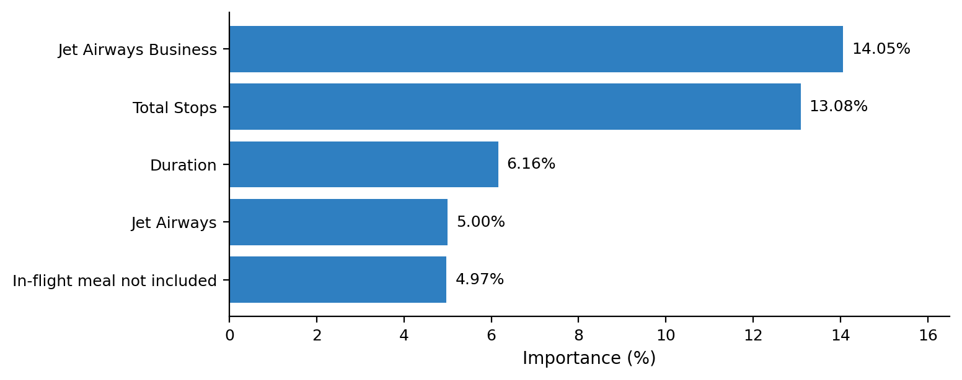
Figure 4.6: Most Important Features Reported by the Model
By the end of the internship, the complete system was working: the cleaned data feeds a trained pipeline, the pipeline is served through a validated API, and the React interface returns an estimated fare for any valid combination of inputs. Just as importantly, I came away with a working understanding of how a machine learning project is built end to end, including keeping preprocessing identical between training and serving, comparing models with more than one metric, and documenting a project so that others can run it.
The work has limitations. The dataset covers a limited period and a small set of Indian domestic routes, rare categories such as Trujet have very few records, 220 duplicate rows were kept, and the model uses no information about booking lead time or seat availability. Future work could add more recent data, tune the hyperparameters, study the effect of duplicates, deploy the application online, and add automated tests.
4.10 Certificates of Completion and Other Communication Mail Proof
The project and its submission requirements were communicated to me by email from the Academic Head of Naviotech Solution Pvt. Ltd. The relevant part of that email, which describes the presentation requirement, the submission steps and the evaluation process, is reproduced below as communication proof. The Internship Completion Certificate will be issued by the company after a successful evaluation.
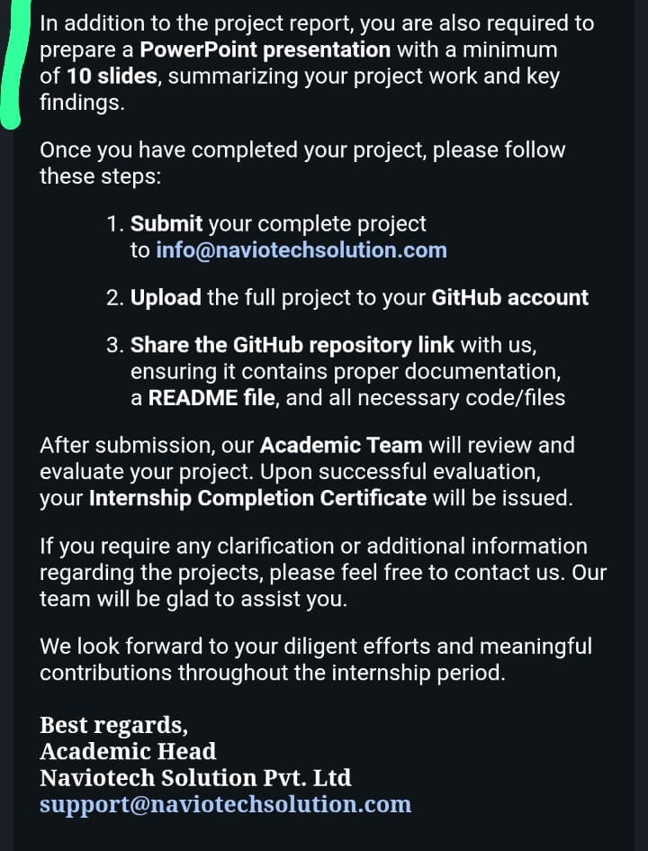
Figure 4.7: Email from Naviotech Solution Pvt. Ltd. Describing the Submission Requirements
5. BIBLIOGRAPHY/REFERENCES
[1] Python Software Foundation. Python 3 Documentation. Available at: https://docs.python.org
[2] Pedregosa, F. et al. (2011). Scikit-learn: Machine Learning in Python. Journal of Machine Learning Research, 12, 2825–2830.
[3] Breiman, L. (2001). Random Forests. Machine Learning, 45(1), 5–32.
[4] Chen, T. and Guestrin, C. (2016). XGBoost: A Scalable Tree Boosting System. Proceedings of the 22nd ACM SIGKDD International Conference on Knowledge Discovery and Data Mining, 785–794.
[5] FastAPI Documentation. Available at: https://fastapi.tiangolo.com
[6] React Documentation. Available at: https://react.dev
[7] Kaggle. Plane Ticket Price dataset (ibrahimelsayed182). Available at: https://www.kaggle.com/datasets/ibrahimelsayed182/plane-ticket-price
[8] Naviotech Solution Pvt. Ltd. Company website. Available at: https://www.naviotechsolution.com
[9] Rishav Rai. Airline-Ticket-Prediction (project source code). Available at: https://github.com/Rishavv75/Airline-Ticket-Prediction

