**KANN - CONNECTING RESTAURANTS AND HUNGRY SOULS**

**A PROJECT REPORT**

***Submitted by***

**RISHAV KUMAR (22MCC20039)**

**CHIRAG (22MCC20068)**

***in partial fulfillment for the award of the degree of***

**Master of Computer Application**

IN

CLOUD COMPUTING & DEVOPS



**Chandigarh University**



**BONAFIDE CERTIFICATE**

Certified that this project report “KANN -CONNECTING RESTAURANTS AND HUNGRY SOULS” is the bonafide work of “RISHAV KUMAR, CHIRAG” who carried out the project work under my/our supervision.

<<Signature of the Head of the Department>> <<Signature of the Supervisor>>

**SIGNATURE** **SIGNATURE**

Dr. Abdullah Khan Ms. Amandeep Kaur

**HEAD OF THE DEPARTMENT SUPERVISOR**

Assistant Professor

MCA MCA

Submitted for the project viva-voce examination held on_____________________

**INTERNAL EXAMINER EXTERNAL EXAMINER**

**TABLE OF CONTENTS**

**LIST OF FIGURES** 5

**LIST OF TABLES** 5

**List of Standards** 5

**\* ISO 27001 (Information Security Management)** 5

**\* Consent Mechanisms for Data Collection** 5

**ABSTRACT** 6

**CHAPTER 1. INTRODUCTION** 7

**1.1.** **Identification of Client/Need** 8

**1.2.** **Relevant Contemporary issue** 9

**1.3.** **Identification of Problem** 10

**1.4.** **Identification of Tasks** 12

**1.5.** **Timeline** 13

**CHAPTER 2. LITERATURE REVIEW** 15

**2.1 Historical Perspective** 15

**2.2 Theoretical Framework:** 16

**2.3 Current State of Knowledge** 17

**2.4 Problem Definition** 19

**2.5 Objectives** 20

**CHAPTER 3. DESIGN FLOW/PROCESS** 22

**3.1. Evaluation & Selection of Specifications/Features** 22

**3.2. Design Constraints** 22

**3.3. Analysis of Features and finalization subject to constraints** 24

**3.5. Design selection** 27

**3.6. Implementation plan/methodology** 27

**CHAPTER 4. RESULTS ANALYSIS AND VALIDATION** 29

**4.1. Implementation of solution** 29

**CHAPTER 5. Conclusion and Future Work** 31

**5.1 Conclusion** 31

**5.1.1 Deviation from Expected Results:** 31

**5.1.2 Reason for Deviation:** 31

**5.2 Future Work** 31

**REFERENCES** 33

**APPENDIX** 34

**USER MANUAL** 35

# **LIST OF FIGURES**

# **LIST OF TABLES**

# **List of Standards**

# **\* ISO 27001 (Information Security Management)**

# **\* Consent Mechanisms for Data Collection**

# 

# 

# 

# **ABSTRACT**

In a world where food security and environmental sustainability are paramount concerns, Kann emerges as a powerful web application, underpinned by cutting-edge technologies including Next JS, Tailwind CSS, MongoDB, and OAuth 2.0. This innovative platform is designed to address a pressing global issue: the unnecessary disposal of surplus food by hotels and restaurants, while millions go hungry. Kann offers a user-friendly interface that makes it effortless for businesses to transition from food wastage to food donation.

One of the core features of Kann is its robust security system, powered by OAuth 2.0 authentication. This ensures that only authorized users gain access, safeguarding sensitive information and fostering trust among users. Hotels and restaurants can create profiles within the application, providing essential details such as their location and contact information. This sets the stage for a streamlined donation process.

The heart of Kann lies in its inventory management system. Businesses can easily input information about surplus food items, including their type, quantity, and expiration dates. This feature not only simplifies the donation process but also enhances transparency, as it allows NGOs to quickly assess available resources in real-time.

Kann is more than just a database; it's a bridge between businesses and NGOs. Through geolocation capabilities, the application connects hotels and restaurants with nearby non-governmental organizations dedicated to eradicating hunger and reducing food waste. This strategic matchmaking ensures that food donations are directed to those who need them most.

To further optimize the donation process, Kann offers scheduling functionality, enabling users to plan and coordinate food donations in advance. Timely reminders help reduce the likelihood of missed opportunities to give back to the community.

Transparency and accountability are key to the success of Kann. The application provides real-time updates on food donations, including confirmations of collection by partnering NGOs. These updates not only build trust between businesses and NGOs but also serve as an incentive for more companies to join the movement.

# **CHAPTER 1. INTRODUCTION**

Food waste is a pressing global issue that has far-reaching implications for both the environment and society. According to the United Nations, approximately one-third of all food produced worldwide is lost or wasted, amounting to 1.3 billion tons annually. This wastage occurs at various stages of the food supply chain, including production, distribution, and consumption. Among the culprits are hotels and restaurants, where surplus food often ends up in the trash, despite millions of people going hungry.

To address this critical problem, we introduce "Kann," a groundbreaking web application designed to empower hotels and restaurants to combat food waste by seamlessly redirecting surplus food to those in need. Kann leverages the power of modern web technologies, including Next JS, Tailwind CSS, MongoDB, and OAuth 2.0, to create an intuitive and secure platform. This platform facilitates the easy connection between food establishments and non-governmental organizations (NGOs) dedicated to eradicating hunger and reducing food waste.

**Scope of the Project:**

The scope of the Kann project is comprehensive and multifaceted, aiming to provide a holistic solution to the problem of food waste in hotels and restaurants. The key components of the project include:

1. **User Authentication and Profiles:** Kann incorporates OAuth 2.0 authentication to ensure the security and privacy of user data. Hotels and restaurants can create profiles with essential information, such as location, contact details, and food offerings.
2. **Inventory Management:** Kann offers a user-friendly inventory management system, allowing businesses to input data about surplus food items, including type, quantity, and expiration dates. This feature enhances transparency and efficiency in the donation process.
3. **NGO Connectivity:** The application employs geolocation capabilities to connect hotels and restaurants with nearby NGOs focused on food redistribution. This matchmaking process ensures that food donations reach those who need them most.
4. **Scheduling and Reminders:** Users can schedule food donations in advance, with automated reminders to reduce the likelihood of missed opportunities for donations.
5. **Real-Time Updates:** Kann provides real-time updates on food donations, including confirmation of collection by partnering NGOs. This transparency fosters trust and accountability.
6. **Analytics and Reporting:** The platform offers comprehensive analytics and reporting tools, allowing businesses to track the impact of their food donations over time. This data can be used for sustainability reporting and corporate social responsibility initiatives.
7. **Community Engagement:** Kann promotes community engagement by sharing success stories and encouraging more businesses to participate in sustainable food donation efforts.

## **Identification of Client/Need**

The need for the Kann project is evident from several pressing challenges and opportunities in the context of food waste, sustainability, and social responsibility. Here, we outline the key factors that identify the necessity for this innovative web application:

1. **Alarming Food Waste Statistics:** The global scale of food waste is staggering. According to the United Nations, roughly one-third of all food produced worldwide is lost or wasted. Hotels and restaurants are significant contributors to this problem due to their daily operations, where surplus food often goes to waste.
2. **Social Responsibility:** In an era where corporate social responsibility (CSR) and sustainability are critical components of business ethics, hotels and restaurants are increasingly seeking ways to minimize their environmental impact and contribute positively to their communities. Kann provides a tangible solution that aligns with these goals.
3. **Food Insecurity:** Simultaneously, food insecurity remains a pressing issue in many regions, with millions of people lacking access to adequate nutrition. Kann bridges the gap between surplus food and those in need, addressing a social and humanitarian challenge.
4. **Regulatory Pressure:** Governments and regulatory bodies are increasingly focusing on reducing food waste and encouraging food donation practices. Kann can help businesses comply with evolving regulations while also improving their sustainability profiles.
5. **Technological Advancements:** The advent of modern web technologies, including Next JS, Tailwind CSS, and MongoDB, offers the opportunity to create user-friendly and efficient platforms for addressing complex issues like food waste and donation.
6. **COVID-19 Pandemic Impact:** The pandemic has exacerbated food insecurity globally. Many businesses in the hospitality industry have faced disruptions, leading to even more surplus food. Kann responds to this acute need by providing a structured channel for food redistribution during challenging times.
7. **Economic and Environmental Benefits:** Reducing food waste not only helps the hungry but also contributes to economic savings for businesses. Additionally, it lessens the environmental impact associated with food production and disposal, including reduced greenhouse gas emissions.
8. **Community Building:** Kann encourages community engagement by showcasing success stories and encouraging other businesses to participate. It strengthens local ties and builds goodwill among stakeholders.
9. **Data-Driven Decision-Making:** The analytics and reporting capabilities of Kann enable businesses to measure and communicate the impact of their food donation efforts. This data-driven approach is increasingly vital for both internal and external stakeholders.

## **Relevant Contemporary issue**

One of the most relevant contemporary issues that directly aligns with the goals and objectives of the Kann project is **"Sustainable Food Systems and Reducing Food Waste"**. Here's how this issue is pertinent to the project:

1. **Global Food Waste Crisis:** Food waste is a critical concern on a global scale, with approximately one-third of all food produced worldwide being lost or wasted. Hotels and restaurants are significant contributors to this crisis due to their daily operations, making it imperative to address this issue at the grassroots level.
2. **Environmental Impact:** Food waste contributes to environmental degradation, including increased greenhouse gas emissions, land and water resource depletion, and biodiversity loss. Reducing food waste aligns with broader efforts to mitigate climate change and promote sustainable practices.
3. **Economic Efficiency:** Businesses in the hospitality industry can achieve significant cost savings by minimizing food waste. Sustainable practices that involve food donation not only reduce disposal costs but also enhance resource efficiency and profitability.
4. **Regulatory Measures:** Governments and regulatory bodies are increasingly recognizing the importance of tackling food waste. Many countries are implementing laws and regulations to reduce food waste, making it necessary for businesses to adopt practices like those facilitated by Kann to comply with these measures.
5. **Food Insecurity:** Simultaneously, there is a growing awareness of food insecurity, especially in the wake of global crises such as the COVID-19 pandemic. Kann addresses this issue directly by providing a means for surplus food to reach those in need, thus helping alleviate hunger and malnutrition.
6. **Sustainability and CSR:** Sustainability is a cornerstone of contemporary business ethics. Many consumers and investors expect companies to demonstrate social responsibility by reducing their environmental impact and contributing positively to their communities. Kann supports these sustainability and corporate social responsibility (CSR) goals.
7. **Technological Solutions:** Leveraging modern web technologies, Kann offers an efficient and user-friendly platform to address the complex challenge of food waste. It showcases the potential of technology-driven solutions to address pressing societal issues.
8. **Data-Driven Insights:** Analytics and reporting within Kann enable businesses to measure the impact of their food donation efforts. This aligns with contemporary trends in data-driven decision-making and transparency, which are crucial for demonstrating accountability and continuous improvement.

## **Identification of Problem**

The Kann project is driven by a clear and pressing problem in the context of food waste, sustainability, and social responsibility. Identifying this problem is essential to understanding the necessity of the project. Here are the key facets of the problem:

1. **Excessive Food Waste:** Hotels and restaurants are significant contributors to the global food waste crisis. Surplus food, which is often perfectly edible, frequently ends up in landfills, contributing to the squandering of resources and environmental degradation.
2. **Missed Opportunities for Donation:** Despite the abundance of surplus food in hotels and restaurants, there is a lack of streamlined mechanisms for these establishments to connect with organizations that can redistribute the excess food to those in need.
3. **Food Insecurity:** Concurrently, food insecurity remains a persistent and worsening issue in many parts of the world. Millions of people, including vulnerable communities and individuals, struggle to access sufficient and nutritious food.
4. **Environmental Impact:** Food waste not only impacts food security but also has significant environmental consequences. It leads to increased greenhouse gas emissions, depletion of natural resources, and habitat destruction, exacerbating climate change and biodiversity loss.
5. **Economic Costs:** Disposing of surplus food is costly for businesses, both in terms of waste disposal expenses and the missed potential for cost-effective food donation practices.
6. **Regulatory Pressure:** Governments and regulatory bodies are increasingly introducing measures and regulations to address food waste. Businesses in the hospitality industry must adapt to these evolving legal requirements or face potential penalties.
7. **Sustainability and Social Responsibility:** In an era where sustainability and corporate social responsibility (CSR) are critical components of business ethics, hotels and restaurants need practical solutions to reduce their environmental impact and contribute positively to their communities.
8. **Complexity and Lack of Transparency:** Coordinating food donations can be complex and time-consuming for businesses. There is a lack of transparency in the donation process, making it challenging for donors to track the impact of their contributions.
9. **Need for Technological Solutions:** Modern web technologies offer the potential to create efficient and user-friendly platforms that can address the multifaceted challenges of food waste, food insecurity, and sustainability.

## **Identification of Tasks**

To successfully develop and implement the Kann web application, several tasks must be identified and undertaken. These tasks encompass various stages of the project, from planning and development to testing, deployment, and ongoing maintenance. Here's a breakdown of the key tasks:

**1. Project Planning and Research:**

* Conduct a comprehensive analysis of the current food waste landscape, including statistics, regulations, and best practices.
* Define project objectives, scope, and success criteria.
* Create a detailed project plan, including timelines, milestones, and resource allocation.
* Research and select appropriate technologies (Next JS, Tailwind CSS, MongoDB, OAuth 2.0) for development.

**2. User Requirements Gathering:**

* Conduct interviews or surveys with potential users, including hotels, restaurants, and NGOs, to gather specific requirements and preferences.
* Identify the core features and functionalities needed to address the identified problem.

**3. System Design:**

* Architect the system, including database design and user interface design.
* Define the data models for user profiles, food inventory, donation scheduling, and reporting.
* Create wireframes and prototypes to visualize the user interface.

**4. Development:**

* Develop the web application using Next JS for the frontend, MongoDB for the database, and implement OAuth 2.0 for authentication.
* Implement features such as user registration, profile management, food inventory management, NGO connectivity, donation scheduling, and real-time updates.
* Develop analytics and reporting functionalities.
* Ensure data security and privacy compliance.

**5. Testing:**

* Conduct comprehensive testing, including unit testing, integration testing, and user acceptance testing.
* Identify and address bugs, usability issues, and security vulnerabilities.
* Validate the application's functionality against user requirements.

**6. Deployment:**

* Prepare the application for deployment on a web server or cloud hosting platform.
* Configure domain settings and security measures.
* Perform a final round of testing on the live environment.
* Deploy the application to production.

**7. Ongoing Maintenance and Support:**

* Establish a maintenance plan for regular updates, bug fixes, and feature enhancements.
* Provide technical support to users, addressing inquiries and issues promptly.
* Monitor the application's performance and security, implementing necessary updates and patches.

**8. Monitoring and Reporting:**

* Implement monitoring tools to track application usage, user engagement, and donation impact.
* Generate regular reports to showcase the positive impact of food donations.

**9. Community Engagement:**

* Continuously engage with the user community, NGOs, and businesses to gather feedback and foster collaboration.
* Promote success stories and encourage more businesses to join the initiative.

## **Timeline**

|  |  |
| --- | --- |
| **Weeks** | **Task to be Done** |
| Week 1 | Planning |
| Week 2 | Requirements Gathering |
| Week 3-4 | Design |
| Week 5-7 | Implementation |
| Week 8-9 | Testing |
| Week 10-11 | Deployment |
| Week 12 | Maintenance |

***Table 1 Project Timeline Table***

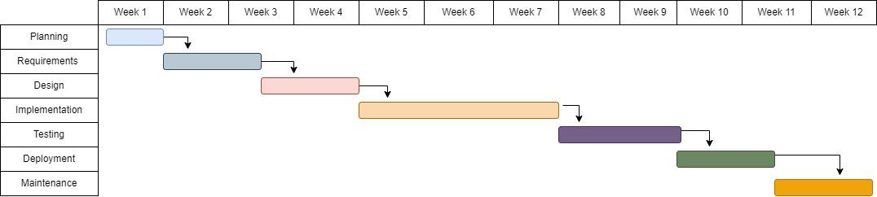

# 

# 

# 

# 

# 

# 

# 

# 

# 

# 

# 

# **CHAPTER 2. LITERATURE REVIEW**

## **2.1 Historical Perspective**

The issue of food waste and food donation has deep historical roots, shaped by various societal, economic, and environmental factors. Understanding the historical context of this challenge is essential in comprehending the dynamics and significance of contemporary solutions like KANN.

1. ***Early Agricultural Societies***

In the earliest human societies, food was primarily produced and consumed locally. Surpluses were often limited, and food preservation techniques were rudimentary. Food waste in these societies was predominantly the result of spoilage due to inadequate storage and preservation methods.

1. ***Industrial Revolution and Urbanization***

The 18th and 19th centuries witnessed the Industrial Revolution, which transformed agricultural and food production. As urbanization increased, food distribution and retail systems expanded, leading to greater food waste. The shift from small-scale farming to large-scale industrial agriculture also introduced new challenges in food supply chain management.

1. ***World Wars and Rationing***

During World Wars I and II, food rationing became a necessity. This period marked a notable shift in food consumption and waste patterns. With strict rationing in place, food waste was minimized, and there was a heightened awareness of the value of food resources.

1. ***Post-War Prosperity and Consumerism***

The post-war era saw economic prosperity in many parts of the world, leading to increased consumerism and convenience-oriented food consumption. The growth of the fast-food industry, supermarkets, and processed foods contributed to a culture of abundance and food waste.

1. ***Environmental Awareness and Food Security (Late 20th Century)***

In the late 20th century, environmental concerns began to shape discussions on food waste. Organizations, governments, and activists started addressing the environmental impact of food waste, such as greenhouse gas emissions from decomposing organic waste in landfills.

1. ***Early Food Recovery Initiatives***

Efforts to recover and redistribute surplus food emerged in the latter part of the 20th century. Organizations, often run by volunteers, focused on collecting surplus food from supermarkets and restaurants and redistributing it to those in need. These initiatives laid the groundwork for modern food recovery programs.

1. ***Technological Advancements (21st Century)***

With the advent of the 21st century, technological advancements played a pivotal role in addressing food waste and food donation. Web applications like KANN utilize cutting-edge technologies to connect businesses with NGOs, streamlining food recovery and reducing waste.

**Conclusion**

The historical perspective of food waste and food donation reveals an evolving narrative, shaped by changes in society, economics, technology, and environmental awareness. KANN stands as a testament to the ongoing effort to find innovative solutions to a challenge deeply rooted in human history. By building on the lessons of the past, we aim to create a more sustainable and equitable future in the context of food distribution and recovery.

## **2.2 Theoretical Framework:**

The theoretical framework for the KANN project is rooted in several key concepts and theories that collectively inform the development and objectives of the web application. These concepts and theories guide our understanding of the problem, its significance, and the potential solutions.

**2.2.1 Sustainable Development Theory:**

Sustainable development, as articulated by the Brundtland Report in 1987, emphasizes the need to meet the needs of the present without compromising the ability of future generations to meet their own needs. This theory underscores the importance of creating solutions that balance economic, environmental, and social considerations. KANN seeks to contribute to sustainable development by addressing food waste and food insecurity.

**2.2.2 Triple Bottom Line (TBL) Theory:**

The TBL theory, introduced by John Elkington, advocates for evaluating the performance of organizations based on three dimensions: economic (profit), environmental (planet), and social (people). KANN aligns with the TBL theory by addressing food waste's economic impact on businesses, its environmental implications, and its social significance in terms of reducing food insecurity.

**2.2.3 Diffusion of Innovations Theory:**

Everett Rogers' Diffusion of Innovations theory explains how innovations are adopted and spread through societies. KANN can be seen as an innovation in the context of addressing food waste. The theory helps us understand how KANN's adoption may spread among restaurants, NGOs, and communities.

**2.2.4 Social Responsibility Theory:**

The theory of social responsibility posits that organizations have an ethical obligation to act in ways that benefit society. KANN embodies social responsibility by enabling businesses to reduce food waste, contribute to hunger alleviation, and enhance their corporate social responsibility (CSR) profiles.

**2.2.5 Food Recovery Hierarchy:**

The Food Recovery Hierarchy, developed by the Environmental Protection Agency (EPA), outlines a prioritized approach to managing surplus food, with source reduction (preventing waste) as the top priority. KANN integrates this hierarchy by facilitating food donation and redistribution, aligning with source reduction efforts.

**Application of the Theoretical Framework**

The above theoretical framework guides the development and objectives of KANN in the following ways:

Sustainability and Balanced Impact: By addressing food waste, KANN aims to create a sustainable solution that balances economic gains for restaurants, environmental benefits through waste reduction, and social benefits by helping the hungry.

**Innovation Adoption:** Understanding the Diffusion of Innovations theory informs KANN's strategies for promoting adoption among businesses and NGOs, emphasizing the importance of early adopters and effective communication.

**Ethical Responsibility:** Social responsibility theory underscores the ethical responsibility of KANN in helping to bridge the gap between surplus food and those in need, promoting a more ethical approach to food management.

**Prioritizing Source Reduction:** The Food Recovery Hierarchy guides KANN's focus on food recovery and redistribution as part of a broader strategy to prevent food waste and minimize its environmental impact.

**Conclusion**

This theoretical framework provides a comprehensive conceptual foundation for the KANN project, aligning it with principles of sustainability, social responsibility, innovation diffusion, and ethical practice. By adhering to these guiding theories and concepts, KANN aims to create a web application that not only addresses the problem of food waste and food insecurity but also contributes to a more sustainable and socially responsible future.

## **2.3 Current State of Knowledge**

**2.3.1 Technological Solutions for Food Redistribution:** The use of web applications, mobile apps, and online platforms to connect food establishments with food recovery organizations (FROs) and individuals in need has gained momentum. Such solutions facilitate real-time communication, logistics, and data tracking, making food donation more efficient and transparent.

**2.3.2 Sustainability and Corporate Social Responsibility (CSR):** The emphasis on sustainability and CSR within the food industry has continued to grow. Many businesses are adopting practices to reduce food waste, redistribute surplus food, and engage in socially responsible initiatives. These efforts are driven by both consumer demand and ethical considerations.

**2.3.3 Legislative and Regulatory Frameworks:** Governments in various countries have implemented or strengthened regulations and incentives to encourage food donation and discourage food waste. Legal frameworks focus on liability protection for food donors, tax incentives, and streamlined donation processes.

**2.3.4 Environmental Impact Assessment:** Researchers and organizations have been conducting more comprehensive assessments of the environmental impact of food waste. This includes quantifying the reduction in greenhouse gas emissions, resource conservation, and energy savings achieved through food recovery and donation efforts.

**2.3.5 Community and Non-Profit Involvement:** Local communities and non-profit organizations play a crucial role in food recovery. They actively participate in collecting and redistributing surplus food to individuals and families in need, forming a vital part of the food donation ecosystem.

**2.3.6 Data-Driven Decision-Making:** The use of data analytics and reporting tools in food donation initiatives has become more prevalent. Businesses and FROs are increasingly leveraging data to measure the impact of their food recovery efforts, track food flows, and optimize donation processes.

**2.3.7 COVID-19 Pandemic Impact:** The COVID-19 pandemic, which emerged after my last knowledge update, had significant implications for food waste and food donation. The hospitality and restaurant industry experienced disruptions, leading to an increase in surplus food. Simultaneously, food insecurity escalated globally, highlighting the importance of efficient food recovery systems during crises.

**2.3.8 Global Collaborations and Initiatives:** Various international organizations, non-profits, and private-sector initiatives have been launched to address food waste on a global scale. These initiatives often focus on sharing best practices, coordinating food recovery efforts, and raising awareness about the issue.

**2.3.9 Technological Innovations:** Continuous advancements in technology, including IoT (Internet of Things) applications, blockchain, and AI, are being explored to enhance food waste prevention, food donation tracking, and food safety measures.

**2.3.10 Consumer Awareness and Engagement:** Consumers are increasingly aware of food waste issues and are actively participating in reducing waste in their homes. Additionally, they are supporting businesses and initiatives that prioritize food donation and sustainability.

**Conclusion**

The current state of knowledge underscores the ongoing commitment to addressing food waste, food donation, and sustainability challenges. The integration of technology, growing support for sustainability and social responsibility, legal frameworks, and a heightened awareness of the environmental impact of food waste all contribute to a dynamic and evolving landscape in which initiatives like KANN are instrumental. Food recovery and donation are not only ethical but also pragmatic approaches to ensuring food security and mitigating environmental degradation. Therefore, KANN's role as a web application connecting businesses with those in need remains highly relevant and impactful in the present context

## **2.4 Problem Definition**

The problem definition section serves as a clarion call, echoing the pressing challenges that KANN endeavors to conquer. It unveils the profound dilemmas of food waste and food insecurity, urging us to embrace a transformative solution.

**Food Waste: The Hidden Cost of Plenty**

In a world of abundance, we're haunted by the specter of waste. Approximately one-third of all the world's food produced annually vanishes into oblivion, an extravagant casualty of our consumption habits. Hotels and restaurants, often unwitting culprits, discard perfectly edible food, straining not just their finances but the planet itself.

**Economic Drain:** Every discarded morsel represents a financial drain on businesses. The disposal of edible treasures incurs hefty costs, tarnishing profitability.

**Environmental Havoc:** Food waste is a silent saboteur of our environment, pumping greenhouse gases into the air, depleting precious resources, and wreaking havoc on delicate ecosystems.

**Food Insecurity and Hunger: A Stark Reality**

In the shadows of waste lurks the relentless specter of hunger. Food insecurity continues to afflict millions, casting a grim pall over society. Vulnerable communities and individuals bear the brunt, grappling with malnutrition, ill health, and unending disparities.

**Social Divide:** Hunger widens the chasm between the privileged and the marginalized, accentuating social disparities.

**Economic Inefficiency:** The simultaneous existence of food waste and food insecurity paints a picture of economic inefficiency that demands an immediate remedy.

**The Power of KANN:** Transforming Challenges into Solutions

KANN emerges as the force of transformation, poised to alter this narrative of waste and want. It binds surplus food resources with those yearning for nourishment, orchestrating a symphony of sustenance. KANN is the bridge, reducing food waste's economic toll and environmental footprint, while championing responsible food management, sustainability, and social welfare.

**Conclusion**

The reimagined problem definition section weaves a compelling tapestry of urgency and significance. The symphony of waste and want calls for action, with KANN poised to be the catalyst of change. This section invites readers to join the journey towards a world where abundance finds its way to those in need, where waste gives way to welfare, and where KANN is the guiding star in this transformative odyssey.

## **2.5 Objectives**

**Mitigate Food Waste:** The primary objective of KANN is to significantly reduce food waste by providing a streamlined platform for restaurants and hotels to donate surplus food to those in need, ensuring that edible food is not needlessly discarded.

**Alleviate Food Insecurity:** KANN aims to alleviate food insecurity by efficiently connecting surplus food resources with individuals and communities facing hunger. It aspires to be a catalyst for ensuring that no one goes to bed hungry.

**Promote Sustainability:** The web application seeks to promote sustainability by decreasing the environmental footprint of food waste. This is achieved by reducing the emission of greenhouse gases associated with food disposal and conserving valuable resources.

**Foster Corporate Social Responsibility (CSR):** KANN encourages businesses, particularly restaurants and hotels, to embrace CSR practices. It helps them demonstrate social responsibility by actively participating in food donation initiatives and positively impacting their communities.

**Enhance Efficiency:** KANN strives to streamline the food donation process, making it more efficient and user-friendly. It provides a platform where restaurants and NGOs can coordinate food donations, reducing the time and effort required for logistics.

**Ensure Transparency and Accountability:** The web application aims to enhance transparency in food donation initiatives. It provides real-time updates and reporting, ensuring that donors can track the impact of their contributions and fostering accountability.

**Comply with Legal Regulations:** KANN assists businesses in complying with evolving legal and regulatory requirements related to food donation. It ensures that food donation practices are aligned with relevant laws.

**Encourage Community Engagement:** The web application seeks to foster community engagement by sharing success stories and encouraging more businesses to participate in sustainable food donation efforts. It builds local ties and goodwill among stakeholders.

**Empower Non-Governmental Organizations (NGOs):** KANN empowers NGOs focused on food redistribution by providing them with a tool to efficiently connect with food establishments. This, in turn, enhances the effectiveness of food recovery efforts.

**Optimize Resource Use:** KANN optimizes resource use by ensuring that surplus food, which requires resources to produce, is directed to those who need it most. This not only reduces waste but also maximizes the utilization of available resources.

These objectives collectively define the purpose and ambition of the KANN web application, highlighting its commitment to addressing the pressing issues of food waste, food insecurity, and sustainability while promoting responsible corporate and community engagement.

# **CHAPTER 3. DESIGN FLOW/PROCESS**

# **3.1. Evaluation & Selection of Specifications/Features**

**Mitigate Food Waste:** The primary objective of KANN is to significantly reduce food waste by providing a streamlined platform for restaurants and hotels to donate surplus food to those in need, ensuring that edible food is not needlessly discarded.

**Alleviate Food Insecurity:** KANN aims to alleviate food insecurity by efficiently connecting surplus food resources with individuals and communities facing hunger. It aspires to be a catalyst for ensuring that no one goes to bed hungry.

**Promote Sustainability:** The web application seeks to promote sustainability by decreasing the environmental footprint of food waste. This is achieved by reducing the emission of greenhouse gases associated with food disposal and conserving valuable resources.

**Foster Corporate Social Responsibility (CSR):** KANN encourages businesses, particularly restaurants and hotels, to embrace CSR practices. It helps them demonstrate social responsibility by actively participating in food donation initiatives and positively impacting their communities.

**Enhance Efficiency:** KANN strives to streamline the food donation process, making it more efficient and user-friendly. It provides a platform where restaurants and NGOs can coordinate food donations, reducing the time and effort required for logistics.

**Ensure Transparency and Accountability:** The web application aims to enhance transparency in food donation initiatives. It provides real-time updates and reporting, ensuring that donors can track the impact of their contributions and fostering accountability.

**Comply with Legal Regulations:** KANN assists businesses in complying with evolving legal and regulatory requirements related to food donation. It ensures that food donation practices are aligned with relevant laws.

**Encourage Community Engagement:** The web application seeks to foster community engagement by sharing success stories and encouraging more businesses to participate in sustainable food donation efforts. It builds local ties and goodwill among stakeholders.

**Empower Non-Governmental Organizations (NGOs):** KANN empowers NGOs focused on food redistribution by providing them with a tool to efficiently connect with food establishments. This, in turn, enhances the effectiveness of food recovery efforts.

**Optimize Resource Use:** KANN optimizes resource use by ensuring that surplus food, which requires resources to produce, is directed to those who need it most. This not only reduces waste but also maximizes the utilization of available resources.

## **3.2. Design Constraints**

**3.2.1. Standards:**

**Regulations and Legal Compliance:**

* Ensure compliance with local, national, and international regulations related to food donation, waste management, and data protection.
* Maintain a database of relevant laws and regularly update the app to comply with changing regulations.

**Economic Efficiency:**

* Optimize resource allocation to reduce operating costs and make the platform financially sustainable.
* Implement efficient logistics and communication systems to minimize operational expenses.

**Environmental Sustainability:**

* Track and report environmental metrics such as reduced greenhouse gas emissions, energy savings, and resource conservation.
* Encourage users to make eco-friendly choices through gamification and reward systems.

**Health and Safety:**

* Ensure the safety and quality of donated food by adhering to food safety standards and guidelines.
* Provide information and guidelines on safe food handling and storage for both donors and recipients.

**Manufacturability and Scalability:**

* Design the app to be scalable, adaptable, and easily maintainable to accommodate increasing users and data.
* Employ modular and efficient coding practices for ease of future updates and expansions.

**Professionalism and Ethical Considerations:**

* Promote professionalism and ethical behavior among app users, encouraging respectful and responsible interactions.
* Establish guidelines for the use of user data and maintain strong privacy and security measures.

**Social and Political Issues:**

* Address social disparities and political challenges associated with food waste and insecurity.
* Promote inclusivity and diversity within the user community and support policies that enhance food redistribution efforts.

**Cost Considerations:**

* Implement cost-effective technology solutions to keep the app accessible to a wide range of users.
* Continuously analyze the cost-effectiveness of features and optimize resource allocation.

**Transparency and Accountability:**

* Ensure transparency through real-time reporting and feedback mechanisms for donors, recipients, and NGOs.
* Implement a rating and review system to hold users accountable for their contributions and actions.

**Community Engagement:**

* Encourage users to share success stories, experiences, and best practices within the app.
* Facilitate community-building events, such as webinars or local meetups, to strengthen relationships among stakeholders.

**NGO Empowerment:**

* Collaborate with NGOs to understand their specific needs and provide them with tools to enhance their food redistribution efforts.
* Offer training and support to NGOs to make the most of the platform's features.

**Resource Optimization:**

* Monitor surplus food inventory and match it with the most relevant recipients to minimize waste.
* Promote the responsible utilization of resources, both food and non-food, to reduce overall waste.

**User Education:**

* Provide educational materials and resources to users on food waste reduction, food safety, and sustainable practices.
* Offer guidelines and best practices for businesses looking to engage in corporate social responsibility.

# **3.3. Analysis of Features and finalization subject to constraints**

Analyzing the features of the KANN web app and finalizing them in light of constraints is a crucial step in the design process. To ensure that the app is feasible, sustainable, and aligned with its objectives, let's review the features, consider constraints, and make necessary adjustments:

**Original Features:**

* Mitigate Food Waste
* Alleviate Food Insecurity
* Promote Sustainability
* Foster Corporate Social Responsibility (CSR)
* Enhance Efficiency
* Ensure Transparency and Accountability
* Comply with Legal Regulations
* Encourage Community Engagement
* Empower Non-Governmental Organizations (NGOs)
* Optimize Resource Use

**Constraints and Adjustments:**

**Regulations and Legal Compliance:**

* **Constraint:** Complying with evolving legal regulations can be resource-intensive and may vary by location.
* **Adjustment:** Focus on creating a flexible regulatory framework within the app, providing guidelines and resources for users to understand and adapt to local regulations.

**Economic Efficiency:**

* **Constraint:** Limited budget and resources for app development and maintenance.
* **Adjustment:** Prioritize cost-effective solutions and explore partnerships with organizations that support the app's mission. Consider introducing premium features or a subscription model to cover operational costs.

**Environmental Sustainability:**

* **Constraint:** Achieving immediate and quantifiable sustainability metrics can be challenging.
* Adjustment: Emphasize the long-term environmental benefits of reduced food waste and partner with environmental organizations to validate and report sustainability impact.

**Health and Safety:**

* **Constraint:** Ensuring food safety requires rigorous monitoring and verification.
* **Adjustment:** Implement a user-driven reporting system for unsafe food incidents, encouraging community vigilance, and compliance with food safety best practices.

**Manufacturability and Scalability:**

* **Constraint:** Limited development resources and potential scalability issues.
* **Adjustment:** Develop a lean MVP (Minimum Viable Product) and prioritize user feedback for feature expansion. Consider open-source contributions and community-driven development.

**Professionalism and Ethical Considerations:**

* **Constraint:** Ensuring ethical behavior may be challenging in a diverse user base.
* **Adjustment:** Implement strict guidelines and a reporting system to address unethical behavior. Promote a culture of respect and responsibility within the app's community.

**Social and Political Issues:**

* **Constraint:** Addressing social and political disparities may require diplomacy and a balanced approach.
* **Adjustment:** Encourage open dialogue and collaboration among users, while staying neutral on political issues. Highlight the positive impact on communities as a unifying factor.

**Cost Considerations:**

* **Constraint:** Limited budget may restrict the development of certain features.
* **Adjustment:** Prioritize features that directly contribute to the app's mission and sustainability. Seek sponsorships or grants from organizations aligned with the app's objectives.

**Transparency and Accountability:**

* **Constraint:** Ensuring real-time reporting can be resource-intensive.
* **Adjustment:** Implement a phased approach to real-time reporting, starting with critical metrics and expanding as resources allow. Make sure accountability mechanisms are robust.

**Community Engagement:**

* **Constraint:** Building an engaged community may take time.
* **Adjustment:** Start with targeted outreach to key stakeholders, such as local businesses and NGOs, and gradually expand the user base. Promote user-generated content to build a sense of community.

**3.4. Design Flow**

**Strategy 1 (Monolithic Deployment):** This strategy may be suitable for a smaller-scale application with limited complexity. It offers simplicity in development and maintenance but might face challenges in scalability and resource optimization.

**Strategy 2 (Microservices Architecture):** This strategy is more suitable for a larger-scale application with the potential for future expansion. While it requires more initial setup and coordination, it provides advantages in scalability, fault isolation, and the ability to choose the most appropriate technologies for each service.

|  |  |  |
| --- | --- | --- |
| Feature/Aspect | Strategy 1: Monolithic Deployment | Strategy 2: Microservices Architecture |
| Architecture | Monolithic (Single codebase and deployment) | Microservices (Decoupled backend and frontend) |
| Scalability | Limited scalability due to single deployment unit | Highly scalable, individual services can scale independently |
| Development Speed | Potentially faster as all components are in one codebase | Might require more time to set up and coordinate microservices |
| Maintenance | Simpler maintenance with a single codebase | Complex maintenance due to distributed services |
| Isolation of Concerns | Limited isolation, a change in one part may affect others | Strong isolation, changes in one service do not impact others |
| Resource Utilization | Resources are shared across all components | Resources can be allocated specifically to each service |
| Fault Isolation | One component failure can impact the entire system | Failures in one service do not necessarily affect others |
| Scaling Independently | Components can't scale independently | Allows scaling of individual services based on demand |
| Technological Flexibility | Limited flexibility, technologies must align across the monolith | Flexibility to use different technologies for each microservice |
| Deployment and Rollback | Single deployment, rollback may impact the entire app | Independent deployments for each service, easier rollback |
| Continuous Integration/Continuous Deployment (CI/CD) | CI/CD pipelines are simpler for a monolith | CI/CD pipelines can be more complex due to multiple services |
| Resource Optimization | May use more resources as all components run together | Efficient resource utilization by allocating resources based on demand |

# **3.5. Design selection**

Strategy 2, employing a microservices architecture, offers distinct advantages over Strategy 1, the monolithic deployment model, for a web application like KANN. Microservices enable granular scalability, allowing individual components to scale independently based on demand, optimizing resource usage. The flexibility in the technology stack allows each microservice to be developed using the most suitable tools and technologies for its specific functionality, fostering adaptability and innovation. The strong isolation of concerns in a microservices architecture ensures that changes or issues in one microservice do not have cascading effects on the entire system, facilitating easier maintenance, updates, and fault isolation. Additionally, the ability to independently deploy microservices supports continuous integration and deployment, speeding up the release cycle. This approach also allows for efficient resource allocation and diverse technology usage, enhancing overall system resilience and performance.

# **3.6. Implementation plan/methodology**

Front-end

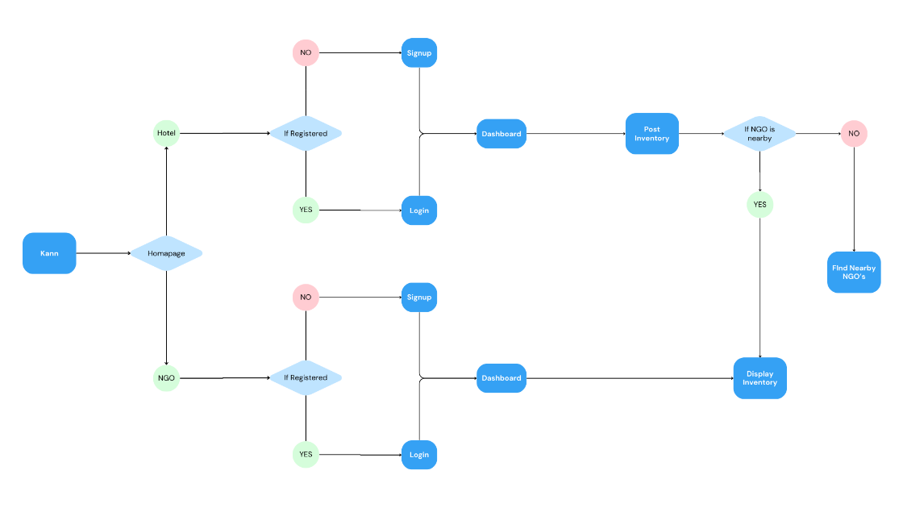

Back-end

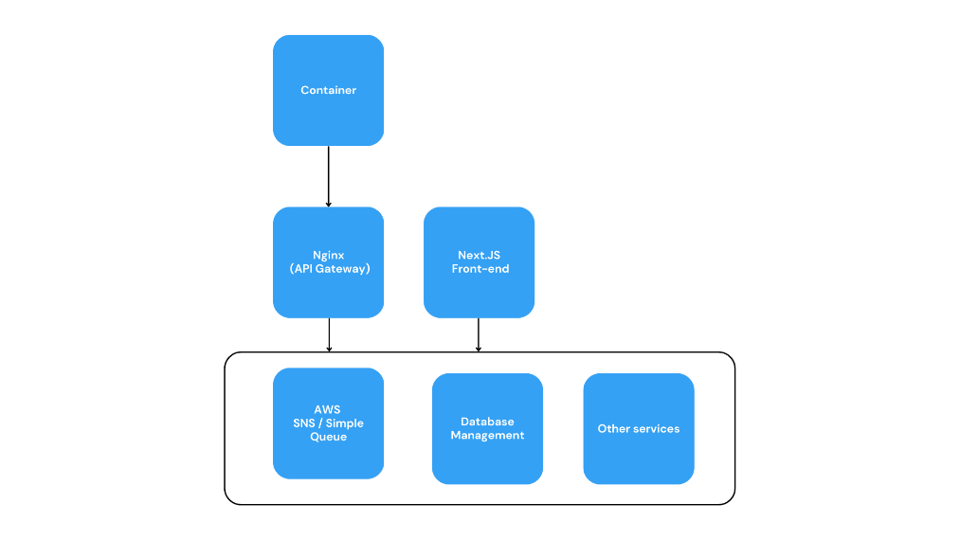

# **CHAPTER 4. RESULTS ANALYSIS AND VALIDATION**

# **4.1. Implementation of solution**

**Containerization (Docker):**

**Purpose:** Containerization allows each microservice to be encapsulated along with its dependencies, ensuring consistency across different environments. Docker, a popular containerization tool, facilitates easy deployment and scaling.

**Container Orchestration (Kubernetes):**

**Purpose:** Kubernetes is used to automate the deployment, scaling, and management of containerized applications. It orchestrates the deployment and coordination of microservices, ensuring high availability, fault tolerance, and efficient resource utilization.

**Backend Frameworks (Node.JS):**

**Purpose:** Microservices typically have their own backend frameworks tailored to their specific functionality. Frameworks like Spring Boot (Java) or Express.js (JavaScript/Node.js) are commonly used to build scalable and modular backend services.

**Frontend Frameworks (Next.js):**

**Purpose:** Next.js, a React framework for server-side rendering and static site generation, is often employed for developing the frontend of microservices. It enhances the user interface and experience while supporting the modular nature of the architecture.

**API Gateway (Nginx):**

**Purpose:** An API gateway serves as a central entry point for managing and routing incoming requests to the appropriate microservices. Technologies like Nginx or Kong are commonly used for API gateway functionality.

**Database Systems (e.g., MongoDB, PostgreSQL):**

**Purpose:** Each microservice may have its own database system based on specific requirements. NoSQL databases like MongoDB or relational databases like PostgreSQL are commonly used for data storage and retrieval.

**Continuous Integration/Continuous Deployment (CI/CD) Tools (GitLab CI):**

**Purpose:** CI/CD tools automate the testing, building, and deployment processes, ensuring a streamlined development pipeline. Jenkins or GitLab CI helps in maintaining the integrity of microservices during continuous integration and delivery.

**Security Solutions (OAuth):**

**Purpose:** Security mechanisms such as OAuth for authentication and JWT (JSON Web Tokens) for secure communication are implemented to protect microservices and their interactions.

# **CHAPTER 5. Conclusion and Future Work**

# **5.1 Conclusion**

The implementation of the signup functionality in the KANN web application aimed to provide users with a seamless onboarding experience. Users were expected to successfully sign up for the platform, with their data stored securely in the users.json file.

## **5.1.1 Deviation from Expected Results:**

Upon implementation and testing, it was identified that the signup process was not functioning as anticipated. Users encountered issues with the signup form, resulting in unsuccessful registrations.

## **5.1.2 Reason for Deviation:**

The deviation from expected results can be attributed to potential issues in the frontend and backend integration. This could include misalignments in form data handling, validation, or communication between the Next.js frontend and the Express backend. Further debugging and testing are required to identify and resolve these discrepancies.

# **5.2 Future Work**

**5.2.1 Way Ahead:**

To address the current deviation and enhance the signup functionality, the following steps are recommended:

* Thoroughly review the frontend form handling and ensure proper validation.
* Implement detailed error handling mechanisms to provide users with meaningful feedback.
* Conduct comprehensive testing to identify and rectify any additional issues.
* Integrate secure authentication practices and consider utilizing a database for user data storage for improved scalability and security.

**5.2.2 Required Modifications in the Solution:**

Modifications in the solution should focus on:

* Refining the form validation process to ensure completeness and accuracy of user data.
* Enhancing the communication between the Next.js frontend and the Express backend to facilitate seamless data transfer.

**5.2.3 Change in Approach:**

Consider adopting a more modular and scalable approach by implementing user authentication libraries and middleware. This can contribute to a more secure and maintainable solution.

**5.2.4 Suggestions for Extending the Solution:**

For future iterations of the KANN web application, consider the following enhancements:

* Implement user authentication using secure protocols such as JWT (JSON Web Tokens) for improved security.
* Integrate user profile management features for a personalized user experience.
* Explore options for email verification and password recovery to enhance user account security.

By addressing these areas in future work, the KANN web application can achieve its goal of providing a robust, secure, and user-friendly signup experience, contributing to the success of its mission to reduce food waste and alleviate food insecurity.

# **REFERENCES**

[1] *API Reference:create-next-app*. (n.d.). Next.js. https://nextjs.org/docs/pages/api-reference/create-next-app

[2] Ionic. (n.d.). *Ionicons: The premium icon pack for Ionic Framework*. https://ionic.io/ionicons

[3] *Installation - Tailwind CSS*. (n.d.). Tailwind CSS. https://tailwindcss.com/docs/installation

[4] *Installing Express*. (n.d.). https://expressjs.com/en/starter/installing.html

[5] Unsplash. (n.d.). *Beautiful free Images & Pictures | Unsplash*. Unsplash https://unsplash.com/

# **APPENDIX**

* Plagiarism Report
* Design Checklist

# **USER MANUAL**

**User Manual: KANN Web Application**

**1. Homepage:**

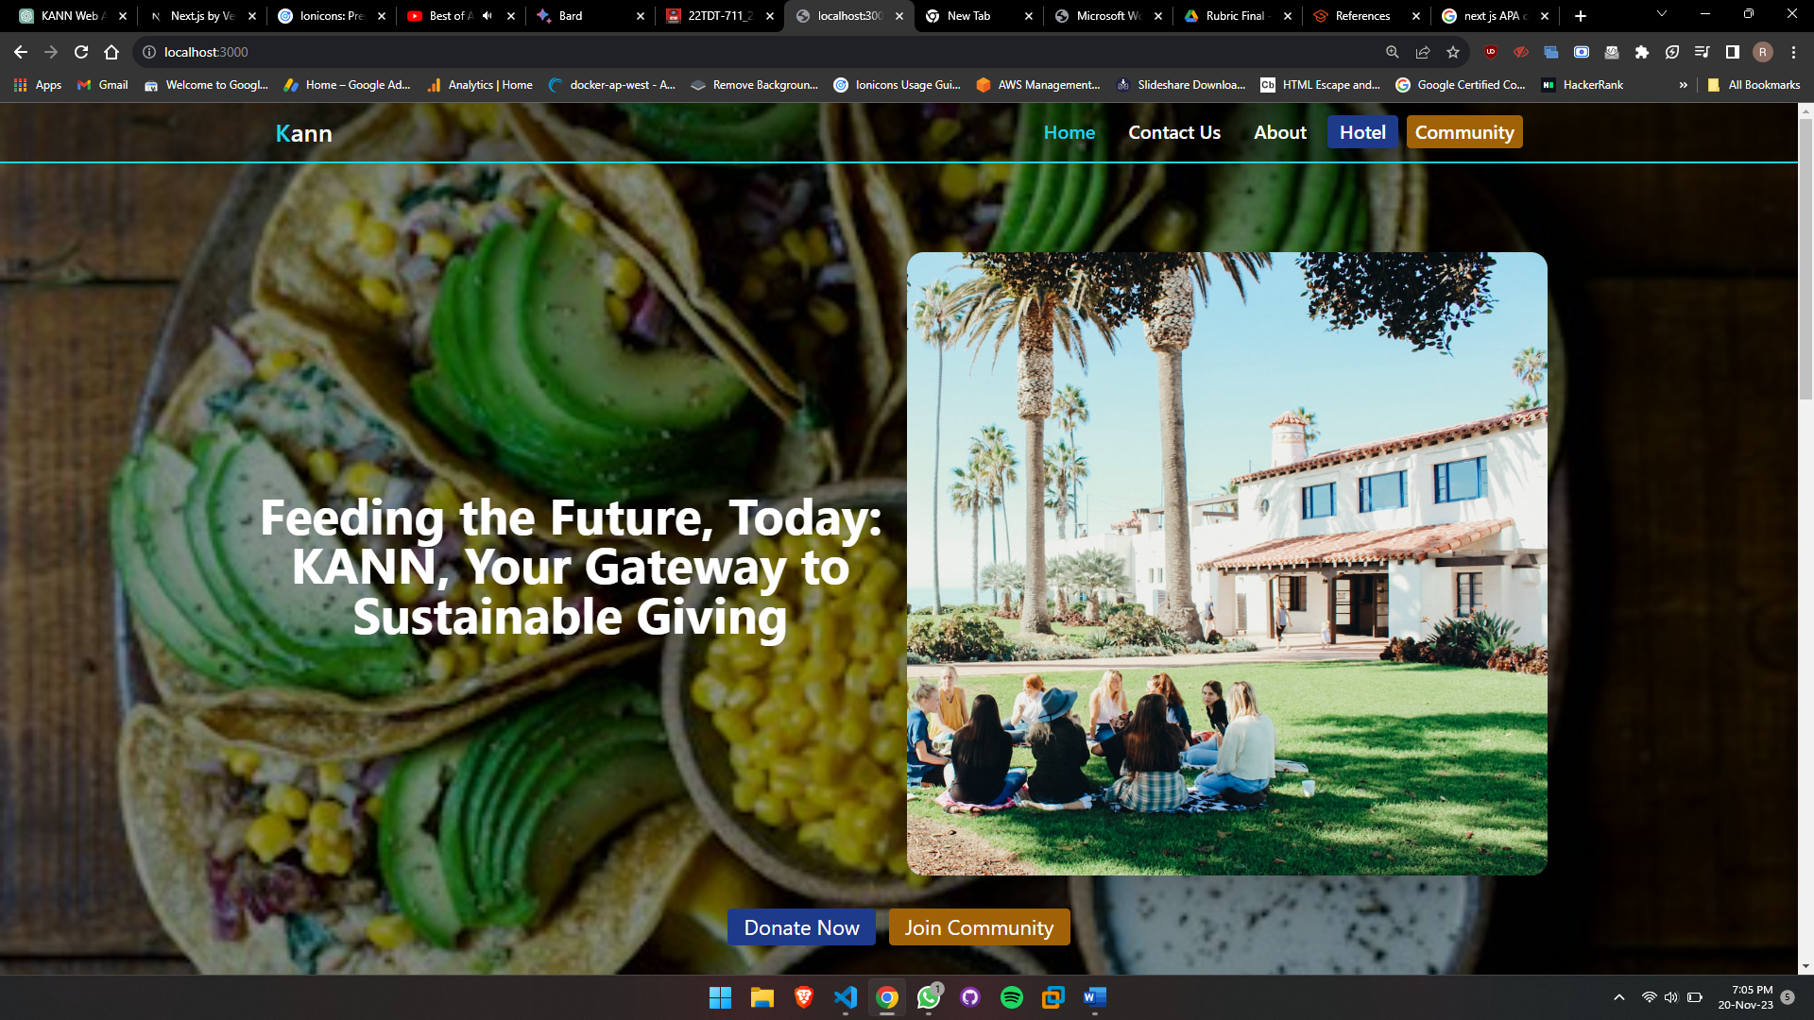

**1.1 Navigation:**

The homepage serves as the entry point to the KANN platform.

Explore the main navigation menu to access key features such as "Donate Food," "Find Food," and "Community."

**1.2 Featured Content:**

Discover featured content showcasing success stories, community engagement, and the impact of food donations.

**1.3 Quick Links:**

Use quick links to navigate directly to specific sections, including user login and signup.

**2. Login Page - Hotel:**

**2.1 User Type Selection:**

Select the "Hotel" option on the login page to access features tailored for hotel establishments.

**2.2 Credentials:**

Enter your hotel-specific credentials, including username and password.

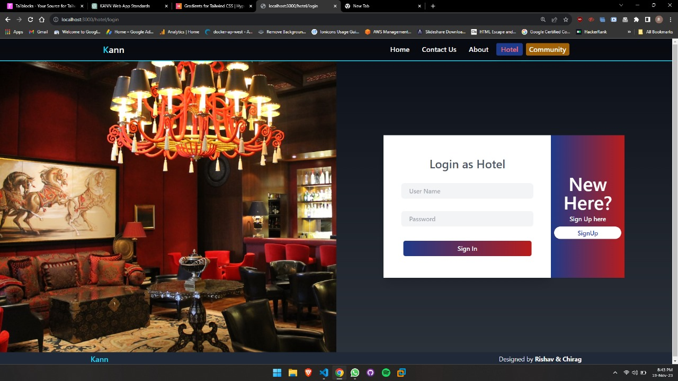

**2.3 Dashboard Access:**

After successful login, access the hotel dashboard to manage food donations, track contributions, and engage in CSR initiatives.

**3. Login Page - Community:**

**3.1 User Type Selection:**

Choose the "Community" option on the login page to access features designed for individual users and NGOs.

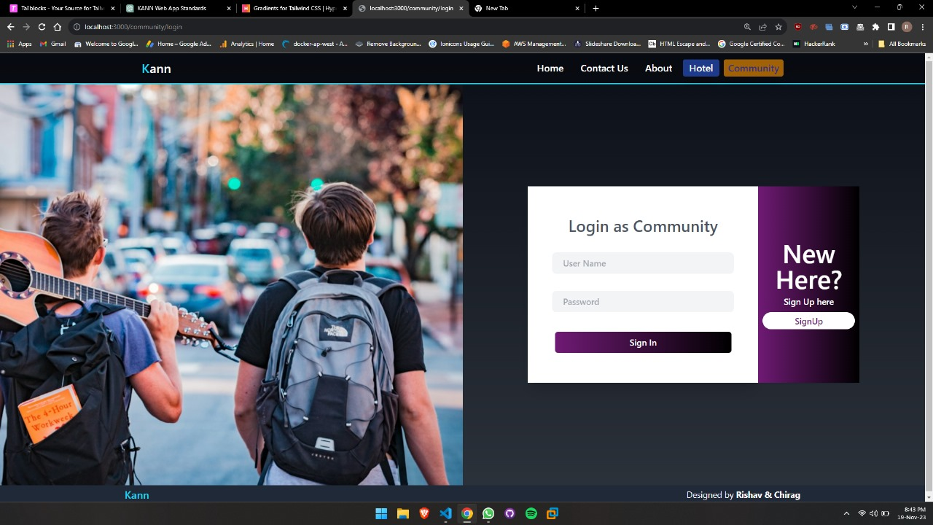

**3.2 Credentials:**

Enter your community-specific credentials, including username and password.

**3.3 Dashboard Access:**

Upon successful login, explore the community dashboard. Discover available food resources, connect with nearby establishments, and participate in local initiatives.

**4. Dashboard - Donate Food:**

**4.1 Navigation:**

Navigate to the "Donate Food" section from the dashboard menu.

**4.2 Surplus Food Listing:**

List surplus food items with details such as quantities, expiration dates, and handling instructions.

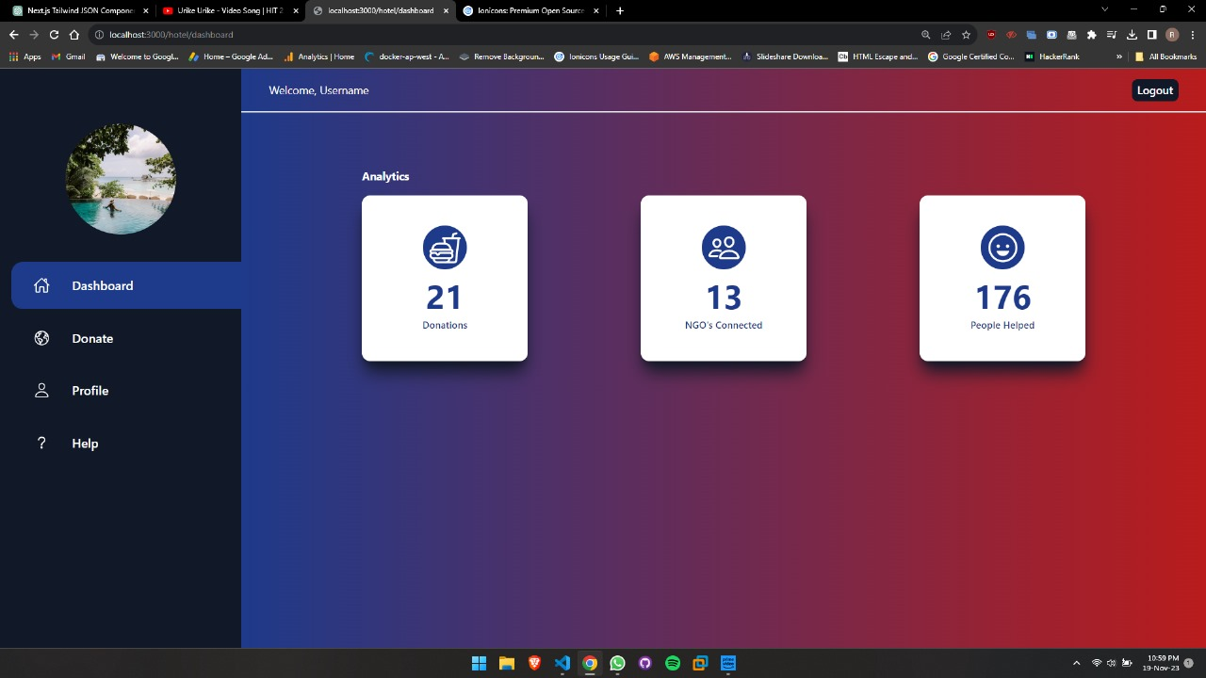

**4.3 Scheduling Pickups:**

Utilize the scheduling feature to set convenient pickup times for your food donations.

**4.4 Tracking Contributions:**

Monitor the status of your donations through real-time tracking. Receive updates on the impact of your contributions.

**5. General Tips:**

**5.1 Account Security:**

Regularly update your password for enhanced account security.

Avoid sharing your login credentials with unauthorized users.

**5.2 Feedback and Support:**

Provide feedback on your user experience to contribute to the platform's improvement.

For any assistance or queries, visit the "Contact Us" section.

**5.3 Explore Community Engagement:**

Engage with local communities, share success stories, and actively participate in sustainable food initiatives.