**Slide 1: Title Slide**

* **Title:** Exploratory Data Analysis (EDA) and Modeling
* **Subtitle:** Analysis and Insights from Mobile Phone Dataset
* **Your Name:** Rishav Harshit
* **Date:** 14/09/2024

**Slide 2: Introduction**

* **Objective:** Conduct Exploratory Data Analysis (EDA) and derive insights from a mobile phone dataset.
* **Dataset Overview:**
  + Contains information on various phone features, price, and ratings.

**Slide 3: Univariate Analysis**

* **Purpose:** Examine individual columns to understand their distribution and characteristics.
* **Key Columns:**
  + Camera
  + Memory
  + Processor
  + Battery
  + Ratings
  + Reviews Count

**Slide 4: Univariate Analysis**

* **Camera:**
  + 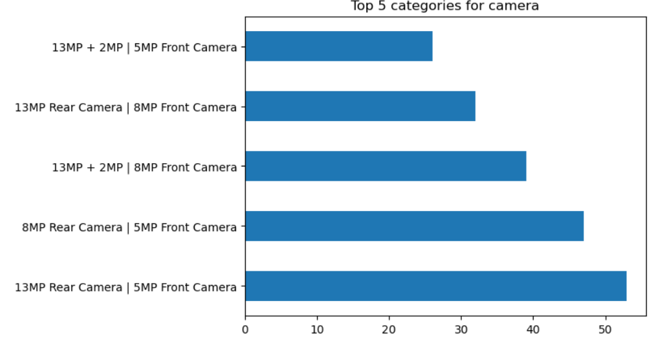
* **Memory:**
  + 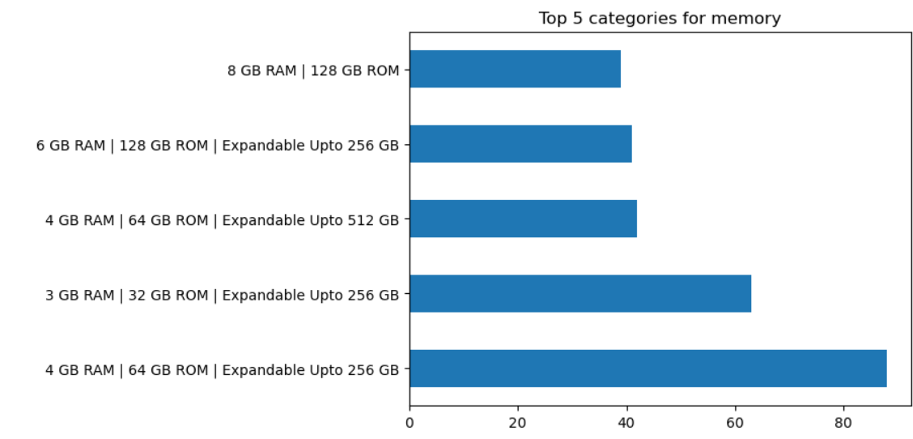
* **Processor:**
  + 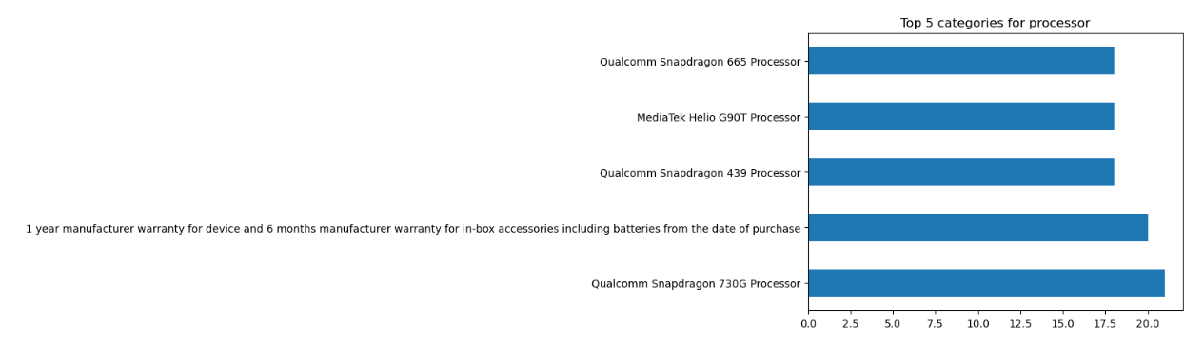
* **Battery:**
  + 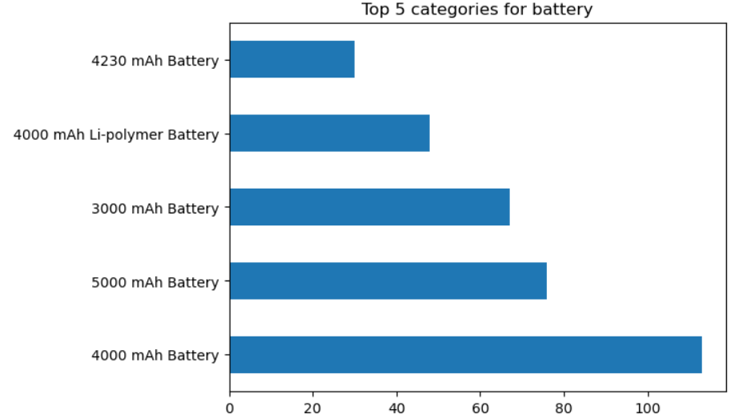
* **Ratings:**
  + 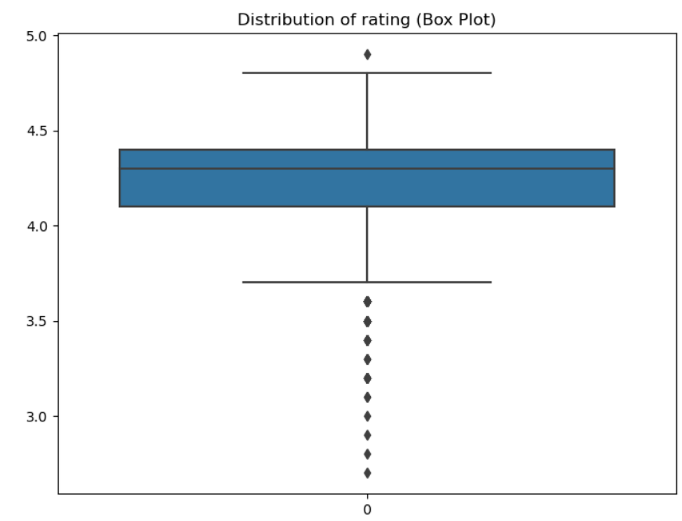
* **Reviews Count:**
  + 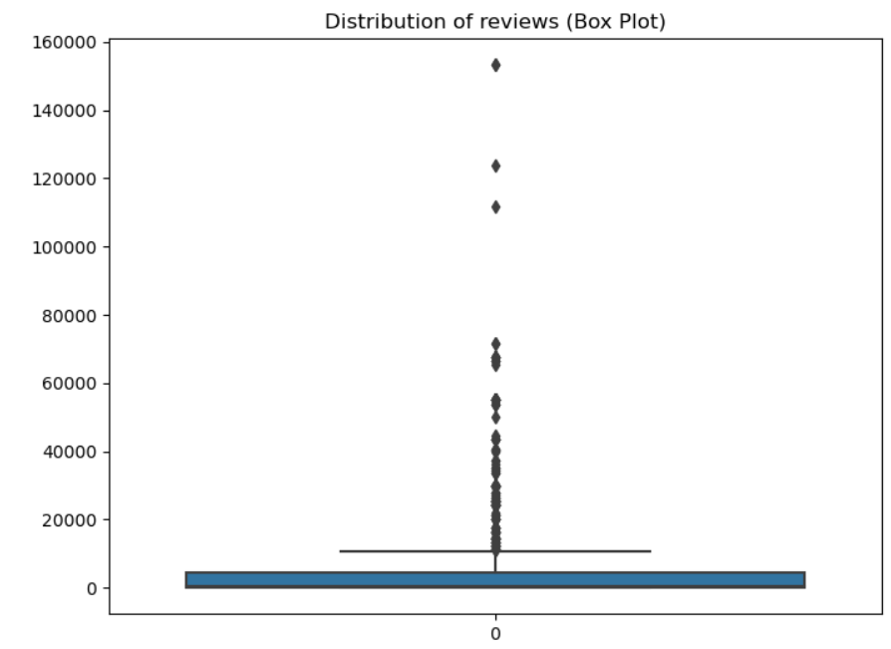

**Slide 5: Univariate Analysis - Categorical Features**

* **Camera Encoding:**
  + 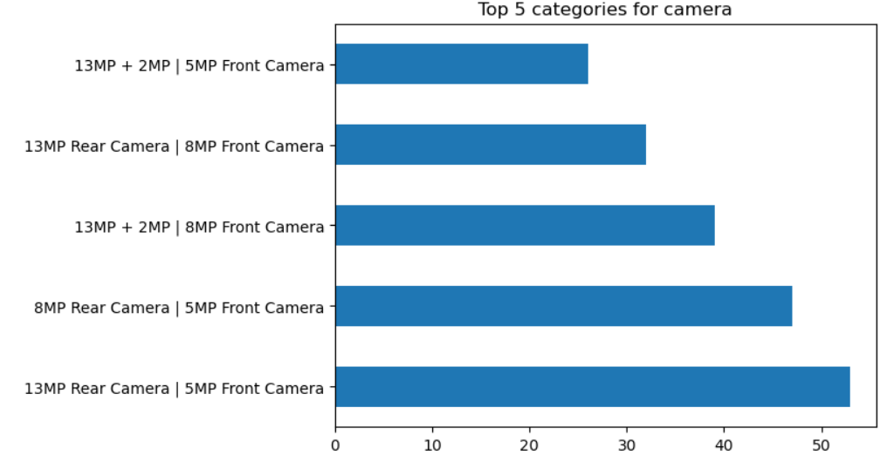
* **Memory Encoding:**
  + 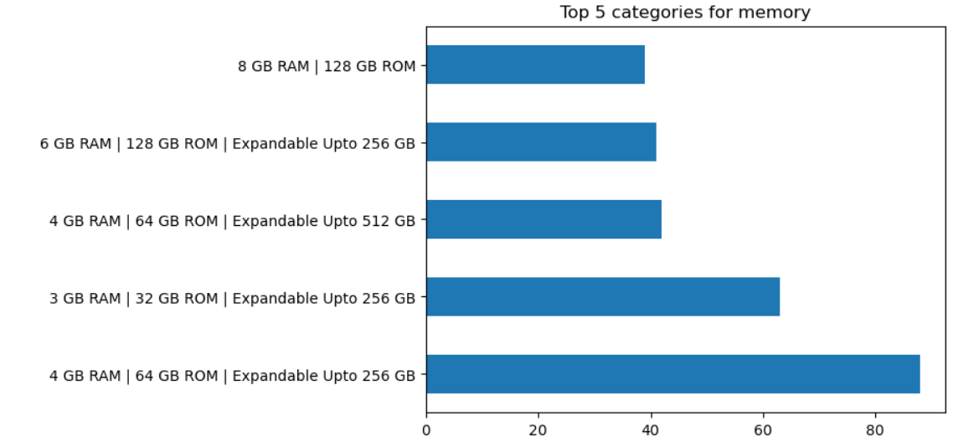
* **Processor Encoding:**
  + 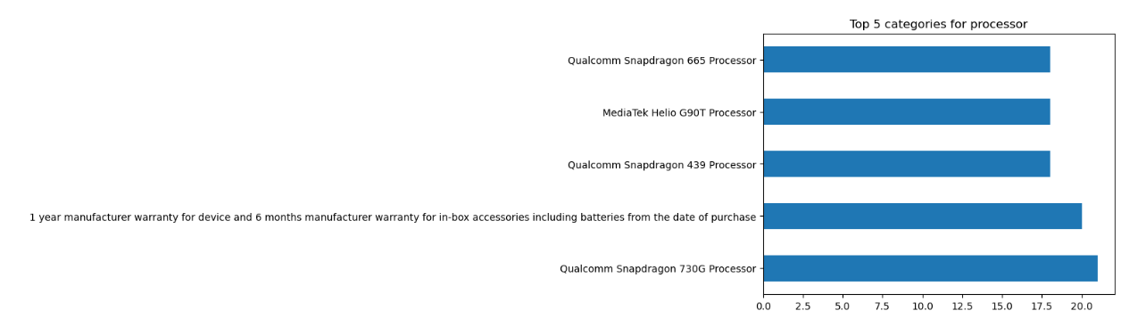

**Slide 6: Bivariate Analysis**

* **Objective:** Understand relationships between features and target variables (Price, Ratings).
* **Key Relationships:**
  + Price vs. Camera
  + Rating vs. Memory
  + Price vs. Processor

**Slide 7: Bivariate Analysis**

* **Price vs. Camera:**
* **Rating vs. Memory:**
  + 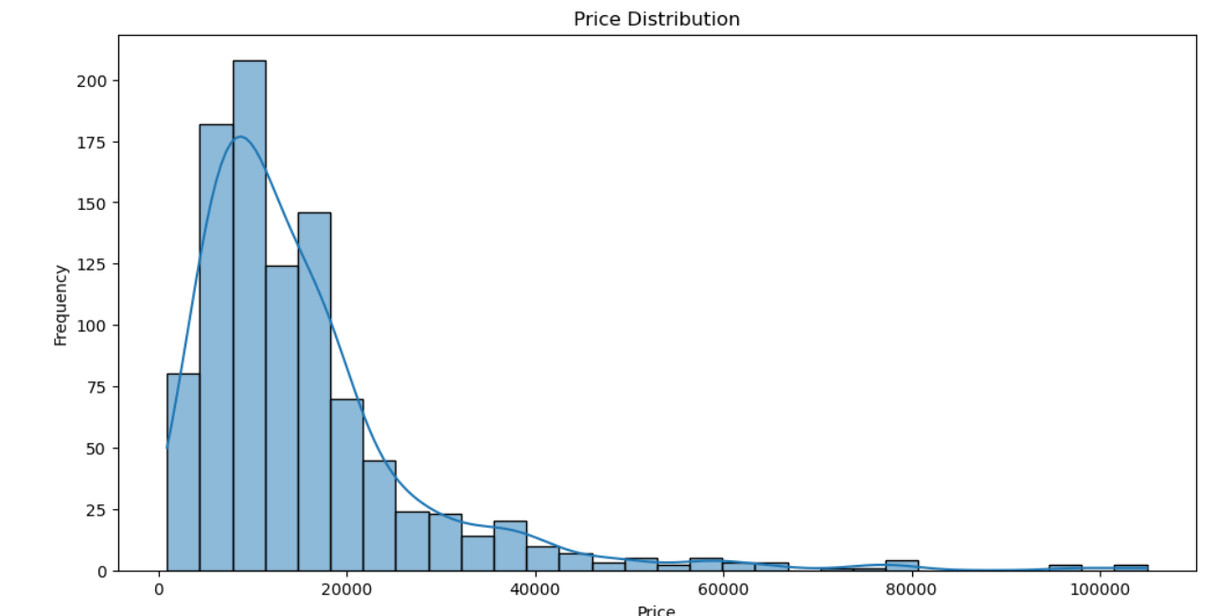
* **Price vs. Processor:**
  + 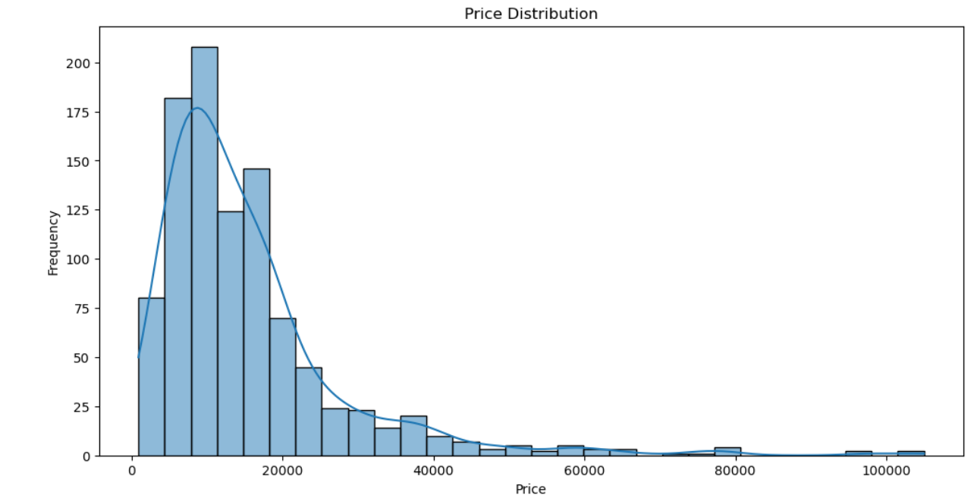

**Slide 8: Additional Insights**

* **Patterns and Trends:**
* **Observations:**

**Slide 9: Predicting Ratings**

* **Objective:** Build a model to predict phone ratings based on other features.
* **Model:** Random Forest Regressor
* **Performance Metric:** Mean Squared Error

**Slide 10: Predicting Ratings - Model Performance**

* **Mean Squared Error:** 25052321.686371624
* **Model Summary:**

**Slide 11: Clustering Analysis**

* **Objective:** Cluster phones based on features.
* **Method:** K-Means Clustering
* **Number of Clusters:** 5

**Slide 12: Clustering Results - Clusters Visualization**

* **Clusters Visualization:**
* **Cluster Characteristics:**

**Slide 13: Conclusion**

* **Summary of Findings:**
  + Key insights from univariate and bivariate analyses.
  + Summary of model performance and clustering results.
* **Recommendations:**