IoT-BASED SMART WATER TANK AND
USAGE ANALYTICS SYSTEM
Supporting UN Sustainable Development Goal 6: Clean Water and Sanitation

Submitted by
Prince Mandal — 24BCE1606
Vineet Verma — 24BCE1611
Harshika Tripathi — 24BCE1627

1. Problem Statement
Water is among the most valuable natural resources available to humanity, yet a considerable proportion of it is wasted every day because of inefficient storage and distribution practices. In residential buildings, hostels, schools, and villages, water tanks are still monitored manually — a caretaker or resident has to physically check the tank to determine the water level and switch the motor pump on or off accordingly. This manual approach is unreliable and directly leads to several recurring problems.
- Overflow of water tanks when the pump is left running unattended, resulting in direct wastage of a scarce resource.
- Dry running of the pump when the tank or the source runs empty, which damages the motor and wastes electrical energy.
- Undetected pipe or joint leakages that continue silently for long periods, increasing water loss and utility costs.
- Absence of any historical record of water consumption, which prevents users from identifying wasteful usage patterns.
- Dependence on manual supervision, which is impractical for multi-storey buildings, hostels, or unattended installations.
These issues collectively result in excessive water wastage, unnecessary electricity consumption for pumping, higher maintenance costs, and a general lack of awareness about actual household or institutional water usage. There is, therefore, a clear need for an automated, sensor-driven system that can continuously monitor tank water levels, control the pump intelligently, detect abnormal flow that indicates leakage, and present consumption data to the user in an easily interpretable form. This project addresses precisely this gap by proposing an IoT-based smart water tank and usage analytics system.

2. Objectives
The primary aim of this project is to design and implement a low-cost, IoT-enabled prototype that automates water tank monitoring and management while generating actionable usage analytics. The specific objectives of the project are as follows:
- To continuously and accurately measure the water level inside the storage tank in real time using an ultrasonic sensor.
- To automatically control the operation of the water pump — switching it ON when the water level is low and OFF when the tank is full — thereby eliminating manual intervention.
- To prevent overflow and dry-running conditions through threshold-based automatic control logic.
- To measure water flow using a flow sensor and compute the daily and weekly volume of water consumed.
- To detect possible pipeline leakage by identifying abnormal or continuous flow when the pump is in the OFF state.
- To generate local alerts through a buzzer and remote notifications through an IoT dashboard for conditions such as low water level, overflow, and suspected leakage.
- To transmit sensor data to a cloud platform and present it through a mobile/web dashboard for real-time and historical monitoring.
- To promote water conservation awareness by providing users with clear analytics on their consumption behaviour, in line with UN Sustainable Development Goal 6 (Clean Water and Sanitation).

3. Motivation
Freshwater is a finite and increasingly stressed resource, and inefficient household and institutional usage significantly worsens local water scarcity. A review of existing literature and real-world installations revealed a consistent set of shortcomings in conventional water tank systems: manual monitoring, frequent overflow, dry running of pumps, absence of leak detection, lack of historical consumption analysis, high electricity usage due to pump misuse, absence of predictive analytics, limited remote monitoring capability, high maintenance cost, and generally poor awareness of water conservation among users.
These recurring problems, identified from published research and everyday observation of hostels, apartments, and campuses, motivated the team to design a system that removes human error from tank management altogether. By combining low-cost sensors, a Wi-Fi-enabled microcontroller, and cloud-based analytics, it becomes possible to automate the routine task of tank monitoring while simultaneously giving users visibility into exactly how much water they consume and where wastage is occurring. The motivation is therefore twofold: first, to reduce the direct, tangible wastage of water and electricity caused by manual and reactive tank management, and second, to cultivate a more data-driven and conservation-conscious mindset among users by making consumption patterns visible and actionable. This aligns the project directly with Sustainable Development Goal 6, which calls for ensuring the availability and sustainable management of water for all.

4. Proposed System / Proposed Solution
The proposed solution is an IoT-Based Smart Water Tank and Usage Analytics System that continuously senses tank conditions, processes the data on a microcontroller, takes automated corrective action, and reports both real-time status and historical analytics to the user through a mobile/web dashboard. The system follows a clear input → processing → output pipeline, described below.

4.1 Input Stage — Sensing
An ultrasonic water level sensor is mounted at the top of the storage tank and continuously measures the distance to the water surface, which is converted into a percentage water level. A water flow sensor is installed on the inlet or outlet pipeline and generates pulses proportional to the volume of water passing through it, which is used both for consumption measurement and leak detection.

4.2 Processing Stage — Decision Making
An ESP32 microcontroller acts as the central processing unit of the system. It continuously reads the digital/analog signals from the ultrasonic sensor and the flow sensor, converts them into meaningful values (percentage level, flow rate, cumulative volume), and applies threshold-based control logic. If the measured level falls below a defined lower threshold, the ESP32 activates the pump through a relay module; if the level reaches the upper (full) threshold, the pump is switched off. In parallel, the ESP32 checks whether the flow sensor is registering continuous flow while the pump is OFF — a condition that indicates a probable leak — and raises the corresponding alert flag. All processed values are also displayed locally on a small LCD screen for on-site viewing.

4.3 Output Stage — Action and Reporting
Based on the processing outcomes, the system produces three categories of output. First, physical/local outputs: the relay-driven pump is turned ON or OFF automatically, and a buzzer sounds for low-level, overflow, or leak conditions, with the current status also shown on the LCD. Second, connectivity outputs: the ESP32's built-in Wi-Fi module transmits the processed sensor readings to a cloud database at regular intervals. Third, analytics outputs: the cloud-connected mobile/web dashboard visualizes the live water level, pump status, and flow rate, and aggregates the raw readings into daily and weekly consumption charts, giving the user a clear picture of usage trends and helping identify unusual consumption that may indicate wastage or leakage.
Overall, the proposed system replaces manual, reactive tank management with continuous, automated, and data-driven management — directly eliminating overflow and dry-running, enabling early leak detection, and giving users the analytics needed to conserve water more effectively.

5. Circuit Architecture
The hardware architecture of the system is centred around the ESP32 microcontroller, which interfaces with the sensing, actuation, and display modules and communicates with the cloud over Wi-Fi. Figure 1 illustrates the complete system architecture.
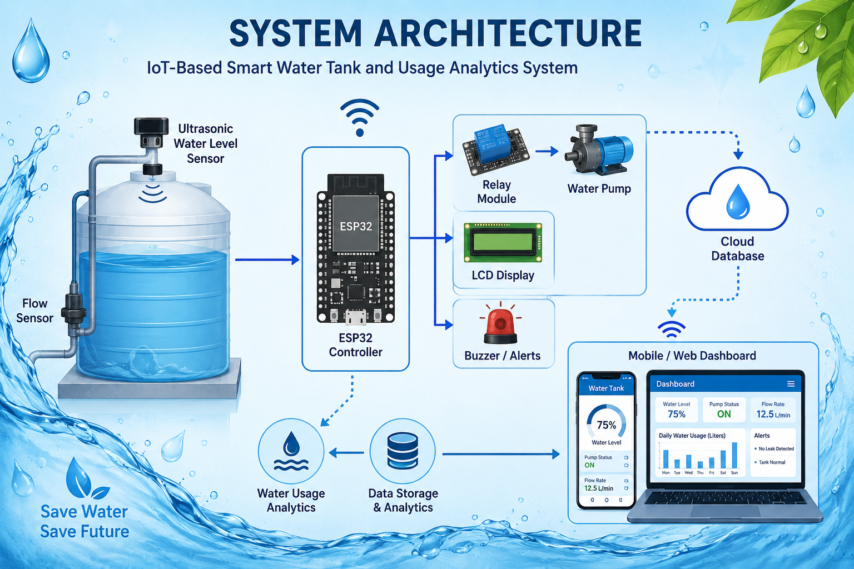
Figure 1: System Architecture of the IoT-Based Smart Water Tank and Usage Analytics System

5.1 Major Components
- Ultrasonic Water Level Sensor — mounted at the top of the tank; measures the distance between the sensor and the water surface using ultrasonic echo timing, which the controller converts into a water level percentage.
- Water Flow Sensor — installed inline on the plumbing; contains a small turbine that produces pulses proportional to the volume of water flowing through it, used for both consumption tracking and leak inference.
- ESP32 Controller — the core processing and communication unit; reads sensor data over its GPIO/ADC pins, executes the control logic, drives the relay and buzzer, updates the LCD, and connects to the cloud database via its integrated Wi-Fi module.
- Relay Module — an electromechanical switch driven by a digital output pin of the ESP32; safely switches the mains-powered water pump ON or OFF under low-voltage control from the microcontroller.
- Water Pump — the actuator responsible for transferring water into the tank; switched automatically based on the water level readings.
- LCD Display — provides an on-site, human-readable readout of the current water level, pump status, and flow rate without requiring a smartphone.
- Buzzer / Alert Module — provides an audible local alert for low water level, overflow, and suspected leakage conditions.
- Cloud Database — receives periodic data uploads from the ESP32 over Wi-Fi and stores historical sensor readings for analytics.
- Mobile / Web Dashboard — a client application that queries the cloud database to display live values (water level, pump status, flow rate) as well as daily/weekly usage analytics and alert history.

5.2 Interconnection and Working
The ultrasonic sensor and the flow sensor are wired to the GPIO pins of the ESP32 and continuously feed raw sensor data to it. The ESP32 processes these readings internally and drives three types of outputs simultaneously: the relay module (which in turn switches the water pump), the LCD display (for local status readout), and the buzzer (for local audible alerts). At the same time, the ESP32 uses its onboard Wi-Fi module to push the processed data to a cloud database at fixed intervals. The cloud database acts as the bridge between the hardware and the software layer — it stores incoming readings and computes aggregated statistics such as water usage analytics and data storage trends, which are then served to the mobile/web dashboard for the end user to view remotely. This layered architecture — sensing at the edge, decision-making on the microcontroller, and analytics in the cloud — allows the system to operate reliably even without constant user supervision, while still keeping the user informed in real time.

6. Flowchart
The operational logic of the system can be represented as an eight-step cyclical process that repeats continuously as long as the system is powered. Figure 2 shows the complete methodology flow, and the step-by-step description follows.
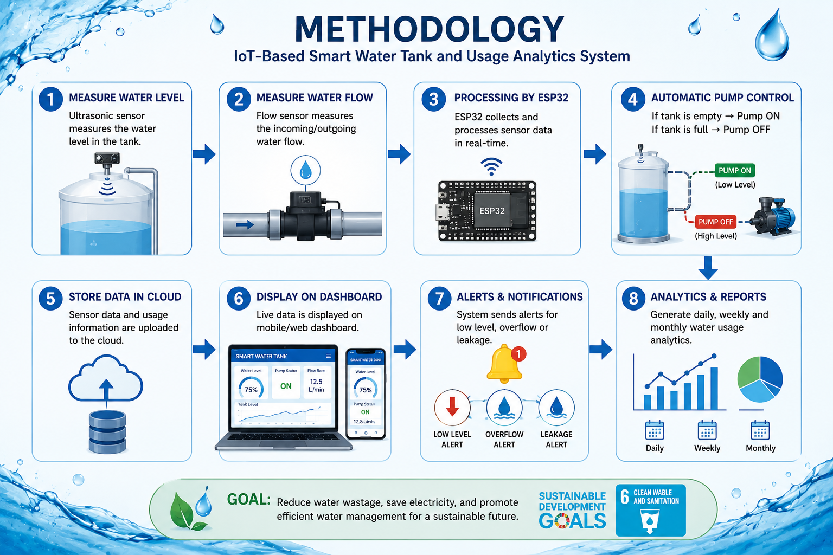
Figure 2: Step-by-step operational flow of the Smart Water Tank system
- Measure Water Level — The ultrasonic sensor measures the current water level inside the tank.
- Measure Water Flow — The flow sensor simultaneously measures the incoming/outgoing water flow through the pipeline.
- Processing by ESP32 — The ESP32 controller collects both sensor readings and processes them in real time.
- Automatic Pump Control — Based on the processed level, the ESP32 decides the pump state: it switches the pump ON when the tank is empty (low level) and OFF when the tank is full (high level).
- Store Data in Cloud — The processed sensor readings and usage information are uploaded to the cloud database.
- Display on Dashboard — The live water level, pump status, and flow rate are displayed on the mobile/web dashboard for the user.
- Alerts and Notifications — If a low-level, overflow, or leakage condition is detected, the system triggers a local buzzer alert as well as a dashboard/mobile notification.
- Analytics and Reports — The accumulated data is aggregated into daily, weekly, and monthly water usage analytics and presented to the user as charts and reports.
After the analytics step, the process loops back to continuous level and flow measurement, making the system a closed-loop, self-correcting monitoring cycle rather than a one-time check.

7. Applications
The proposed system is designed as a general-purpose water management solution and can be deployed across a wide range of real-world settings:
- Residential apartments and independent houses, where it eliminates manual tank checking and prevents overflow-related water wastage.
- Hostels and student accommodations, where shared water tanks are prone to overflow and pump misuse due to lack of individual accountability.
- Educational institutions and office campuses, where centralized dashboards allow facility staff to monitor multiple tanks from a single interface.
- Residential societies and gated communities, enabling the housing management to track overall water consumption and detect leakages across common storage tanks.
- Rural and semi-urban households and villages, where irregular water supply makes automated low-level alerts and efficient pump scheduling particularly valuable.
- Industrial and commercial premises that rely on overhead or underground storage tanks and require reliable, unattended pump automation.
- Smart city and smart building initiatives, where the system can be integrated as one node within a larger network of utility monitoring devices.

8. Conclusion
This project presents the design of an IoT-Based Smart Water Tank and Usage Analytics System that directly addresses the inefficiencies of traditional, manually operated water storage systems. By combining an ultrasonic level sensor, a water flow sensor, an ESP32 microcontroller, a relay-driven pump, and a cloud-connected dashboard, the system is able to automatically manage pump operation, prevent overflow and dry-running, detect probable leakages, and present users with meaningful daily and weekly consumption analytics. The prototype demonstrates that a relatively low-cost combination of commonly available sensors and a Wi-Fi-enabled microcontroller is sufficient to bring meaningful automation and data visibility to a problem that is otherwise handled through manual supervision.
Beyond the immediate benefits of reduced water wastage and lower electricity consumption from pump misuse, the system also supports the broader goal of encouraging conservation-conscious behaviour by making usage patterns visible to the end user. This work can be extended further with AI-based water demand prediction, water quality monitoring for parameters such as pH and turbidity, rainwater harvesting integration, solar-powered operation, multi-tank monitoring, and eventual integration into larger smart-city utility networks. Overall, the project contributes a practical, scalable step toward Sustainable Development Goal 6: Clean Water and Sanitation.

9. References
[1] M. T. Huque, J. J. Godhuli, S. R. R. Pushon, and F. Z. Ekah, "Internet of Things (IoT) Based Smart Water Tank Level Monitoring and Motor Pump Control System for Preventing Water Waste," International Research Journal of Engineering and Technology (IRJET), vol. 10, no. 6, pp. 352–358, 2023.
[2] P. Mahale, S. Panse, and P. Rajule, "IoT Based Water Level Monitoring System," International Research Journal of Modernization in Engineering Technology and Science (IRJMETS), vol. 4, no. 3, pp. 2262–2264, 2022.
[3] S. Ramesh and M. Pavithra, "Automated Water Level Monitoring and Pump Control System Using Arduino," International Journal of Engineering Trends and Technology (IJETT), vol. 57, no. 2, pp. 67–70, 2018.
[4] A. Patil, M. Madavi, A. Bhimte, D. Shripad, and S. Khan, "Water Leakage Detection and Monitoring System Using IoT," International Journal of Scientific Research in Science and Technology (IJSRST), vol. 9, no. 2, pp. 203–207, 2022.
[5] S. M. Tedjojuwono and J. D. Jahja, "Smart Water Management System Using IoT Based Sensors," IOP Conference Series: Earth and Environmental Science, vol. 1324, art. no. 012106, 2023.
[6] T.-K. Chi, H.-C. Chen, S.-L. Chen, and P. A. R. Abu, "A High-Accuracy and Power-Efficient Self-Optimizing Wireless Water Level Monitoring IoT Device for Smart City," Sensors (MDPI), vol. 21, no. 6, art. no. 1936, 2021.
[7] Espressif Systems, "ESP32 Series Datasheet," Official ESP32 Technical Documentation, Espressif Systems, 2023. [Online]. Available: https://www.espressif.com/en/products/socs/esp32
[8] United Nations, "Sustainable Development Goal 6: Ensure availability and sustainable management of water and sanitation for all," United Nations Department of Economic and Social Affairs — Sustainable Development, 2023. [Online]. Available: https://sdgs.un.org/goals/goal6
[9] R. Faludi, Building Wireless Sensor Networks: with ZigBee, XBee, Arduino, and Processing, 1st ed. Sebastopol, CA, USA: O'Reilly Media, 2010.
[10] D. Kellogg, "Understanding and Applying Ultrasonic Sensors for Non-Contact Liquid Level Measurement," Texas Instruments Application Report, Texas Instruments Inc., 2020. [Online]. Available: https://www.ti.com/lit/an

