EASYBID
(A WEB-BASED APPLICATION)

BY
Rishav Shrestha & Pratik Majhi
(College Roll No.15375/22 & 15372/22)
Himalaya Darshan College

A Project Report Submitted to
Faculty of Management, Tribhuvan University
in partial fulfillment of the requirements for the degree of

Bachelor of Information Management (BIM)

Biratnagar
Date??
STUDENT DECLARATION

This is to certify that we have completed the Project entitled “EasyBid” under the guidance of “Mr. Nabin Ghimire” in partial fulfillment of the requirements for the degree of Bachelor of Information Management at Faculty of Management, Tribhuvan University. This is our original work and we have not submitted it earlier elsewhere.

Date Signature……………………….
Name: Rishav Shrestha
TU Reg No. 7-2-1073-84-2022

Signature……………………….Name: Pratik Majhi
TU Reg No. 7-2-1073-81-2022

CERTIFICATE FROM THE SUPERVISOR
This is to certify that the project entitled “EasyBid” is an academic work done by “Rishav Shrestha” submitted in the partial fulfillment of the requirements for the degree of Bachelor of Information Management at Faculty of Management, Tribhuvan University under my guidance and supervision. To the best of my knowledge, the information presented by them in the project report has not been submitted earlier.

______________________
Signature of the Supervisor
Name: Mr. Nabin Ghimire
Designation: Lecturer
Date:

APPROVAL SHEET
ACKNOWLEDGEMENT
ABSTRACT

Chapter 1: Introduction
1.1 Background of the project
EasyBid is a web-based application designed to facilitate online auctions by allowing users to list items for auction and participate in bidding from anywhere. Traditional auction methods often face challenges such as limited participation, lack of real-time transparency, and time-consuming manual processes. EasyBid aims to address these issues by providing a secure, transparent, and user-friendly platform for conducting online auctions. The system ensures fair bidding through real-time bid updates and enables administrators to efficiently monitor and manage auction activities.
1.2 Problem Statement
Traditional auction systems face several challenges, including limited accessibility, lack of real-time transparency, and time-consuming manual processes, making them inefficient for participants. Existing offline auction methods often require physical presence and fail to provide timely updates on bid status, leaving bidders uncertain about the current highest bid and auction progress. Additionally, auctioneers encounter difficulties in managing auction items, tracking bids, and maintaining accurate records due to the absence of a centralized digital system. Administrators also struggle with effective monitoring and control of auction activities, which can result in inconsistencies and reduced fairness in the bidding process. To address these issues, there is a need for a centralized, web-based auction management platform that simplifies auction listing and bidding, ensures transparency through real-time bid updates, and improves overall auction management efficiency. Implementing such a solution will enhance accessibility, improve operational efficiency, and build trust among all stakeholders involved in the auction process.
1.3 Objectives
- To develop a web-based auction management system for listing items and conducting bidding.
- To ensure transparency and fairness in auctions by displaying live bid updates and highest bid information.
- To provide a secure and user-friendly platform with proper authentication and access control.
- To enable efficient monitoring and management of auction activities by administrators.
1.4 Review of Related Work and Literature
1.4.1 Review of Related Work
In the field of online auctions, conducting transparent and efficient bidding has become an important necessity. Whether it is for auctioning items for a short period, long-term auctions, or scheduling auctions for a specific event, users seek a seamless and transparent system. EasyBid is designed to meet these needs by providing a web-based platform that enables users to list items for auction and participate in real-time bidding efficiently. The core concept of EasyBid revolves around enhancing accessibility, transparency, and fairness while ensuring a smooth auction experience for both bidders and auctioneers.
The development of EasyBid involves the study of existing systems such as eBay, Catawiki, and local Nepali systems like NIC Asia Bank’s Online Auction Portal, where users can participate in auctions for various items, including bank assets and collectibles. These platforms provide basic functionalities such as item listing, bid submission, auction timers, and bid history tracking. However, EasyBid enhances this approach by offering a more user-friendly and centralized system that allows users to schedule auctions, access real-time bidding updates, and monitor auction results securely, making it a more versatile and efficient solution.
One of the key conclusions drawn from the study of existing systems is that instead of relying solely on static updates, it is more effective to implement real-time bid tracking and a centralized auction dashboard. This ensures that all participants have access to the latest bid information instantly, improving fairness and minimizing disputes. Additionally, EasyBid integrates a role-based system where users can act as bidders or auctioneers and administrators can monitor all auction activities, ensuring security, proper record-keeping, and transparent management of the online auction process.
1.4.2 Literature Review
eBay (eBay, n.d.) is a widely recognized international online auction platform that allows users to list items for auction and participate in real-time bidding. The platform provides features such as item categorization, bid tracking, auction timers, and secure payment processing. Specifically, this study aims to develop an online auction system that ensures transparency by displaying the current highest bid and maintaining a complete bidding history. Traditional offline auctions often face challenges such as limited participation, lack of real-time updates, and inefficiency in record-keeping. The eBay system addresses these issues by providing a centralized platform where users can access auction information instantly, bid on items from any location, and monitor auction progress in real time. Usability and functionality evaluations suggest that eBay enhances user trust and convenience by maintaining clear records of bids, providing secure transactions, and offering real-time updates.
Catawiki (Catawiki, n.d.) is a Dutch online auction platform specializing in collectibles and high-value items. Users can submit auction items, and interested bidders can place competitive bids over a set period. This platform emphasizes transparency by displaying bid histories and item details and ensuring fair auction closure based on the highest bid. The study of Catawiki informs the development of EasyBid by highlighting the importance of structured item listings, bid tracking, and scheduled auction timings, which enhance user confidence in the fairness of online auctions.
NIC Asia Bank Online Auction Portal (NIC Asia Bank, n.d.) is a Nepal-based digital auction system used primarily for auctioning bank-owned assets and collateral. The system allows registered users to view detailed information about listed assets, including images, descriptions, and QR codes, and to place bids online. Unlike general marketplace auctions, this platform focuses on a secure and controlled bidding environment for financial and real estate assets. Studying this system informs EasyBid’s design by demonstrating how real-time bid updates, user authentication, and secure access control can be implemented in the Nepali context to ensure transparency and reliability.
Nepal Rastra Bank Online Bidding System (NRB, n.d.) is used for government and financial auctions such as treasury bills and monetary instruments. The system supports electronic bid submission, instant bid validation, and centralized tracking of bidding activities. Lessons from this platform reinforce the need for real-time bid processing, audit trails, and secure administration in developing EasyBid.
Local Nepali Auction Initiatives (Various, n.d.) are emerging in online marketplaces, where items such as electronics, collectibles, and vehicles are auctioned through smaller web portals. These initiatives often provide basic listing and bidding functionality but lack real-time bid updates, user-friendly dashboards, and structured auction management. Analyzing these platforms highlights the gaps that EasyBid aims to address mainly real-time transparency, centralized auction monitoring, and a secure, role-based system for bidders, auctioneers, and administrators.
This literature review positions EasyBid as a system that builds on the strengths of international platforms like eBay and local Nepali solutions while addressing gaps in real-time transparency, usability, and centralized auction management. The studies conclude that real-time bid updates, auction transparency, and clear item details contribute significantly to bidder trust, fairness, and overall satisfaction in online auction systems.
1.5 Development Methodology
The incremental model divides the EasyBid development process into smaller, manageable increments, allowing for gradual implementation and refinement. Each increment delivers a functional component of the system, enabling early user feedback and adjustments. This approach enhances flexibility in accommodating evolving requirements while maintaining a structured development process.

SDLC Model
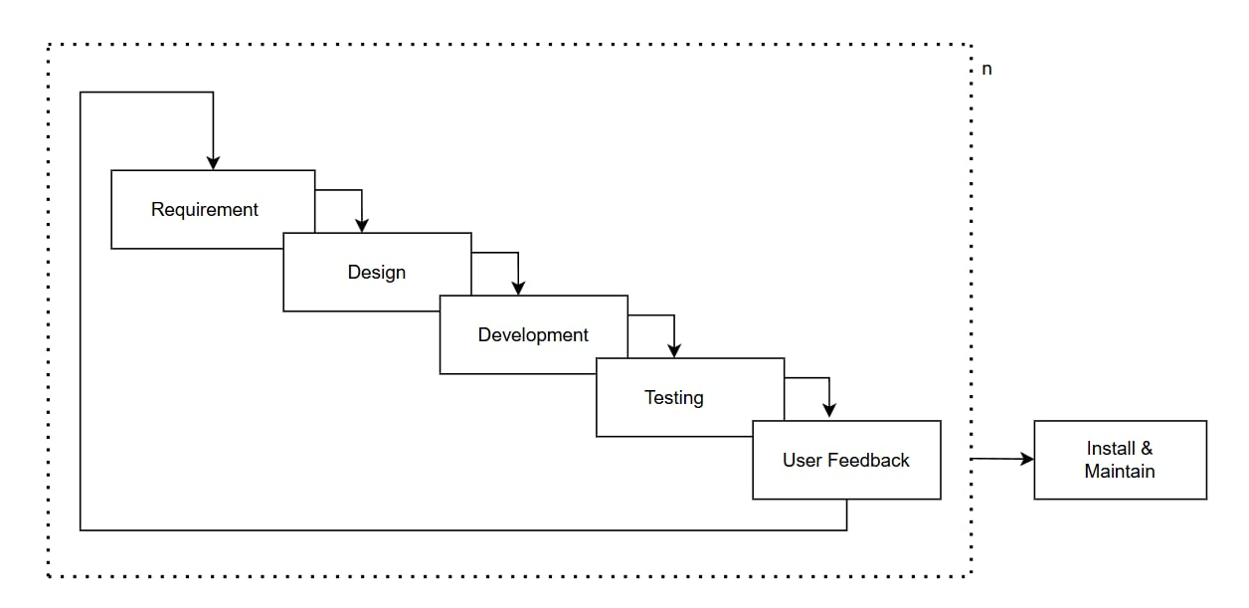Requirement Gathering
In this phase, various requirements such as user(bidder, auctioneer, admin), auction preferences, and auction item types in the EasyBid application are identified. The analysis includes essential features like real-time bidding, auction scheduling, highest bid tracking, and transparent auction history. Additionally, system requirements for ensuring secure transactions, user authentication, and smooth auction management are gathered to enhance the overall efficiency, fairness, and usability of the platform.
Design
Based on the requirement gathering, user interface design is created, including layout, colors, typography, and arrangement of components in the web application. Responsive design is considered for different screen sizes and devices, ensuring the platform is accessible on desktops, laptops, tablets, and mobile devices. The design focuses on clear dashboards for bidders, auctioneers, and administrators, making the system intuitive and easy to navigate.
Development
In this phase, coding of EasyBid begins following the website architecture and design guidelines. Small chunks of functionality such as user registration, item listing, bidding module, and admin dashboards are implemented incrementally. Each module is tested individually before integration to ensure correctness and functionality.

Testing
During the testing phase, various types of tests are conducted, including functional, usability, performance, and security testing of EasyBid. Test cases are created based on the system requirements and executed by simulating real auction scenarios. Inputs, user interactions, and auction workflows are tested, comparing actual outcomes with expected results. After overall system testing is completed, the product is deployed for user access.
Maintainance
In the maintenance phase, EasyBid ensures that the platform remains stable, secure, and efficient, addressing user concerns and fixing any issues. Continuous updates and enhancements are applied to meet changing user needs, improve user experience, and incorporate additional features such as advanced analytics, notifications, and enhanced auction functionalities.
1.6 Scope and Limitation
1.6.1 Scope
The EasyBid web application is a digital platform designed to streamline online auctions by enabling users to list items for auction, participate in competitive bidding, and schedule auctions for short-term or long-term periods. It addresses key challenges such as limited participation, lack of transparency, and inefficient auction management by offering real-time bid updates, highest bid tracking, and secure auction history management. With a user-friendly interface for bidders, auctioneers, and administrators, it enhances operational efficiency and oversight. By integrating centralized auction monitoring, role-based access control, and structured auction workflows, EasyBid aims to improve transparency, fairness, and accessibility, making online auctions more efficient, trustworthy, and convenient for all participants.
1.6.2 Limitation
It does not provide fully live real-time bid updates and does not include automated fraud or dispute resolution mechanisms, and Mobile application support is not available yet.
1.7 Report Organization
The report consists of three chapters which will cover the designing and development application. 6 Chapter One introduces the system and the problems and literature review which is the previous related work that has been done before and gives an overview of the study. Similarly, Chapter Two cover the analysis, designing and implementation and testing. And Chapter Three discusses the summary, conclusion, recommendations for future works to improve this study.
Gantt chart
