**Life-Line**

**Deliverable 1 : Vision Document**

**Problem Description:**

The world is advancing fast, but the health systems are not. Need of blood is increasing in the hospitals and unfortunately due to the busy lifestyles, the numbers of blood donors has not increased much. There is need of a medium that let blood donors and the blood receivers (the patients) to connect with the hospitals. Not only let the users (donor and receiver), but a system which lets hospitals connect with each other. The donors can connect with the hospitals (or camps) and book an appointment according to their time schedule and get verification and can then donate blood conveniently. If the blood is required from hospital to hospital, a shipper is required as well.

A new convenient, safe and efficient system is required to be deployed so that it is easier for the donors to know about the nearby blood banks, nearby blood donation camps. The system needs to verify the authenticity of the people that connect to make the system environment safe.

**System Capabilities:**

This new system should be capable of doing the following work:

* Collecting and storing information about the hospitals.
* Collecting and storing information about the users (donors and receivers).
* Collecting verified information about their identities and blood.
* Collecting information about the shippers.
* Storing the identities and blood in a blood bank.
* Connecting with the hospital representative via telephone.
* Functioning as a stand-alone without a connection, for information related to the blood and identity.
* Ship the required blood to different hospitals.

**Business Benefits:**

It is anticipated that after the deployment of this new system, the following will be the business benefits to ‘Life-Line’:

* Working for a good cause promoting brand name.
* Tax dollars from government for helping people by creating a medium.
* Helping donors and hospitals to get a medium, providing commission based income.
* Promoting blood donation camps, providing commission based income.
* The application will generate some revenue.
* New concept to the user, promoting the user’s willingness to use the system.

**Deliverable 2 : Interview Question**

|  |  |  |  |  |  |
| --- | --- | --- | --- | --- | --- |
| Stakeholder Register | | | | | |
| Stakeholder Name | Stakeholder  Position | External/Internal | Stakeholder contact details | Operational/ Executive | Interest  (high, medium, low) |
| Peter Livingston | Project Manager | Internal | 114 houseton drive, Toronto, ON  Phone #(416)-668-9999  Email: [Peter55@hotmail.com](mailto:Peter55@hotmail.com) | Operational | High |
| Tommy Graham | Users | External | 65 kita rd Ottawa, ON  Phone# (905)-888-9788  Emal: [tommy6657@gmail.com](mailto:tommy6657@gmail.com) | Operational | High |
| Bob Ho | Investors | Internal | 9008 Broadway blvd Oakville, ON  Phone#(416)-658-9999  Email: [bobjoseph@yahoo.ca](mailto:bobjoseph@yahoo.ca) | Executive | High |
| Jack Milo | Medical association representative | Internal | 4005 Hollywood drive Cambridge, ON  Phone # (416)-477-2898  Email:jackm@koko.com | Operational | High |

**Stakeholder Register**

**Interview Questions**

|  |  |  |
| --- | --- | --- |
| **ANALYST**  **Interview Questions** | | |
| Question | Stakeholder | Answer |
| 1) When is the product going to be released? | * Peter Livingston * Project manager | The product will be released by January 2019 |
| 2) What are the project risks? What are the chances of success vs failure | * Peter Livingston: Project Manager | There are risk for the project is coordinating with the hospitals for money and space. |
| 3) What steps does the audience go through before making a decision to get the application? | * Tommy Graham: User | The audience will have to go through a registration process in which they will be filling out their personal information. |
| 4)Who will be the customers? | * Jack Milo * Medical association representative | The customers will be patients that are in need for blood and are looking for donors. |
| 5)What similar tools are in use today? | - Project manager/user: Peter Livingston, Tommy Graham | Blood donor American red cross |
| 6)What is missing in the current world that this tool will provide? | - project manager/user  - Peter Livingston  - Tommy Graham | We will provide a faster and convenient way to have access to blood donors. |
| 7)Are you willing to invest more money if the application grows? | * Investors: Bob Ho | I am certainly willing to invest more money if the application grows |
| 8) How many users will be using the app the same time? | * Users: Tommy Graham | There is no certain number of users that can use the app the same time. Many people can use the app the app same time. |
| 9) What is the growth expectations of this app? | - Medical association representative: Jack Milo | We are confident in our team project and know that there are many people in the world that are looking for help. |
| 10) If you receive additional funding for this project, what would you do with it? | - Project manager: Peter Livingston | We will enhance the app and add more features to the app. |

**Meeting Log with Team Members**

|  |  |  |  |  |  |
| --- | --- | --- | --- | --- | --- |
| **Minutes of meetings log between team members** | | | | | |
| **Meeting #** | **Date**  dd/mm/yyyy | **Duration**  minutes | **Names of attendees** | **Type**  (in person, over the phone, over the internet) | **Key actions agreed upon** |
| **1** | 07/03/2018 | 1 hour | 1.Rishav | In person | 1. Divided staff into teams |
| 2.Dushant | In person | 1. Agreed upon the scrum |
| 3.Keshav | In person | 1. Agreed upon next meeting date |
| 4.Aaqil | In person | 1. Divided tasks |
|  |  |  |
| **2** | 03/04/2018 | 1 hour | 1.Rishav | In person | 1. Started 2nd sprint |
| 2.Dushant | In person | 1. Discussed requirements |
| 3.Keshav | In person | 1. Agreed upon next meeting date |
| 4.Aaqil | In person |  |
|  |  |  |
| **3** | 2018 | 2 hour | 1.Rishav | In person | 1. Started 3rd sprint |
| 2.Dushant | Over the phone | 1. Surveys |
| 3.Keshav | In person | 1. Agreed upon next meeting date |
| 4.Aaqil | In person |  |
|  |  |  |
| **4** | 02/06/2018 | 1 hour | 1.Rishav | In person | 1. Started 4th sprint |
| 2.Dushant | In person | 1. Looked over the surveys for betterment |
| 3.Keshav | In person |  |
| 4.Aaqil | In person |  |
|  |  |  |

**Meeting Log with Customers**

|  |  |  |  |
| --- | --- | --- | --- |
| **Minutes of meetings with customer** | | | |
| **Date:** | 29/05/2018 | **Start time:** | 1.30 PM |
| **Duration:** | 1 hour |  |  |
|  |  |  |  |
| **Attendees:** |  | | |
| **Name** | **Position** | **Name** | **Position** |
| 1. Peter Livingston | Project Manager | 1. Jack Milo | Medical association representative |
| 1. Tommy Graham | Users |  |  |
| 1. Bob Ho | Investors |  |  |
|  | | | |
| **Key Points agreed** | | | |
| 1. Design | | | |
| 1. Interface | | | |
| 1. Requirements | | | |
| 1. Specifications | | | |
| 1. Contact and Help info | | | |
| **Key point to be followed up upon** | | | **Assigned to:** |
| 1. Information gathering | | | Rishav Mahajan |
| 1. Design of the application | | | Keshav Anand Singh |
| 1. Contact with the stakeholders | | | Aaqil Shaikh |
| 1. Other details | | | Dushant Chauhan |

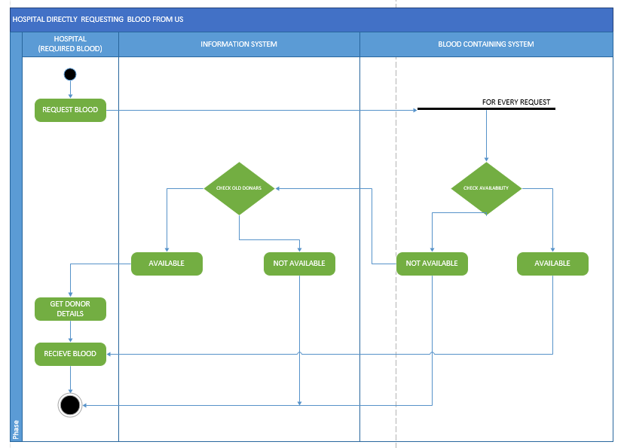**Deliverable 3 : Activity Diagrams**

* Start
* Hospitals who require blood will request
* Blood data system will check the availability : if available then hospital receives blood from us;
* if not available => information system will check the donors for same blood group and the contact details will be provided to hospitals
* They will receive blood from donors
* End

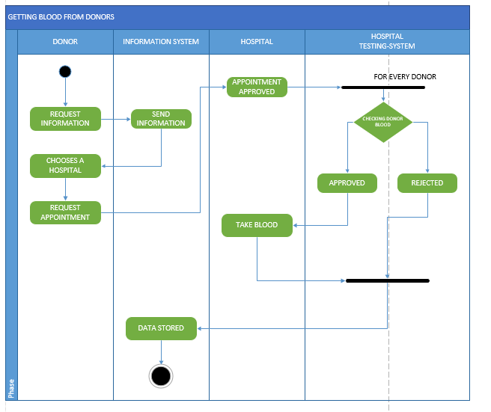

* Start
* Donor will request information about hospitals
* Information system will send information
* Donor will request appointment with the hospital
* Hospital will verify blood and receive it
* System will store the data
* End

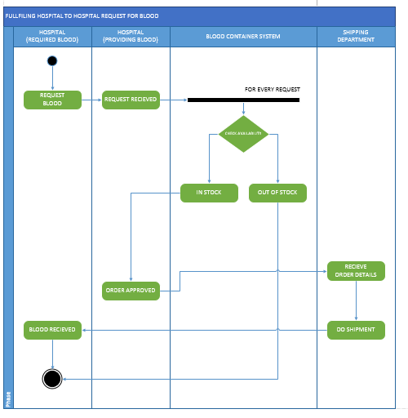

* Start
* Hospital will request blood from another hospital
* Blood data system will check for availability
* Hospital will approve the order
* Details will be sent to shipping department
* Blood will be shipped
* End

1. Accounts Subsytem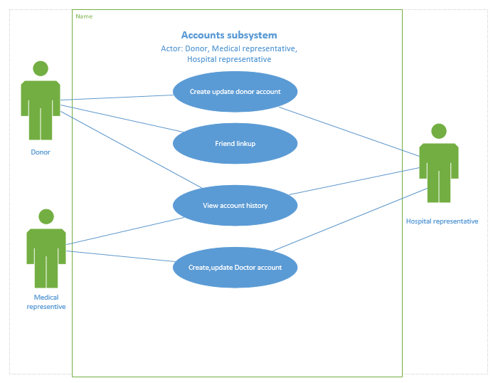
2. Donor Information Subsystem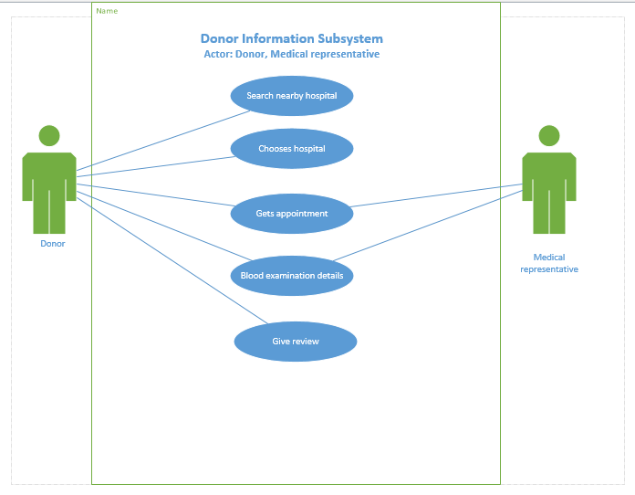
3. Shipping Subsystem

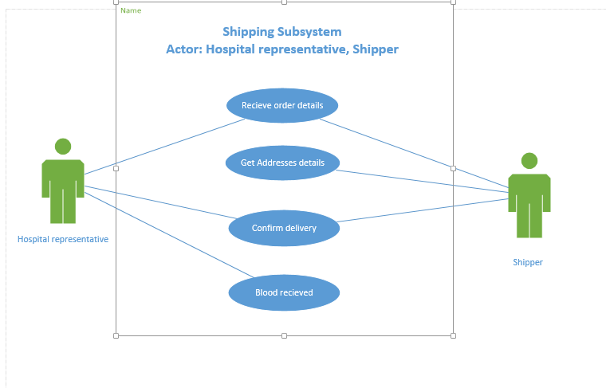

1. Blood Subsystem

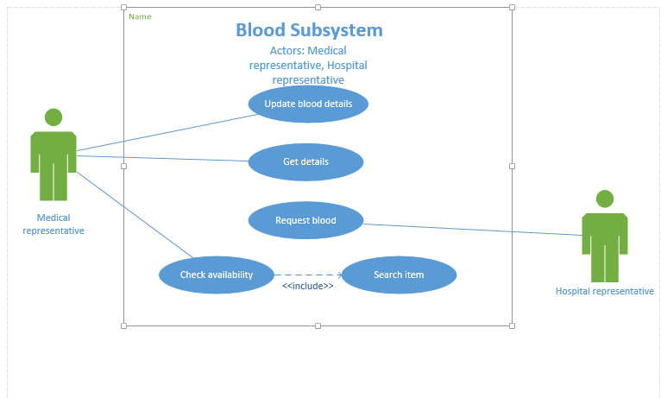

Tables for deliverables 2&3 of Part B

Per subsystem please fill the following table(s)

Table #1

|  |  |  |  |  |
| --- | --- | --- | --- | --- |
| # | Goal use case name | Actor(s) | Brief description | Priority(H,M,L) |
| 1. | Donor information Subsystem | 1. Donor 2. Doctor | In this subsystem, all the information related to the donor will be stored. | High |
| 2. | Accounts Subsystem | 1. Donor 2. Doctor 3. Hospital Representative | In this subsystem, accounts will be created and updated. | Medium |
| 3. | Blood Subsystem | 1. Doctor 2. Hospital Representative | In this subsystem, information related to the blood will be stored. | High |
| 4. | Shipping Subsystem | 1. Shipper 2. Hospital Representative | In this subsystem, information related to the shipment of the blood will be stored. | Medium |

**Domain Class Diagrams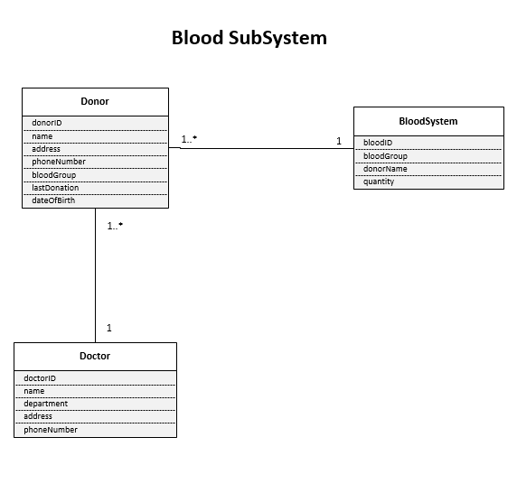Multiplicity –**

1. One blood system can have one or many (optional) donors, while 1 donor can be in only one (mandatory) blood system.
2. One doctor can treat one or many (optional) donor. One donor will be treated by only one (mandatory) doctor.

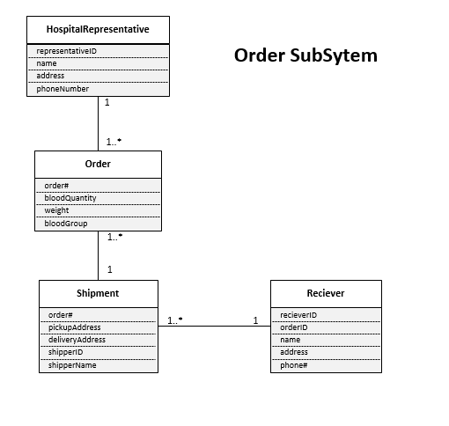

**Multiplicity –**

1. One hospital representative can process one or many (optional) orders, an order can be processed by only one (mandatory) representative.
2. One shipment can take one or many (optional) orders while one order can be taken by only one (mandatory) shipment.
3. One receiver can receive one or many (optional) orders while one (mandatory) shipment can be received.

**ER Diagrams**

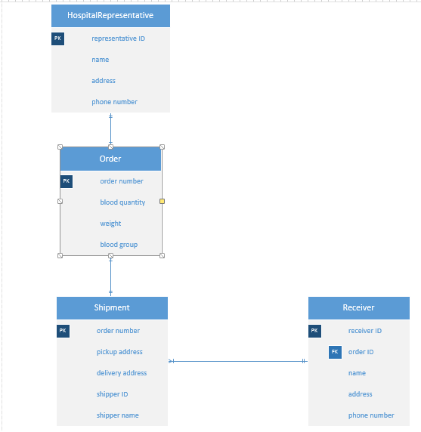Order Subsystem

Blood subsytem

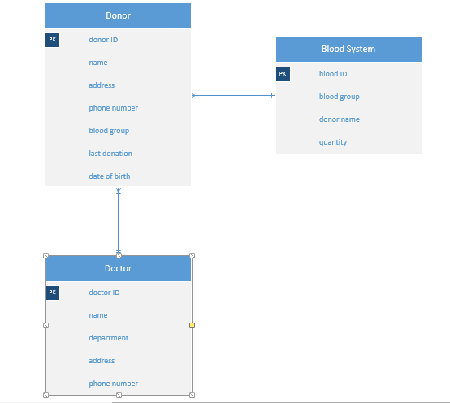

CLASS DIAGRAM

# Blood Subsystem

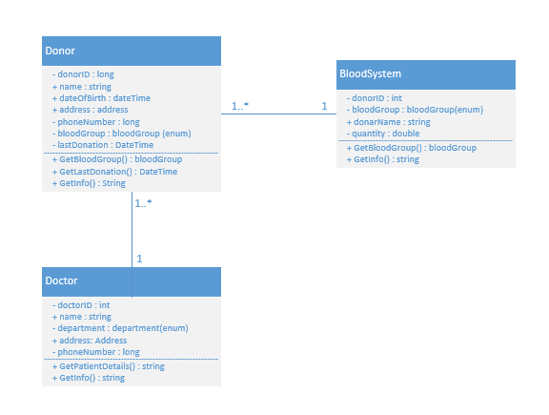

# Order SubSystem

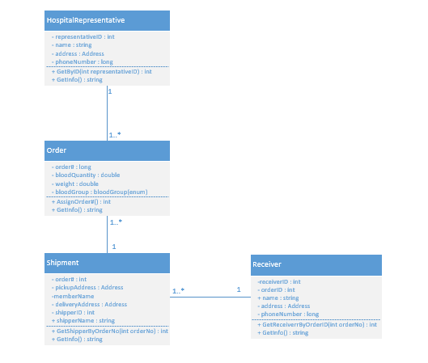

System Sequence Diagram

## SSD FOR BLOOD SYSTEM

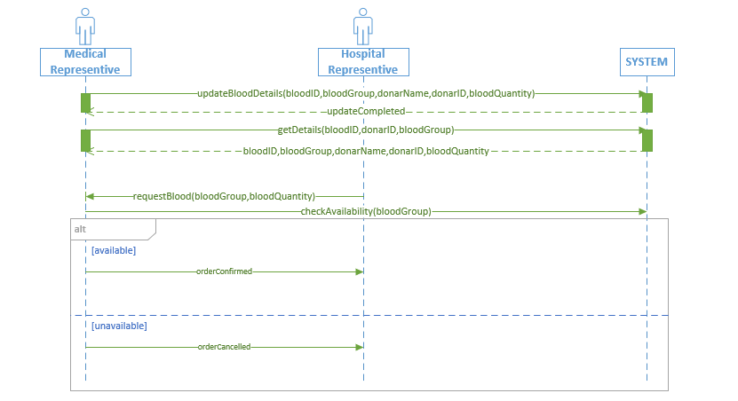

# SSD FOR SHIPPING SUBSYSTEM

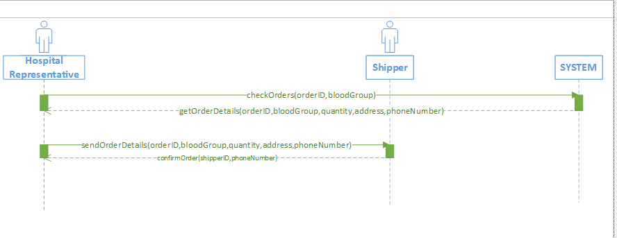

STATE MACHINE DIAGRAMS

# SMD FOR NEW DONAR

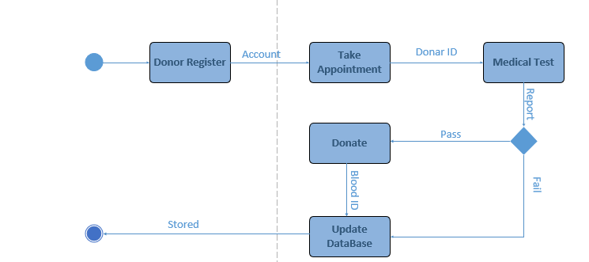

# SSD FOR NEW ORDER

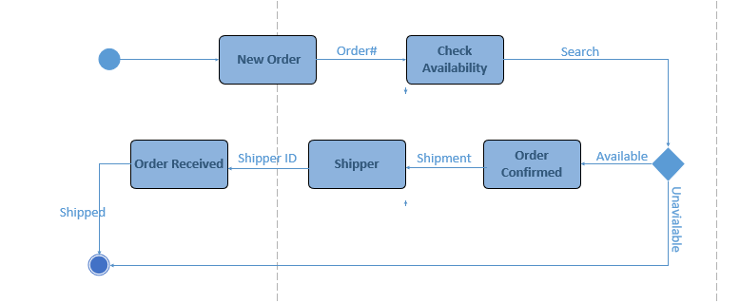

### GANTT CHART

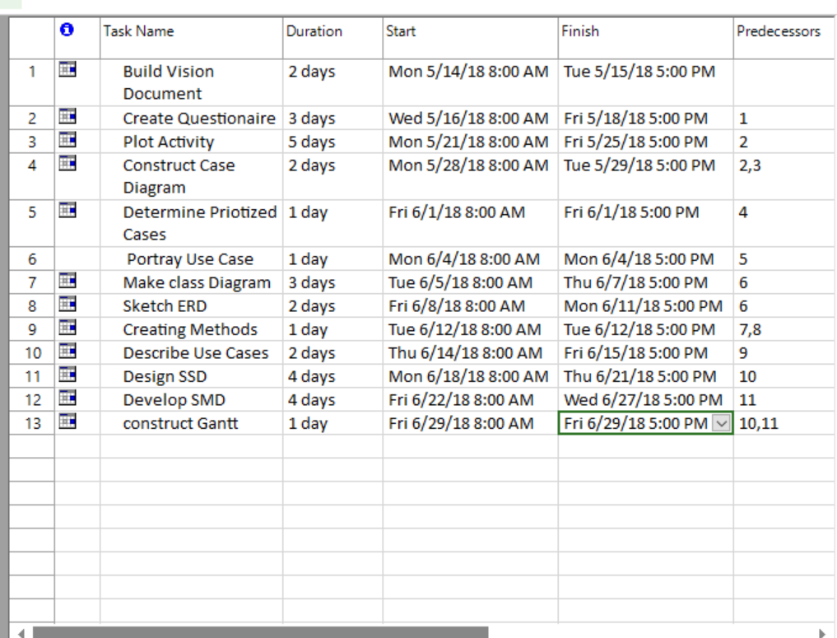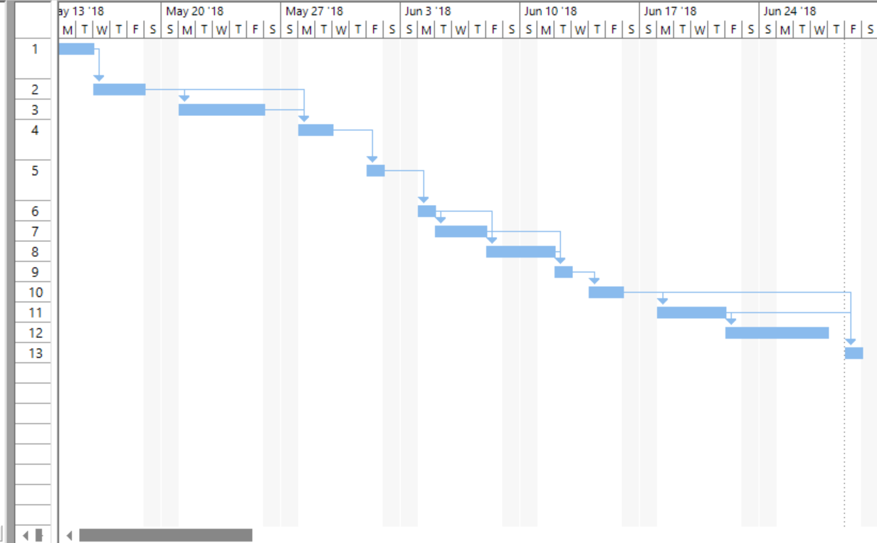

**By:**

**Aaqil Shaikh: 300934038,**

**Dushant Chauhan: 300983781,**

**Keshav Anand Singh: 300988081,**

**Rishav Mahajan: 300988104**