**Assignment** : 6

**Q1. Implement IPC between a parent and a child process where parent will print a message received from the child, who will take the message as user input. Use un-nnamed pipe for IPC.**

#CODE :

#include <stdio.h>

#include <unistd.h>

#include <string.h>

int main() {

int fd[2];

pid_t pid;

char message[100];

if (pipe(fd) == -1) {

perror("Pipe creation failed");

return 1;

}

pid = fork();

if (pid < 0) {

perror("Fork failed");

return 1;

}

if (pid == 0) {

close(fd[0]);

printf("Child: Enter a message: ");

fgets(message, sizeof(message), stdin);

message[strcspn(message, "\n")] = 0;

write(fd[1], message, strlen(message) + 1);

close(fd[1]);

} else {

close(fd[1]);

read(fd[0], message, sizeof(message));

close(fd[0]);

printf("Parent: Received message - \"%s\"\n", message);

}

return 0;

}

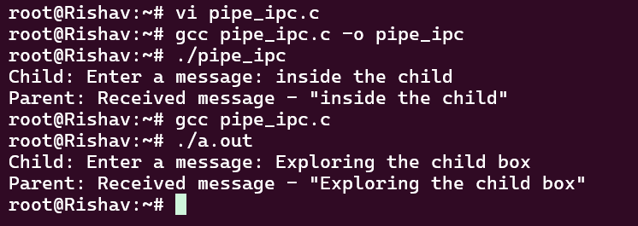

**Q2. Implement IPC between two processes where proceess-1 will take two strings as user input and send them to process-2. Process-2 will compare them and return the result ("SAME" or "NOT SAME") back to process-1. Use FIFO for IPC.**

#CODE : (fifo_writer.c)

#include <stdio.h>

#include <stdlib.h>

#include <string.h>

#include <fcntl.h>

#include <unistd.h>

int main() {

char str1[100], str2[100], result[10];

int fd1 = open("fifo1", O_WRONLY);

if (fd1 == -1) {

perror("Error opening fifo1");

exit(1);

}

printf("Enter first string: ");

fgets(str1, sizeof(str1), stdin);

str1[strcspn(str1, "\n")] = 0;

printf("Enter second string: ");

fgets(str2, sizeof(str2), stdin);

str2[strcspn(str2, "\n")] = 0;

write(fd1, str1, sizeof(str1));

write(fd1, str2, sizeof(str2));

close(fd1);

int fd2 = open("fifo2", O_RDONLY);

if (fd2 == -1) {

perror("Error opening fifo2");

exit(1);

}

read(fd2, result, sizeof(result));

close(fd2);

printf("Comparison Result: %s\n", result);

return 0;

}

#CODE : (fifo_reader.c)

#include <stdio.h>

#include <stdlib.h>

#include <string.h>

#include <fcntl.h>

#include <unistd.h>

int main() {

char str1[100], str2[100], result[10];

int fd1 = open("fifo1", O_RDONLY);

if (fd1 == -1) {

perror("Error opening fifo1");

exit(1);

}

read(fd1, str1, sizeof(str1));

read(fd1, str2, sizeof(str2));

close(fd1);

printf("Process 2 (Reader) received:\n");

printf("String 1: %s\n", str1);

printf("String 2: %s\n", str2);

if (strcmp(str1, str2) == 0)

strcpy(result, "SAME");

else

strcpy(result, "NOT SAME");

printf("Comparison result: %s\n", result);

int fd2 = open("fifo2", O_WRONLY);

if (fd2 == -1) {

perror("Error opening fifo2");

exit(1);

}

write(fd2, result, sizeof(result));

close(fd2);

return 0;

}

