Goal Statement

Scheduling IT load on Servers such that Use of Non-renewable energy is reduced

Goal

Given a set of data centers, whenever a request is made, schedule that load to a Data center depending on following factors:
-minimize the power consumption cost
-minimize the use of non renewable energy

Gap Analysis

Currently there are algorithms present which could balance the load efficiently amongst the servers.
This project aims to improve upon the current process & include a “Renewable Energy” parameter during the job scheduling process so that the utilisation of non renewable energy is reduced.

Tools & Technology

Technology: Language : Python,Django (For forwarding and receving the request )
Library : Numpy,Pandas,Scipy,metaplot lib.,for machine learning to Predict Load and Energy.
Model : KNN algorithm(For both Load and Energy pridiction).

Tools : Anaconda(Jupyter Notebook),Eclipse,Git,Latex;

Architecture

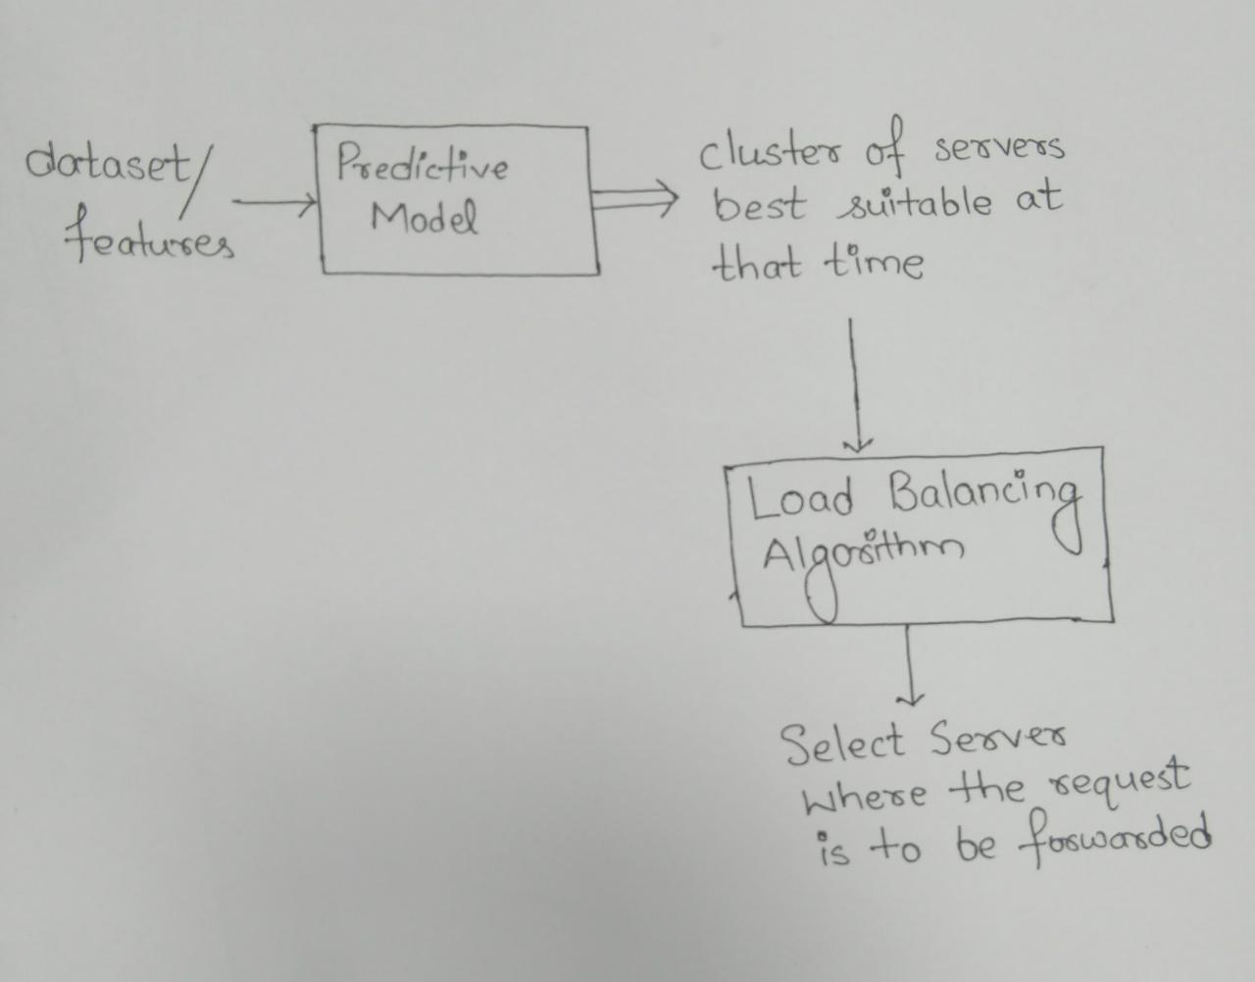

Milestones

1 | Read and understand research work already done in this area | 17 Jan, 2018
2 | Data Collection | 31 Feb, 2018
3 | Data Visualisation | 14 Feb, 2018
4 | Create Prediction Model | 07 March, 2018
5 | Load Distribution Algo | 21 March, 2018
6 | Testing and Final touch | 14 April, 2018

Predicted
Load-Energy
Pair
Historical Data
Load Prediction Module
Renewable Energy Prediction Module
Transmit to Master
Historical Data

Master
Receiving and Saving Module
Data from diff. Data Centers
Load-Energy pair from all Data Centers
Load Forwarding Module
Requests
Preferrable Server Selected and load forwarded

