

**Department of computer science (BCA)**

B.S.K College Barharwa, Sahibganj, Jharkhand, 816101

Bachelor of Computer Applications (BCA)

A

Project Report

On

Clothify.

**A thesis submitted in partial fulfillment of the requirements for the degree of**

**Bachelor of Computer Applications (BCA)**

**A Report Project:**

Under the Guidance of

**Mr. Jayant Kumar**

Dept. of BCA

B. S. K. College, Barharwa

**Submitted By:**

**Group Leader: Rishav Raj (216011342482)**

**Members:  Sneha Sinha (216011342484)**

**Waquar Hasan (216011342487)**

**Aayush Kumar(216011342475)**

**BCA (Session: 2021-2024)**

## DECLARATION

This is to declare that this project report title "Clothify." has been developed by me along with other project members for the major project of final semester of Bachelor of Computer Application (BCA) of U-G, Department of BCA B.S.K College, Barharwa.

We have declared that this project is own work by the best of knowledge and belief. This project has never been submitted to any University of Institute for the partial fulfillment of the award of any degree of diploma.

**Group Leader: Rishav Raj**

**Members: Sneha Sinha**

**Waquar Hasan**

**Aayush Kumar**

**BCA (Session: 2021-2024)**



Department Of Computer Science (BCA)

B. S. K. College Barharwa, Sahibganj, Jharkhand,816101

CERTIFICATE

This is to certify that the work embodies in this dissertation entitled " Clothify." being submitted by "Rishav Raj, Sneha Sinha, Waquar Hasan, Aayush Kumar " for partial fulfilment of the requirement for the degree of "Bachelor of Computer Application (BCA)" discipline to B.S.K College, Barharwa, during the academic year 2021-24 is a record of bonafide piece of work, carried out by him under the supervision and guidance of " **Mr. Jayant Kumar**", Department of BCA, B.S.K College, Barharwa.

Project guide External examiner

ACKNOWLEDEGEMENT

I would like to express my deepest appreciation to all those who provided me the possibility to complete this project. A special gratitude I give to my respected guide **Mr. Jayant Kumar**, department in BCA in B.S.K COLLEGE BARHARWA under SKMU, whose contribution in stimulating suggestions and encouragement helped me to coordinate my project especially in writing this report.

Furthermore, I would also like to acknowledge and thanks to **Mr. Jayant Kumar**, HOD of BCA department, all faculty members and staff for providing me all the facilities and for their support to all activities, and gave the permission to use all required equipment and the necessary materials to complete the Project.

This project is made by our group **Rishav** **Raj, Sneha Sinha, Waquar Hasan, Aayush Kumar** together. Last but not the least I would like to thanks all my classmates of Bachelor of Computer Application (BCA) batch 2021-2024 for their co-operation and support.

**Submitted By:**

**Group Leader: Rishav Raj**

**Members: Sneha Sinha**

**Waquar Hasan**

**Aayush Kumar**

**BCA (Session: 2021-2024)**

**Table Of Contents**

|  |  |  |
| --- | --- | --- |
| **Sl No.** | **Content** | **Page.no** |
| 1. | Introduction | 7 |
|  | 1.1 Purpose |  |
| 2. | System Features | 8 |
|  | 2.1 Modules |  |
|  | 2.2 Users |  |
|  | 2.3 Advantages |  |
|  | 2.4 Applications |  |
| 3. | Requirement specifications | 12 |
|  | 3.1 Hardware requirements |  |
|  | 3.2 Software requirements |  |
| 4. | Technology Used  used | 14 |
|  | 5.1 Front-End |  |
|  | 5.1.1 HTML |  |
|  | 5.1.2 CSS |  |
|  | 5.1.3 Javascript |  |
|  | 5.2 Back-End |  |
|  | 5.2.1 PHP |  |
|  | 5.2.2 Mysql |  |
| 5. | Database Design | 18 |
| 6. | Functional decomposition diagram | 22 |
| 7. | Data flow diagram | 29 |
| 8. | SDLC | 32 |
| 9. | Input & output snapshots | 40 |
| 10. | Conclusion | 42 |

**INTRODUCTION**

INTRODUCTION

**Clothify** is an online clothing store that redefines the shopping experience by offering customers a convenient, user-friendly platform to explore, select, and purchase fashionable clothing from the comfort of their homes. With just a few clicks, users can browse through a wide variety of trendy apparel, customize their choices by selecting sizes, colours, and styles, and seamlessly place orders.

Clothify provides a hassle-free shopping experience by allowing users to easily filter products, read detailed descriptions, and view high-quality images of clothing items. The platform ensures secure payment methods, along with prompt and reliable delivery services, making it a go-to solution for fashion enthusiasts looking to upgrade their wardrobe without the stress of traditional shopping.

With a diverse range of clothing options—from casual wear to formal attire—Clothify caters to various fashion needs, making it easy for customers to find the perfect outfit for any occasion. The platform enhances the joy of shopping by delivering quality, style, and convenience, all in one place.

**Objectives**

The primary objectives of Clothify are:

1. **Convenience:** Allow customers to browse and shop for clothing at any time, from anywhere.
2. **Product Variety:** Offer a wide range of clothing items, including casual, formal, and seasonal collections to meet diverse fashion needs.
3. **Secure Transactions:** Ensure the safety of all financial transactions with encrypted payment gateways.
4. **Customer Engagement:** Enable users to leave product reviews, create Wishlist’s, and track their order history to build long-term relationships with the platform.

**SYSTEM FEATURES**

**2. System Features**

**2.1 Modules**

**2.1.1 Design and Backend**

* **Create Home Page:**
  + A visually appealing landing page featuring featured products, promotions, and categories.
* **Create Category Page:**
  + A page to showcase different clothing categories (e.g., Men, Women, Kids, Accessories) with filters for size, color, and style.
* **Create Profile:**
  + A user profile section where customers can manage their information and preferences.
* **Create About Us Page:**
  + Information about Clothify, its mission, and values.
* **Create Contact Us Page:**
  + A page with a contact form, email address, and phone number for customer inquiries.
* **Create Registration/Login Page:**
  + Pages for user registration and login to access the platform.
* **User Verification:**
  + An email or SMS verification system to confirm user identity during registration.

**2.1.2 Profile Management**

* **Edit Name and Number:**
  + Users can update their name and contact number in their profiles.
* **My Orders:**
  + A section to view past and current orders, including order status and tracking information.
* **Address Management:**
  + Options to add, edit, or delete shipping addresses.
* **My Reviews:**
  + A feature for users to view and manage their product reviews.
* **Logout:**
  + Option for users to securely log out of their accounts.

**2.1.3 Cart**

* **Add to Cart/Buy:**
  + Users can add products to their shopping cart or proceed to buy directly.
* **Checkout:**
  + A streamlined checkout process for users to review their cart and proceed to payment.
* **Payment:**
  + Integration of secure payment gateways for processing transactions.
* **Place Order:**
  + Confirmation of order placement, followed by a summary of the order details.

**2.1.4 Admin Panel**

* **Admin Page:**
  + A dashboard for administrators to manage the platform, including user management and analytics.
* **Payment Management:**
  + Oversight of payment transactions and dispute resolution.
* **Order Management:**
  + Tools for managing customer orders, updating statuses, and handling returns.

**2.2 User**

* **Register:**
  + Users must register to create an account for login access.
* **Login:**
  + Users log in to access their accounts and manage purchases.
* **View Profile:**
  + Users can view and edit their profile information.
* **Buy:**
  + Users can select and purchase clothing items from the platform.
* **Payment:**
  + Users can choose from various payment methods, including online payment and cash on delivery.

**2.3 Advantages**

* **Convenience:**
  + Users can shop for clothing anytime and from anywhere.
* **Diverse Selection:**
  + A wide variety of clothing options, styles, and brands available.
* **Customization:**
  + Users can personalize their shopping experience by selecting sizes, colors, and styles.
* **Secure Transactions:**
  + Reliable payment methods ensure safety and security for all financial transactions.
* **Timely Delivery:**
  + Orders are processed and delivered promptly, ensuring customer satisfaction.

**2.4 Applications**

* **Corporate Gifting:**
  + Providing clothing gifts to employees or clients for occasions like holidays and anniversaries.
* **Special Occasions:**
  + Offering clothing for events such as weddings, graduations, and other celebrations.
* **Last-Minute Needs:**
  + Quick and easy orders for last-minute clothing needs or gifts.

**REQUIREMENT**

**SPECIFICATION**

#### Minimum Software Requirement specification

**Operating system- Independent**

**x64 PHP (v7.4.29)**

**MYSQL (v15.1)**

**Apache web server (v2.4.54)**

#### Minimum Hardware Specification:-

**Processor :Intel i3,64bit**

**Clock Speed : 2 GHz**

**RAM : 512 MB**

**HDD : 80 GB**

**Keyboard : 101 Keys**

**Mouse : Optical Mouse**

**TECHNOLOGIES USED**

#### Technologies Used

Front-End

HTML

HTML stands for Hypertext Markup Language. It is a standard markup language for web page creation. It allows the creation and structure of sections, paragraphs, and links using HTML elements (the building blocks of a web page) such as tags and attributes.

###### Example:

<!DOCTYPE html>

<html>

<head>

<title> PCMART.Com </title>

</head>

<body>

Hello World!

</body>

</html>

CSS

CSS stands for Cascading Style Sheets language and is used to stylize elements written in a markup language such as HTML It separates the content from the visual representation of the site. The relation between HTML and CSS is strongly tied together since HTML is the very foundation of a site and CSS is all of the aesthetics of an entire website.

###### Example:

body {

background-color: lightblue;

}

h1 {

color: white;

text-align: center;

}

p {

font-family: verdana;

font-size: 20px;

}

JavaScript

JavaScript is a scripting language for creating dynamic web page content. It creates elements for improving site visitors' interaction with web pages, such as dropdown menus, animated graphics, and dynamic background colors.

###### Example:

1. **<script** type="text/javascript"**>**
2. alert("Hello world");
3. **</script>**

#### Back-End

PHP

Hypertext Preprocessor (PHP) is an open-source, free server-side scripting language widely used in web development. According to Web Technology Surveys, PHP is used by 78.1% of all websites, including high-traffic websites like Facebook and Wikipedia.

###### Example:

1. <!DOCTYPE>
2. **<html>**
3. **<body>**
4. **<?php**
5. echo "**<h2>**Hello World**</h2>**";
6. **?>**
7. **</body>**
8. **</html>**

#### MySQL

MySQL is an open source relational database management system (RDBMS) with a client-server model. RDBMS is a software or service used to create and manage databases based on a relational model. Now, let's take a closer look at each term:

**CREATE TABLE users (**

**id INT AUTO_INCREMENT PRIMARY KEY,**

**username VARCHAR(50) NOT NULL,**

**email VARCHAR(100) NOT NULL**

**);**

**DATABASE DESIGN**

#### Database Design:

**Database Name: Clothify.**

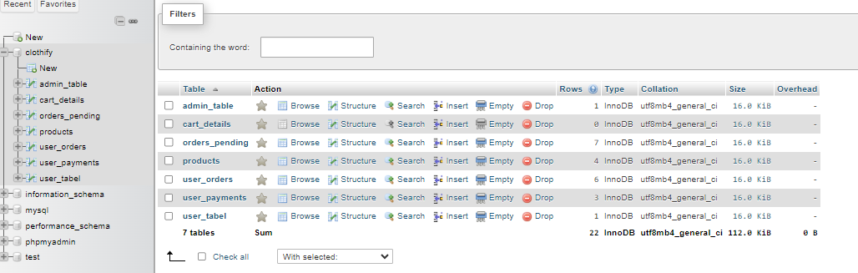

**Table Name: Products**

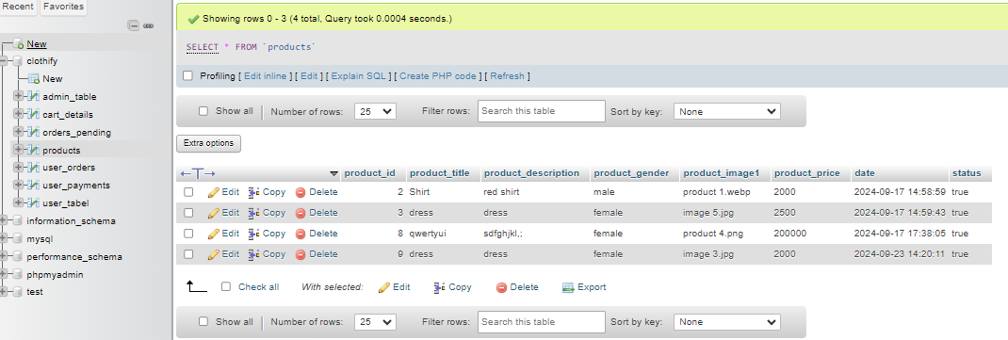

**Table Name: Users_tabel**

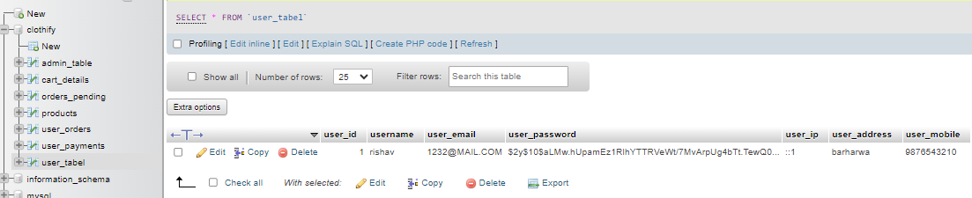

**Table Name: admins_table**

#### 

**Table Name: cart_details**

#### 

**Table Name: user_order**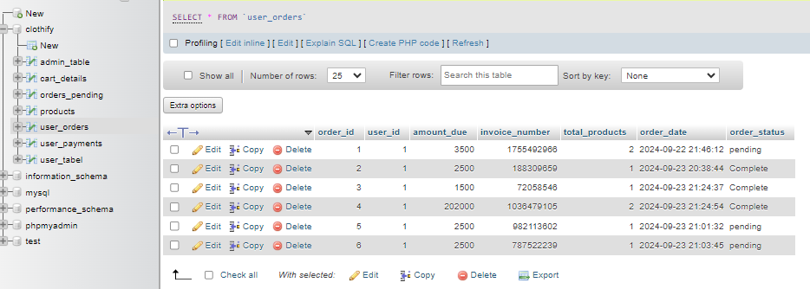

#### 

**Table Name: orders_pending**

**FUNCTIONAL**

**DECOMPOSITION**

**DIAGRAM**

Functional Decomposition Diagram (FDD)

A Functional Decomposition Diagram (FDD) for a cake ordering website is

a visual representation that breaks down the system into its fundamental

functional components. In the context of a cake ordering website, the

FDD would delineate major functions such as user registration, menu navigation,

order placement and payment processing. These functions are organized

hierarchically, with sub-functions detailing specific actions within each major function.

For instance, under "Order Placement, " sub-functions might include

selecting items, specifying quantity, and confirming the order. The diagram

illustrates the interrelationships among these functions, offering a

comprehensive overview of the website's core capabilities. FDD serve as effective

tools for system analysis and design, aiding developers and stakeholders

in understanding the modular structure and functionalities essential for

the seamless operation of the cake ordering website.

**Authentication**

**├── Sign Up**

**└── Login**

**└── Product Browsing**

**├── Browse Categories**

**└── Search Items**

**└── Product Selection**

**├── Select Item**

**├── Specify Quantity**

**└── Add to Cart**

**└── Checkout**

**├── Select Address**

**└── Confirm Order**

**└── Payment**

**├── Choose Payment Method**

**├── Enter Payment Details**

**└── Verify Payment**

**DATAFLOW DIAGRAM**

**Data Flow Diagram (DFD)**

A Data Flow Diagram (DFD) for a cake ordering website is a visual representation showcasing how data moves through various processes in the system. In the context   
of a cake ordering website, the DFD would outline key functions such as user registration, menu exploration, order placement, payment processing, and

delivering product. Arrows depict the flow of data between these processes, highlighting how user inputs, order details, and payment information circulate

within the system. External entities like users, the website's database, and

payment gateways are represented, emphasizing their interaction with the

processes. DFD simplify the understanding of information flow, aiding

developers, analysts, and stakeholders in comprehending the core functionalities

and relationships within the cake ordering website's data ecosystem.

DFD for e-commerce website

**DFD for Overall System:**



**DFD for Admin Authentication:**

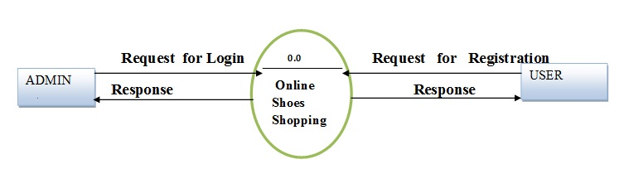

**DFD for Authentication:**

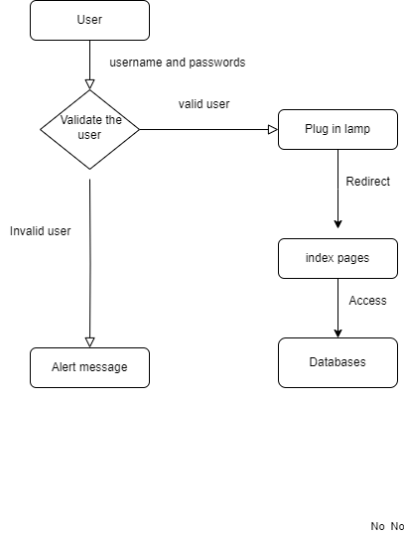

**DFD for user entry:**



**DFD for complete transaction:**

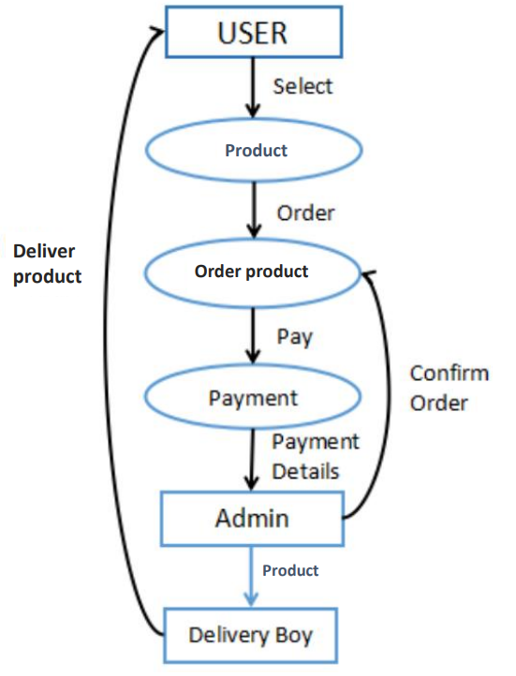

**SDLC**

#### SDLC

Software Development Life Cycle (SDLC) is a process used by the software industry to design, develop and test high quality softwares. The SDLC aims to produce a high-quality software that meets or exceeds customer expectations, reaches completion within times and cost estimates.

* + SDLC is the acronym of Software Development Life Cycle.
  + It is also called as Software Development Process.
  + SDLC is a framework defining tasks performed at each step in the software development process.
  + ISO/IEC 12207 is an international standard for software life-cycle processes. It aims to be the standard that defines all the tasks required for developing and maintaining software.

WATER FALL MODEL

**Winston Royce introduced the Waterfall Model in 1970.This model has five phases: Requirements analysis and specification, design, implementation, and unit testing, integration and system testing, and operation and maintenance. The steps always follow in this order and do not overlap. The developer must complete every phase before the next phase begins. This model is named "Waterfall Model", because its diagrammatic representation resembles a cascade of waterfalls.**

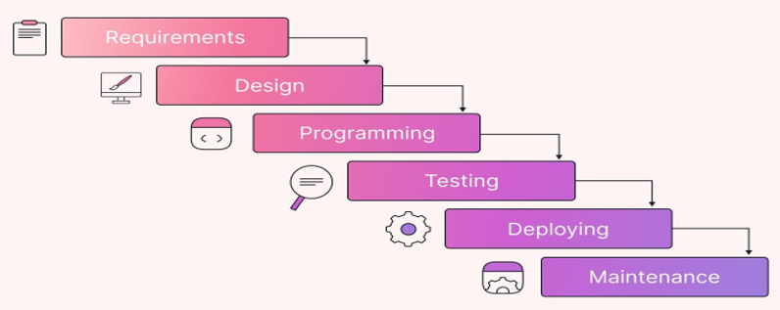

1. **Requirements analysis and specification phase:** The aim of this phase is to understand the exact requirements of the customer and to document them properly. Both the customer and the software developer work together so as to document all the functions, performance, and interfacing requirement of the software. It describes the "what" of the system to be produced and not "how."In this phase, a large document called Software Requirement Specification (SRS) document is created which contained a detailed description of what the system will do in the common language.

**2.** Design Phase:This phase aims to transform the requirements gathered in the SRS into a suitable form which permits further coding in a programming language. It defines the overall software architecture together with high level and detailed design. All this work is documented as a Software Design Document (SDD).

3.Implementation and unit testing:During this phase, design is implemented. If the SDD is complete, the implementation or coding phase proceeds smoothly, because all the information needed by software developers is contained in the SDD.

During testing, the code is thoroughly examined and modified. Small modules are tested in isolation initially. After that these modules are tested by writing some overhead code to check the interaction between these modules and the flow of intermediate output.

**4.Integration and System Testing:** This phase is highly crucial as the quality of the end product is determined by the effectiveness of the testing carried out. The better output will lead to satisfied customers, lower maintenance costs, and accurate results. Unit testing determines the efficiency of individual modules. However, in this phase, the modules are tested for their interactions with each other and with the system.

**5.Operation and maintenance phase:** Maintenance is the task performed by every user once the software has been delivered to the customer, installed, and operational.

**INPUT & OUTPUT**

**SNAPSHOTS**

#### Home Page

A home page is the top-level page of a website and is typically the first page that visitors will see when they arrive at a website. The home page usually contains an overview of the website, as well as links to the other pages within the website.

#### Carousels

Carousels let you display text, graphics, images, and even video in one interactive, “sliding” block.

Source Code:

<div class="banner">

        <img src="images/image1.jpg" alt="Banner" class="banner-image">

        <div class="banner-text">

            <h1>Welcome to Our Clothing Store</h1>

            <p>Discover the best fashion trends for all seasons!</p>

            <a href="#" class="btn">Shop Now</a>

        </div>

    </div>

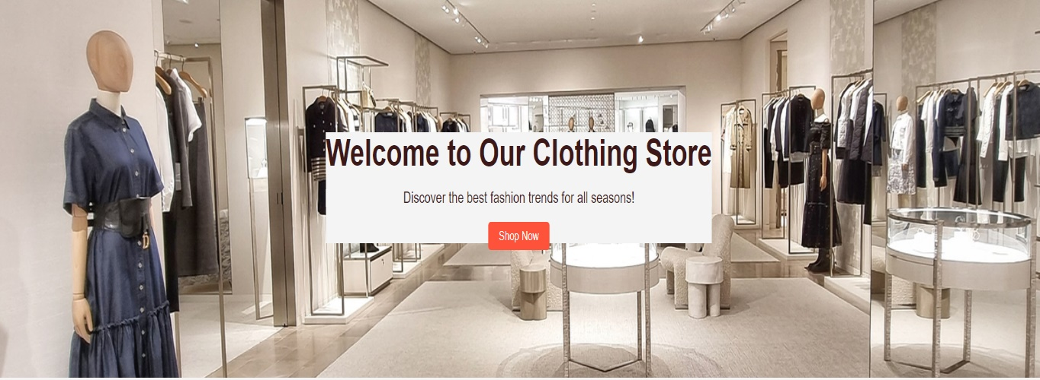

#### About Us Page

In this section users will know about our Product Reviews and Developer Message etc.

Source Code:

<body>

    <?php

    include('HF/main_header1.php')

    ?>

        <div class="heading">

            <h1>About Us</h1>

            <p>Elevate your style with fashion store: Where fashion meets passion.</p>

        </div>

        <div class="container">

            <section class="about">

                <div class="about-image">

                    <img src="about image.jpg">

                </div>

                <div class="about-content">

                    <h2>Elevate your style</h2>

                    <p>This clothing brand emphasizes its sustainability and mission to bring sustainable

                        fashion to everyone.They use a simple design and a striking slogan to distinguish

                        themselves feom last fashion brands.</p>

                        <a href="" class="read-more">Read More</a>

                </div>

            </section>

        </div>

    </body>

</html>

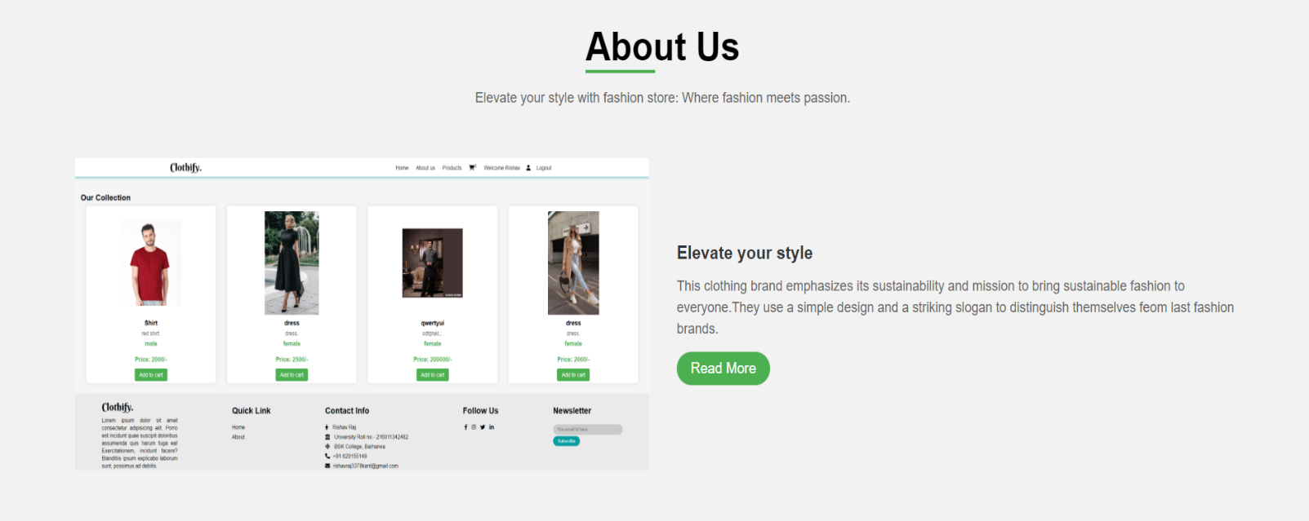

#### Registration Page

Source Code:

<form action="" method="post">

      <h3>Register Now.</h3>

      <input type="text" name="name" required placeholder="enter your username" maxlength="20"  class="box">

      <input type="email" name="email" required placeholder="enter your email" maxlength="50"  class="box" oninput="this.value = this.value.replace(/\s/g, '')">

      <input type="password" name="pass" required placeholder="enter your password" maxlength="20"  class="box" oninput="this.value = this.value.replace(/\s/g, '')">

      <input type="password" name="cpass" required placeholder="confirm your password" maxlength="20"  class="box" oninput="this.value = this.value.replace(/\s/g, '')">

      <input type="submit" value="register now" class="btn" name="submit">

      <p>Already have an account?</p>

      <a href="user_login.php" class="option-btn">Login Now.</a>

   </form>

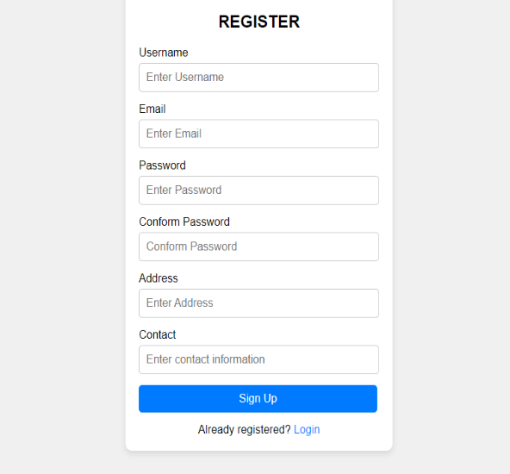

#### Login Page

Source Code:

   <form action="" method="post">

      <h3>Login Now</h3>

      <input type="email" name="email" required placeholder="enter your email" maxlength="50"  class="box" oninput="this.value = this.value.replace(/\s/g, '')">

      <input type="password" name="pass" required placeholder="enter your password" maxlength="20"  class="box" oninput="this.value = this.value.replace(/\s/g, '')">

      <input type="submit" value="login now" class="btn" name="submit">

      <p>Don't have an account?</p>

      <a href="user_register.php" class="option-btn">Register Now.</a>

   </form>

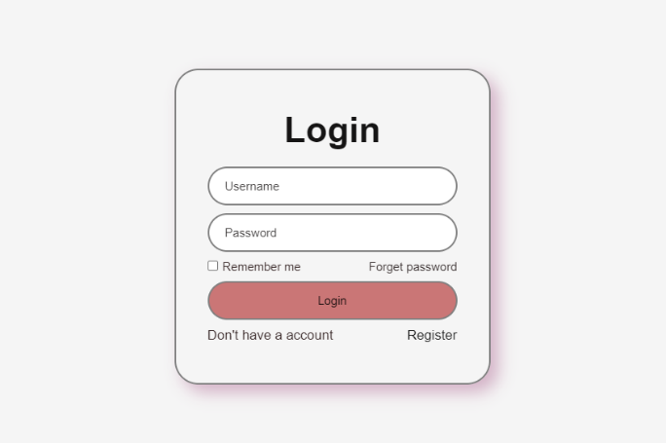

**Our collection:**

<!DOCTYPE html>

<html lang="en">

<head>

    <meta charset="UTF-8">

    <meta name="viewport" content="width=device-width, initial-scale=1.0">

    <title>clothify Store | collection </title>

    <link rel="stylesheet" href="styles/style3.css">

</head>

<style>.cloth-item img {

        width: 200px;

        height: 300px;

        object-fit: contain;

}</style>

<body>

    <?php

    cart();

    ?>

    <!-- cloth Collection -->

    <div class="container">

        <h2>Our Collection</h2>

        <!-- displaying the products -->

        <div class="cloth-collection">

        <!-- product function -->

            <?php

                getproducts();

        // this is function to show the product in collection page

            ?>

            <!-- end -->

        </div>

    </div>

</body>

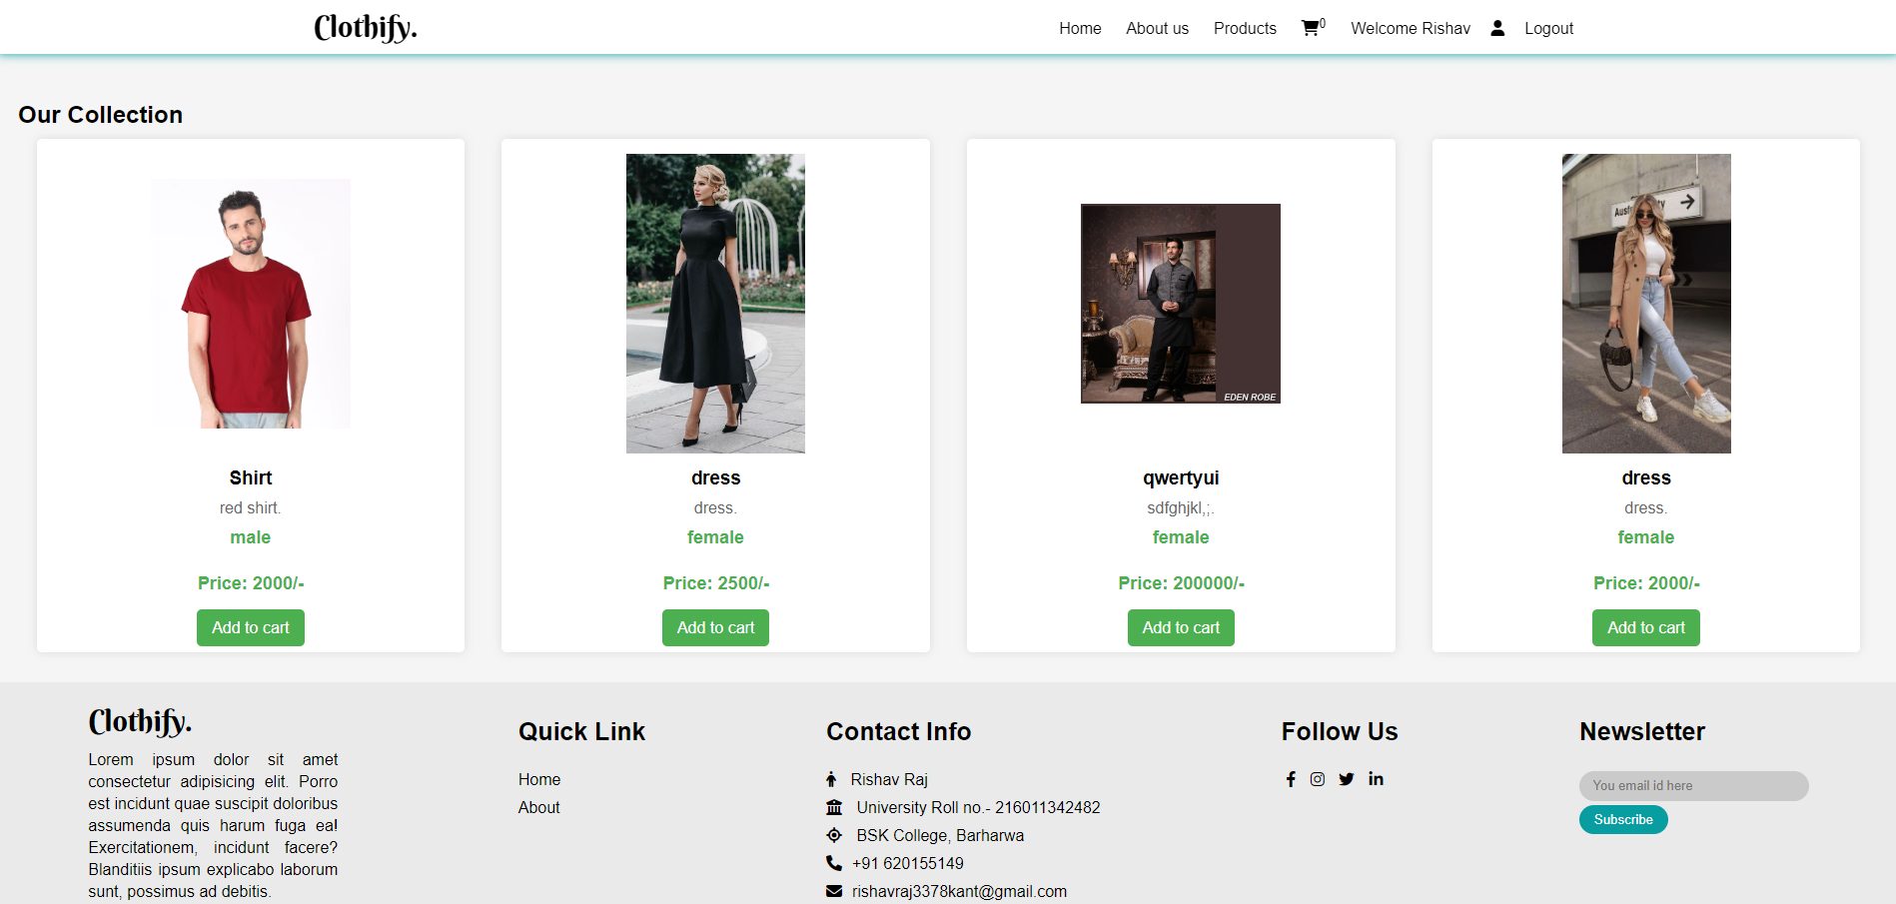

#### Admin Panel:

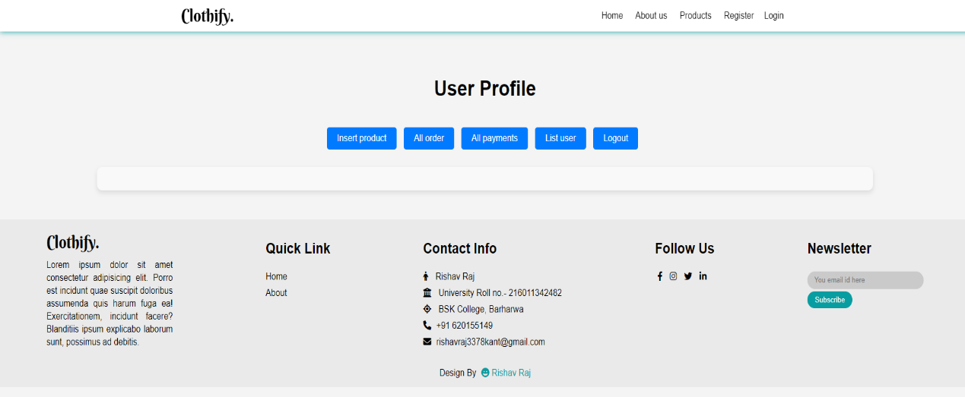

**Insert product:**

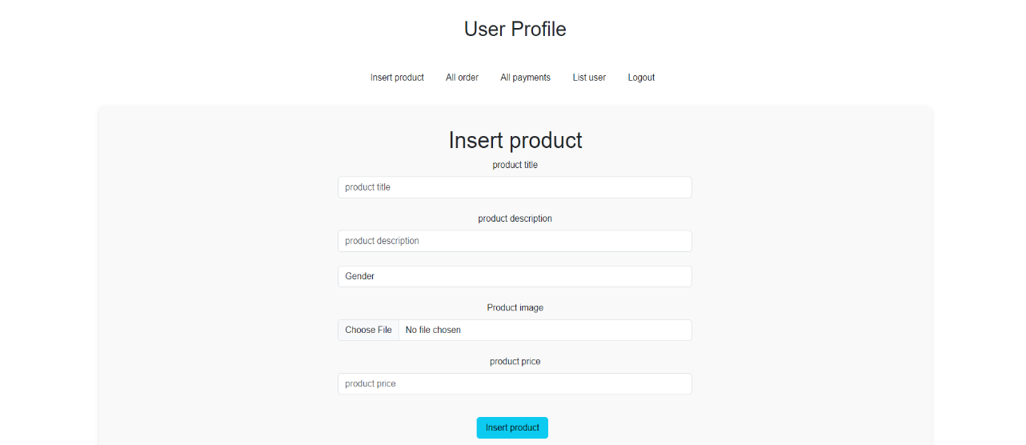

User orders:

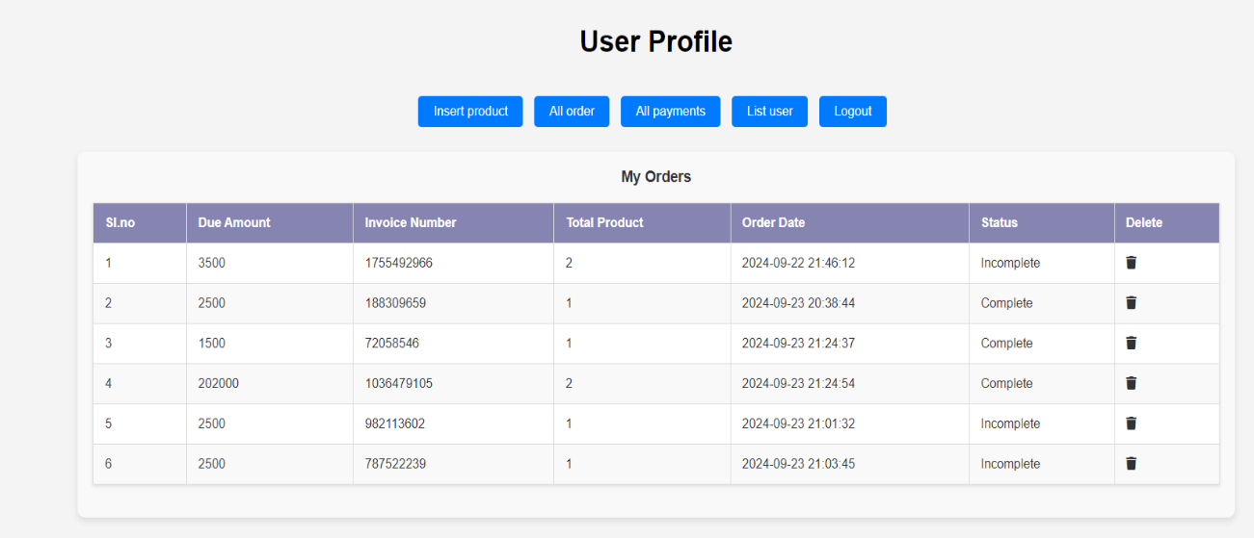

**ER DIAGRAM**

ER Diagram

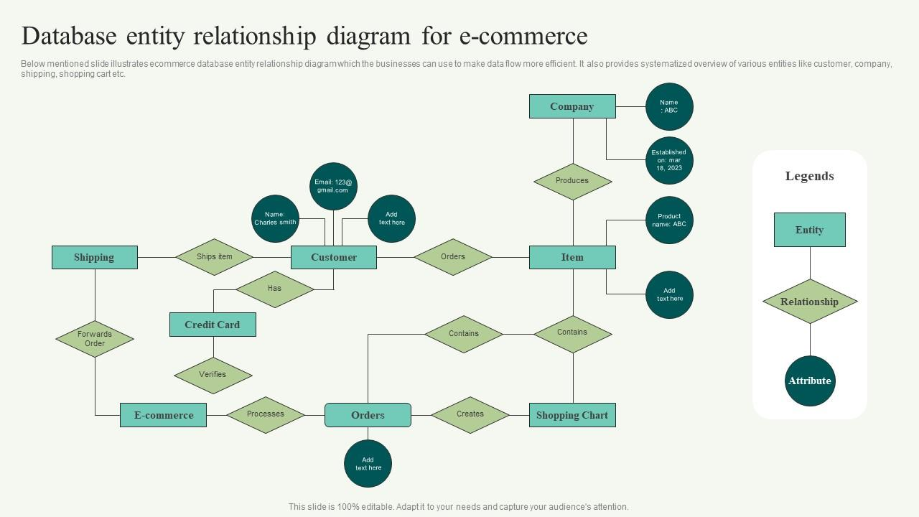

**CONCLUSION**

Conclusion:

Clothify. emerges as a leading destination for online clothing shopping, providing customers with an effortless and enjoyable shopping experience. With an extensive selection of stylish apparel for men, women, and children, along with competitive pricing, Clothify. ensures that fashion enthusiasts can easily discover the latest trends and timeless classics to suit their personal style.

Supported by exceptional customer service and fast, secure shipping, Clothify. is dedicated to delivering satisfaction at every turn. Whether you're refreshing your wardrobe, searching for the perfect outfit for a special occasion, or simply indulging in a little retail therapy, Clothify. is your ultimate platform for all your clothing needs. Experience the joy of shopping with us today!

**THANK YOU**

**FRONT END**

**BACK END**