Operational Manual for admin

Contents

Opening admin panel: 3

Dashboard: 7

Doctor panel: 8

Adding new doctor: 9

Edit doctor’s details: 12

View doctor’s details: 15

Remove the doctor: 16

Schedule: 18

Add new session: 18

View the session details: 21

Remove the session: 22

Appointment: 22

Delete the appointment: 24

Patients: 25

View detail of patient: 26

Logout: 27

# Opening admin panel:

Click on the Sign in button on the right side of home page.

link to home page: localhost/colab1/index.html

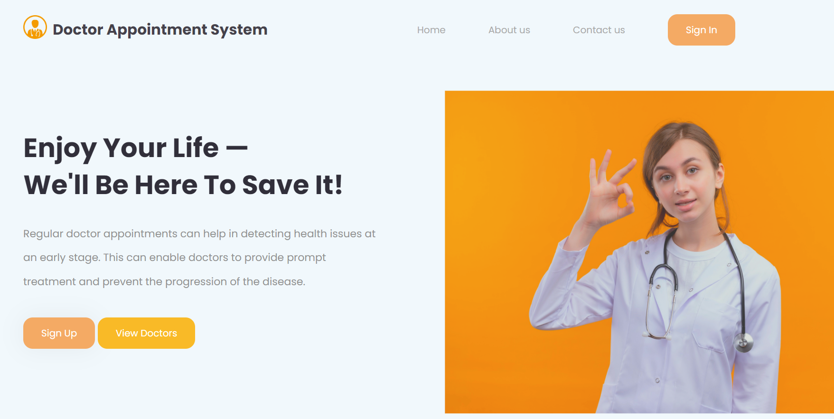



Also, you might go directly to link : localhost/colab1/login.php

This is the login page that will appear after clicking on Sign in button or going to the link:

There is only one email which is valid for admin and you cant create new account for admin:

Email: [admin@gmail.com](mailto:admin@gmail.com)

Password: 123

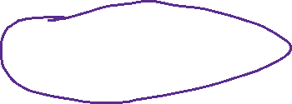

# Dashboard:

After entering email and password click on login button and you will be redirected to page like this:

In dashboard of admin there is nothing to do only some data are shown extracting the number of rows from database table. Now let’s go to the next page for that click on doctor on left side of the page.

# Doctor panel:

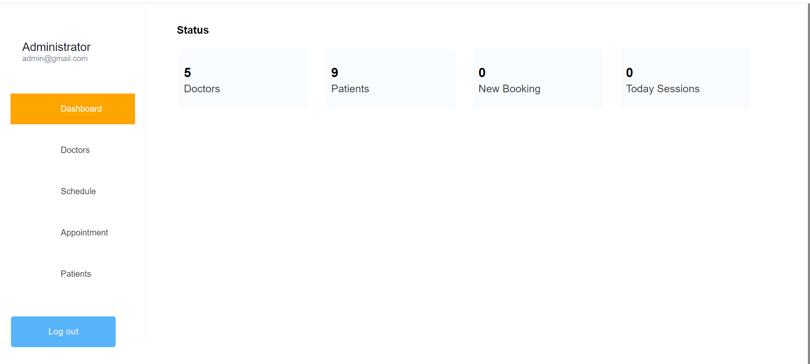



The page should look like this:

# Adding new doctor:

Now to add new doctor you should click on the “Add New” button on top of the page:



Then page like this will appear:

Now fill in all the details and then click on the add button to add a new doctor.

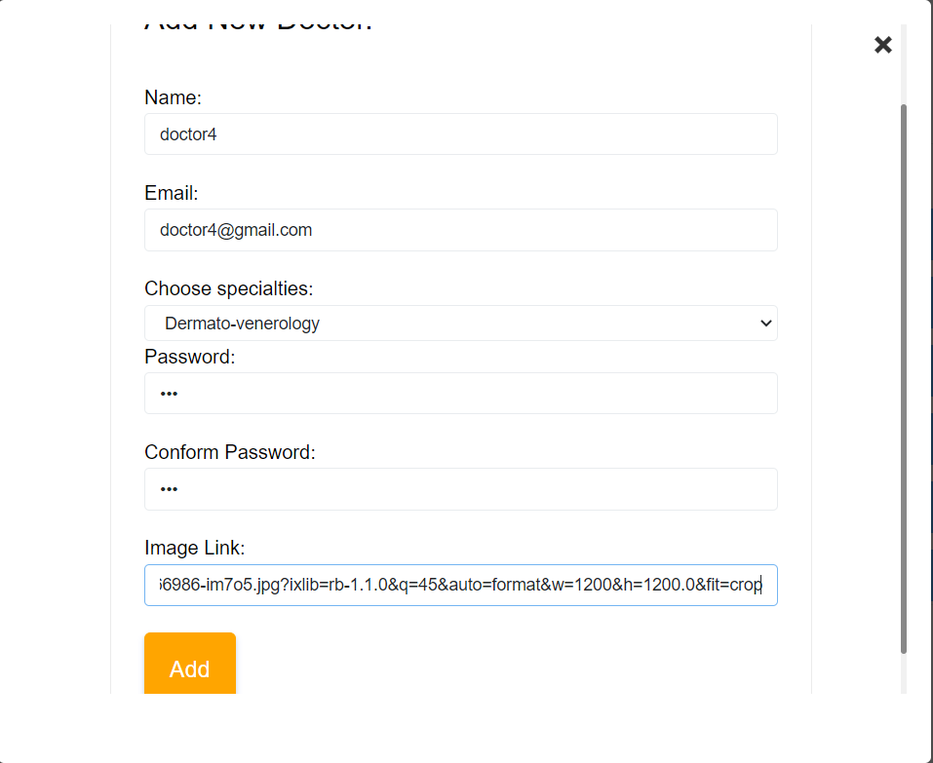



Then if the popup like this appears then your doctor had been added successfully:

# Edit doctor’s details:

Now to edit the doctor’s details click on the edit button:



Page like this will appear and you may change the details after that:  
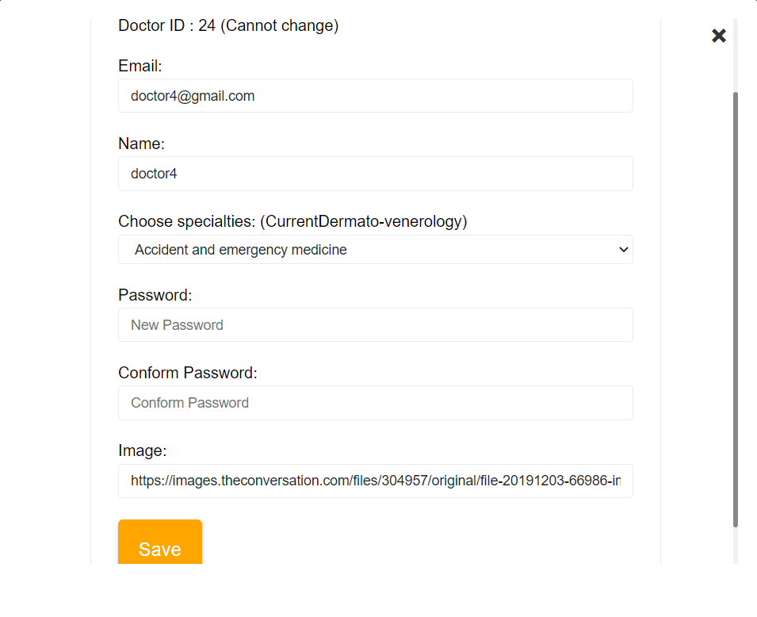

Then edit the details you want and click on the save button:



After that the popup like this will appear showing that the doctor’s details have been edited successfully:



# View doctor’s details:

To view the doctor’s details you may click on the view button:

# Remove the doctor:

To remove the doctor from your system you can click on the remove button:



After which confirmation is asked so that you don’t mistakenly remove any doctor:

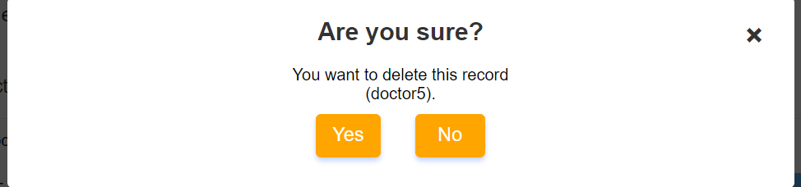

Now click on yes to remove the doctor:



After clicking on yes, the doctor will be permanently removed from your system.

# Schedule:

To go to schedule page click on the schedule on the left side of your page:



After which you should see the page like this:

# Add new session:

To add new session, you may click on the add a session button:



After that you will be directed to this page:

Now fill up all the fiend and then click on place the session button:



Then the popup like this will appear if the session had been added successfully:

# View the session details:

To view the session details, you may click on the view button:  
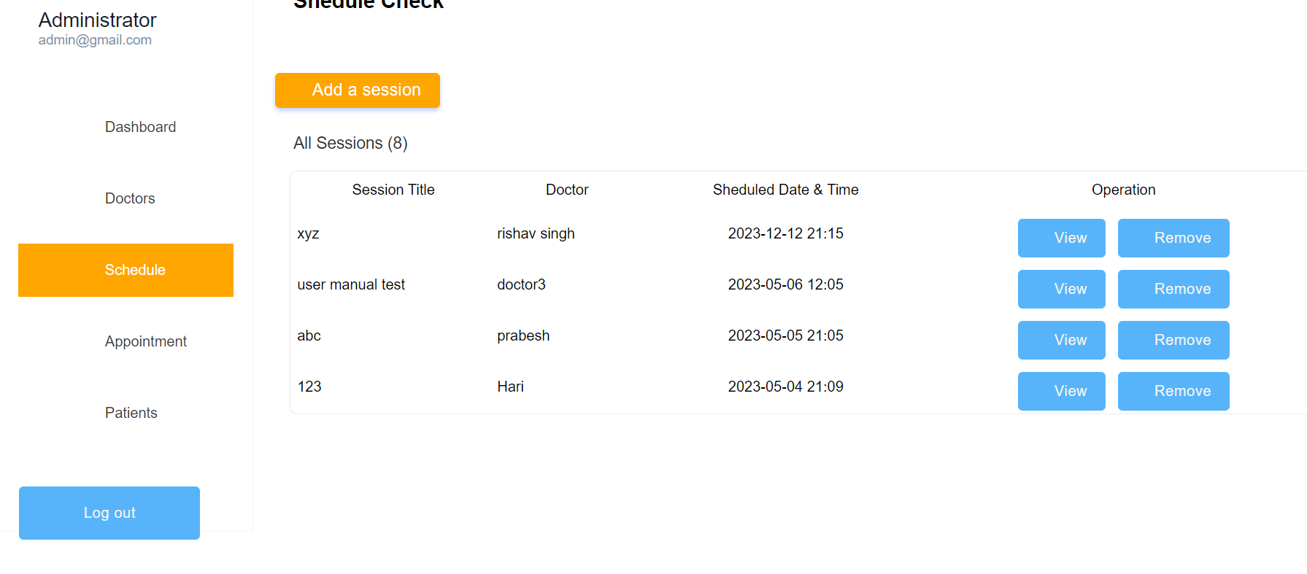



You will see all the details of the session also details of the patient who has placed the booking in this session:

# Remove the session:

Now to remove the session you may click on the remove button:



After clicking on remove there should be popup like this:

Click on yes if you want to delete the session.

# Appointment:

Now to go to appointment page click on the appointment on the left side of the page:

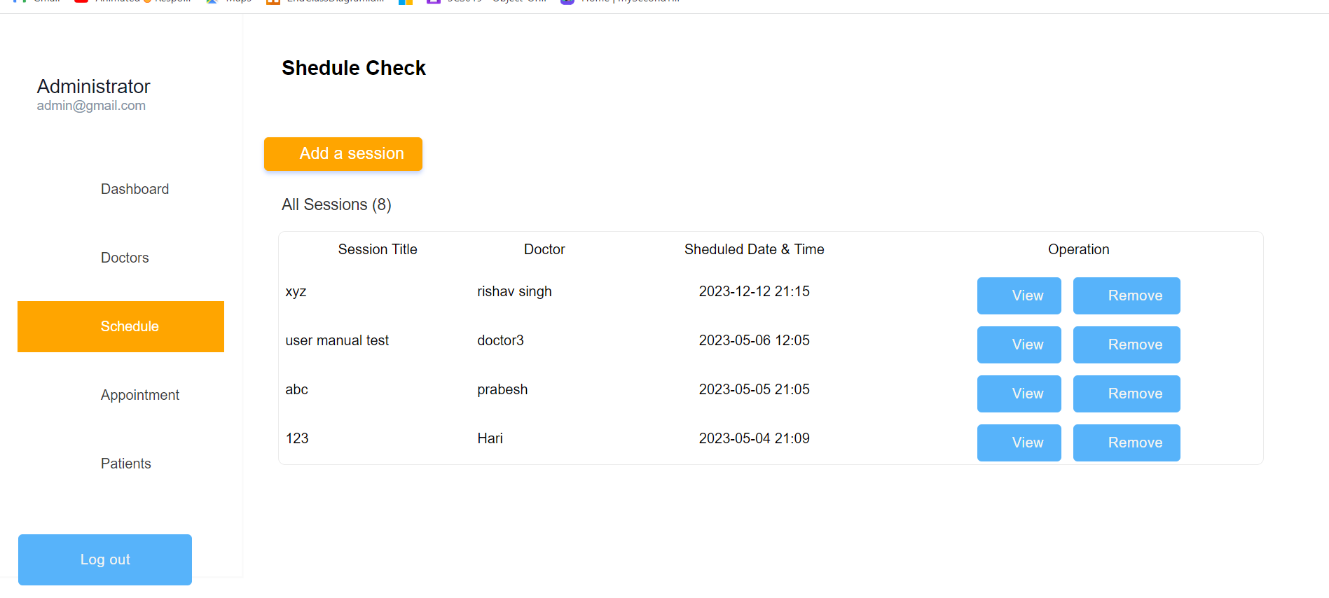



After which page like this should appear:

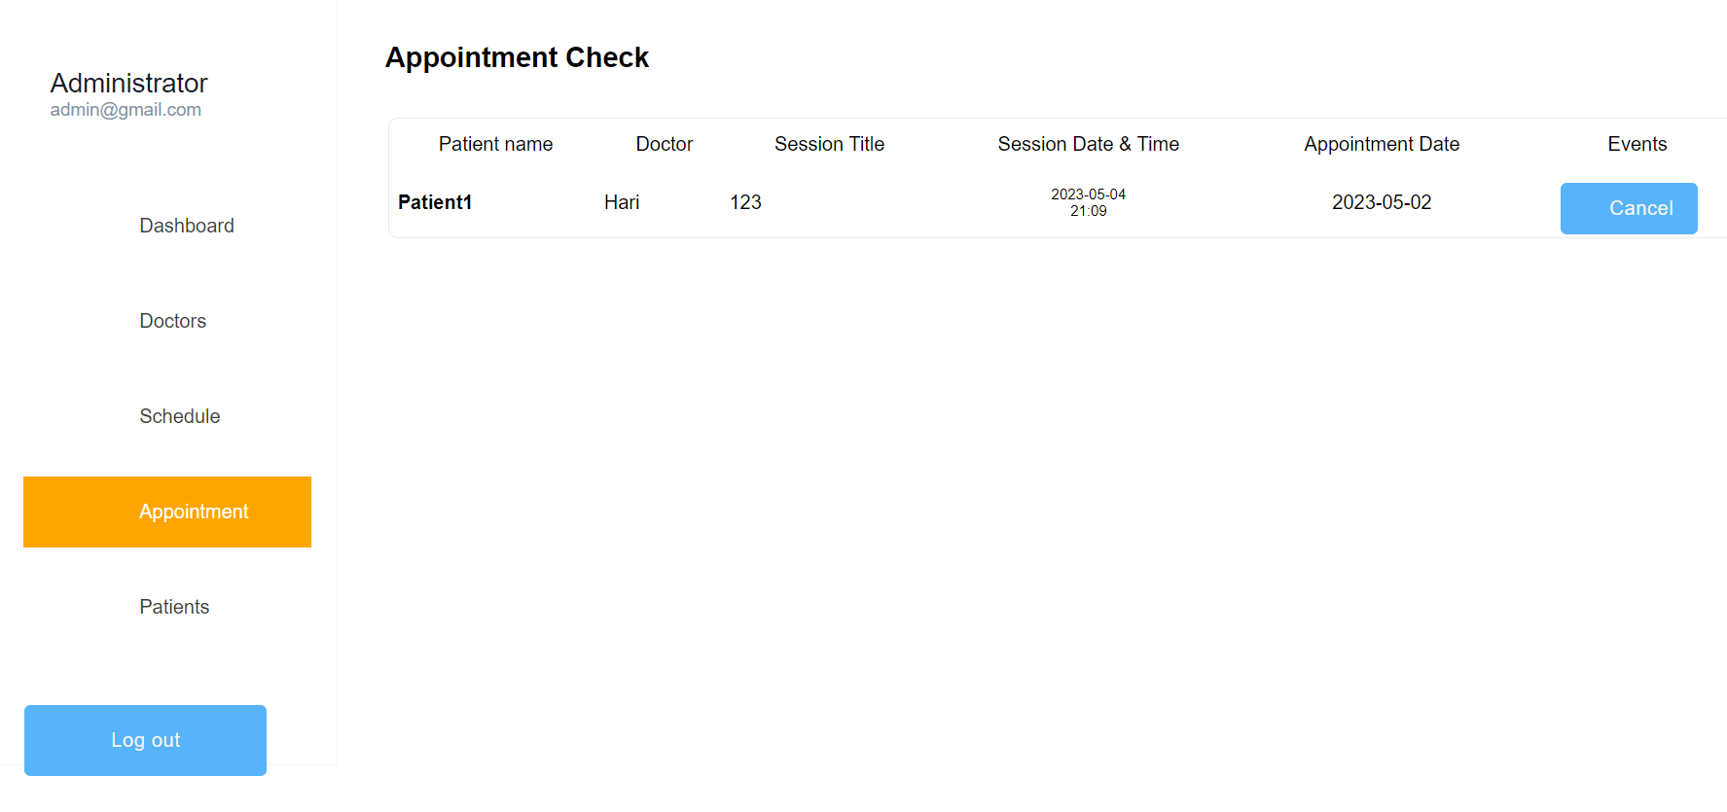

# Delete the appointment:

To delete the appointment click on the cancel button:



After clicking on cancel you should see popup like this:

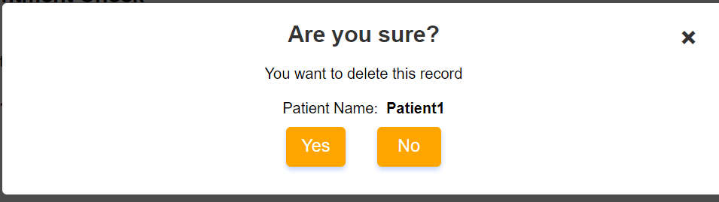

Click on yes to delete the appointment permanently.

# Patients:

To show all the patients list click on patients on left side of the page:



Then you should be redirected to this page:

# View detail of patient:

Here to view the detail of a patient you may click on the view button:



After clicking on view, you should be redirected to page like this:

# Logout:

Finally, to logout from admin panel you may click on the logout button on button left of page:



Then you will be redirected to login page.