IILM UNIVERSITY
B.Tech in Computer Science and Engineering
INTERNSHIP PROJECT REPORT
Airline Ticket Price Prediction
Using Machine Learning: A Full-Stack Application with Random Forest, XGBoost, FastAPI and React
Submitted to
Naviotech Solution Pvt. Ltd
Submitted by
Rishav Rai
B.Tech CSE, IILM University
rairiahav961@gmail.com
GitHub: github.com/Rishavv75/Airline-Ticket-Prediction
September 2026
Declaration
I, Rishav Rai, a student of B.Tech in Computer Science and Engineering at IILM University, hereby declare that the project report titled “Airline Ticket Price Prediction” is a record of original work carried out by me as an internship project assigned by Naviotech Solution Pvt. Ltd. The datasets, libraries and references used in the work have been acknowledged, and this report has not been submitted elsewhere for any other purpose.

Rishav Rai
B.Tech CSE, IILM University
Date: ______________
Acknowledgement
I would like to express my sincere gratitude to Naviotech Solution Pvt. Ltd and its Academic Team for giving me the opportunity to work on this internship project and for the clear guidelines provided throughout the internship.
I am also thankful to the faculty of the Computer Science and Engineering programme at IILM University for the knowledge and support that helped me to complete this work. Finally, I thank the open-source community behind Python, scikit-learn, XGBoost, FastAPI and React, and the creator of the public dataset used in this project.

Rishav Rai
Abstract
Airline ticket prices depend on many interacting factors such as airline, route, number of stops, travel date and time. This project develops a full-stack machine learning application that predicts the price of an airline ticket in Indian Rupees from flight details. The system is trained on a public dataset of 10,683 flight records with 11 attributes. After cleaning the data, date, time and duration fields were converted into numerical features and four additional features were derived, giving 13 numerical and 5 categorical inputs. Categorical features were one-hot encoded and the data was split 80/20 into training and test sets.
Two regression models were compared: Random Forest and XGBoost. On the test set, Random Forest achieved an MAE of ₹569.76, an RMSE of ₹1,451.92 and an R² of 0.9022, while XGBoost achieved an MAE of ₹746.99, an RMSE of ₹1,289.40 and an R² of 0.9229. The final Random Forest pipeline, combining preprocessing and the model, was saved with Joblib and is served through a FastAPI backend to a React web interface where users enter flight details and receive an estimated fare.
Keywords: airline ticket price prediction, machine learning, regression, Random Forest, XGBoost, FastAPI, React.
Table of Contents
1. Introduction 6
1.1 Background 6
1.2 Problem Statement 6
1.3 Objectives 6
1.4 Scope of the Project 6
1.5 Organisation of the Report 6
2. Tools and Technologies 7
3. Dataset Description 8
3.1 Source and Overview 8
3.2 Exploratory Analysis 8
3.3 Data Quality Observations 9
4. Methodology 11
4.1 Overview 11
4.2 Data Cleaning 11
4.3 Feature Engineering 11
4.4 Preprocessing 12
4.5 Train–Test Split 12
4.6 Model Selection and Training 12
4.7 Evaluation Strategy 12
4.8 Final Model Packaging 12
5. Results and Analysis 14
5.1 Model Comparison 14
5.2 Feature Importance 14
5.3 Final Model Choice 15
6. System Design and Implementation 16
6.1 Architecture 16
6.2 Backend (FastAPI) 16
6.3 Frontend (React) 17
6.4 Repository Structure 18
7. Testing and Validation 19
8. Limitations 20
9. Future Scope 21
10. Conclusion 22
References 23
Appendix A: Running the Project 24

1. Introduction

1.1 Background
Airline ticket prices are not fixed. The fare for the same seat can change with the airline, the route, the number of stops, the date of travel, the time of day and the class of service. For a traveller this makes planning difficult, because it is hard to know whether a quoted fare is fair. Machine learning offers a practical way to study this problem: a model trained on historical flight records can learn how these factors relate to price and then estimate the fare of a new flight.

1.2 Problem Statement
The aim of this project is to build a complete, working system that predicts the price of an airline ticket from flight details such as airline, source, destination, route, journey date, departure and arrival time, duration, number of stops and additional flight information. The system must go beyond a notebook experiment: it should include a reproducible machine learning pipeline, a prediction service and an interactive user interface.

1.3 Objectives
- Build an end-to-end airline ticket price prediction system.
- Clean the raw flight data and engineer useful features from dates, times and durations.
- Train and compare multiple regression models.
- Evaluate the models using MAE, RMSE and R², together with cross-validation.
- Analyse feature importance and prediction errors.
- Package the final model and serve it through a FastAPI backend with a React frontend.

1.4 Scope of the Project
The system is trained on a historical dataset of Indian domestic flights covering 12 airline categories, five source cities and six destination labels. It returns a single estimated fare in Indian Rupees (INR) for a set of flight details entered by the user. It is an estimation tool for learning and demonstration; it is not connected to live airline inventory and does not perform bookings.

1.5 Organisation of the Report
Chapter 2 lists the tools and technologies used. Chapter 3 describes the dataset and its quality. Chapter 4 explains the methodology, from cleaning to model training and evaluation. Chapter 5 presents the results. Chapter 6 describes the design and implementation of the backend and frontend. Chapter 7 covers testing and validation. Chapters 8 to 10 discuss limitations, future scope and conclusions.

2. Tools and Technologies
The project uses a Python-based machine learning stack, a FastAPI service for inference and a React single-page application for the interface. Library versions are those pinned in the project’s requirements.txt and package.json files.
Table 1: Technology stack
Layer | Technology | Purpose
Language | Python | Data processing, model training and backend
Data handling | pandas 3.0.6, NumPy 2.5.3, openpyxl 3.1.5 | Loading the Excel dataset and transforming it
Machine learning | scikit-learn 1.9.1, XGBoost 3.4.1 | Preprocessing, Random Forest, XGBoost, metrics
Model storage | Joblib 1.6.0, Git LFS | Saving the trained pipeline and versioning the large file
Visualisation | Matplotlib 3.11.2, Seaborn 0.13.2 | Exploratory analysis
Notebooks | JupyterLab 4.6.3 | Data understanding notebook
Data access | kagglehub 1.0.2 | Downloading the dataset from Kaggle
Backend | FastAPI 0.141.1, Uvicorn 0.53.0, Pydantic 2.13.5 | REST API, request validation, server
Frontend | React 19, Vite 8, Tailwind CSS 4 | User interface and build tooling
Version control | Git and GitHub | Source hosting and submission

3. Dataset Description

3.1 Source and Overview
The project uses the public Kaggle dataset plane-ticket-price (published by ibrahimelsayed182), downloaded programmatically with the kagglehub library and stored locally as flights.xlsx. The dataset contains 10,683 records and 11 columns. Each row describes one flight and its ticket price in INR.
Table 2: Attributes of the dataset
Column | Type | Description and example
Airline | Categorical | Carrier name, e.g. IndiGo, Jet Airways
Date_of_Journey | Text (day first) | Travel date, e.g. 01/03/2019
Source | Categorical | City of departure, e.g. Delhi
Destination | Categorical | City of arrival, e.g. Cochin
Route | Categorical | Airport sequence, e.g. BLR → BOM → DEL
Dep_Time | Text (HH:MM) | Departure time, e.g. 09:45
Arrival_Time | Text | Arrival time, sometimes with a date, e.g. 09:25 07 May
Duration | Text | Flight duration, e.g. 23h 40m
Total_Stops | Categorical | non-stop, 1 stop, 2 stops, 3 stops, 4 stops
Additional_Info | Categorical | Extra service information, e.g. In-flight meal not included
Price | Integer (target) | Ticket price in INR

3.2 Exploratory Analysis
The data understanding notebook (ml/notebooks/01_data_understanding.ipynb) was used to inspect shapes, data types, missing values, duplicates and category frequencies. Ticket prices vary widely: the cheapest fare is ₹1,759 and the most expensive is ₹79,512, while the median is ₹8,372. The mean of ₹9,087 sits above the median, which indicates a right-skewed distribution with a small number of very expensive tickets.
Table 3: Summary statistics of the Price column (INR)
Statistic | Value
Count | 10,683
Mean | 9,087.06
Standard deviation | 4,611.36
Minimum | 1,759
25th percentile | 5,277
Median | 8,372
75th percentile | 12,373
Maximum | 79,512

Jet Airways is the largest carrier in the data with 3,849 records, followed by IndiGo (2,053) and Air India (1,752). Several categories are very small, for example Jet Airways Business (6 records), Vistara Premium economy (3) and Trujet (1). Journeys are dominated by one-stop flights (5,625), followed by non-stop (3,491) and two-stop flights (1,520); three-stop and four-stop flights are rare (45 and 1).
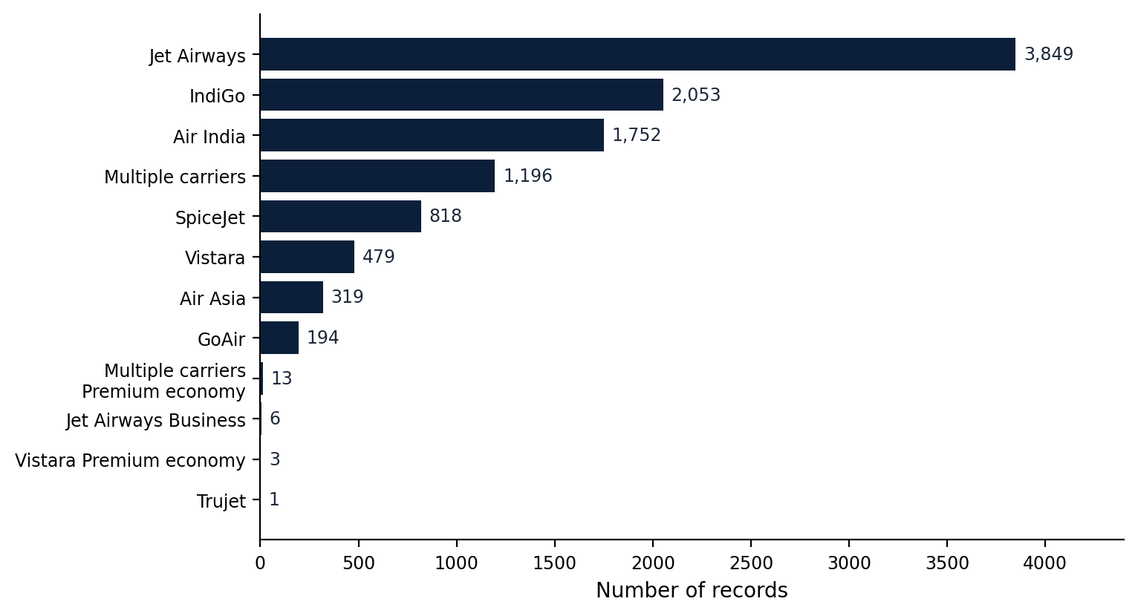
Figure 1: Number of records per airline category

3.3 Data Quality Observations
- Missing values: one record has no Route and no Total_Stops value. All other columns are complete.
- Duplicates: 220 rows are exact duplicates of other rows.
- Inconsistent labels: Additional_Info contains both “No info” (8,345 records) and “No Info” (3 records) for what is effectively the same category.
- Rare categories: a few airline and additional-information categories occur only once or a handful of times, so the model has little evidence for them.
- Premium fares: the highest fares in the dataset are dominated by Jet Airways Business and Jet Airways records on Bangalore–Delhi and Delhi–Cochin routes.
- Spelling: the source city Bangalore is spelled “Banglore” in the dataset; the same spelling is kept throughout the project so that inputs match the training data.

4. Methodology

4.1 Overview
The machine learning workflow follows the standard supervised regression steps shown in Figure 2. All steps are implemented as Python scripts in the ml/src folder so that the experiment can be repeated from raw data to a saved model.
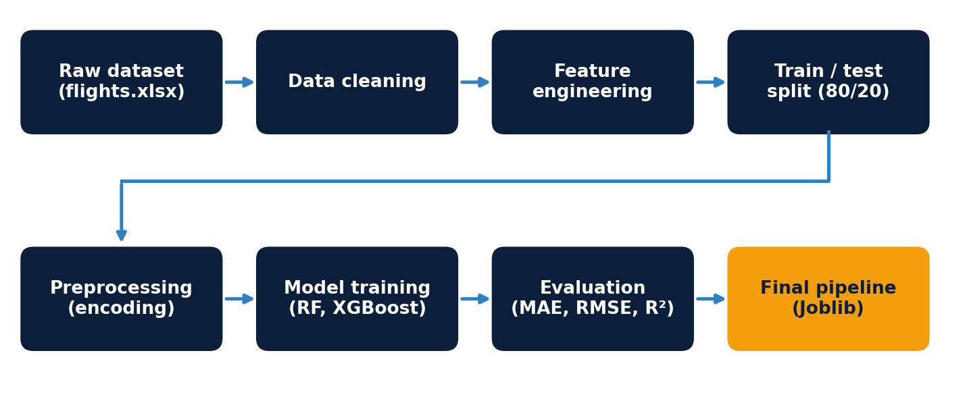
Figure 2: Machine learning pipeline of the project

4.2 Data Cleaning
- Rows with a missing Route or Total_Stops value are removed, because route information is critical to the price.
- Missing Additional_Info values, if any, are filled with the label “Unknown”.
- The journey date is parsed as day-first, the departure time in HH:MM format, and the arrival time with a pattern that also handles values such as “09:25 07 May”.
- Duration strings such as “2h 50m” are converted to a number of minutes.
- Total_Stops is converted from text to an ordinal number from 0 (non-stop) to 4.

4.3 Feature Engineering
The raw text columns cannot be used directly by a regression model, so they are converted into numeric features. In addition, four derived features capture patterns that are likely to influence fares: the time of day expressed in minutes since midnight for both departure and arrival, a weekend indicator and a night-flight indicator (departure between 22:00 and 04:59).
Table 4: Features used by the models
Group | Features
Categorical (5) | Airline, Source, Destination, Route, Additional_Info
Date features (3) | Journey_Day, Journey_Month, Journey_Weekday
Time features (4) | Departure_Hour, Departure_Minute, Arrival_Hour, Arrival_Minute
Flight features (2) | Total_Stops, Duration_Minutes
Derived features (4) | Departure_Time_Minutes, Arrival_Time_Minutes, Is_Weekend, Is_Night_Flight

4.4 Preprocessing
A scikit-learn ColumnTransformer applies one-hot encoding to the five categorical columns, with unknown categories ignored at prediction time, and passes the 13 numerical features through unchanged. Tree-based models do not require feature scaling, so no scaler is used. The preprocessor is fitted only on the training data.

4.5 Train–Test Split
The cleaned data is split into 80% training and 20% test data using a fixed random seed (random_state = 42), so that results are reproducible and every model is evaluated on the same unseen records. With 10,682 usable records this gives roughly 8,545 training and 2,137 test samples.

4.6 Model Selection and Training
Two ensemble regressors based on decision trees were trained and compared. Random Forest builds many independent trees on random subsets of the data and averages their predictions, which reduces variance. XGBoost builds trees one after another, each correcting the errors of the previous ones, and is widely used for structured tabular data. Both can model non-linear relationships and interactions between features such as airline and route.
Table 5: Model configurations
Setting | Random Forest (baseline) | XGBoost
Number of trees | 200 | 500
Learning rate | not applicable | 0.05
Maximum depth | default (unlimited) | 6
Row sampling | bootstrap (default) | 0.8
Column sampling | default | 0.8
Objective | squared error | reg:squarederror
Random seed | 42 | 42

4.7 Evaluation Strategy
Model quality is measured with three regression metrics on the held-out test set:
- MAE (Mean Absolute Error): the average size of the prediction error in rupees. It is easy to interpret.
- RMSE (Root Mean Squared Error): the square root of the average squared error. It penalises large errors more strongly than MAE.
- R² (coefficient of determination): the proportion of the variation in ticket prices explained by the model; 1.0 is a perfect fit.
In addition, the project includes a 5-fold cross-validation script (shuffled KFold, seed 42) that compares both models across folds, a feature-importance script, an error-analysis script that lists the largest prediction errors, and a script that evaluates errors by price range.

4.8 Final Model Packaging
The final model is a single scikit-learn Pipeline that combines the preprocessor and a Random Forest with 300 trees. Bundling both steps means that the exact same encoding is applied during training and prediction. The fitted pipeline is saved with Joblib as ml/models/final_pipeline.joblib. Because the file is large (about 125 MB), it is stored in the repository through Git LFS.

5. Results and Analysis

5.1 Model Comparison
Table 6 reports the test-set performance of both models, as recorded in the project’s evaluation panel.
Table 6: Test-set performance of the two models
Model | MAE (₹) | RMSE (₹) | R²
Random Forest | 569.76 | 1,451.92 | 0.9022
XGBoost | 746.99 | 1,289.40 | 0.9229

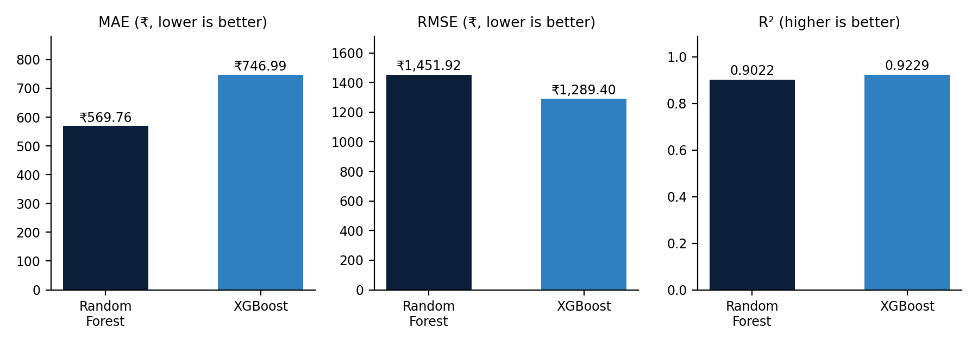
Figure 3: Comparison of Random Forest and XGBoost
Both models explain more than 90% of the variation in ticket prices. Random Forest achieved the lower MAE, about ₹177 less than XGBoost, meaning its typical prediction is closer to the true fare. XGBoost achieved the lower RMSE (about ₹163 less) and the higher R² (0.9229 against 0.9022). Because RMSE punishes large misses more heavily, this pattern suggests that XGBoost makes fewer very large errors, mostly on expensive tickets, while Random Forest is more accurate on ordinary fares. The two metrics therefore describe different aspects of error and should be read together.
Relative to the average ticket price of ₹9,087, the Random Forest MAE corresponds to roughly 6.3% and the XGBoost MAE to roughly 8.2%.

5.2 Feature Importance
The application’s model insights panel reports the most influential features of the deployed Random Forest model, shown in Figure 4. The premium Jet Airways Business category and the number of stops carry the largest importance, followed by flight duration, the Jet Airways carrier and the absence of an in-flight meal.
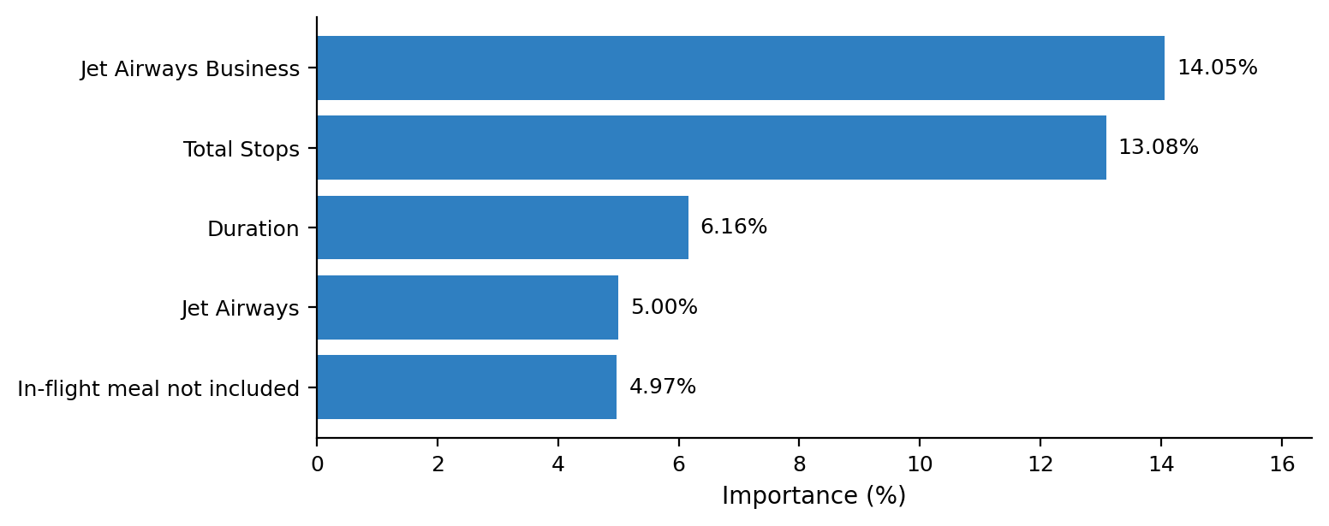
Figure 4: Most important features reported by the model
These results match intuition: premium cabins cost more, and each additional stop changes the itinerary and the fare. Feature importance describes the model’s behaviour across the whole training set. It should not be read as the causal effect of a feature on any single ticket.

5.3 Final Model Choice
The Random Forest pipeline was selected as the final model and is the one served by the API and shown in the interface. XGBoost remains in the repository as a trained comparison model, and the comparison is displayed in the application so that users can see both sets of results.

6. System Design and Implementation

6.1 Architecture
The application has three layers, shown in Figure 5. The React frontend collects flight details and sends them to the FastAPI backend as JSON. The backend converts the request into the same raw format as the training data, applies the feature engineering functions and passes the result to the saved pipeline. The predicted price is returned to the frontend and displayed.
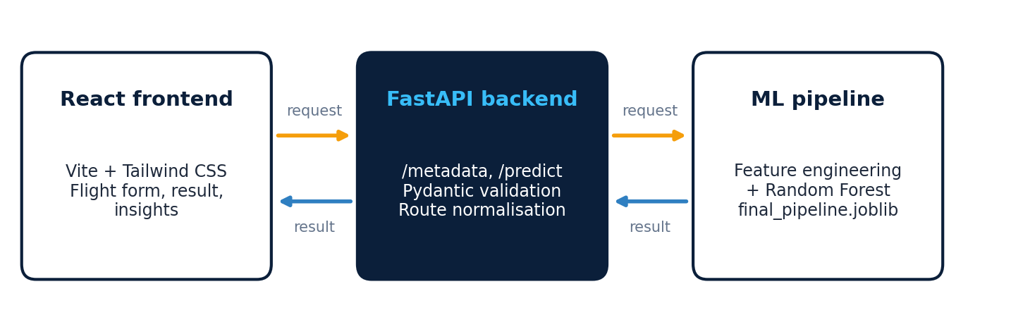
Figure 5: Three-layer architecture of the application

6.2 Backend (FastAPI)
The backend is implemented in backend/main.py, with input and output models in backend/schemas.py and the model loading and prediction logic in backend/services/predictor.py. The trained pipeline is loaded once when the server starts, and prediction reuses the same engineer_features function that was used in training, which avoids mismatch between training and serving.
Table 7: API endpoints
Method | Endpoint | Description
GET | / | Root message showing that the API is running
GET | /health | Health check returning the service status
GET | /metadata | Lists the valid airlines, cities, stop options and additional-information values for the form
POST | /predict | Accepts flight details and returns the predicted price

The /predict endpoint expects a FlightInput object with ten required text fields: airline, date_of_journey, source, destination, route, departure_time, arrival_time, duration, total_stops and additional_info. Pydantic validates that each field is present and non-empty. The response contains the predicted_price (rounded to two decimals), the currency (INR), the model name and the model version.
Two practical details are handled in the service. First, the route is normalised so that a user-typed “BLR->DEL” matches the “BLR → DEL” format used during training. Second, Cross-Origin Resource Sharing (CORS) is enabled for the local frontend addresses (localhost:5173 and 127.0.0.1:5173). Prediction errors are caught and returned as an HTTP 500 response with an error message.
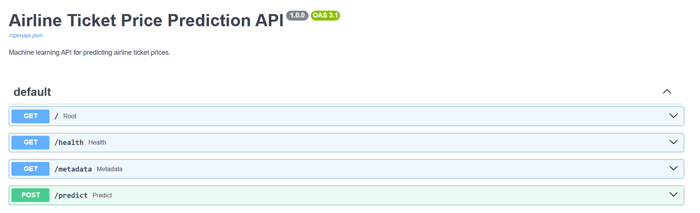
Figure 6: Interactive API documentation generated by FastAPI (Swagger UI)

6.3 Frontend (React)
The frontend is a React 19 application built with Vite and styled with Tailwind CSS. When it starts, it calls /metadata to fill the dropdown lists, which guarantees that users can only choose values the model knows. The interface is organised into components.
Table 8: Frontend components
Component | Role
FlightForm | Collects airline, cities, date, times, duration, stops, route and additional information, and submits them to /predict
PredictionCard | Shows the estimated fare with a flight summary and model information
ModelInsights | Displays the top features and the model performance figures
ModelComparison | Compares Random Forest and XGBoost in a table
HowItWorks | Explains the four steps from input to price estimate

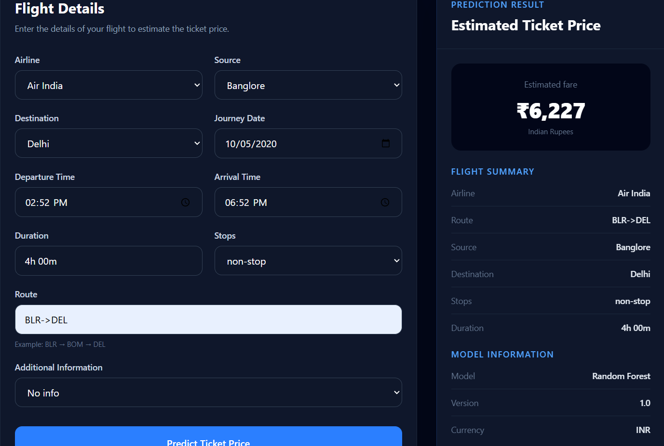
Figure 7: Flight details form and prediction result in the web application
Figure 7 shows a sample prediction. For an Air India non-stop flight from Bangalore to Delhi with a duration of 4h 00m, departing at 02:52 PM and arriving at 06:52 PM, the application estimates a fare of ₹6,227 using Random Forest version 1.0.

6.4 Repository Structure
The complete source code is available at github.com/Rishavv75/Airline-Ticket-Prediction and is organised as follows.
Table 9: Repository layout
Path | Contents
ml/src/ | Scripts for data download, feature engineering, training, evaluation, cross-validation and feature importance
ml/notebooks/ | Data understanding notebook
ml/models/ | Saved final pipeline (final_pipeline.joblib, tracked with Git LFS)
backend/ | FastAPI application, schemas and prediction service
frontend/ | React application (components, API service, styling)
requirements.txt | Python dependencies
README.md | Project overview

7. Testing and Validation
The project was validated at the model level and at the application level.
Table 10: Testing summary
Area | Method | Outcome
Model accuracy | Hold-out evaluation on the 20% test set | MAE, RMSE and R² reported in Chapter 5
Model stability | 5-fold cross-validation for both models | Script provided (ml/src/cross_validate.py)
Error analysis | Largest-error listing and error by price range | Scripts provided for inspecting weak spots
API | Swagger UI at /docs; endpoints /, /health, /metadata, /predict | All four endpoints are exposed and documented
End to end | Form submission in the React app | Sample: Air India BLR → DEL, non-stop, 4h 00m gives ₹6,227

8. Limitations
- The data covers a limited period and a small set of Indian domestic routes and airlines, so the model cannot be expected to generalise to other markets or to current fares.
- The model uses only static flight attributes. Real prices also depend on factors that are not in the dataset, such as days remaining before departure, seat availability, demand and promotions.
- Rare categories, such as Trujet and Vistara Premium economy, have very few examples, so predictions for them are less reliable.
- The dataset contains 220 duplicate rows that were kept. Duplicates that fall into both the training and test sets can make test scores look slightly better than they would be on genuinely new flights.
- Prices are right-skewed, and errors are larger for expensive tickets, as the gap between RMSE and MAE shows.
- The metrics and feature-importance values shown in the frontend are static values and are not recomputed when the model changes.

9. Future Scope
- Deploy the backend and frontend to a public host and add the live link to the repository.
- Tune hyperparameters for both models, for example with randomised or grid search.
- Remove or study the effect of duplicate rows and standardise labels such as “No info” and “No Info”.
- Try additional models and ensembles, and predict on a log-transformed price to reduce the effect of expensive outliers.
- Add more recent data and features such as booking lead time to improve accuracy.
- Generate the evaluation and feature-importance panels directly from the saved model artefacts.
- Add automated tests for the API and the feature engineering functions.

10. Conclusion
This project delivered a complete airline ticket price prediction system, from raw data to a usable web application. The data was cleaned and converted into 18 model features, two tree-based regressors were trained and evaluated, and the final Random Forest pipeline was packaged with Joblib and served through a validated FastAPI service and a React interface.
Both models explained over 90% of the variation in fares on unseen data. Random Forest reached a mean absolute error of ₹569.76 and XGBoost an R² of 0.9229, showing that airline category, number of stops and duration are strong signals for ticket price. The work also highlights the importance of consistent preprocessing between training and serving, which the single-pipeline design addresses. With more recent data and further tuning, the same architecture can be extended into a more accurate and production-ready tool.

References
[1] Kaggle dataset “Plane Ticket Price” (ibrahimelsayed182). kaggle.com/datasets/ibrahimelsayed182/plane-ticket-price
[2] Breiman, L. (2001). Random Forests. Machine Learning, 45(1), 5–32.
[3] Chen, T. and Guestrin, C. (2016). XGBoost: A Scalable Tree Boosting System. Proceedings of the 22nd ACM SIGKDD International Conference on Knowledge Discovery and Data Mining, 785–794.
[4] Pedregosa, F. et al. (2011). Scikit-learn: Machine Learning in Python. Journal of Machine Learning Research, 12, 2825–2830.
[5] FastAPI documentation. fastapi.tiangolo.com
[6] React documentation. react.dev
[7] Project repository. github.com/Rishavv75/Airline-Ticket-Prediction

Appendix A: Running the Project
The steps below start the project locally. The dataset must be downloaded first with ml/src/download_data.py and placed at data/raw/flights.xlsx, and the Git LFS model file must be available.

Backend
pip install -r requirements.txt
uvicorn backend.main:app --reload
The API then runs at http://127.0.0.1:8000, with documentation at /docs.

Frontend
cd frontend
npm install
npm run dev
The application opens at http://localhost:5173.

Retraining the model
python ml/src/train_final.py

