High-Level Design (HLD) — What to Cover

- System Overview
1.1 Purpose and Scope of the System
The purpose of this High‑Level Design is to define the enterprise integration architecture for the Viya 2.0 platform. The integration architecture enables seamless and secure interaction between customer‑facing digital channels and a diverse set of internal enterprise systems, partner platforms, third‑party service providers, and government entities.
MuleSoft Anypoint Platform is adopted as the central integration layer, responsible for enabling API‑first connectivity, business orchestration, security enforcement, and governance across all systems.

1.2 Business Objectives and Goals
The MuleSoft‑based integration architecture supports the following SOW‑driven business objectives:
- Enable a unified digital experience across mobile apps, partner apps, websites, and B2B portals
- Integrate multiple booking, payment, loyalty, and partner systems in a scalable manner
- Avoid point‑to‑point integrations and reduce platform complexity
- Centralize cross‑system business orchestration
- Ensure enterprise‑grade security, auditing, and regulatory compliance
- Enable analytics, reporting, and AI‑driven features

1.3 Key Stakeholders
- Viya Business and Product Owners
- Enterprise Architecture and IT Governance
- Integration and Platform Engineering Teams
- External Partners and System Vendors
- Security, Risk, and Compliance Teams

  - Assumptions and Constraints
- MuleSoft acts as the single integration backbone for Viya 2.0
- All backend and external systems exposed via APIs
- No direct channel‑to‑system or system‑to‑system integrations
- Integration logic is centralized and governed

- Architecture Overview
2.1 Architectural Pattern
The integration architecture follows an API-Led Connectivity pattern, implemented using MuleSoft Anypoint Platform. The pattern combines microservices-based APIs with event-driven integration, supporting both synchronous and asynchronous use cases as outlined in the SOW.

2.2 High-Level Architecture
At a high level:
- All consumer channels consume services via MuleSoft APIs
- MuleSoft orchestrates business workflows across multiple systems
- Backend systems are abstracted behind system-specific APIs
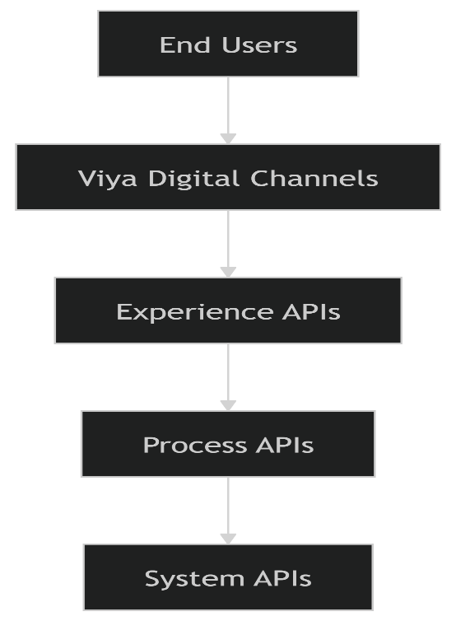
This architecture ensures scalability, reuse, and controlled system access.

2.3 System Context Diagram (C4 – Level 1)

- Actors: Customers, Partners, Internal Users
- Channels: Mobile App, Partner App, Websites, B2B Portals
- Integration Layer: MuleSoft Anypoint Platform
- Systems: Enterprise, partner, third‑party, and government systems
All interactions are routed through MuleSoft
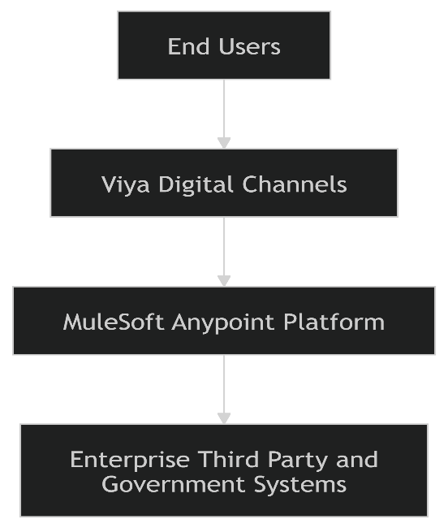

3. Component Design
3.1 Major Integration Components
- Experience APIs – Channel‑specific interfaces
- Process APIs – Business orchestration services
- System APIs – Backend and external system abstraction\
3.2 Responsibilities of Each Component
Experience APIs
- Serve mobile, web, partner, and B2B channels
- Apply channel-specific security and throttling
- Shape payloads for optimized consumption
Process APIs
- Orchestrate multi-system business flows
- Implement booking, payments, loyalty, and membership logic
- Coordinate synchronous and asynchronous interactions
System APIs
- Provide standardized access to individual systems
- Normalize data models and error handling
- Shield backend systems from direct exposure
3.3 Component Interaction
Consumer Channels → Experience APIs → Process APIs → System APIs → Backend / External Systems
3.4 Service Boundaries
- Channel logic remains in frontend platforms
- Business orchestration resides in Process APIs
- System-specific logic remains isolated behind System APIs

4. Technology Stack
4.1 Integration Platform
- MuleSoft Anypoint Platform
4.2 Integration Protocols
- RESTful APIs
- Event-driven messaging
- JSON payloads
- OAuth 2.0 / OpenID Connect

4.3 Cloud Provider
Azure‑aligned deployment as per SOW requirements.

5. Data Flow & Integration
5.1 Data Flow Overview
The integration architecture supports:
- Synchronous API‑based flows for transactional operations.
- Asynchronous event‑based flows for analytics, loyalty, marketing, and AI.

5.2 Key Business Flows
- Booking → Availability → Pricing → Payment → Loyalty → Confirmation
- Cancellation → Policy Validation → Refund → Notification
- Membership and Access Pass lifecycle management
- Subscription renewals and retries
- Partner check-in and usage capture
5.3 External System
Enterprise Systems
- Loyalty Management System
- ERP (SAP – Finance & Inventory)
- CRM / Customer Care System
- Identity and Access Management (IAM)
Payments & Commerce
- Payment Gateways
- POS Systems (F&B and Retail)
- Wallet and Subscription Services
Booking & Reservation Systems
- Concept Tee Sheet
- SevenRooms
- Five Iron
- MindBody
- VGS (Topgolf)
- BatFast / WIKIT
- Yalago
- PrioHub
- Global Distribution Systems (Amadeus, Sabre, Galileo)
Partner & Internal Platforms
- Viya Partner Portal
- Venue-specific internal systems
Engagement, Data & AI
- Marketing Automation Platform
- Deep-Linking Platform
- Data Lake
- Analytics Platforms
- AI / GenAI Services
Government & Regulatory
- Department of Tourism and Commerce Marketing (DTCM)
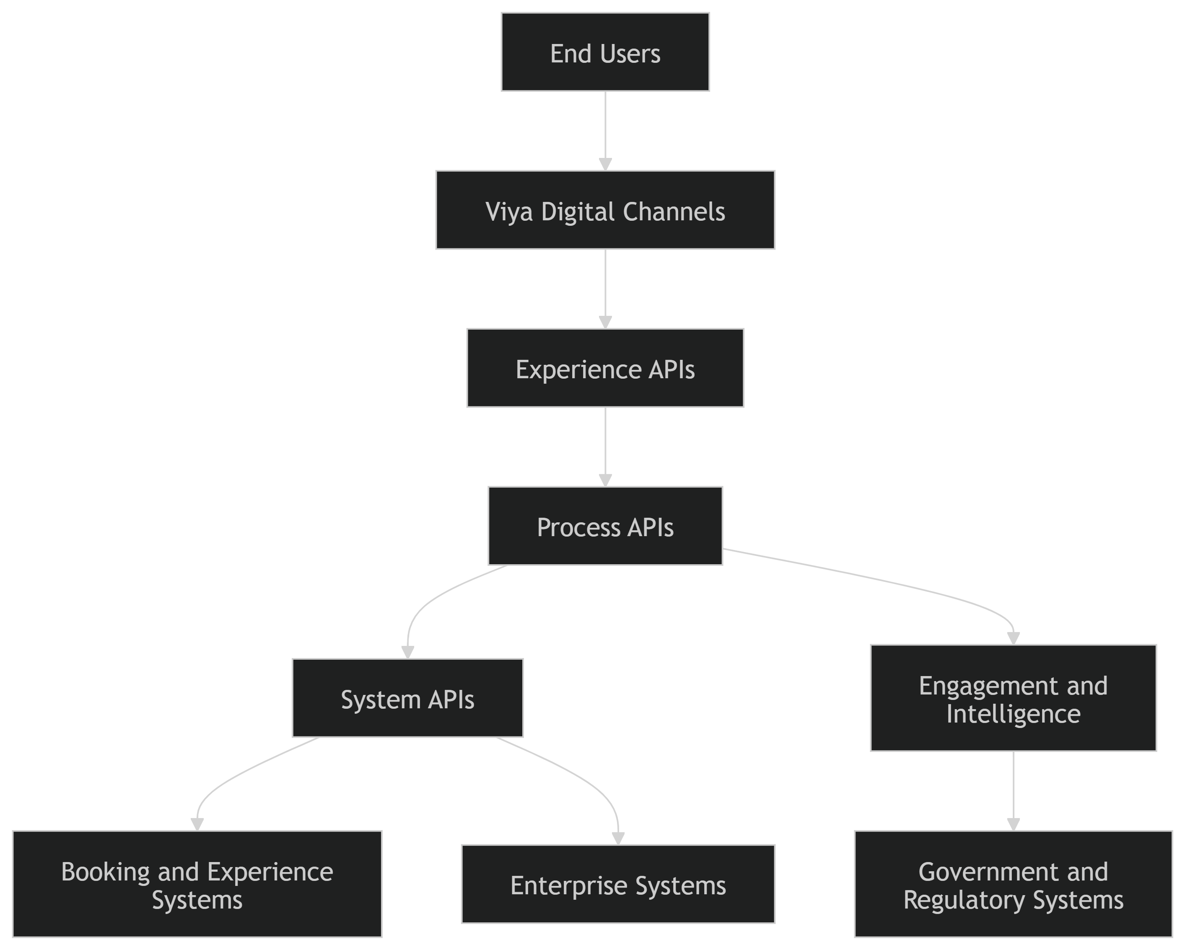
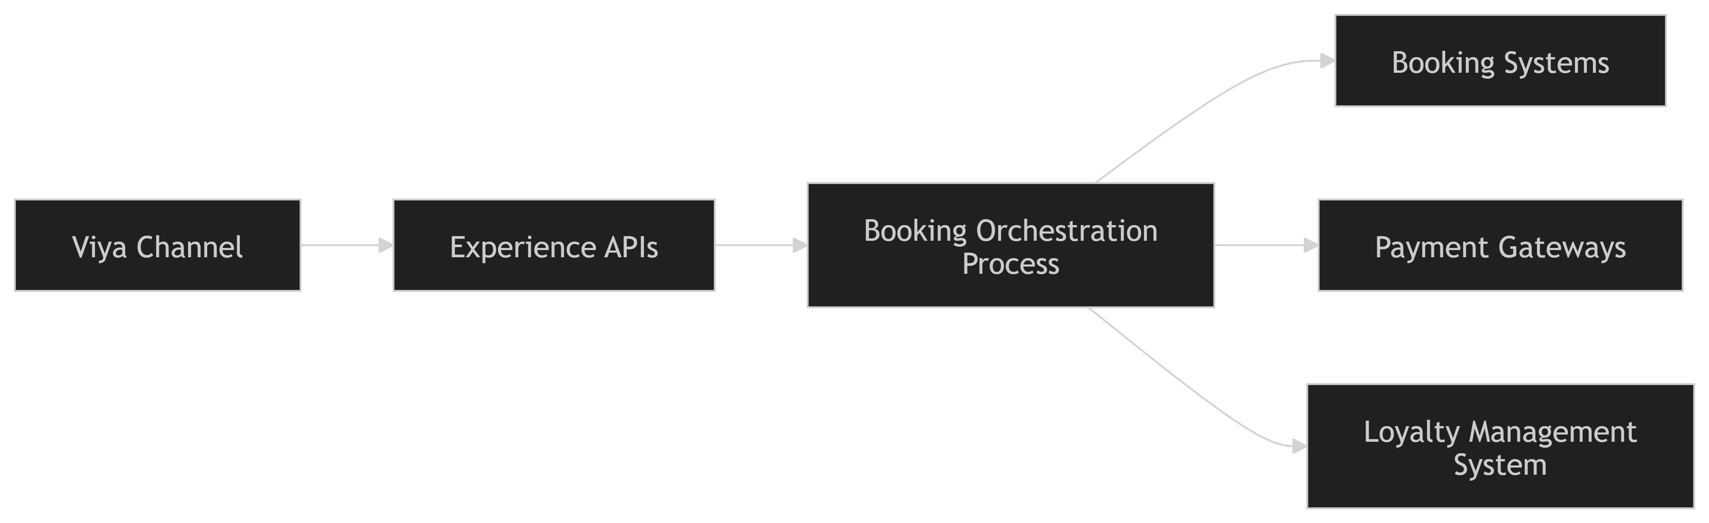

6. Database Design (High Level)
MuleSoft does not act as a system of record. It functions as a stateless integration layer, responsible for secure and governed data exchange between systems.

Caching Strategy
- API-level caching for read-heavy operations
- CDN usage where applicable

7. Security Design
Authentication & Authorization
- OAuth 2.0 and OpenID Connect
- Role-based access control
Data Protection
- Encryption in transit
- Payload validation and masking
API Security
- Centralized rate limiting
- Threat protection and access policies
Compliance
- GDPR
- UAE data protection regulations
- PCI DSS

8. Scalability & Performance
- Stateless APIs enabling horizontal scaling
- Support for high concurrent usage and peak events
- Asynchronous processing for non‑blocking workloads
- API caching and traffic throttling

9. Availability & Reliability
- Target availability of 99.9%
- Backend fault isolation
- Retry, timeout, and circuit‑breaker patterns
- Graceful degradation of non‑critical services

10. Deployment Architecture
- CI/CD‑driven API deployment
- Environment segregation (Dev, QA, UAT, Prod)
- Configuration‑driven deployments aligned.

11. Monitoring & Logging
- Centralized API logging
- Performance metrics and dashboards
- End‑to‑end transaction tracing
- Alerting for failures and SLA breaches

12. Non-Functional Requirements (NFRs)
NFR | Target
Availability | 99.9% uptime
Latency | < 200ms response
Scalability | 10k concurrent users
Security | OWASP Top 10 compliant

Risk | Mitigation
Point‑to‑point integrations | MuleSoft‑only integration policy
Backend changes impacting apps | System API abstraction
Peak‑load failures | Horizontal scaling and async processing
Security vulnerabilities | Centralized policy enforcement
13. Risks & Mitigations

14. Open Issues / Decisions Pending
- Final API lifecycle governance model
- SLA ownership with third‑party vendors
- Integration rollout sequencing across venues

