Time and Attendance Reporting System
  - User Manual
SecureLock Global | Version 1.0 | October 2026

Table of Contents
1. Introduction 3
2. System Overview 3
3. Getting Started 3
3.1 Starting the application 3
3.2 First-run setup 3
3.3 Signing in 5
4. The Attendance Overview Dashboard 6
5. Working with Exceptions 8
6. Email Reports and Alerts 9
6.1 Weekly report 11
6.2 Daily alert for open exceptions 11
7. Administration 11
8. Troubleshooting 12

Table of Figures
Figure 1: Welcome screen on first start. 4
Figure 2: Sign-in page. 5
Figure 3: Home page after signing in. 6
Figure 4: Attendance Overview dashboard. 7
Figure 5: Recent Exceptions table on the dashboard. 8
Figure 6: The Open Exceptions list. 9
Figure 7: Email settings with the Send test email button. 10
Figure 8: Mailpit test inbox with a captured test email. 11

1. Introduction
The Time and Attendance Reporting System imports the daily clock-in/clock-out export from the plant timeclock, cleans it, and automatically flags attendance problems (“exceptions”): missing clock-outs, overtime, and shifts that deviate from the roster. Results appear on a web dashboard (Metabase), which can also email a weekly report and a daily alert while exceptions remain open.
This manual is for managers, HR staff and supervisors who use the dashboard, and for the administrator who installs the system. Normal use needs no technical knowledge; administrative commands are shown ready to copy and paste.

2. System Overview
The system runs as four Docker containers, started with one command:
Component | Purpose | Address
PostgreSQL | Database holding attendance records, rosters and exceptions. | port 5432
ETL service | Automated import job; runs nightly at 02:00. | log output only
Metabase | The web dashboard everyone uses. | http://localhost:3000
Mailpit (optional) | Local test inbox for outgoing email. | http://localhost:8025

Data flows one way: the CSV export is imported and cleaned, exception rules are applied, and Metabase reads the results. Because the import runs at 02:00, the dashboard shows the previous day’s data each morning.

3. Getting Started

3.1 Starting the application
Install Docker Desktop, open a terminal in the project folder, and run:
docker compose up -d
Add “--profile mail” to also start the test inbox. The first start takes a few minutes; check progress with “docker compose ps”.

3.2 First-run setup
Open http://localhost:3000 about a minute after starting. Metabase shows its welcome screen (Figure 1).
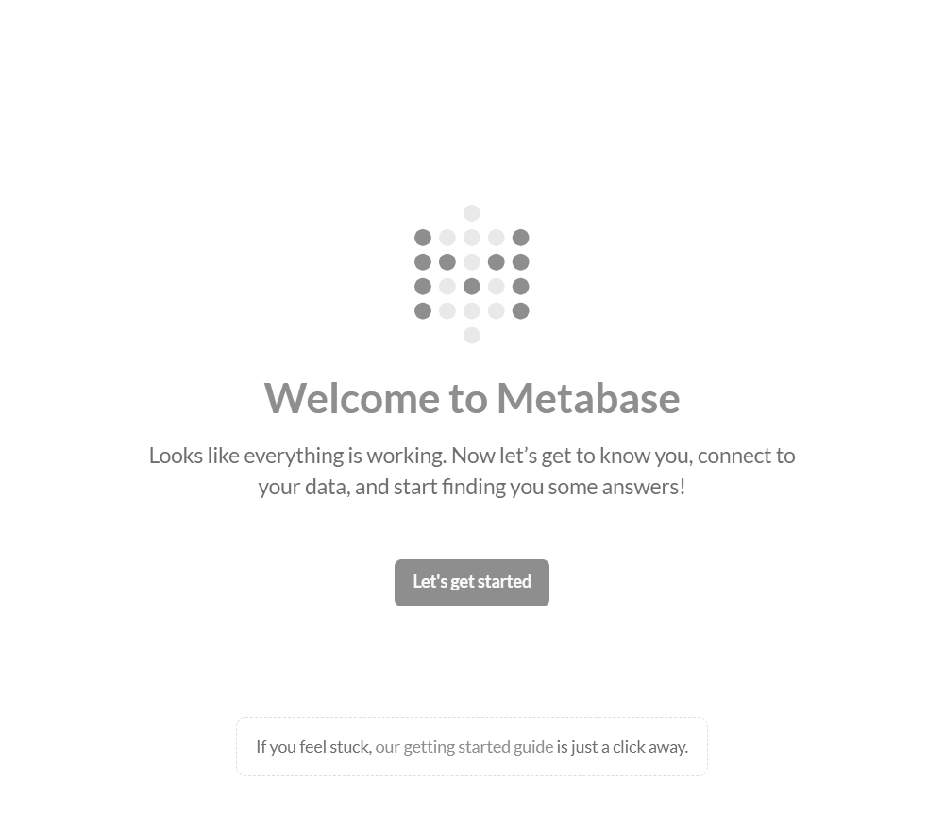
Figure 1: Welcome screen on first start.
Click “Let’s get started”, create the administrator account, and at “Add your data” choose PostgreSQL with these values:
Field | Value
Display name | SecureLock Attendance
Host / Port | postgres / 5432
Database name | attendance
Username | metabase_reader
Password | METABASE_READER_PASSWORD from the .env file
Schemas | Only these… → public, reporting

This account is read-only, so the dashboard can never change attendance data. Finally, set the report timezone (Admin settings → Localization) to the plant’s timezone.

3.3 Signing in
Afterwards Metabase shows the sign-in page (Figure 2). Use the account created during setup; add more users under Admin settings → People.
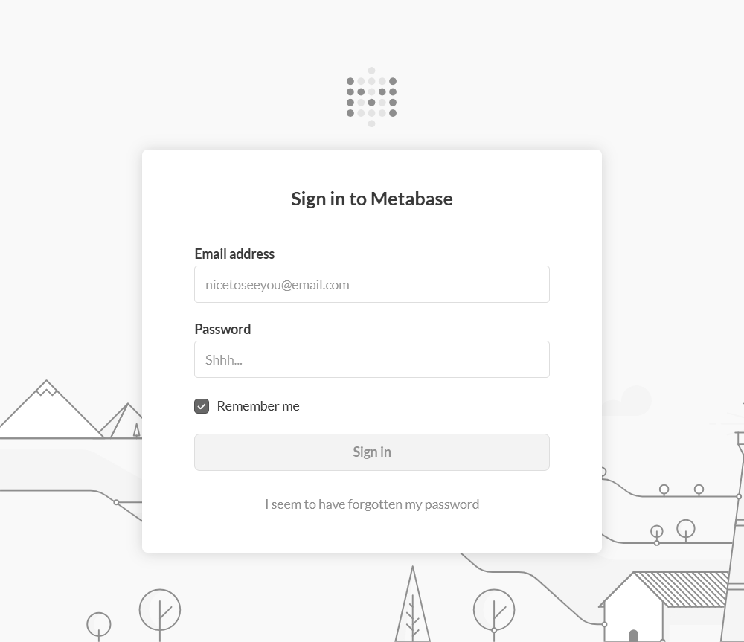
Figure 2: Sign-in page.

The home page (Figure 3) lists collections on the left; “Attendance Reporting” holds everything used by this system.
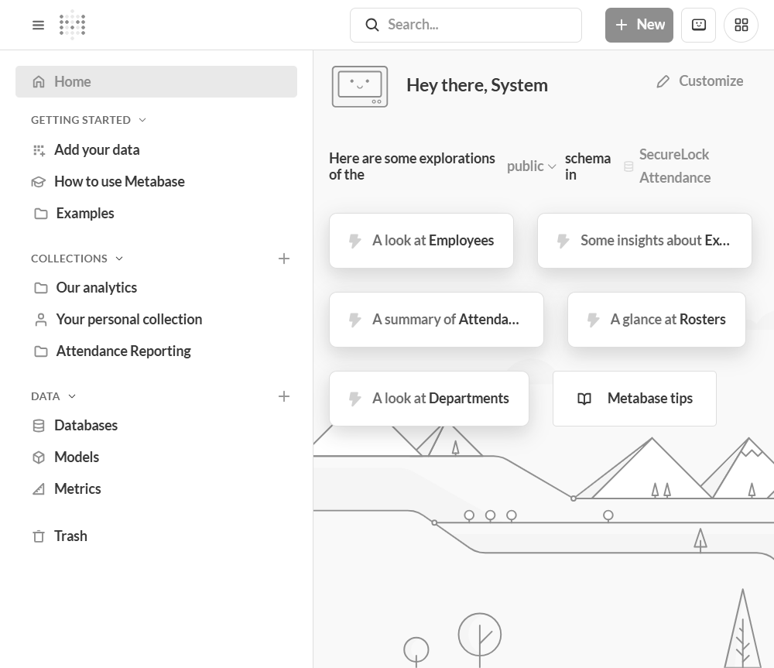
Figure 3: Home page after signing in.

4. The Attendance Overview Dashboard
Open Collections → Attendance Reporting → Attendance Overview (Figure 4). This is the main day-to-day screen.
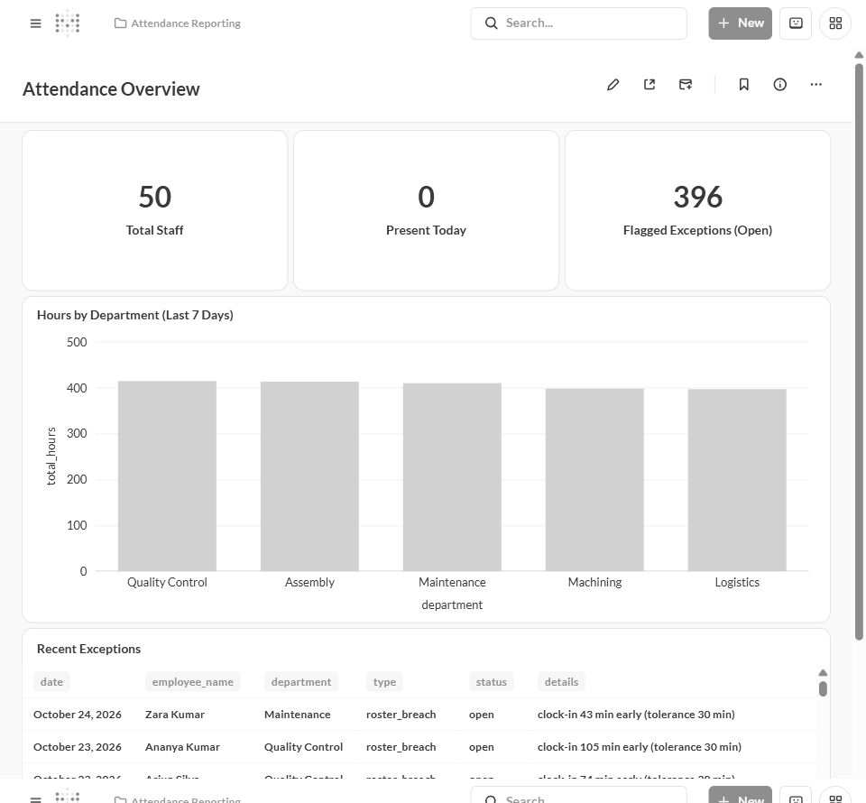
Figure 4: Attendance Overview dashboard.
Card | Meaning
Total Staff | Number of employees on record.
Present Today | Employees with an attendance record today (normally 0 on non-working days).
Flagged Exceptions (Open) | Exceptions not yet resolved or escalated.
Hours by Department | Total hours worked per department, last 7 days.
Recent Exceptions | Latest flagged problems with full detail.

Scroll down for the Recent Exceptions table (Figure 5). Each row explains the problem in plain language, e.g. “clock-in 43 min early (tolerance 30 min)”.
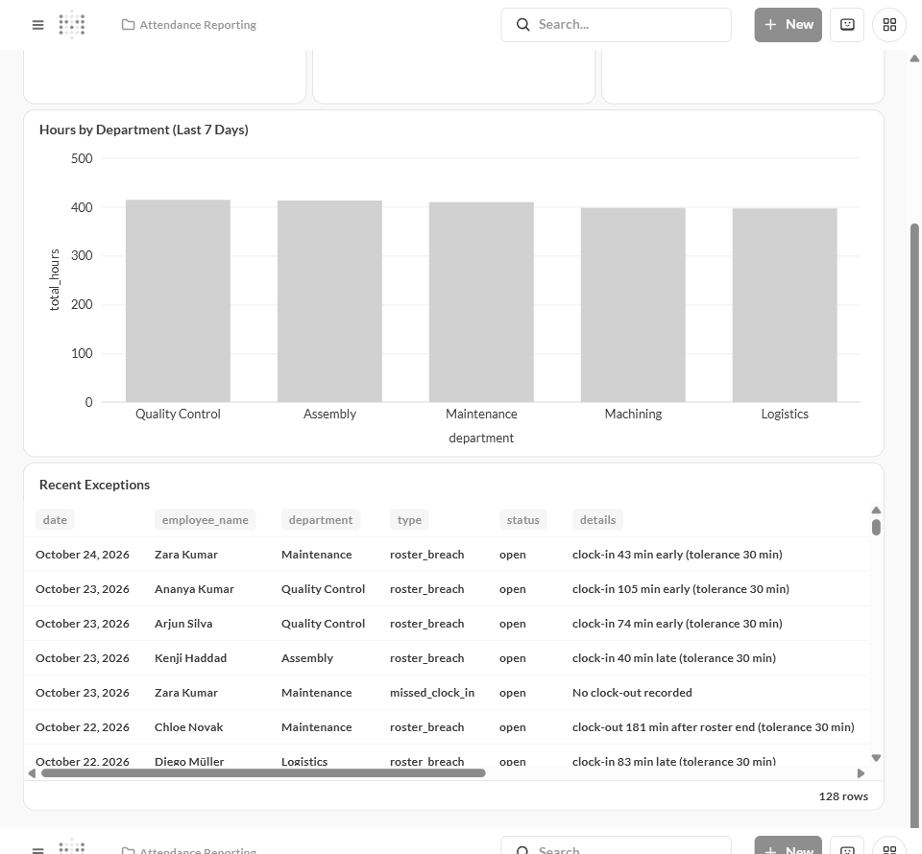
Figure 5: Recent Exceptions table on the dashboard.

5. Working with Exceptions
Type | Raised when
missed_clock_in | The record has no clock-out.
overtime | The shift exceeded the threshold (default 10 hours).
roster_breach | Clock-in or clock-out deviates from the roster by more than the tolerance (default 30 minutes), or no roster exists for that day.

The saved question “Open Exceptions” (Figure 6) lists every unresolved exception with the employee’s manager. Supervisors should review it daily; results can be downloaded as Excel or CSV.
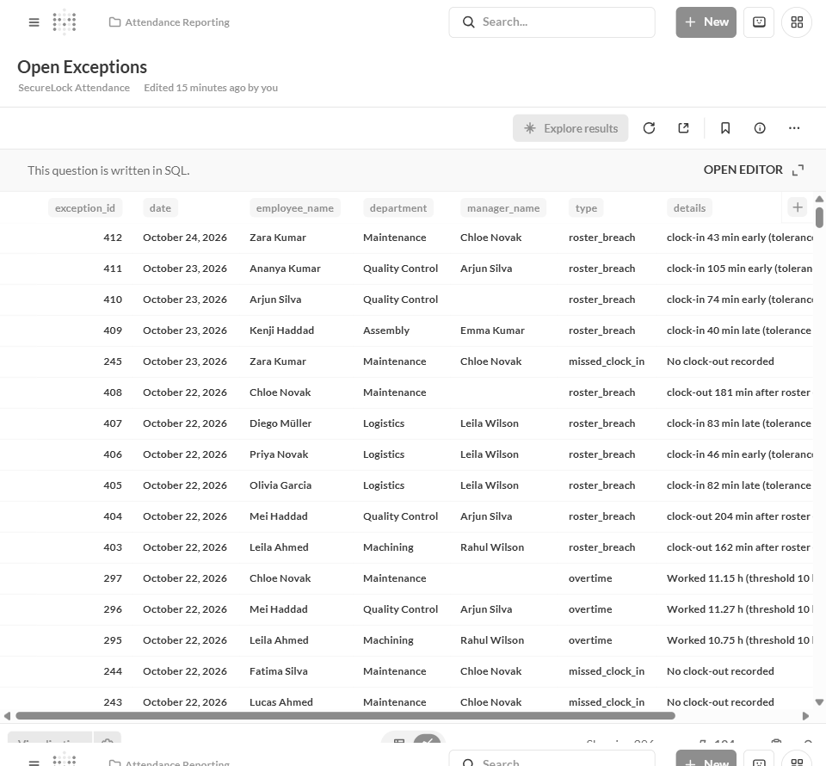
Figure 6: The Open Exceptions list.
To mark an exception resolved (or escalated), the administrator updates its status using the exception_id from the first column:
docker compose exec postgres psql -U attendance_admin -d attendance \
-c "UPDATE exceptions SET status = 'resolved' WHERE exception_id = 123;"
Statuses set this way are never overwritten by later imports.

6. Email Reports and Alerts
Email settings come from the .env file and appear under Admin settings → Email (Figure 7). Use “Send test email” there to confirm delivery. With the test inbox running, every sent email appears at http://localhost:8025 (Figure 8).
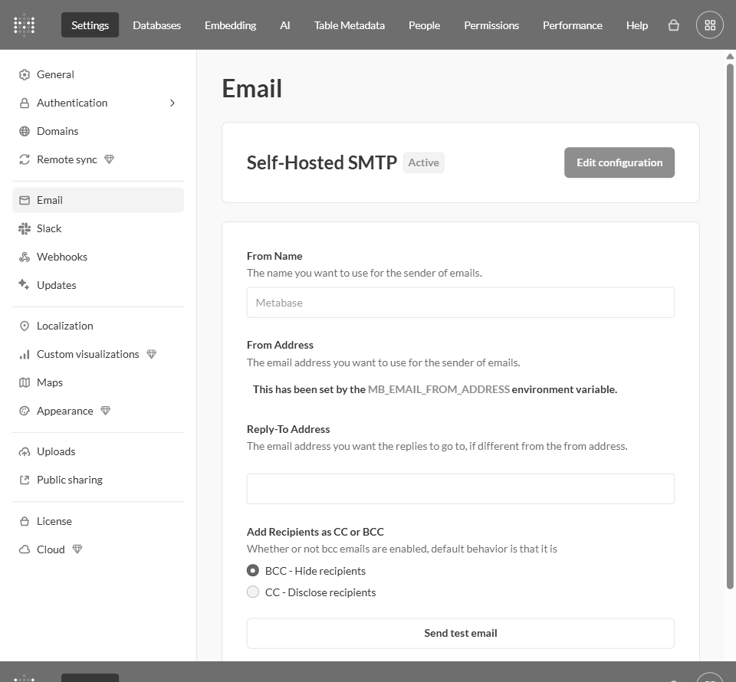
Figure 7: Email settings with the Send test email button.

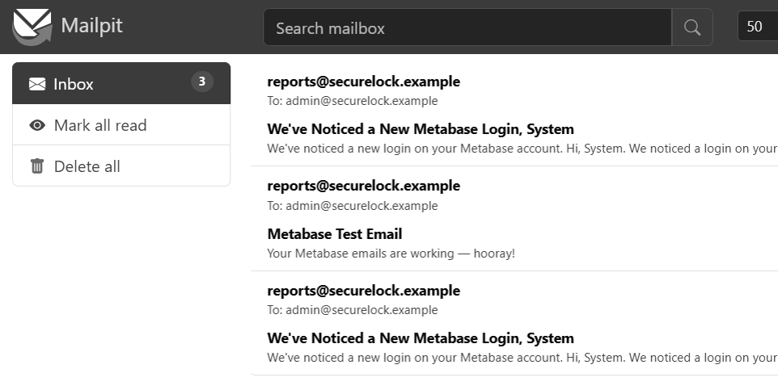
Figure 8: Mailpit test inbox with a captured test email.

6.1 Weekly report
- On the dashboard, click Sharing, Subscriptions and choose Email.
- Add recipients; set frequency to Weekly, Monday, 8:00 AM.
- Optionally attach results as .xlsx or .csv, then click Done.

6.2 Daily alert for open exceptions
- Open the Open Exceptions question and click the bell icon (Create an alert).
- Condition: “When this question has results”; schedule: Daily, 8:00 AM.
- Add recipients and leave “Only send this alert once” off, so it repeats until the queue is empty.

7. Administration
Place the latest timeclock export at data/attendance_export.csv before 02:00; the nightly job imports it automatically and logs to “docker compose logs etl”. Useful commands:
docker compose exec etl python -m etl.run_etl # import now
docker compose exec etl python -m etl.run_etl --dry-run # dry run
docker compose exec etl python -m db.seed # reload rosters
Re-running a file is safe: records are updated, never duplicated. Key settings in the .env file: OVERTIME_THRESHOLD_HOURS (default 10), ROSTER_TOLERANCE_MINUTES (default 30), ETL_CRON_SCHEDULE (default 0 2 * * *), TZ, METABASE_PORT, and the MB_EMAIL_* mail settings. Apply changes with “docker compose up -d”.

8. Troubleshooting
Symptom | What to do
Present Today shows 0 | Normal on non-working days. Otherwise check the import log and that the report timezone matches TZ.
Metabase cannot connect | Use host “postgres” (not localhost) and user metabase_reader.
No emails arrive | Start the test inbox (--profile mail) or set real MB_EMAIL_* values, then use Send test email.
Port already in use | Change METABASE_PORT or POSTGRES_HOST_PORT in .env and restart.
Rows were rejected | The import log names the reason (unknown employee, bad date, missing clock-in). Fix the export and re-run.

