**Babu Banarasi Das University**

**Case Study**

**On**

**CUSTOMER SEGMENTATION AND CHRUN PREDICTION**

**SUBMITTED TO: SUBMITTED BY:**

**Mr. Vikas Kumar Rishi Singh**

**Riya Pandey**

**Roshni K. Verma**

**Riya Saxena**

**Agenda/Definition:**

The objective of this project is to perform customer segmentation using K-Means clustering and predict customer churn using the CHAID decision tree model in IBM SPSS Modeler 18.6.

**Outcomes/Learning:**

How to perform customer segmentation, derive meaningful insights, and apply CHAID for churn prediction.

**Required Tool:**

IBM SPSS Modeler 18.6

**Working:**

Customer data is segmented using K-Means, followed by derivation of customer segments and churn prediction using CHAID decision tree analysis.

**Step 1: Data Loading and Type Node**

The dataset 'mall_cust_training.xlsx' is loaded and connected to the Type node to assign measurement levels and data types.

Screenshot shows data fields being defined in the Type node.

**Step 2: K-Means Customer Segmentation**

K-Means clustering is applied to segment customers based on their Spending Score and Income levels.

Screenshot shows the K-Means node setup with spending score input.

**Step 3: K-Means Model Summary**

The Model Summary shows three clusters formed based on customer spending patterns.

Screenshot displays cluster sizes and silhouette scores.

**Step 4: Derive Customer Segment**

,I used a Derive node to create a new field named 'Customer_Segment'. This converted the numeric cluster labels into meaningful names:  
- Cluster 1 → Loyal Regulars  
- Cluster 2 → VIP Customers  
- Cluster 3 → Budget Shoppers  
This made the clusters more understandable for business interpretation.

.

Screenshot shows the Derive node rules mapping clusters to segment names.

**Step 5: Derive Churn Field (chrun)**

I created a new derived field named 'chrun' using the Derive node. This field labels each customer as 'Churn' or 'Retained' based on spending score and customer segment.

Screenshot displays rules used for deriving churn or retained customers.

**Step 6: CHAID Model for Churn Prediction**

I used the CHAID model to predict churn using 'chrun' as the target variable and predictors such as Gender, Age, Annual Income, Spending Score, and Customer_Segment. The CHAID tree provided clear decision rules and helped identify which segments are more likely to churn.

Screenshot shows CHAID tree structure with decision nodes.

**Step 7: Evaluation of Results**

The model results are visualized and evaluated to identify churn-prone segments for business insights.

Screenshot presents churn distribution across segments.

**Step 8: Final Model Flow**

The final SPSS Modeler flow demonstrates the complete pipeline from data input to churn prediction output.

Screenshot shows the complete workflow in IBM SPSS Modeler.

**Step 9: Output Visualization**

The CHAID model output nodes highlight churn and retention patterns visually.

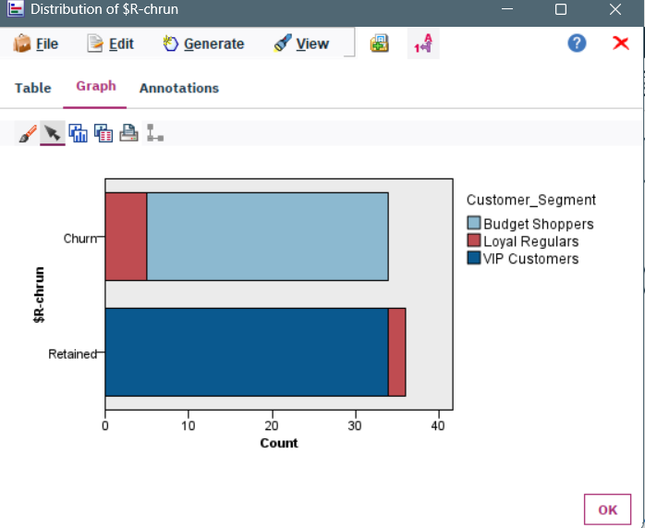

Screenshot shows the CHAID decision tree and churn visualization results.

**Step 10: Conclusion**

VIP Customers now show 0% churn, while Budget Shoppers are the new high-risk segment with 29 churned customers.