AI CAREER FOR WOMEN
Engineering Spoke

RetailVision AI
Intelligent Customer Behavior and Product Interaction Analysis Using Computer Vision

A Project Report
submitted in partial fulfillment of the requirements
of
AICW Project
by
Akula Rishitha, rishithaakula05@gmail.com
Ambati Keerthana, goudkeerthana685@gmail.com
Bachu Varsha, varshabachu5254@gmail.con

Under the Guidance of
N L Venu Gopal

ACKNOWLEDGEMENT

We would like to express our sincere gratitude to everyone who supported us directly and indirectly during the development of the RetailVision AI project.
We are especially thankful to our project guide, Venu Gopal sir, for providing valuable guidance, encouragement, suggestions, and continuous support throughout the project. The guidance helped us understand the practical application of artificial intelligence and computer vision to a real-world retail problem.
We also thank our institution, faculty members, friends, and family for their support and encouragement during the completion of this project.
Finally, we are grateful to everyone who contributed to the successful completion of this work.

ABSTRACT

Retail stores generate large amounts of customer activity, but conventional sales reports provide limited information about what customers notice, where they spend time, and which products they interact with before making or not making a purchase. RetailVision AI is a computer vision-based retail analytics system designed to analyze customer behavior from store video footage. The proposed system detects customers, assigns anonymous tracking IDs, tracks their movement, identifies predefined store zones, calculates dwell time, and analyzes customer-product interactions. A behavioral interest score can be estimated using measurable signals such as time spent near a product, proximity, interaction, and repeated visits. The system also generates customer movement paths, store heatmaps, zone-level analytics, and product interaction statistics through a web-based dashboard. The project uses computer vision and deep learning techniques such as object detection and multi-object tracking, supported by a backend database and visualization interface. The system is designed to focus on anonymous behavior analysis rather than personal identification and therefore avoids facial recognition. RetailVision AI can help retailers understand customer movement patterns, identify high-interest products and areas, compare store zones, and discover interaction patterns that are not visible in ordinary sales data. The project demonstrates how AI can transform CCTV video into structured behavioral information and practical retail analytics.

TABLE OF CONTENTS
1. Abstract
2. List of Figures
3. List of Tables
4. Chapter 1. Introduction
5. 1.1 Problem Statement
6. 1.2 Motivation
7. 1.3 Objectives
8. 1.4 Scope of the Project
9. Chapter 2. Literature Survey
10. Chapter 3. Proposed Methodology
11. 3.1 System Design
12. 3.1.1 Video Input and Upload
13. 3.1.2 Customer Detection and Tracking
14. 3.2 Modules Used
15. 3.2.1 Customer Detection
16. 3.2.2 Multi-Object Tracking
17. 3.2.3 Store Zone Detection
18. 3.2.4 Dwell Time Analysis
19. 3.2.5 Product Detection
20. 3.2.6 Product Interaction Analysis
21. 3.2.7 Interest Score Estimation
22. 3.2.8 Analytics Dashboard
23. 3.3 Data Flow Diagram
24. 3.3.1 DFD Level 0
25. 3.3.2 DFD Level 1 - Customer Tracking Module
26. 3.3.3 DFD Level 1 - Zone and Dwell Time Module
27. 3.3.4 DFD Level 1 - Product Interaction Module
28. 3.4 Advantages
29. 3.5 Requirement Specification
30. 3.5.1 Hardware Requirements
31. 3.5.2 Software Requirements
32. Chapter 4. Implementation and Results
33. 4.1 Results of Customer Detection
34. 4.2 Results of Customer Tracking
35. 4.3 Results of Zone and Dwell Time Analysis
36. 4.4 Results of Product Interaction Analysis
37. 4.5 Results of Dashboard Analytics
38. Chapter 5. Discussion and Conclusion
39. 5.1 Key Findings
40. 5.2 GitHub Link of the Project
41. 5.3 Video Recording of Project Demonstration
42. 5.4 Limitations
43. 5.5 Future Work
44. 5.6 Conclusion
45. References
46. Appendices

LIST OF FIGURES

Figure 1. RetailVision AI System Architecture

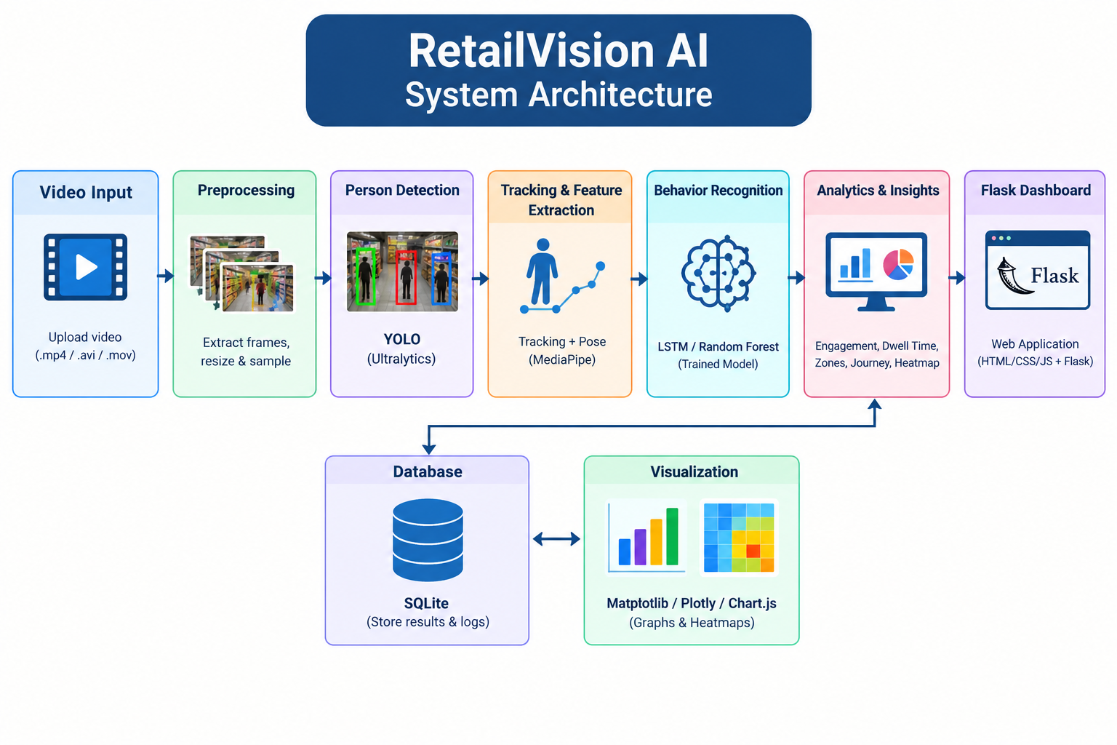

Figure 2. Customer Detection and Tracking

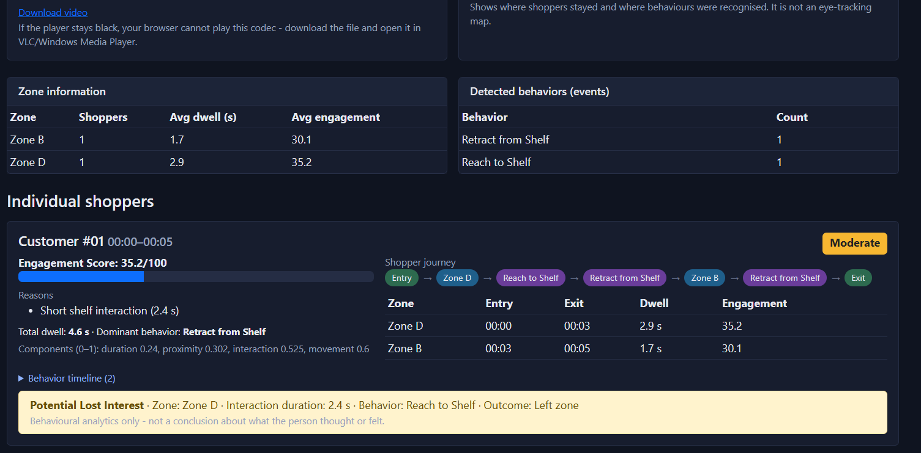

Figure 3. Zone Mapping
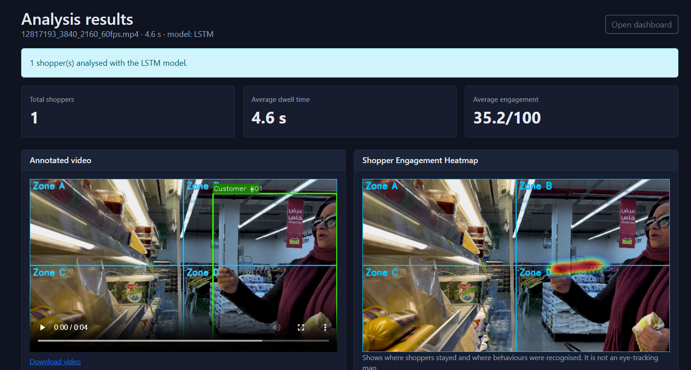

Figure 3. Interest Score Analysis
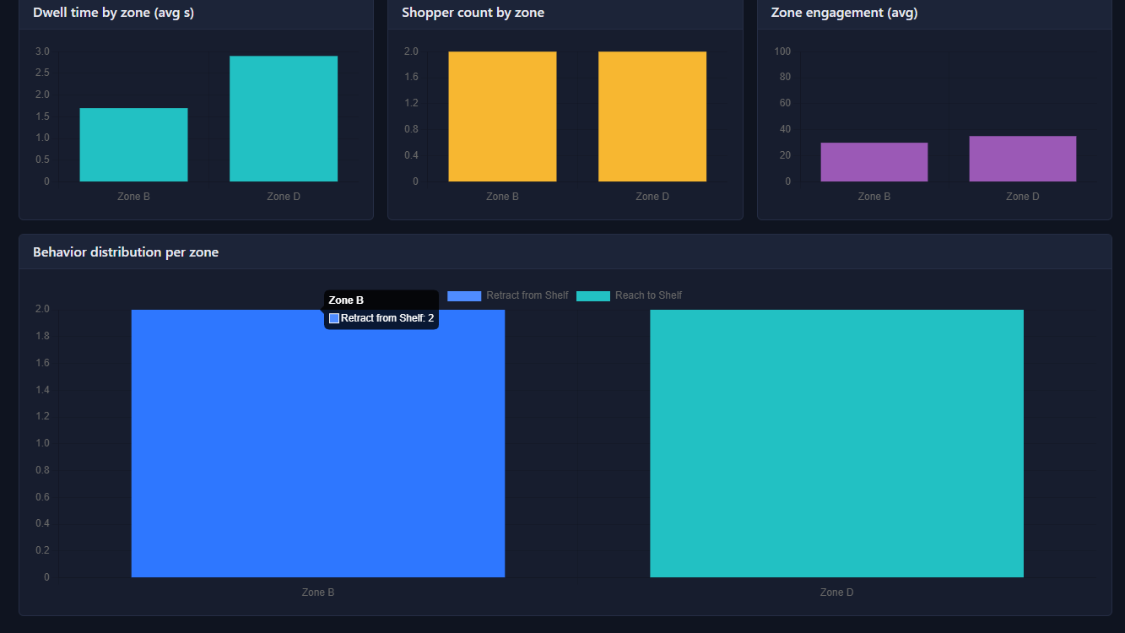
Figure 8. Retail Analytics Dashboard
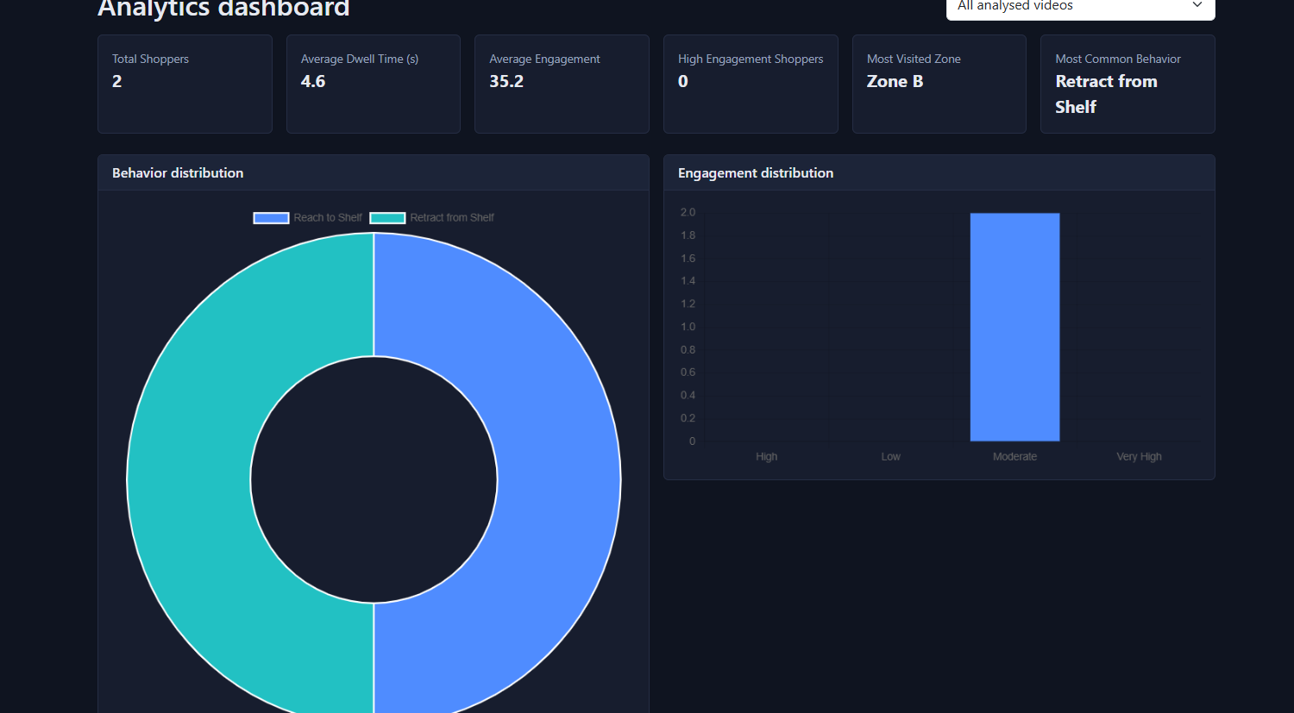

LIST OF TABLES
Table 1. Hardware Requirements

Hardware Component | Minimum Requirement | Recommended Specification | Purpose / Role
CPU | Intel Core i5 (10th Gen) / AMD Ryzen 5 | Intel Core i7/i9 (12th Gen+) / AMD Ryzen 7+ | Handles video frame decoding, background API processing, and database operations.
GPU | NVIDIA GTX 1660 (6GB VRAM) | NVIDIA RTX 3060/4070 (8GB+ VRAM, CUDA Cores) | Accelerates YOLO object detection and real-time tensor operations.
RAM | 16 GB DDR4 | 32 GB DDR4/DDR5 | Manages multi-frame video buffers, tracking memory, and concurrent web API requests.
Storage | 256 GB SSD | 1 TB NVMe M.2 SSD | High-speed read/write for CCTV video files, processed frames, and database logs.
Camera Feed / Video Source | 1080p Recorded CCTV Video (30 FPS) | 1080p/4K High-Angle Store CCTV (30–60 FPS) | Primary visual input for customer tracking and product interaction modules.

Table 2: Software Requirements
Category | Tool / Technology | Purpose / Application
Operating System | Windows 11 / Ubuntu 22.04 LTS | Deployment OS
Language | Python 3.10+ | Core AI pipeline & API backend
Vision Frameworks | OpenCV, PyTorch, YOLOv8 | Object detection & image processing
Tracking | ByteTrack | Persistent anonymous customer IDs
Backend API | FastAPI | High-speed REST API engine
Database | SQLite / PostgreSQL | Customer trajectory & analytics storage
Frontend | React.js (Vite) + Recharts | Interactive Web Dashboard
Authentication | PyJWT + Bcrypt | Role-based security & admin login

Table 3. Major System Modules
Module Name | Core Responsibility | Tech / Algorithm
1. Video Ingestion | Ingests CCTV video and extracts frame sequence | OpenCV, Python-Multipart
2. Customer Detection | Detects people and outputs bounding boxes | YOLOv8 (Person Class)
3. Customer Tracking | Tracks trajectories with persistent temporary IDs (Person_01) | ByteTrack
4. Zone & Dwell Time | Maps store polygon zones & calculates time spent | Spatial Point-in-Polygon
5. Product Interaction | Detects product pickups, examinations, and returns | Fine-Tuned YOLO, Proximity Rules
6. Interest Scoring | Calculates normalized interest score (0–100) | Heuristic Formula
7. Analytics Engine | Generates store heatmaps & non-conversion reports | Matplotlib, NumPy, Pandas
8. Dashboard & Reports | Displays charts and exports downloadable PDF summaries | React.js, FPDF2
Table 4. Customer Behavior Data
Field Name | Data Type | Description | Example Value
customer_id | String | Anonymous tracking ID | "Person_01"
session_id | UUID | Unique video session ID | "sess_98214a"
entry_time | Timestamp | Customer entry timestamp | "2026-09-20 14:10:02"
exit_time | Timestamp | Customer exit timestamp | "2026-09-20 14:15:35"
total_duration | Integer | Visit duration in seconds | 333 (5 min 33 sec)
zones_visited | Array/JSON | Zones visited with dwell times | [{"zone": "Cosmetics", "dwell_sec": 155}]
trajectory_path | Array/JSON | List of $\left(x,y\right)$ path coordinates | [[120, 230], [125, 238], [140, 251]]

Table 5. Product Interaction Data
Field Name | Data Type | Description | Example Value
interaction_id | Integer | Primary key log ID | 1024
customer_id | String | Interacting customer ID | "Person_01"
product_id | String | Target product ID | "Product_A" (Shampoo)
zone_id | String | Interaction store zone | "Zone_2" (Cosmetics)
dwell_time_near_product | Integer | Proximity time (seconds) | 24
interaction_type | String | Interaction classification | "Returned"
interest_score | Integer | Calculated interest score (0–100) | 78 (High Interest)
observed_purchase | Boolean | Purchase event observed flag | False

Table 6. Model Evaluation Metrics
Component | Minimum Spec | Recommended Spec | Function
CPU | Core i5 / Ryzen 5 | Core i7/i9 / Ryzen 7+ | Frame extraction & backend API
GPU | GTX 1660 (6GB) | RTX 3060/4070 (8GB+) | YOLO model acceleration
RAM | 16 GB DDR4 | 32 GB DDR4/DDR5 | Frame buffer & active tracking
Storage | 256 GB SSD | 1 TB NVMe SSD | Video storage & database logs
Camera | 1080p @ 30 FPS | 1080p/4K High-Angle CCTV | Store video input stream

CHAPTER 1

Introduction

1.1 Problem Statement
Retail stores need to understand customer behavior in order to improve product placement, store layout, and the shopping experience. However, traditional methods such as sales reports, customer surveys, and manual observation mainly provide information about purchases and do not capture the complete customer journey inside a store. A customer may spend considerable time near a product, pick it up, examine it, return it, and leave without purchasing it. Such behavior can be difficult to identify from sales data alone.
RetailVision AI addresses this problem by using computer vision and artificial intelligence to analyze store video footage. The system detects and tracks customers anonymously, measures their movement and time spent in different zones, identifies product interactions where feasible, and converts these observations into retail analytics.

1.2 Motivation
The motivation for this project is the need for data-driven understanding of customer behavior in physical retail environments. Online stores can measure clicks, views, time spent on pages, and product interactions, whereas physical stores often have less detailed behavioral information. RetailVision AI attempts to bring similar behavioral analytics to physical retail spaces using video analysis while avoiding personal identification.

1.3 Objectives
• To detect customers in retail video footage using computer vision.
• To track customers using anonymous IDs across video frames.
• To identify customer movement across predefined store zones.
• To calculate the time customers spend in different areas.
• To detect selected products and estimate customer-product interactions.
• To generate an estimated behavioral interest score using measurable signals.
• To generate heatmaps and analytics showing high- and low-activity areas.
• To provide a dashboard for visualizing customer and product behavior.
• To maintain privacy by avoiding facial recognition and unnecessary personal identification.

1.4 Scope of the Project
The project focuses on analyzing recorded retail video or CCTV footage in a controlled environment. It covers customer detection, anonymous tracking, zone analysis, dwell time, movement visualization, selected product detection, interaction analysis, and dashboard-based reporting. The project does not attempt to identify the real identity of customers or make claims about their emotions or exact psychological attention. Product pickup and return detection may be estimated from spatial and temporal evidence and should be presented as observed or estimated events.

CHAPTER 2

Literature Survey
Computer vision has been widely used for object detection, object tracking, people counting, surveillance, and video analytics. Modern deep learning-based object detectors can identify objects in individual video frames, while multi-object tracking methods associate detections across frames to maintain temporary identities. These techniques provide a foundation for analyzing movement in crowded or structured environments.
Retail analytics research and commercial systems commonly use video-based people counting, heatmaps, queue analysis, shelf analytics, and customer journey analysis. Such systems demonstrate that physical-store video can provide information beyond conventional sales records.
A key limitation of basic people-counting systems is that they provide only customer counts and do not fully describe movement, dwell time, or product interactions. Systems based on facial recognition may also introduce unnecessary privacy concerns when the objective is behavioral analytics rather than personal identification.
RetailVision AI addresses these gaps by combining anonymous person tracking, zone-level movement analysis, dwell-time calculation, product interaction analysis, and dashboard visualization in a single workflow. The system emphasizes behavioral analytics rather than identity recognition.

CHAPTER 3

Proposed Methodology

3.1 System Design
RetailVision AI follows a pipeline in which video is uploaded to the system, frames are processed using a computer vision model, customers are detected and tracked, their locations are mapped to store zones, dwell time and movement paths are calculated, and product interactions are analyzed. The resulting information is stored and displayed through a web dashboard.

3.1.1 Video Input and Upload
The administrator uploads a supported retail video file. The backend validates the file and prepares it for frame-by-frame processing. The system may also be connected to a suitable CCTV stream in a future version.

3.1.2 Customer Detection and Tracking
A deep learning object detection model such as YOLO is used to detect people in each frame. A multi-object tracking method such as ByteTrack or DeepSORT can then associate detections across frames and assign temporary anonymous IDs such as Person_01 and Person_02.

3.2 Modules Used

3.2.1 Customer Detection
Detect people in video frames and obtain their bounding boxes and confidence values.

3.2.2 Multi-Object Tracking
Maintain anonymous customer IDs and trajectories across consecutive frames.

3.2.3 Store Zone Detection
Divide the store into named polygonal or rectangular zones and determine which zone contains each customer.

3.2.4 Dwell Time Analysis
Calculate how long customers remain within each zone and summarize average dwell time.

3.2.5 Product Detection
Detect selected products or product categories using a trained or fine-tuned object detection model.

3.2.6 Product Interaction Analysis
Use proximity and temporal behavior to estimate interactions such as approaching, remaining near, possible pickup, examination, and possible return.

3.2.7 Interest Score Estimation
Estimate an interest score from measurable signals such as dwell time, proximity, interaction, and repeated visits.

3.2.8 Analytics Dashboard
Display customer counts, zone analytics, movement paths, heatmaps, product interactions, and reports.

3.3 Data Flow Diagram
The Data Flow Diagram represents how video data moves through the RetailVision AI system. The major flow is: Video Input → Frame Processing → Customer Detection → Tracking → Zone Analysis → Dwell Time → Product Detection → Interaction Analysis → Analytics Database → Dashboard.

3.3.1 DFD Level 0
External Entity: Store Administrator. Input: Retail Video. Process: RetailVision AI Analytics System. Output: Customer Behavior Analytics, Product Interaction Analytics, Heatmaps, and Reports.

3.3.2 DFD Level 1 - Customer Tracking Module
Video frames are supplied to the detection model. Detected people are passed to the tracking algorithm, which assigns anonymous IDs and stores their coordinates over time. The output is a customer trajectory dataset.

3.3.3 DFD Level 1 - Zone and Dwell Time Module
Customer coordinates are compared with configured store zones. Zone entry and exit timestamps are recorded, and the difference between them is used to calculate dwell time. Aggregated zone statistics are then stored for visualization.

3.3.4 DFD Level 1 - Product Interaction Module
Detected customers and products are analyzed using spatial and temporal relationships. When a customer remains near a product or shows a measurable interaction pattern, an interaction event is recorded with a confidence or estimation status. These events are used for product analytics.

3.4 Advantages
• Provides behavioral information beyond ordinary sales reports.
• Measures customer movement and dwell time automatically.
• Identifies high-traffic and high-interest areas.
• Supports product interaction analysis.
• Provides visual analytics through heatmaps and charts.
• Uses anonymous tracking instead of facial identification.
• Can support retail layout and product-placement analysis.
• Can be extended to queue and crowd-density analytics.

3.5 Requirement Specification

3.5.1 Hardware Requirements
• Computer with a modern multi-core processor.
• Minimum 8 GB RAM; 16 GB or more recommended for video processing.
• GPU with CUDA support is recommended for faster deep learning inference but is not mandatory for small videos.
• Web camera or CCTV/recorded retail video for input.
• Sufficient storage for videos, models, and results.

3.5.2 Software Requirements
• Python
• OpenCV
• PyTorch
• YOLO-based object detection framework
• ByteTrack or DeepSORT
• NumPy and Pandas
• FastAPI or Flask
• React.js, HTML, CSS and JavaScript
• MongoDB or PostgreSQL
• Chart.js or Recharts
• Git and GitHub

CHAPTER 4

Implementation and Results
The implementation is divided into computer vision processing, behavioral analytics, database storage, backend services, and frontend visualization. Results shown in this chapter should be replaced with actual screenshots and measured values obtained from the final implementation.

4.1 Results of Customer Detection
The customer detection module identifies people appearing in the input video and displays bounding boxes with detection confidence. The final report should include a screenshot of the processed video showing detected customers.

4.2 Results of Customer Tracking
The tracking module assigns anonymous IDs to detected customers and maintains their trajectories across consecutive frames. The result can be visualized by drawing movement paths over the video.

4.3 Results of Zone and Dwell Time Analysis
The system maps customers to configured store zones and calculates their dwell time. The final implementation should report the number of visitors and average dwell time for each zone.

4.4 Results of Product Interaction Analysis
The product interaction module records measurable customer-product proximity and interaction events. Where pickup or return behavior is inferred, it should be clearly marked as an estimated event. Actual results should be reported using values generated by the system.

4.5 Results of Dashboard Analytics
The dashboard presents customer counts, average visit duration, zone traffic, dwell time, product interactions, heatmaps, and other analytics. Screenshots of the completed dashboard should be inserted here.

CHAPTER 5

Discussion and Conclusion

5.1 Key Findings
The proposed RetailVision AI system demonstrates how computer vision can be used to transform retail video footage into structured customer-behavior information. The major outputs include anonymous customer tracking, movement trajectories, zone visits, dwell time, product interactions, heatmaps, and dashboard analytics. The actual numerical findings must be reported from the completed system rather than assumed in advance.

5.2 GitHub Link of the Project
GitHub Repository: [Insert GitHub Project Link]

5.3 Video Recording of Project Demonstration
Project Demonstration Video: [Insert Demonstration Video Link]

5.4 Limitations
• Performance depends on video quality, camera position, lighting, and crowd density.
• Occlusion can cause temporary tracking errors or ID switches.
• Product interaction detection may be difficult when products are small or visually similar.
• Pickup and return events may be estimated rather than perfectly identified from a single camera.
• Exact eye gaze or psychological attention is not measured.
• Sales conversion cannot be confirmed without integration with point-of-sale transaction data.
• Real-time processing may require GPU resources for high-resolution or multiple-camera video.

5.5 Future Work
• Integrate real-time CCTV streams.
• Integrate POS data to compare observed interactions with actual purchases.
• Improve product pickup and return detection using pose estimation and action recognition.
• Support multiple cameras and cross-camera tracking.
• Add queue and checkout waiting-time analytics.
• Add natural-language querying of stored analytics.
• Add store-layout comparison and simulation.
• Deploy the system as a scalable cloud or edge-computing application.

5.6 Conclusion
RetailVision AI presents a computer vision-based approach for understanding customer behavior in physical retail environments. Instead of relying only on sales information or manual observation, the system extracts customer movement, zone visits, dwell time, product interactions, and spatial activity from video. The resulting analytics can help retailers understand how customers navigate a store and which areas or products receive greater interaction. The privacy-oriented design focuses on anonymous behavioral analysis rather than personal identification. With further validation, POS integration, improved interaction recognition, and real-time deployment, the system can be extended into a more comprehensive retail intelligence platform.

REFERENCES
[1]. N. Wojke, A. Bewley and D. Paulus, “Simple Online and Realtime Tracking with a Deep Association Metric,” IEEE International Conference on Image Processing (ICIP), 2017.
[2]. Y. Zhang et al., “ByteTrack: Multi-Object Tracking by Associating Every Detection Box,” European Conference on Computer Vision (ECCV), 2022.
[3]. J. Redmon et al., “You Only Look Once: Unified, Real-Time Object Detection,” Proceedings of the IEEE Conference on Computer Vision and Pattern Recognition (CVPR), 2016.
[4]. G. Jocher, A. Chaurasia and J. Qiu, “Ultralytics YOLO,” Ultralytics documentation and software resources.
[5]. G. Bradski, “The OpenCV Library,” Dr. Dobb's Journal of Software Tools, 2000.

APPENDICES
Appendix A: Sample Screenshots
Appendix B: Dataset and Annotation Details
Appendix C: Sample API Responses
Appendix D: Sample Analytics Report
Appendix E: Important Code Snippets, if required

