### User Story for View/Download Statements

|  |  |
| --- | --- |
| **As a** | Logged-in user of <https://FinTrust.com> |
| **I want** | To be able to view and download my account statements |
| **So that** | I can save a copy of the transaction records on my device/mail |
| **Acceptance Criteria** | 1. On <https://FinTrust.com>, a registered user logs in, and the system navigates the user to the account summary page in the same window 2. User then clicks on the ‘View Statements’ command button (refer Appendix 2: Wireframe 1 & Appendix 3: Data Table) 3. System navigates the user to the ‘View Statements’ page in the same window (refer Appendix 4: ‘View Statements’ page, Wireframe 2 & Appendix 5: Data Table) 4. User chooses to view their account statements for a financial year by using the filter. It has all financial years listed since the user started making transactions 5. User can choose to View statements or Download statements in PDF for different months in the selected financial year (refer Appendix 4: ‘View Statements’ page, Wireframe 2 & Appendix 5: Data Table) |

**Appendix 1:** ‘View Statements’ Process Flow

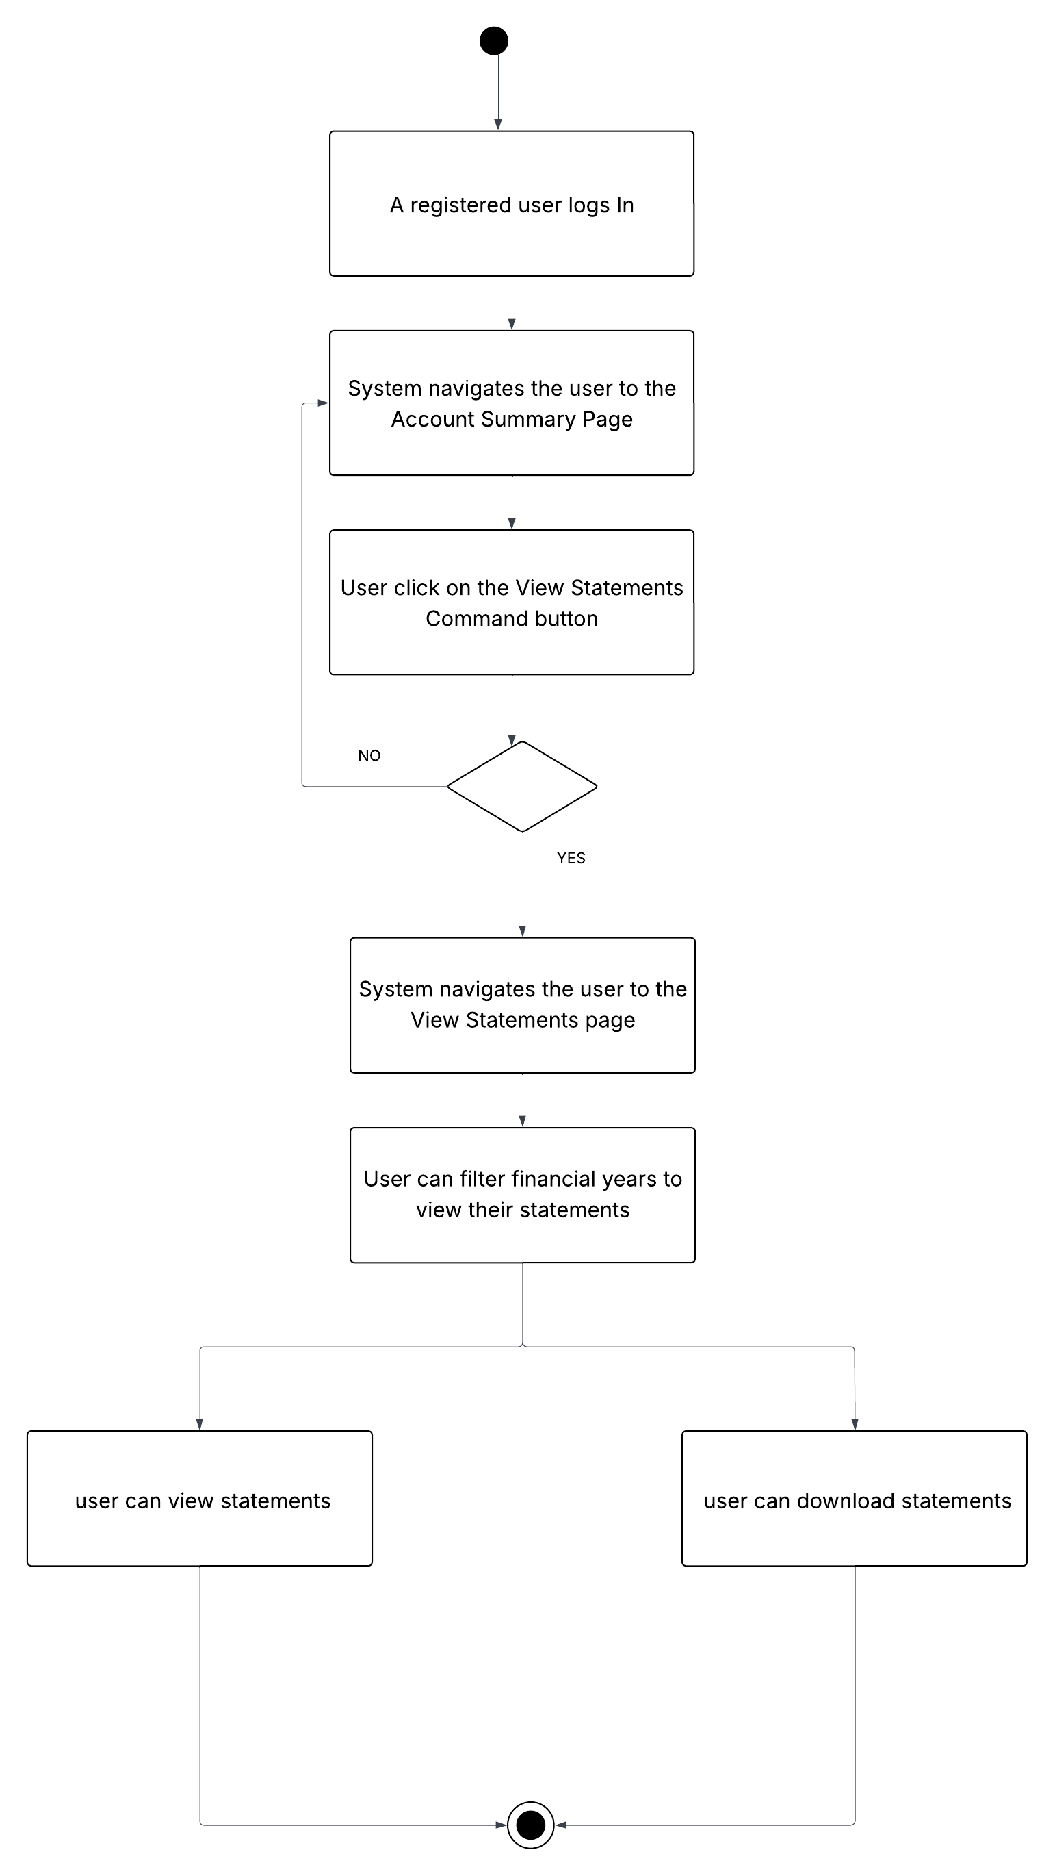

**Appendix 2:** Display ‘View Statements’ Command Button on ‘Account Summary’ Page, Wireframe 1

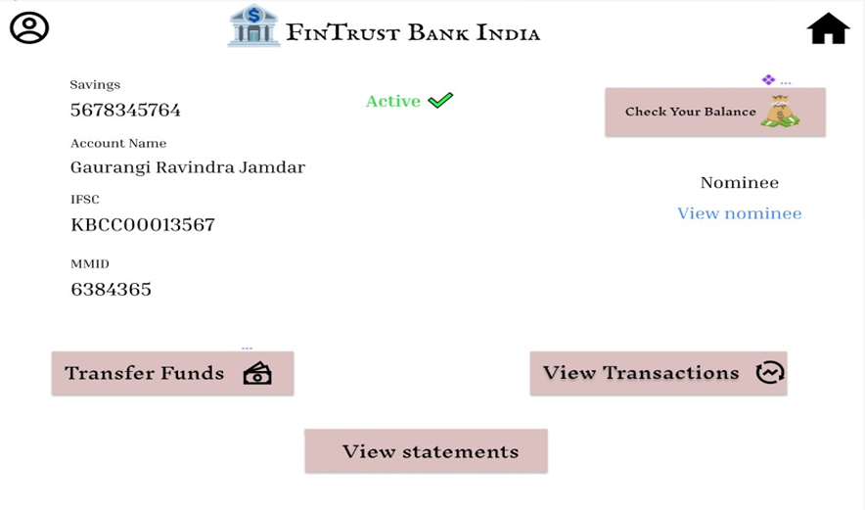

1

**Appendix 3:** Data Table for ‘View Statements’ Command Button

|  |  |  |  |  |  |
| --- | --- | --- | --- | --- | --- |
| **ID** | **Field Name** | **Field Type** | **Content** | **Required Field?** | **Notes** |
| 1 | View Statements | Command Button | N/A | N/A | On click, navigate the user to ‘View Statements’ page in the same browser window. |

**Appendix 4:** ‘View Statements’ Page, Wireframe 2

7

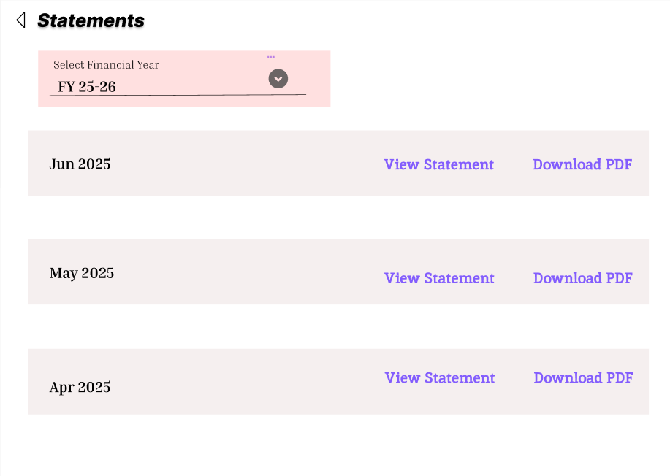

2

6

5

4

3

1

**Appendix 5:** ‘View Statements’ Page Data Table

|  |  |  |  |  |  |
| --- | --- | --- | --- | --- | --- |
| **ID** | **Field Name** | **Field Type** | **Content** | **Required Field?** | **Notes** |
| 1 | Page Title | Text | Statements | N/A | Static page header text. |
| 2 | Financial Year Label | Text | Select Financial Year | N/A | Label above the dropdown. |
| 3 | Financial Year Selector | Dropdown | No default | Yes | Dynamic values.  User must select a financial year before statements are shown. Options: e.g., FY 23-24, FY 24-25, FY 25-26.  The financial years displayed should be fetched dynamically, starting from the year the user’s transactions began, up to the current financial year. |
| 4 | Month Statement Block | Section | Apr 2025, May 2025, Jun 2025, etc | N/A | Each block shows the month name and year corresponding to the financial year selected. |
| 5 | View Statement Link | Link | View Statement | N/A | Opens the corresponding month statement in a new tab or viewer. |
| 6 | Download PDF Link | Link | Download PDF | N/A | Downloads the corresponding month statement PDF directly. |
| 7 | Back | Command Button | N/A | N/A | Navigates back to ‘Account Summary’ page |