### User Story for Transfer Funds

|  |  |
| --- | --- |
| **As a** | Logged-in user of <https://FinTrust.com> |
| **I want** | To be able to transfer funds to an account |
| **So that** | I can make payments to a payee from my account |
| **Acceptance Criteria** | 1. On <https://FinTrust.com>, a registered user logs in, and the system navigates the user to the account summary page in the same window 2. User then clicks on the ‘Transfer Funds’ command button (refer Appendix 2: Wireframe 1 & Appendix 3: Data Table) 3. System navigates the user to the ‘Transfer Funds’ page in the same window (refer Appendix 4: ‘Transfer Funds’ page, Wireframe 2 & Appendix 5: Data Table) 4. User enters payee account details – Account Number, Account Holder Name and IFSC Code, and Amount to be transferred (refer Appendix 4: ‘Transfer Funds’ page, Wireframe 2 & Appendix 5: Data Table) 5. User then clicks on ‘PAY’ command button (refer Appendix 4: ‘Transfer Funds’ page, Wireframe 2 & Appendix 5: Data Table) 6. System checks for validations and passes to next step if all validations pass (refer Appendix 6: Validations Table & Appendix 7: Wireframe 3 & Appendix 8: Data Table) 7. System checks if the entered details match with an active user account. If the details do not match any active user account, the system displays an error message: “The entered details do not match an active account. Please re-enter” (refer Appendix 7: Wireframe 3 & Appendix 8: Data Table) 8. System shows a final confirmation pop-up and asks approval from the user (refer Appendix 9: Wireframe 4 & Appendix 10: Data Table) 9. User clicks on the ‘Yes’ command button and funds get transferred to the payee account (refer Appendix 9: Wireframe 4 & Appendix 10: Data Table) 10. System shows pop-up screen with the successful transaction details (refer Appendix 11: Wireframe 5 & Appendix 12: Data Table) 11. User can click on ‘HELP’ command button if they have any issues regarding the transaction done   (refer Appendix 13: ‘Help’ page, Wireframe 6 & Appendix 14: Data Table)   1. Transaction gets added in Payments History and Account Balance gets updated immediately |

**Appendix 1:** ‘Transfer Funds’ Process Flow

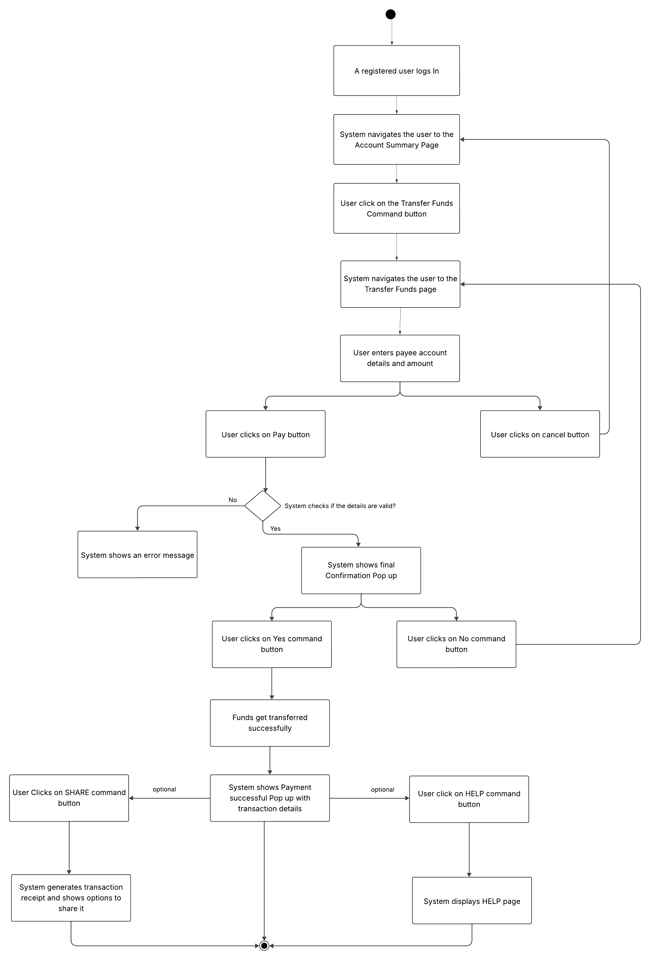

**Appendix 2:** Display ‘Transfer Funds’ Command Button on ‘Account Summary’ Page, Wireframe 1

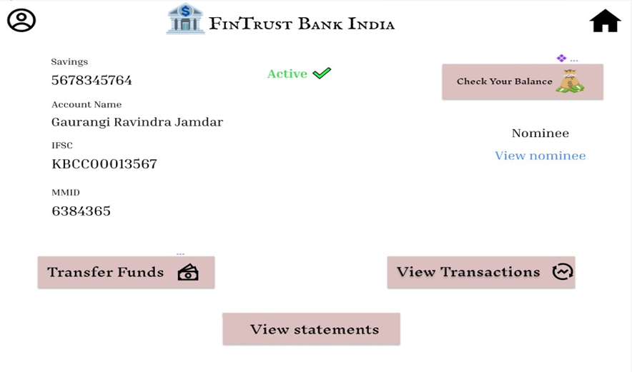

1

**Appendix 3:** Data Table for ‘Transfer Funds’ Command Button

|  |  |  |  |  |  |
| --- | --- | --- | --- | --- | --- |
| **ID** | **Field Name** | **Field Type** | **Content** | **Required Field?** | **Notes** |
| 1 | Transfer Funds | Command Button | N/A | N/A | On click, navigate the user to ‘Transfer Funds’ page in the same browser window. |

**Appendix 4:** ‘Transfer Funds’ Page, Wireframe 2

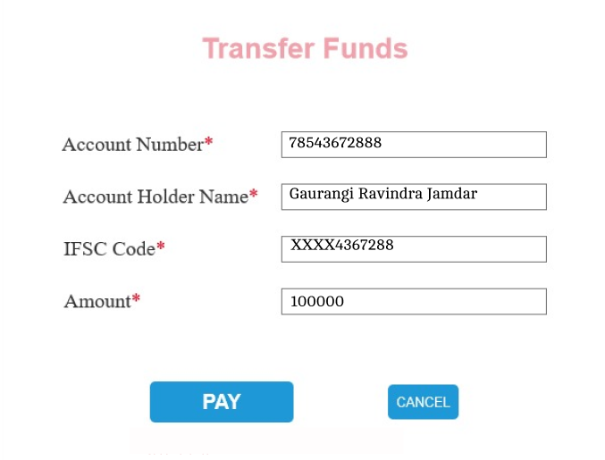

7878

6

3

5

4

2

1

**Appendix 5:** ‘Transfer Funds’ Page Data Table

|  |  |  |  |  |  |
| --- | --- | --- | --- | --- | --- |
| **ID** | **Field Name** | **Field Type** | **Content** | **Required Field?** | **Notes** |
| 1 | Page Title | Text | Transfer Funds | N/A | Static page header. |
| 2 | Account Number | Text Box | Numeric only | Yes | Min: 10 digits, Max: 16 digits (depending on different bank’s policy). |
| 3 | Account Holder Name | Text Box | Alphabetic | Yes | Min: 2 characters, Max: 50 characters.  Spaces Allowed. |
| 4 | IFSC Code | Text Box | Alpha-Numeric | Yes | Format: 4 letters (bank code), 0 (zero), followed by 6 digits (branch code). Exact 11 characters. |
| 5 | Amount | Text Box | Numeric only | Yes | Min value: ₹1, Max value: as per transfer limits (e.g., ₹500,000). |
| 6 | PAY Button | Command Button | PAY | Yes | On click, validates all fields and moves to confirmation pop-up. |
| 7 | CANCEL Button | Command Button | CANCEL | No | On click, clears the form and navigates back to account summary page. |

**Appendix 6:** ‘Transfer Funds’ Page Validations Table

|  |  |
| --- | --- |
| **Field Name** | **Validation Rule** |
| Account Number Format | Must be exactly 11–16 digits. No alphabets or special characters allowed. |
| Account Holder Name Format | Cannot be empty. Should contain only alphabets and spaces. |
| IFSC Code Format | Must follow standard IFSC format: 4 alphabets + 7 digits (e.g., ABCD0123456) |
| Amount | Cannot be zero. Should be a positive number within allowed transfer limits. |
| Active Account | Entered details should match with an active account |
| All fields show red error text if **account doesn't match** (as shown in the image below). | |

**Appendix 7:** Transfer Funds (if Invalid), Wireframe 3

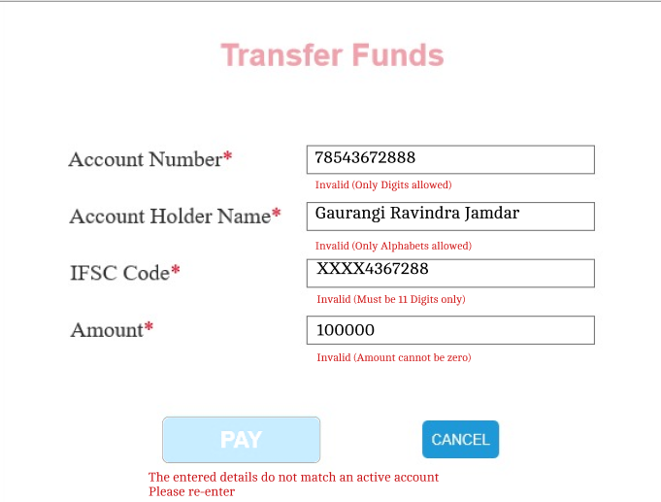

5

4

3

2

1

**Appendix 8:** Transfer Funds (if Invalid) Data Table

|  |  |  |  |  |  |
| --- | --- | --- | --- | --- | --- |
| **ID** | **Field Name** | **Field Type** | **Content** | **Required Field?** | **Notes** |
| 1 | Invalid Account Number | Text | Invalid (Only Digits allowed) | N/A | Displayed in red below the Account Number field when validation fails against Account Number Format. |
| 2 | Invalid Account Holder Name | Text | Invalid (Only Alphabets allowed) | N/A | Displayed in red below the Account Holder Name when validation fails against Account Holder Name Format. |
| 3 | Invalid IFSC Code | Text | Invalid (Must be 11 Digits only) | N/A | Displayed in red below the IFSC Code field when validation fails against IFSC Code Format. |
| 4 | Invalid Amount | Text | Invalid (Amount cannot be zero) | N/A | Displayed in red below the Amount field when validation fails against Amount. |
| 5 | Invalid Payee Details | Text | The entered details do not match an active account. Please re-enter | N/A | Displayed in red below the Pay command button when validation fails against active account. |

**Appendix 9:** Confirmation Pop-up on ‘Transfer Funds’ Page, Wireframe 4

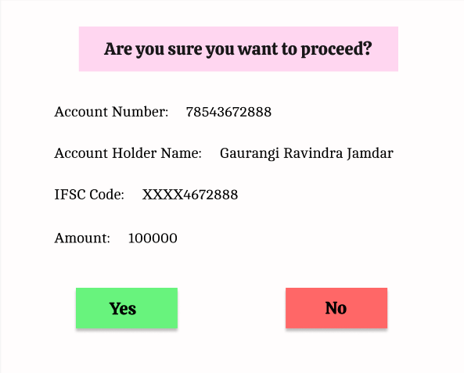

5

4

3

2

6

7

1

**Appendix 10:** ‘Transfer Funds’ Page Data Table

|  |  |  |  |  |  |
| --- | --- | --- | --- | --- | --- |
| **ID** | **Field Name** | **Field Type** | **Content** | **Required Field?** | **Notes** |
| 1 | Confirmation Message | Text | Are you sure you want to proceed? | N/A | Static header text in the pop-up. |
| 2 | Account Number | Text | 78543672888 | N/A | Fetched from user input. |
| 3 | Account Holder Name | Text | Gaurangi Ravindra Jamdar | N/A | Fetched from user input. |
| 4 | IFSC Code | Text | XXXX4672888 | N/A | Fetched from user input; masked for security. |
| 5 | Amount | Text | 100000 | N/A | Transfer amount entered by the user. |
| 6 | Yes Button | Command Button | Yes | Yes | Confirms and proceeds with fund transfer. |
| 7 | No Button | Command Button | No | No | Cancels the transaction and returns to ‘Transfer Funds’ page. |

**Appendix 11:** ‘Payment Successful’ Pop-up on ‘Transfer Funds’ Page, Wireframe 5

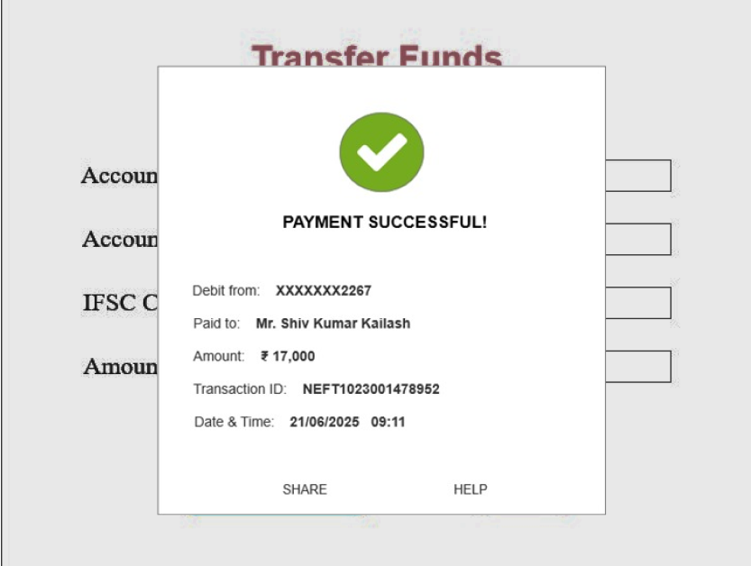

2

9

8

6

7

5

4

3

1

**Appendix 12:** ‘Payment Successful’ Pop-up Data Table

|  |  |  |  |  |  |
| --- | --- | --- | --- | --- | --- |
| **ID** | **Field Name** | **Field Type** | **Content** | **Required Field?** | **Notes** |
| 1 | Success Icon | Icon | Green tick/checkmark | N/A | Visual confirmation of successful transaction. |
| 2 | Success Message | Text | PAYMENT SUCCESSFUL! | N/A | Static header text. |
| 3 | Debit From | Text | XXXXXXXX2267 | N/A | Masked debit account number of the user; dynamically fetched. |
| 4 | Paid To | Text | Mr. Shiv Kumar Kailash | N/A | Payee name; dynamically fetched from transfer details. |
| 5 | Amount | Text | ₹ 17,000 | N/A | Amount transferred; dynamic. |
| 6 | Transaction ID | Text | NEFT1023001478952 | N/A | Unique transaction identifier; dynamically generated. |
| 7 | Date & Time | Text | 21/06/2025 09:11 | N/A | Transaction timestamp; dynamic. |
| 8 | SHARE Button | Command Button | SHARE | N/A | Allows user to share transaction details (e.g., via email, SMS, or social apps). |
| 9 | HELP Button | Command Button | HELP | N/A | Opens help or support options. |

**Appendix 13:** ‘Help’ Page, Wireframe 6



2

6

5

4

3

1

**Appendix 14:** ‘Help’ Page Data Table

|  |  |  |  |  |  |
| --- | --- | --- | --- | --- | --- |
| **ID** | **Field Name** | **Field Type** | **Content** | **Required Field?** | **Notes** |
| 1 | Page Title | Text | Need help about your transaction? | N/A | Header text for the help screen. |
| 2 | Mail Instruction Text | Text | Mail your transaction details to our Mail ID: | N/A | Static instructional text. |
| 3 | Help Email Address | Hyperlink | transaction.help@fintrust.com | N/A | Opens default mail app when clicked. |
| 4 | Alternate Contact Instruction | Text | Or you can also contact us on: | N/A | Follow-up instruction. |
| 5 | Toll-Free Contact Number | Hyperlink/Text | 1800-234-675 | N/A | Click-to-call link for mobile. |
| 6 | Back Arrow Icon | Command Button | N/A | N/A | Navigates back to ‘Account Summary’ page. |