### User Story for View Transactions

|  |  |
| --- | --- |
| **As a** | Logged-in user of <https://FinTrust.com> |
| **I want** | To be able to view a list of all transactions made from my account |
| **So that** | I can view my transactions anytime and manage them on my own |
| **Acceptance Criteria** | 1. On <https://FinTrust.com>, a registered user logs in, and the system navigates the user to the account summary page in the same window 2. User then clicks on the ‘View Transactions’ command button (refer Appendix 2: Wireframe 1 & Appendix 3: Data Table) 3. System navigates the user to the ‘View Transactions’ page in the same window (refer Appendix 4: ‘View Transactions’ page, Wireframe 2 & Appendix 5: Data Table) 4. User chooses to view their account transactions by using the filter having the following options:    1. Last 10 transactions    2. Last Month transactions    3. Custom Dates transactions 5. System shows user’s account number on the page (refer Appendix 4: ‘View Transactions’ page, Wireframe 2 & Appendix 5: Data Table) 6. System shows available account balance on the page (refer Appendix 4: ‘View Transactions’ page, Wireframe 2 & Appendix 5: Data Table) |

**Appendix 1:** ‘View Transactions’ Process Flow

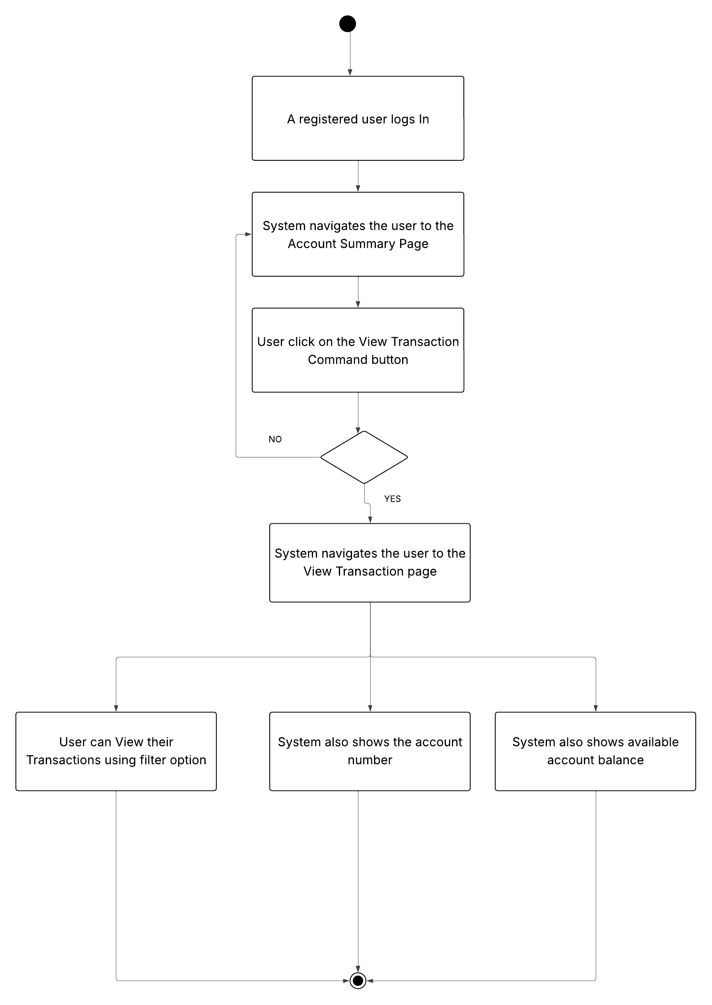

**Appendix 2:** Display ‘View Transactions’ Command Button on ‘Account Summary’ Page, Wireframe 1

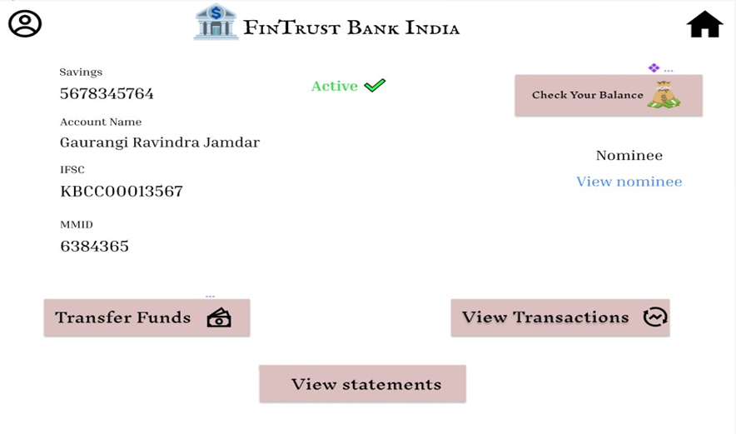

1

**Appendix 3:** Data Table for ‘View Transactions’ Command Button

|  |  |  |  |  |  |
| --- | --- | --- | --- | --- | --- |
| **ID** | **Field Name** | **Field Type** | **Content** | **Required Field?** | **Notes** |
| 1 | View Transactions | Command Button | N/A | N/A | On click, navigate the user to ‘View Transactions’ page in the same browser window |

**Appendix 4:** ‘View Transactions’ Page, Wireframe 2

11

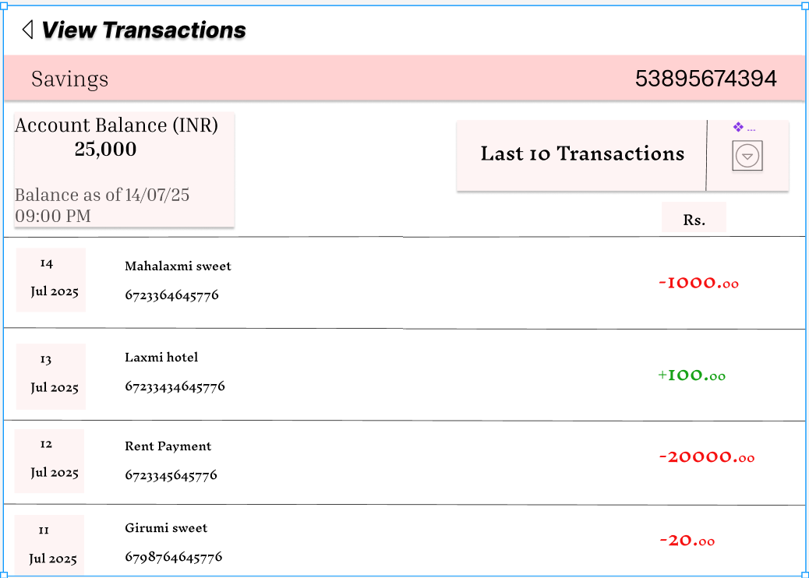

8

10

9

7

5

4

3

2

6

1

**Appendix 5:** ‘View Transactions’ Page Data Table

|  |  |  |  |  |  |
| --- | --- | --- | --- | --- | --- |
| **ID** | **Field Name** | **Field Type** | **Content** | **Required Field?** | **Notes** |
| 1 | Page Title | Text | View Transactions | N/A | Static page header. |
| 2 | Account Type | Text | Savings | N/A | Fixed value indicating account type (Savings or Current). |
| 3 | Account Number | Text | Dynamic | N/A | Populated from user's account details. |
| 4 | Account Balance | Text | Dynamic | N/A | Latest account balance value. |
| 5 | Balance Date/Time | Text | Dynamic | N/A | Last balance update timestamp. |
| 6 | Transactions Filter Label | Dropdown | Last 10 Transactions | Yes | Default option shown as "Last 10 Transactions"; options include "Last 10 Transactions", "Last Month Transactions", and "Custom Dates".  When "Custom Dates" is selected, system displays "From Date" and "To Date" pickers with appropriate validations and no future dates allowed. |
| 7 | Transaction Date | Text | 14 Jul 2025, etc. | N/A | Transaction date (dynamic per record). |
| 8 | Payee Account Name | Text | Mahalaxmi, Laxmi hotel, etc. | N/A | Payee Name (dynamic per record). |
| 9 | Reference ID | Text | 672334645776, etc. | N/A | UPI/transaction reference (dynamic per record). |
| 10 | Amount | Text | 1,000.00, 100.00, etc. | N/A | Debit amounts shown in red, credit amounts shown in green.  Values are always positive; color indicates transaction type. |
| 11 | Back | Command Button | N/A | N/A | Navigates back to ‘Account Summary’ page |