Functional Requirements Document (HappyTummies)

Contents

**1. Scope** 2

**2. System(s) Impacted** 2

**3. Assumptions/Dependencies** 2

**4. As-Is Business Process (via activity diagram)** 3

**5. To-Be Business Process (via activity diagram)** 4

**6. Requirements** 6

**6.1 Requirements: ‘Checkout’ Page** 6

**6.1.1** **‘Checkout’ page data fields** 6

**6.1.2 ‘Apply Coupon’ data validations** 8

**6.1.3 ‘Place Order’ Command Button Navigation** 8

**6.2 Requirements: ‘Order Confirmation’ Page** 9

**6.2.1 ‘Order Confirmation’ page data fields** 9

**6.3 Requirements: ‘Order Cancel Confirmation’ Page** 11

**6.3.1 ‘Order Cancel Confirmation’ page data fields** 11

**6.4 Requirements: ‘Order Cancelled’ Page** 13

**6.4.1 ‘Order Cancelled’ page data fields** 13

**6.5 Requirements: ‘Coupon Management’ Page** 15

**6.5.1 ‘Coupon Management’ page data fields** 15

**6.6 Requirements: ‘Coupon Performance’ Page** 17

**6.6.1‘Coupon Performance’ page data fields** 17

**6.7 Requirements: ‘Create New Coupon’ Page** 19

**6.7.1 ‘Create New Coupon’ page data fields** 19

**6.7.2 ‘Create New Coupon’ page data validations** 20

6.7.2.1 ‘Create New Coupon’ page data validation = Pass 20

6.7.2.2 ‘Create New Coupon’ page data validation = Fail 20

**6.8 Requirements: ‘Coupon Created Successfully’ Page** 22

**6.8.1 ‘Coupon Created Successfully’ page data fields** 22

**7.** Issues/Open Questions 24

**1. Scope**

Enhance the HappyTummies mobile application by adding key features that improve user flexibility and payment convenience. The update will include:

* Multiple digital payment options (UPI, Card, Wallet)
* Promo code and coupon functionality
* Order cancellation with confirmation
* Admin interface for coupon management and analytics

**2. System(s) Impacted**

• **HappyTummies Android App:**

* Checkout screen
* Order confirmation & cancellation screen
* Payment method selection logic

• **Admin Panel (Web):**

* Coupon creation, activation, and performance tracking interface

**3. Assumptions/Dependencies**

• The app is available on Android and supports the required updates.

• A secure third-party payment gateway will be used to process digital transactions.

• Coupon logic will be built internally or integrated via a marketing engine/tool.

• API endpoints for coupon validation, order updates, and payment processing will be available.

• Customer support will handle queries related to payment failures, coupon issues, or cancellations.

**4. As-Is Business Process (via activity diagram)**

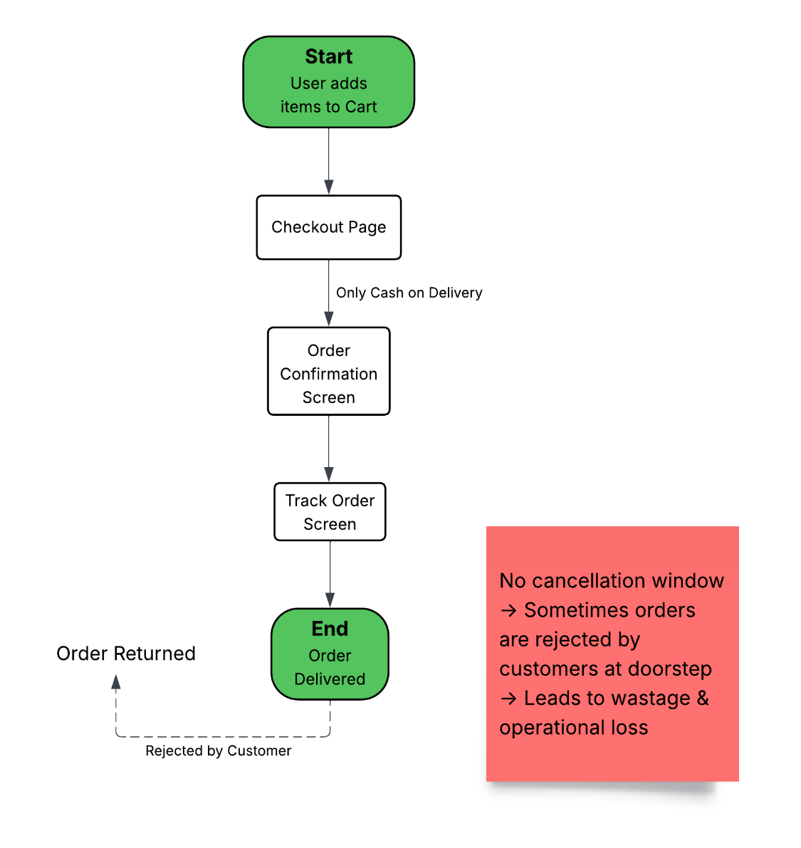

**5. To-Be Business Process (via activity diagram)**

**User-Side**

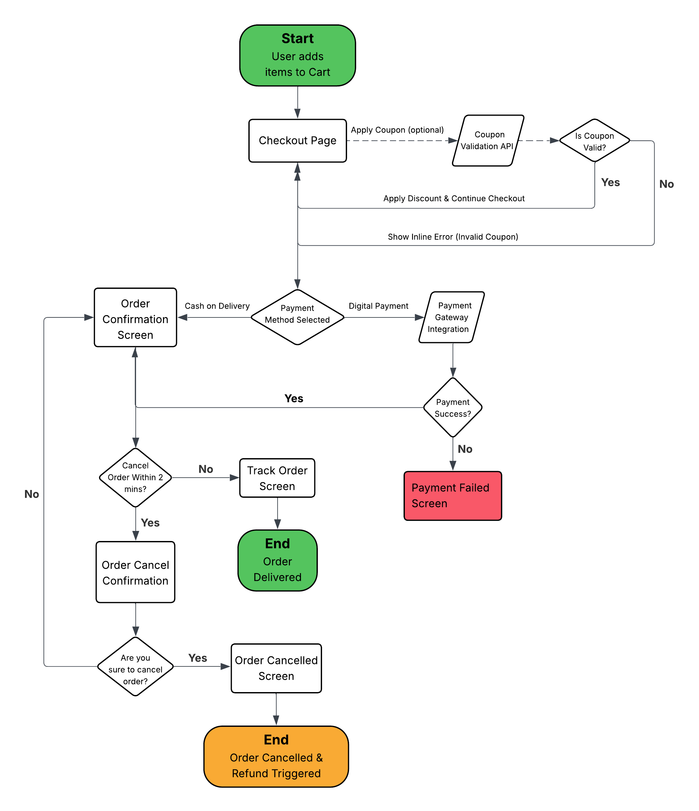

**Admin-Side**

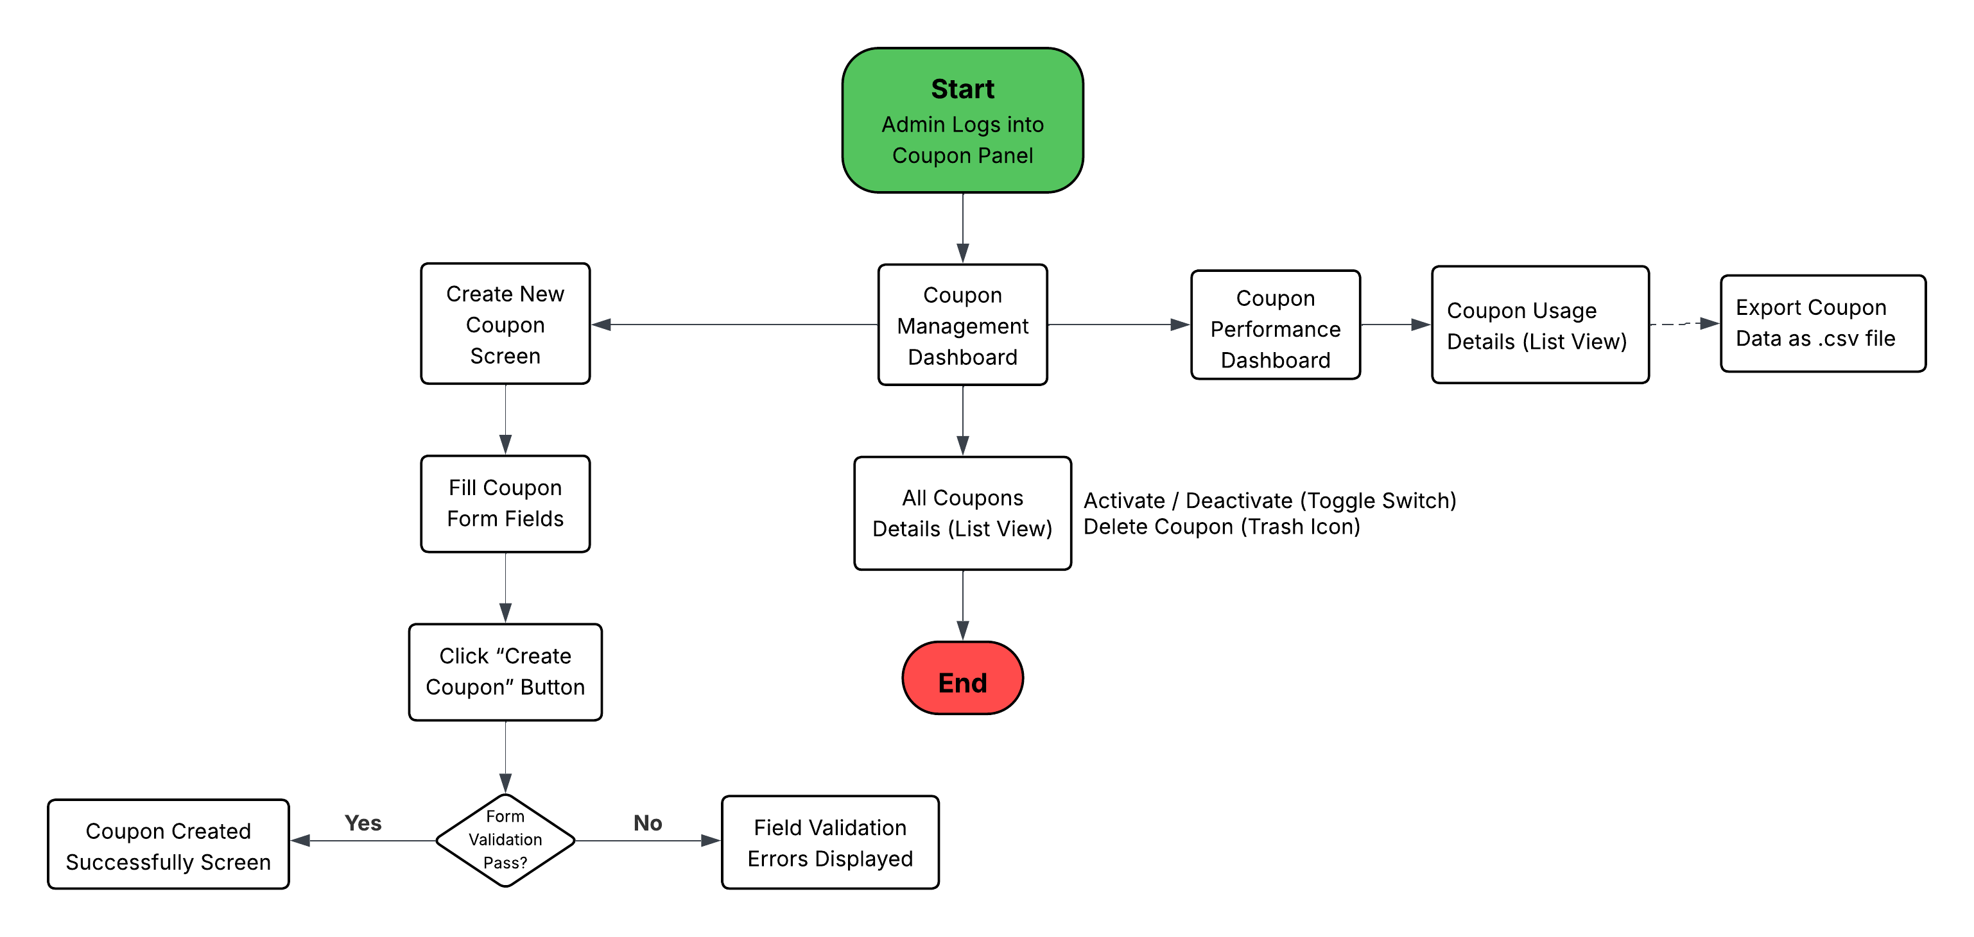

**External Process (for User)**

**6. Requirements**

**6.1 Requirements: ‘Checkout’ Page**

Displays the order summary before the user places the order.

### **6.1.1** **‘Checkout’ page data fields**

The system shall display the following fields on the '**Checkout’** page:

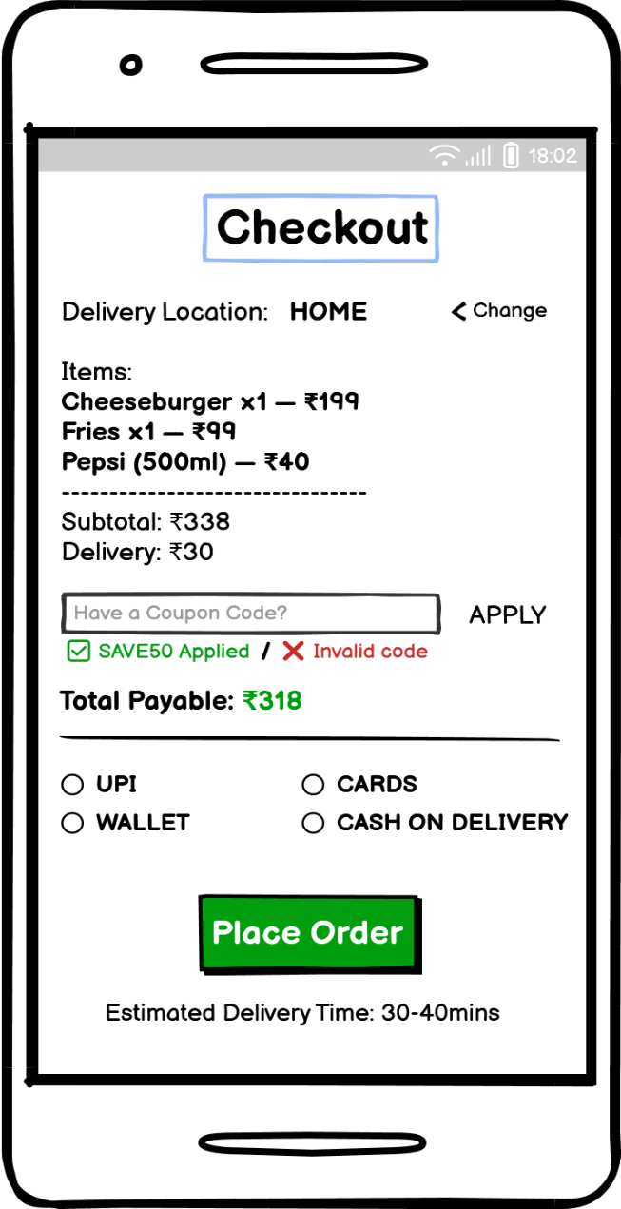

|  |  |  |  |  |  |  |  |
| --- | --- | --- | --- | --- | --- | --- | --- |
| **Sr. No.** | **Field Name** | **Field Type** | **Content** | **Required Field?** | **Min. Char.** | **Max Char.** | **Notes** |
| 1 | Page Title | Label / Heading | Checkout | N/A | N/A | N/A | Heading shown at the top of the checkout screen |
| 2 | Delivery Location | Text Label | Delivery Location: HOME | N/A | N/A | N/A | Current delivery address; can be edited via “Change” link |
| 3 | Change Location Link | Command Link | Change | No | N/A | N/A | Allows user to change the delivery address |
| 4 | Items List | Item Summary List | Cheeseburger ×1 – ₹199, Fries ×1 – ₹99, Pepsi (500ml) – ₹40 | N/A | N/A | N/A | Shows user’s selected items with quantities and individual prices |
| 5 | Subtotal Label | Text Label | Subtotal: ₹338 | N/A | N/A | N/A | Auto-calculated based on items in cart |
| 6 | Delivery Fee Label | Text Label | Delivery: ₹30 | N/A | N/A | N/A | Variable delivery charge based on user location and order value |
| 7 | Coupon Code Field | Text Input | Alpha-Numeric | No | 3 | 30 | Optional field for applying promo codes |
| 8 | Apply Button | Command Button | APPLY | No | N/A | N/A | Validates and applies entered coupon code |
| 9 | Coupon Status Message | Text Label | ✅ SAVE50 Applied / ❌ Invalid code | N/A | N/A | N/A | Shows result of coupon validation |
| 10 | Total Payable Amount | Text Label | Total Payable: ₹318 | N/A | N/A | N/A | Displays total amount payable after discounts |
| 11 | Payment Method Options | Radio Buttons | UPI, Wallet, Cards, Cash on Delivery | Yes | N/A | N/A | User must select one option for placing the order |
| 12 | Place Order Button | Command Button | Place Order | Yes | N/A | N/A | Confirms the order and proceeds to payment or confirmation screen |
| 13 | Estimated Delivery Time | Text Label | Estimated Delivery Time: 30–40 mins | N/A | N/A | N/A | Displays estimated time for order to be delivered |

**6.1.2 ‘Apply Coupon’ data validations**

On click of the **‘Apply’ Command Button**, the system shall perform the following validations on the entered coupon code and related parameters:

1. The coupon code input must not be blank when Apply button is clicked.
2. The coupon code must contain only alphabets and numbers. Special characters are not allowed.
3. The entered coupon code must have at least 3 characters to be considered valid.
4. The coupon code must exist in the coupon database and must be in Active status.
5. The current system date must fall within the coupon's Valid From and Valid To dates.
6. The user must meet the eligibility criteria defined for the coupon (e.g., first-time user, targeted campaign).
7. If the coupon has a Min Order Value condition, the cart total must meet or exceed it.
8. The number of times the user has redeemed this coupon must not exceed the defined Max Usage per User.
9. The system shall ensure only one active coupon code is applied per order. Applying a new code overrides any previously applied coupon.

**Error Messages:**

|  |  |
| --- | --- |
| **Failed Validation** | **Error Message Displayed** |
| Coupon code field is empty | Please enter a coupon code to apply. |
| Coupon code is invalid format (special characters, less than 3 chars) | Invalid coupon code format. |
| Coupon does not exist or expired | The coupon code entered is invalid or expired. |
| Coupon is not applicable on current cart/order | This coupon is not applicable for your order. |
| Coupon usage limit exceeded by the user | You have already used this coupon. |
| Order value is below minimum required for coupon | Add items worth ₹X more to use this coupon. |
| Multiple coupons entered | Only one coupon can be applied per order. |
| Coupon code field is empty | Please enter a coupon code to apply. |

### **6.1.3 ‘Place Order’ Command Button Navigation**

On clicking the ‘Place Order’ command button, the system shall initiate the selected payment method. Upon successful payment, the system shall display the ‘Order Confirmation’ page.

**6.2 Requirements: ‘Order Confirmation’ Page**

Displays a confirmation message along with order details after successful payment.

**6.2.1 ‘Order Confirmation’ page data fields**

System shall display the following data fields on ‘Order Confirmation’ page:

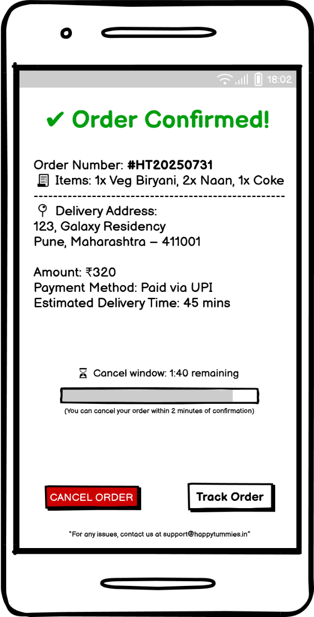

|  |  |  |  |  |  |  |  |
| --- | --- | --- | --- | --- | --- | --- | --- |
| **Sr. No.** | **Field Name** | **Field Type** | **Content** | **Required Field?** | **Min. Char.** | **Max Char.** | **Notes** |
| 1 | Confirmation Message | Label / Heading | ✅ Order Confirmed! | N/A | N/A | N/A | Displayed at top in green indicate success |
| 2 | Order Number | Text Label | Order Number: #HT20250731 | N/A | N/A | N/A | Unique order ID generated |
| 3 | Ordered Items | Text Label | 🧾Items: 1x Veg Biryani, 2x Naan, 1x Coke | N/A | N/A | N/A | Summary of items and quantities placed |
| 4 | Delivery Address | Text Label | 📍Delivery Address: 123, Galaxy Residency, Pune, Maharashtra – 411001 | N/A | N/A | N/A | Full address shown as per user selection |
| 5 | Amount | Text Label | Amount: ₹320 | N/A | N/A | N/A | Total amount paid or to be paid for the order |
| 6 | Payment Method | Text Label | Payment Method: Paid via UPI | N/A | N/A | N/A | Shows payment mode used by user |
| 7 | Estimated Delivery Time | Text Label | Estimated Delivery Time: 45 mins | N/A | N/A | N/A | Approximate delivery duration based on distance between restaurant and delivery address |
| 8 | Cancel Window Timer | Countdown Label | Cancel window: 1:40 remaining | N/A | N/A | N/A | Shows time left to cancel order (within 2 minutes from order confirmation) |
| 9 | Cancel Timer Progress Bar | Progress Indicator | [Visual progress bar] | N/A | N/A | N/A | Visual representation of time left to cancel the order |
| 10 | Cancel Order Button | Command Button | CANCEL ORDER | No | N/A | N/A | Navigates user to ‘Order Cancel Confirmation’ page (Enabled only while cancel window is active) |
| 11 | Track Order Button | Command Button | Track Order | No | N/A | N/A | Navigates user to real-time order tracking screen |
| 12 | Support Message | Footer Text | For any issues, contact us at support@happytummies.in | N/A | N/A | N/A | Static footer message with contact email for support |

**6.3 Requirements: ‘Order Cancel Confirmation’ Page**

Displays a confirmation prompt before proceeding with order cancellation.

**6.3.1 ‘Order Cancel Confirmation’ page data fields**

System shall display the following data fields on ‘Order Cancel Confirmation’ page:

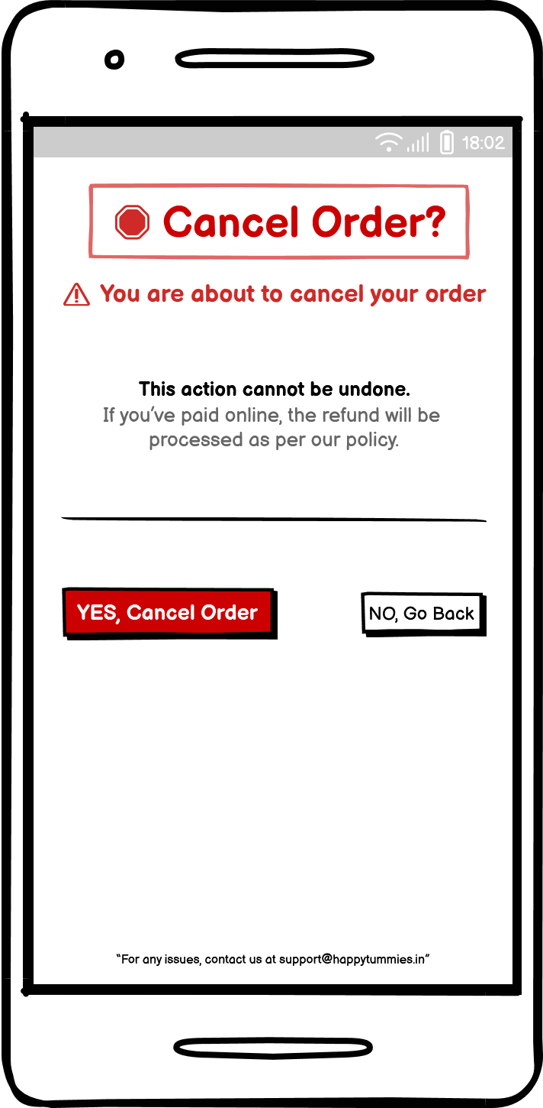

|  |  |  |  |  |  |  |  |
| --- | --- | --- | --- | --- | --- | --- | --- |
| **Sr. No.** | **Field Name** | **Field Type** | **Content** | **Required Field?** | **Min. Char.** | **Max Char.** | **Notes** |
| 1 | Page Title | Label / Heading | 🛑 Cancel Order? | N/A | N/A | N/A | Heading displayed at the top in red and bold |
| 2 | Warning Message | Text Label | ⚠️ You are about to cancel your order | N/A | N/A | N/A | Warning message shown in red |
| 3 | Info Message | Text Label | This action cannot be undone. | N/A | N/A | N/A | Displayed in bold black text |
| 4 | Refund Policy Text | Text Label | If you’ve paid online, the refund will be processed as per our policy. | N/A | N/A | N/A | Shown in grey below the main warning |
| 5 | Horizontal Divider | Visual Divider | [Line] | N/A | N/A | N/A | Separates message content from action buttons |
| 6 | Cancel Order Button | Command Button | YES, Cancel Order | No | N/A | N/A | In red; confirms cancellation and navigates user to ‘Order Cancelled’ page |
| 7 | Go Back Button | Command Button | NO, Go Back | No | N/A | N/A | In grey; returns to previous screen |
| 8 | Support Message | Footer Text | “For any issues, contact us at support@happytummies.in” | N/A | N/A | N/A | Static footer message with contact email for support |

**6.4 Requirements: ‘Order Cancelled’ Page**

Displays a confirmation message after the order has been successfully cancelled.

**6.4.1 ‘Order Cancelled’ page data fields**

System shall display the following data fields on ‘**Order Cancelled**’ page:

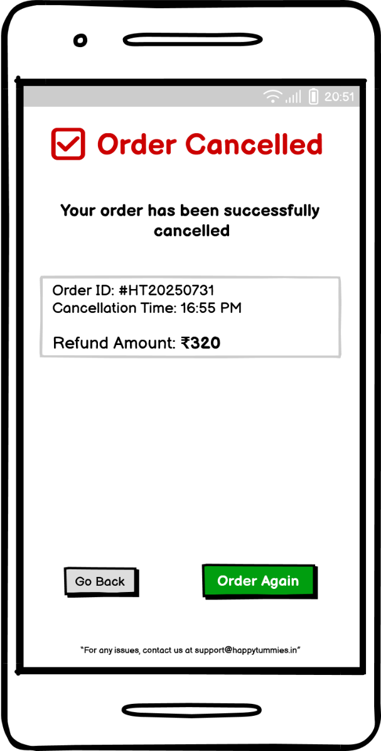

|  |  |  |  |  |  |  |  |
| --- | --- | --- | --- | --- | --- | --- | --- |
| **Sr. No.** | **Field Name** | **Field Type** | **Content** | **Required Field?** | **Min. Char.** | **Max Char.** | **Notes** |
| 1 | Cancellation Message | Label / Heading | ✅ Order Cancelled | N/A | N/A | N/A | Displayed at the top in red to confirm successful cancellation |
| 2 | Subheading Text | Text Label | Your order has been successfully cancelled | N/A | N/A | N/A | Short status message below the heading |
| 3 | Order Details Box | Container Group | Order ID: #HT20250731  Cancellation Time: 16:55 PM  Refund Amount: ₹320 | N/A | N/A | N/A | Grey-shaded card showing order ID, cancellation time, and refund amount (in bold) |
| 4 | Go Back Button | Command Button | Go Back | No | N/A | N/A | Navigates user back to home screen |
| 5 | Order Again Button | Command Button | Order Again | No | N/A | N/A | Takes user to menu screen to start a new order |
| 6 | Support Message | Footer Text | For any issues, contact us at support@happytummies.in | N/A | N/A | N/A | Static footer message with contact email for support |

**Internal Process (for Admin)**

**6.5 Requirements: ‘Coupon Management’ Page**

Displays the Admin Panel for viewing and managing discount coupons.

**6.5.1 ‘Coupon Management’ page data fields**

System shall display the following data fields on ‘Coupon Management’ page:

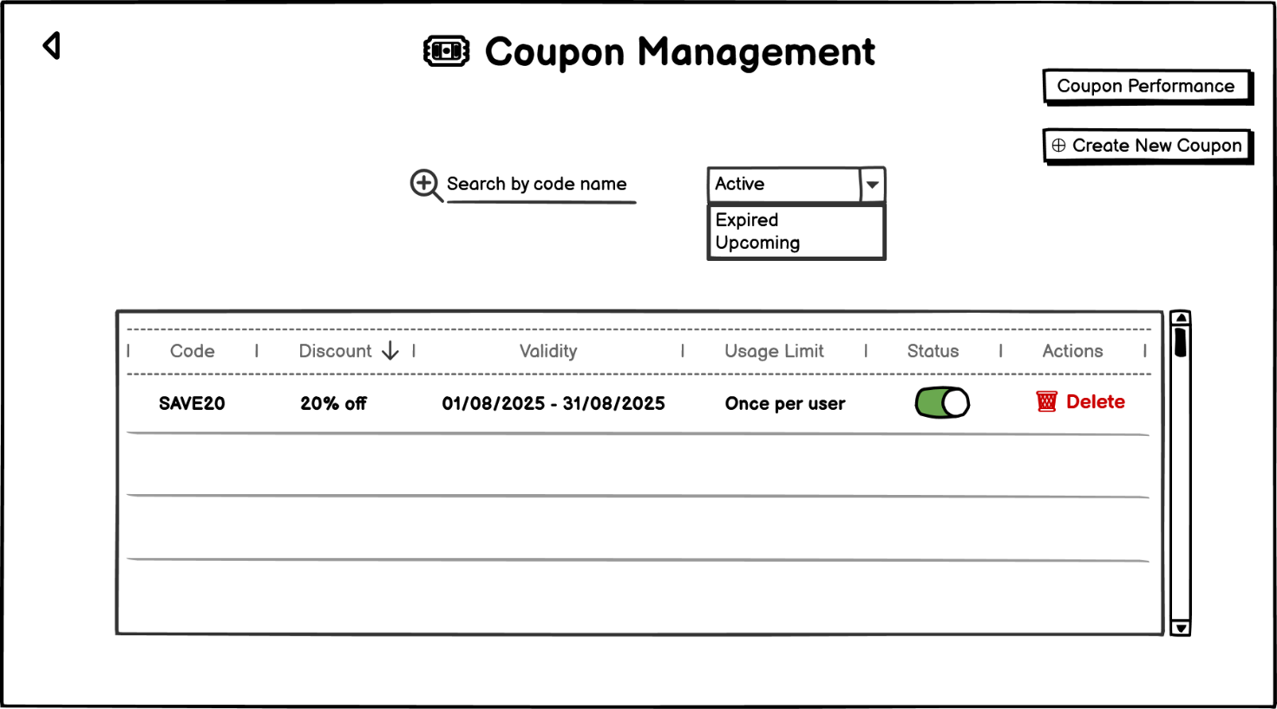

|  |  |  |  |  |  |  |  |
| --- | --- | --- | --- | --- | --- | --- | --- |
| **Sr. No.** | **Field Name** | **Field Type** | **Content** | **Required Field?** | **Min. Char.** | **Max Char.** | **Notes** |
| 1 | Page Title | Label / Heading | Coupon Management | N/A | N/A | N/A | Displayed at the top-center of the admin panel page |
| 2 | Search Bar | Text Input + Icon | Alpha-Numeric | No | 3 | 30 | Helps admin search for specific coupon codes |
| 3 | Status Filter Dropdown | Dropdown Select | Active, Expired, Upcoming | No | N/A | N/A | Used to filter coupon records based on status |
| 4 | Coupon Performance Button | Command Button | Coupon Performance | No | N/A | N/A | Navigates to ‘Coupon Performance’ page |
| 5 | Create New Coupon Button | Command Button | ➕ Create New Coupon | No | N/A | N/A | Navigates to ‘Create New Coupon’ page |
| 6 | Coupon Table | Data Table | Code, Discount, Valid Dates, etc. | N/A | N/A | N/A | Displays all coupon data in a tabular format |
| 7 | Code | Table Column | SAVE20 | N/A | N/A | N/A | Unique alphanumeric identifier for the coupon |
| 8 | Discount | Table Column | 20% off | N/A | N/A | N/A | Type of discount applicable |
| 9 | Validity | Table Column | 01/08/2025 – 31/08/2025 | N/A | N/A | N/A | Duration in which the coupon is valid |
| 10 | Usage Limit | Table Column | Once per user | N/A | N/A | N/A | Restriction on number of times a user can redeem the coupon |
| 11 | Status Toggle | Switch | Toggle ON/OFF | No | N/A | N/A | Allows admin to activate/deactivate a coupon |
| 12 | Delete Coupon | Command Link/Button | 🗑️ Delete | No | N/A | N/A | Allows admin to permanently delete a coupon |
| 13 | Scrollbar | Scroll Component | Vertical scrollbar | N/A | N/A | N/A | Allows scrolling if coupon list exceeds visible area |
| 14 | Back Button | Command Button | ← | No | N/A | N/A | Navigates back to previous screen |

**6.6 Requirements: ‘Coupon Performance’ Page**

Displays coupon usage analytics and redemption performance to the admin.

**6.6.1‘Coupon Performance’ page data fields**

System shall display the following data fields on ‘Coupon Performance’ page:

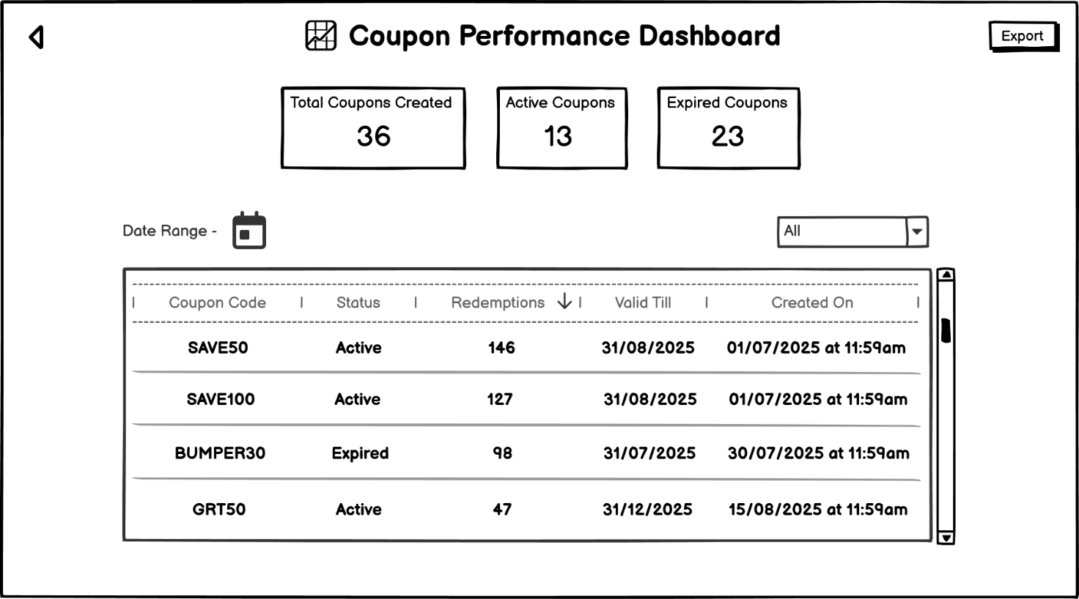

|  |  |  |  |  |  |  |  |
| --- | --- | --- | --- | --- | --- | --- | --- |
| **Sr. No.** | **Field Name** | **Field Type** | **Content** | **Required Field?** | **Min. Char.** | **Max Char.** | **Notes** |
| 1 | Page Title | Label / Heading | Coupon Performance Dashboard | N/A | N/A | N/A | Appears at the top to indicate current admin section |
| 2 | Export Button | Command Button | Export | No | N/A | N/A | Allows exporting data in CSV/Excel format |
| 3 | Total Coupons Created | Stat Display Card | Total Coupons Created – 36 | N/A | N/A | N/A | Displays the total number of coupons added till now |
| 4 | Active Coupons | Stat Display Card | Active Coupons – 13 | N/A | N/A | N/A | Displays number of currently active coupons |
| 5 | Expired Coupons | Stat Display Card | Expired Coupons – 23 | N/A | N/A | N/A | Displays number of expired coupons |
| 6 | Date Range Picker | Date Input | [Calendar Icon] | No | N/A | N/A | Used to filter coupons based on selected date range |
| 7 | Status Filter Dropdown | Dropdown | All / Active / Expired | No | N/A | N/A | Dropdown to filter coupons based on the current status |
| 8 | Coupon Code | Table Column | SAVE50, SAVE100, BUMPER30, GRT50 | N/A | N/A | N/A | Displays coupon codes in list view |
| 9 | Status | Table Column | Active / Expired | N/A | N/A | N/A | Shows current state of coupons |
| 10 | Redemptions Count | Table Column | 146, 127, 98, 47 | N/A | N/A | N/A | Number of times each coupon has been used |
| 11 | Valid Till Date | Table Column | e.g., 31/08/2025 | N/A | N/A | N/A | End date of coupon validity |
| 12 | Created On Date & Time | Table Column | e.g., 01/07/2025 at 11:59am | N/A | N/A | N/A | Timestamp when coupon was created |
| 13 | Scrollbar | UI Control | Vertical Scrollbar | N/A | N/A | N/A | Allows scrolling through the list of coupons |
| 14 | Back Button | Command Button | ← | No | N/A | N/A | Navigates back to previous screen |

**6.7 Requirements: ‘Create New Coupon’ Page**

Displays screen for the admin to create new coupons.

**6.7.1 ‘Create New Coupon’ page data fields**

System shall display the following data fields on ‘Create New Coupon’ page:

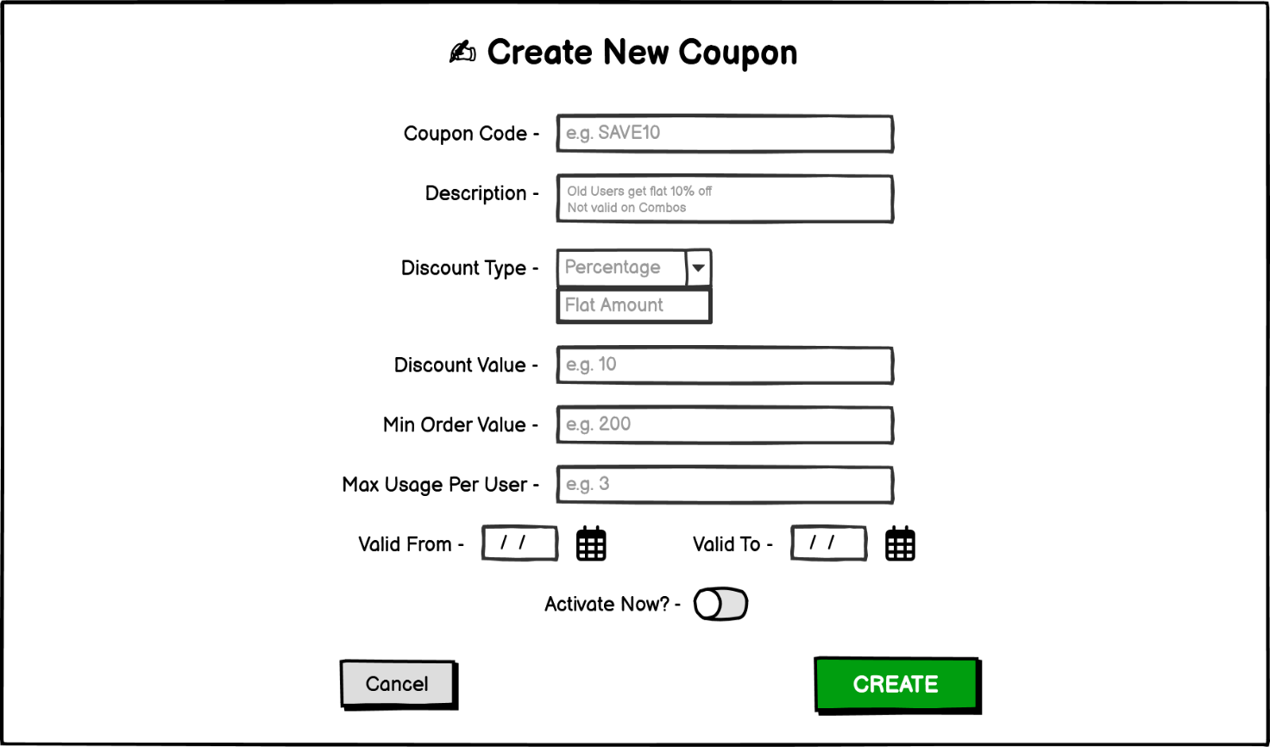

|  |  |  |  |  |  |  |  |
| --- | --- | --- | --- | --- | --- | --- | --- |
| **Sr. No.** | **Field Name** | **Field Type** | **Content** | **Required Field?** | **Min. Char.** | **Max Char.** | **Notes** |
| 1 | Page Title | Label / Heading | Create New Coupon | N/A | N/A | N/A | Main heading at the top of the page |
| 2 | Coupon Code | Text Input | Alpha-Numeric | Yes | 3 | 20 | Unique code identifier entered by admin |
| 3 | Description | Text Area | Alpha-Numeric | No | 10 | 200 | Optional coupon description with rule or condition |
| 4 | Discount Type | Dropdown | Percentage, Flat Amount | Yes | N/A | N/A | Admin must select one type of discount |
| 5 | Discount Value | Text Input | Numeric | Yes | 1 | 3 | Numeric value, interpreted based on discount type |
| 6 | Min Order Value | Text Input | Numeric | Yes | 0 | 4 | Minimum cart amount for coupon to be applicable |
| 7 | Max Usage Per User | Text Input | Numeric | Yes | 1 | N/A | Max times a user can apply this coupon |
| 8 | Valid From | Date Picker | [Calendar icon] | Yes | N/A | N/A | Start date of coupon validity |
| 9 | Valid To | Date Picker | [Calendar icon] | Yes | N/A | N/A | End date of coupon validity |
| 10 | Activate Now? | Toggle Switch | On / Off | No | N/A | N/A | Optional toggle to activate the coupon immediately |
| 11 | Create Button | Command Button | CREATE | Yes | N/A | N/A | Navigates to ‘Coupon Created Successfully’ page |
| 12 | Cancel Button | Command Button | Cancel | No | N/A | N/A | Navigates to ‘Coupon Management (Admin)’ page without saving |

**6.7.2 ‘Create New Coupon’ page data validations**

On click of **‘Create’** command button, the system shall perform the following validations:

* All required fields are filled
* Coupon code is alphanumeric (no special characters)
* Discount type is selected (Percentage or Flat Amount)
* Discount value is a positive number
* Min Order Value is a positive number (0 accepted)
* Max Usage per User is a valid non-zero number
* Valid From and Valid To dates are selected and are in the correct chronological order

### 6.7.2.1 ‘Create New Coupon’ page data validation = Pass

In the event of **passing** all validations, the system shall:

* Save the coupon
* Navigate the admin to the **‘Coupon Created Successfully’** page, showing all entered values and confirmation of coupon creation.

### 6.7.2.2 ‘Create New Coupon’ page data validation = Fail

In the event of **failure** of one or more validations, system shall display relevant error messages as per the table below:

**Error Messages:**

|  |  |
| --- | --- |
| **Failed Validation** | **Error Message Displayed** |
| Required field missing | <Field Name> is a required field. Please enter a value. |
| Invalid coupon code format | Coupon Code is invalid. Use alphanumeric characters only. |
| Discount type not selected | Please select a discount type. |
| Discount value is not a valid number | Discount Value must be a positive number. |
| Min Order Value is invalid (if required) | Min Order Value must be a valid number. |
| Max Usage Per User is not valid | Max Usage must be a non-zero positive number. |
| Invalid or missing date range | Select valid ‘Valid From’ and ‘Valid To’ dates. |
| Valid From is after Valid To | Valid From date cannot be after Valid To date. |

**6.8 Requirements: ‘Coupon Created Successfully’ Page**

Displays confirmation that the coupon is created successfully.

**6.8.1 ‘Coupon Created Successfully’ page data fields**

System shall display the following data fields on ‘Coupon Created Successfully’ page:

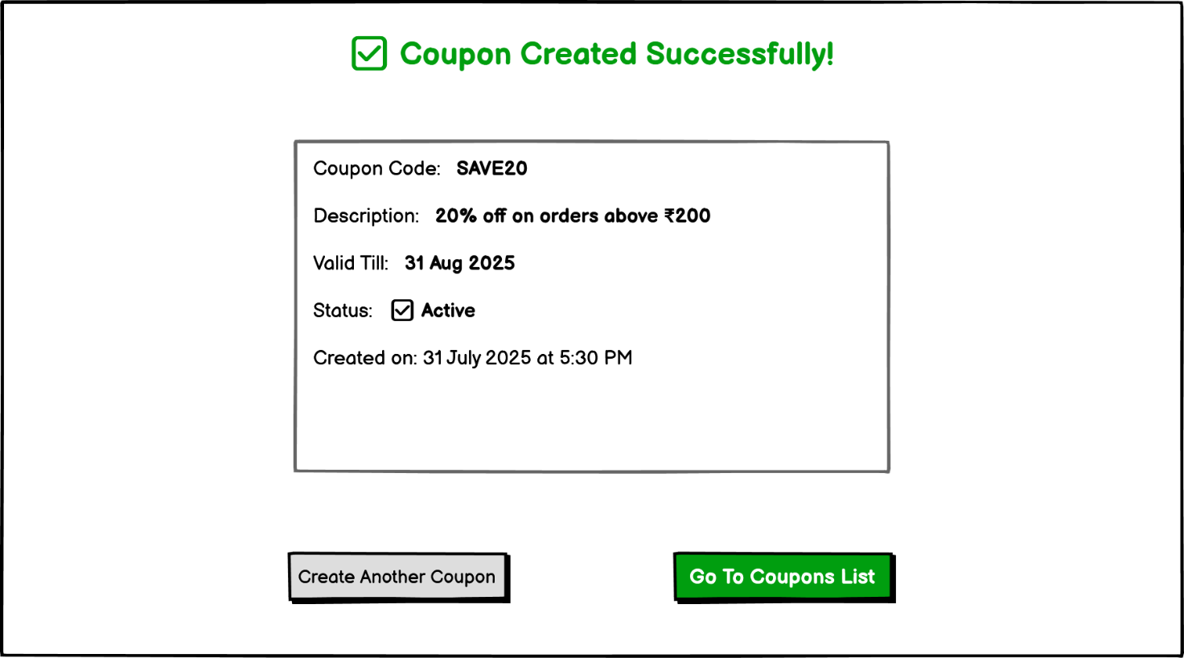

|  |  |  |  |  |  |  |  |
| --- | --- | --- | --- | --- | --- | --- | --- |
| **Sr. No.** | **Field Name** | **Field Type** | **Content** | **Required Field?** | **Min. Char.** | **Max Char.** | **Notes** |
| 1 | Confirmation Message | Label / Heading | ✅ Coupon Created Successfully! | N/A | N/A | N/A | Displayed in green at the top-center |
| 2 | Coupon Code | Text Label | Coupon Code: SAVE20 | N/A | N/A | N/A | Shows the code of the newly created coupon |
| 3 | Description | Text Label | Description: 20% off on orders above ₹200 | N/A | N/A | N/A | Description shown as entered in form |
| 4 | Valid Till | Text Label | Valid Till: 31 Aug 2025 | N/A | N/A | N/A | End date of coupon validity |
| 5 | Status | Text Label | Status: ✅ Active | N/A | N/A | N/A | Shows the current status of coupon |
| 6 | Created On | Text Label | Created on: 31 July 2025 at 5:30 PM | N/A | N/A | N/A | Timestamp showing coupon creation |
| 7 | Create Another Coupon | Command Button | Create Another Coupon | No | N/A | N/A | Navigates to ‘Create New Coupon’ page |
| 8 | Go To Coupons List | Command Button | Go To Coupons List | No | N/A | N/A | Navigates to ‘Coupon Management (Admin)’ page |

**7.** Issues/Open Questions

* Who will be responsible for configuring and updating coupon rules — the marketing team or a dedicated admin role?
* What payment gateway provider will be finalized for UPI, Cards, and Wallets — and who will handle its integration?
* Should users receive a digital receipt on email/SMS after successful payment or order placement?
* Will the system support partial refunds or full refunds only in case of cancellation?
* What happens if a coupon is applied but the payment fails — should it be reusable or marked as consumed?
* Should there be a maximum limit on how many active coupons a user can hold or apply in a month?
* Is there a plan to implement multi-language support (e.g., Hindi) in the checkout and order flows?
* Will customer support have admin access to manually cancel orders or override coupon issues?