USE CASE 1

**Use Case Name:** Place Order with Coupon

**Primary Actor:** HappyTummies Mobile App User

**Use Case Story:** This use case enables a customer to review their cart, apply a coupon code, choose a payment method, and place an order for delivery.

**Trigger:** The user clicks the “Place Order” button on the Checkout page after reviewing their cart.

**Pre-Condition:**

* User has items in their cart
* Checkout page is accessible
* Payment gateway is operational

**Post-Condition:**

* Order is successfully placed
* Confirmation message and email/SMS are sent to the user

**Primary Flow:** User places an order using a coupon code

|  |  |
| --- | --- |
| **Actor Action** | **System Response** |
| 1. User opens the Checkout page | 1. System displays order summary, delivery address, and payment method options |

**Wireframe: Checkout Page**

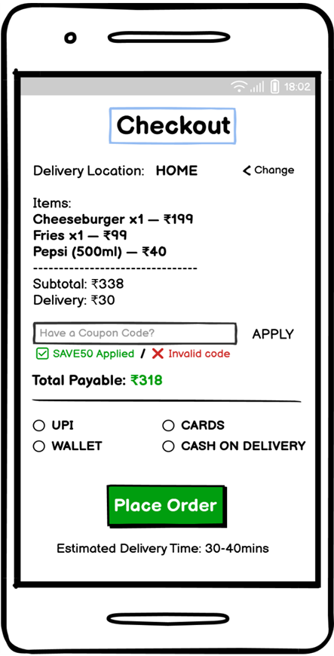

|  |  |  |  |  |  |  |  |
| --- | --- | --- | --- | --- | --- | --- | --- |
| **Sr. No.** | **Field Name** | **Field Type** | **Content** | **Required Field?** | **Min. Char.** | **Max Char.** | **Notes** |
| 1 | Page Title | Label / Heading | Checkout | N/A | N/A | N/A | Heading shown at the top of the checkout screen |
| 2 | Coupon Code Field | Text Input | Alpha-Numeric | No | 3 | 30 | Optional field for applying promo codes |
| 3 | Apply Button | Command Button | APPLY | No | N/A | N/A | Validates and applies entered coupon code |
| 4 | Place Order Button | Command Button | Place Order | Yes | N/A | N/A | Confirms the order |

|  |  |
| --- | --- |
| **Actor Action** | **System Response** |
| 1. User enters a coupon code and clicks APPLY | 1. System validates coupon and applies discount if valid |
| 1. User selects a payment method | 1. System records selection |
| 1. User clicks Place Order | 1. System initiates payment process |
| 1. User completes payment successfully | 1. System navigates to Order Confirmation page |

**Wireframe: Order Confirmation Page**

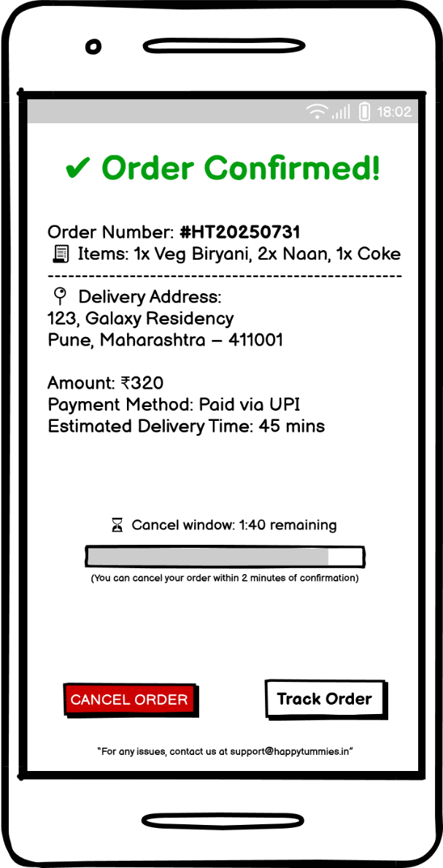

|  |  |  |  |  |  |  |  |
| --- | --- | --- | --- | --- | --- | --- | --- |
| **Sr. No.** | **Field Name** | **Field Type** | **Content** | **Required Field?** | **Min. Char.** | **Max Char.** | **Notes** |
| 1 | Confirmation Message | Label / Heading | ✅ Order Confirmed! | N/A | N/A | N/A | Displayed at top in green |
| 2 | Order Number | Text Label | Order Number: #HT20250731 | N/A | N/A | N/A | Unique order ID |

**Alternate Flow 1 (AF1):** Invalid or Missing Coupon Code

|  |  |
| --- | --- |
| **Actor Action** | **System Response** |
| 1. User enters invalid/expired coupon | 2. System shows error message; no discount applied |

**Exception Flow 1 (EF1):** Payment Failure

|  |  |
| --- | --- |
| **Actor Action** | **System Response** |
| 1. Payment declined or timed out | 2. System shows “Payment Failed” and prompts retry |

USE CASE 2

**Use Case Name:** Cancel Order

**Primary Actor:** HappyTummies Mobile App User

**Use Case Story:** This use case enables a customer to cancel a recently placed order within the cancellation time window and receive a refund if prepaid.

**Trigger:** The user clicks the “Cancel Order” button on the Order Confirmation page.

**Pre-Condition:**

* Order is in the cancellable window.
* Cancellation option is enabled.

**Post-Condition:**

* Order is successfully cancelled.
* Refund process is initiated if applicable.

**Primary Flow:** User cancels an order

|  |  |
| --- | --- |
| **Actor Action** | **System Response** |
| 1. User clicks Cancel Order | 1. System navigates to Order Cancel Confirmation page |

**Wireframe: Order Cancel Confirmation Page**

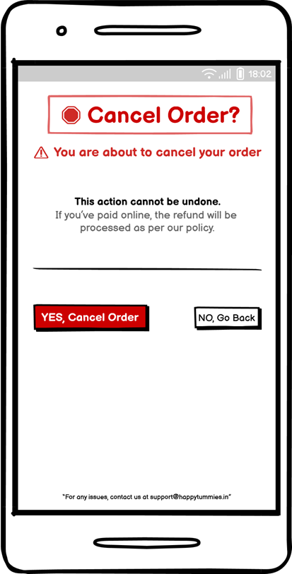

|  |  |  |  |  |  |  |  |
| --- | --- | --- | --- | --- | --- | --- | --- |
| **Sr. No.** | **Field Name** | **Field Type** | **Content** | **Required Field?** | **Min. Char.** | **Max Char.** | **Notes** |
| 1 | Page Title | Label / Heading | 🛑 Cancel Order? | N/A | N/A | N/A | Heading displayed at the top in red |
| 2 | Cancel Order Button | Command Button | YES, Cancel Order | No | N/A | N/A | Confirms cancellation |

|  |  |
| --- | --- |
| **Actor Action** | **System Response** |
| 1. User clicks YES, Cancel Order | 1. System cancels the order and navigates to Order Cancelled page |

**Wireframe: Order Cancelled Page**

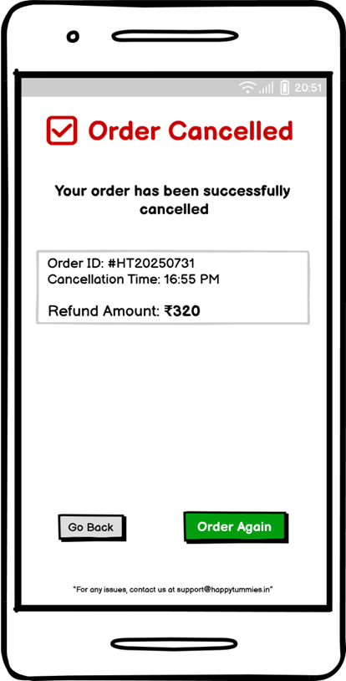

|  |  |  |  |  |  |  |  |
| --- | --- | --- | --- | --- | --- | --- | --- |
| **Sr. No.** | **Field Name** | **Field Type** | **Content** | **Required Field?** | **Min. Char.** | **Max Char.** | **Notes** |
| 1 | Cancellation Message | Label / Heading | ✅ Order Cancelled | N/A | N/A | N/A | Displayed at the top to confirm |

**Alternate Flow 1 (AF1):** Cancel Window Expired

|  |  |
| --- | --- |
| **Actor Action** | **System Response** |
| 1. User clicks Cancel Order after allowed time | 2. System shows “Cancellation window expired” |

**Exception Flow 1 (EF1):** Refund Processing Error

|  |  |
| --- | --- |
| **Actor Action** | **System Response** |
| 1. Refund initiation fails | 2. System shows “Refund initiation failed. Contact support” |

USE CASE 3

**Use Case Name:** Create New Coupon (Admin)

**Primary Actor:** HappyTummies Admin User

**Use Case Story:** This use case enables an admin to create a new discount coupon and optionally activate it.

**Trigger:** The admin clicks the “Create New Coupon” button on the Coupon Management page.

**Pre-Condition:**

• Admin is logged into Admin Panel.

• Coupon Management page is accessible.

**Post-Condition:**

• New coupon is created and stored.

• Coupon is available for eligible users if activated.

**Primary Flow:** Admin creates a new coupon

|  |  |
| --- | --- |
| **Actor Action** | **System Response** |
| 1. Admin clicks Create New Coupon | 1. System navigates to Create New Coupon page |

**Wireframe: Coupon Management Page**

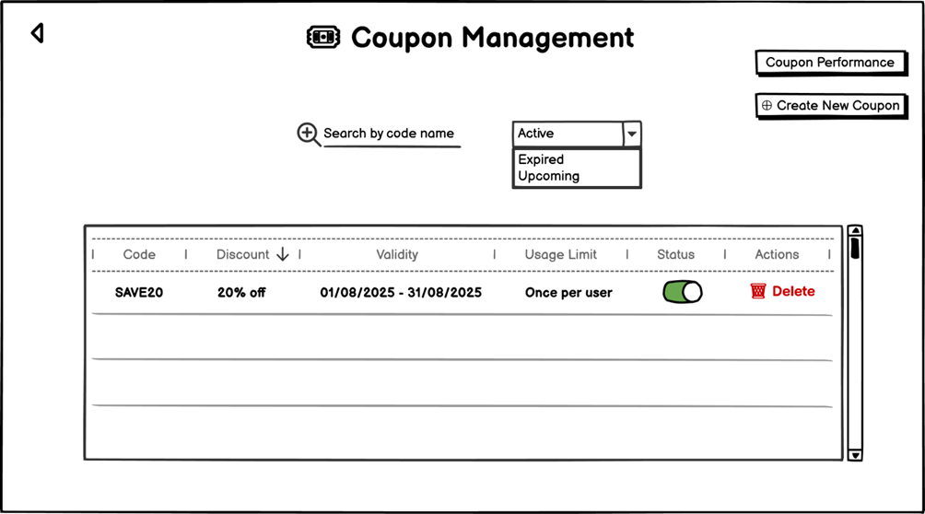

|  |  |  |  |  |  |  |  |
| --- | --- | --- | --- | --- | --- | --- | --- |
| **Sr. No.** | **Field Name** | **Field Type** | **Content** | **Required Field?** | **Min. Char.** | **Max Char.** | **Notes** |
| 1 | Page Title | Label / Heading | Coupon Management | N/A | N/A | N/A | Displayed at top of admin panel |
| 2 | Create New Coupon Button | Command Button | ➕ Create New Coupon | No | N/A | N/A | Navigates to create coupon page |

|  |  |
| --- | --- |
| **Actor Action** | **System Response** |
| 1. Admin fills coupon details and clicks CREATE | 1. System validates and saves coupon; navigates to success page |
| 1. All validations pass | 1. System navigates to Coupon Created Successfully page |

**Wireframe: Create New Coupon Page**

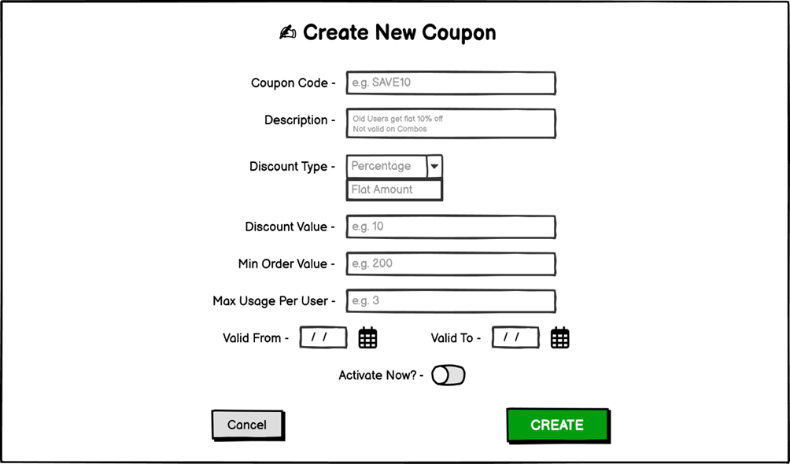

|  |  |  |  |  |  |  |  |
| --- | --- | --- | --- | --- | --- | --- | --- |
| **Sr. No.** | **Field Name** | **Field Type** | **Content** | **Required Field?** | **Min. Char.** | **Max Char.** | **Notes** |
| 1 | Page Title | Label / Heading | Create New Coupon | N/A | N/A | N/A | Main heading |
| 2 | Coupon Code | Text Input | Alpha-Numeric | Yes | 3 | 20 | Unique code identifier |
| 3 | Create Button | Command Button | CREATE | Yes | N/A | N/A | Navigates to success page |

**Wireframe: Coupon Created Successfully Page**

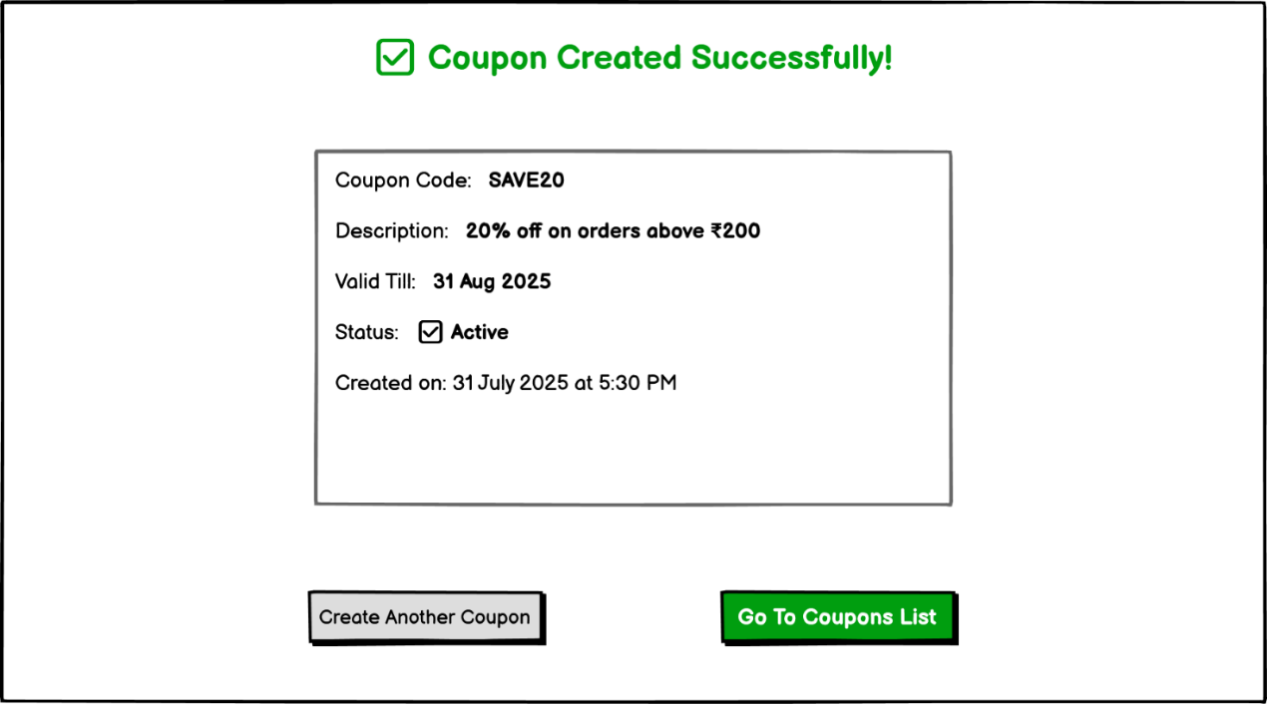

|  |  |  |  |  |  |  |  |
| --- | --- | --- | --- | --- | --- | --- | --- |
| **Sr. No.** | **Field Name** | **Field Type** | **Content** | **Required Field?** | **Min. Char.** | **Max Char.** | **Notes** |
| 1 | Confirmation Message | Label / Heading | ✅ Coupon Created Successfully! | N/A | N/A | N/A | Displayed in green at top-center |
| 2 | Coupon Code | Text Label | Coupon Code: SAVE20 | N/A | N/A | N/A | Shows the code of the newly created coupon |
| 3 | Create Another Coupon | Command Button | Create Another Coupon | No | N/A | N/A | Navigates to Create New Coupon page |
| 4 | Go To Coupons List | Command Button | Go To Coupons List | No | N/A | N/A | Navigates to Coupon Management page |

**Alternate Flow 1 (AF1):** Validation Errors

|  |  |
| --- | --- |
| **Actor Action** | **System Response** |
| 1. Admin enters invalid/missing details | 2. System shows relevant error message; does not save coupon |

**Exception Flow 1 (EF1):** System Save Failure

|  |  |
| --- | --- |
| **Actor Action** | **System Response** |
| 1. System fails to save coupon due to server error | 2. System shows “Coupon creation failed. Try later” |

USE CASE 4

**Use Case Name:** View Coupon Performance (Admin)

**Primary Actor:** HappyTummies Admin User

**Use Case Story:** This use case enables an admin to view analytics and performance statistics of all coupons.

**Trigger:** The admin clicks the “Coupon Performance” button on the Coupon Management page.

**Pre-Condition:**

• Admin is logged into Admin Panel.

• Coupon data exists in the system.

**Post-Condition:**

• Admin views coupon performance metrics and can export data.

**Primary Flow:** Admin views coupon performance

|  |  |
| --- | --- |
| **Actor Action** | **System Response** |
| 1. Admin clicks Coupon Performance | 1. System navigates to Coupon Performance Dashboard page |

**Wireframe: Coupon Performance Page**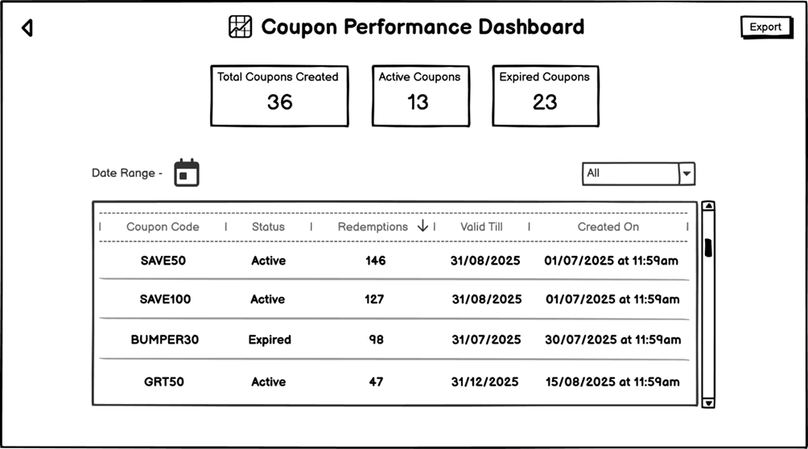

|  |  |  |  |  |  |  |  |
| --- | --- | --- | --- | --- | --- | --- | --- |
| **Sr. No.** | **Field Name** | **Field Type** | **Content** | **Required Field?** | **Min. Char.** | **Max Char.** | **Notes** |
| 1 | Page Title | Label / Heading | Coupon Performance Dashboard | N/A | N/A | N/A | Appears at the top |
| 2 | Export Button | Command Button | Export | No | N/A | N/A | Exports data |

|  |  |
| --- | --- |
| **Actor Action** | **System Response** |
| 1. Admin applies filters and optionally exports data | 1. System updates display or downloads file |

**Alternate Flow 1 (AF1):** No Coupons Found

|  |  |
| --- | --- |
| **Actor Action** | **System Response** |
| 1. Admin applies filters returning no results | 2. System shows “No coupons found” |

**Exception Flow 1 (EF1):** Data Load Failure

|  |  |
| --- | --- |
| **Actor Action** | **System Response** |
| 1. System fails to load data | 2. System shows “Unable to load data. Refresh or try again” |