Functional Requirements Document (PolicyBazaar)

Contents

**1. Scope** 2

**2. System(s) Impacted** 2

**3. Assumption(s)/Dependencies** 2

**4. As-Is Business Process (via activity diagram)** 3

**5. To-Be Business Process (via activity diagram)** 4

**6. Requirements** 5

**6.1 Requirements: ‘Home’ Page** 5

**6.1.1** **Display ‘Pet Insurance’ Command Button** 5

**6.1.2 ‘Pet Insurance’ Command Button Navigation** 5

**6.2 Requirements: ‘Pet Insurance Landing’ Page** 6

**6.2.1 ‘Pet Insurance Landing’ page data fields** 6

**6.3 Requirements: ‘Select a Plan’ Page** 7

**6.3.1 ‘Select a Plan’ page data fields** 7

**6.4 Requirements: ‘Plan Details’ Page** 9

**6.4.1 ‘Plan Details’ page data fields** 9

**6.5 Requirements: ‘Purchase and Payment’ Page** 10

**6.5.1 ‘Purchase and Payment’ page data fields** 10

**6.5.2 ‘Purchase and Payment’ page data validations** 12

6.5.2.1 ‘Purchase and Payment’ page data validation= Pass 12

6.5.2.2 ‘Purchase and Payment’ page data validation= Fail 12

**6.6 Requirements: ‘Confirmation’ Page** 13

**6.6.1‘Confirmation’ page data fields** 13

**6.7 Requirements: Email Confirmation** 14

**6.7.1 Email Confirmation contents** 14

**7.** Issues/Open Questions 16

**1. Scope**

Add a new **Pet Insurance** section to the PolicyBazaar website, allowing users to explore dog/cat insurance plans, view benefits, and purchase insurance policy for their pets without needing branch visits or support calls.

**2. System(s) Impacted**

Enhancement to [**https://policybazaar.com**](https://policybazaar.com) homepage and plan listing section to include a new **Pet Insurance** category.

**3. Assumption(s)/Dependencies**

* Feature accessible via **desktop and mobile browsers**
* User selects **Dog or Cat** to view relevant plans
* API availability for plan details and benefits

**4. As-Is Business Process (via activity diagram)**

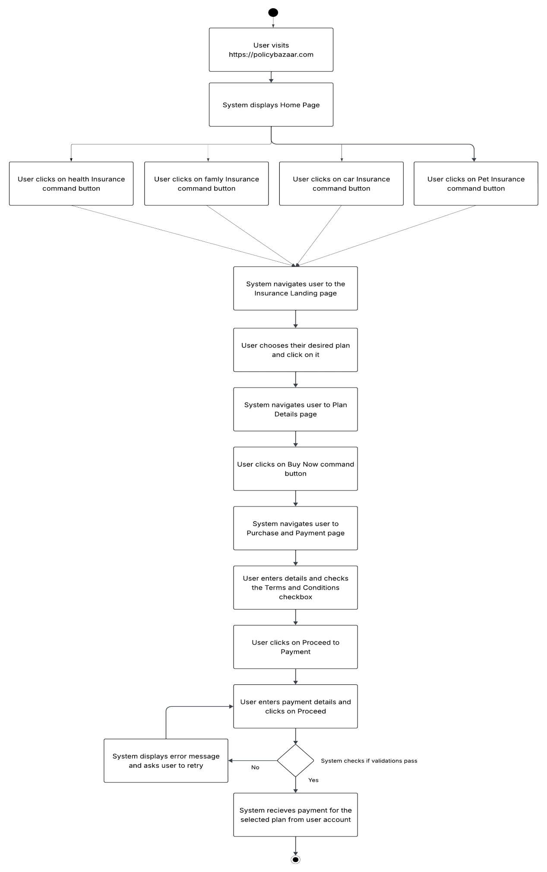

**5. To-Be Business Process (via activity diagram)**

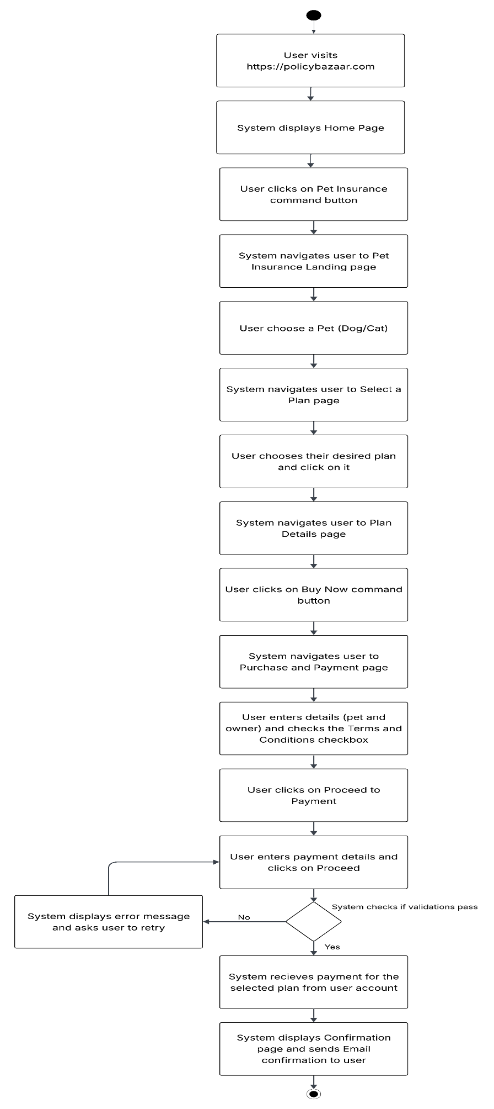

**6. Requirements**

**6.1 Requirements: ‘Home’ Page**

### **6.1.1** **Display ‘Pet Insurance’ Command Button**

System shall display ‘Pet Insurance’ Command button, which shall be located in between the existing policies command buttons.

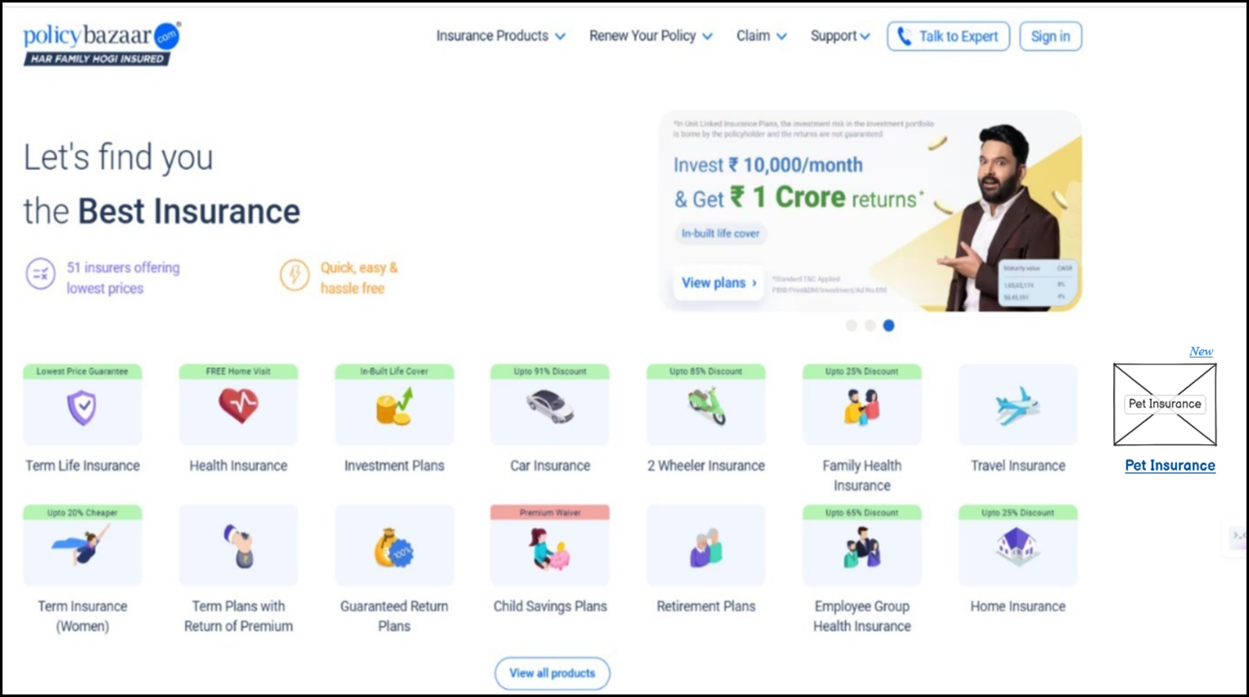

2

1

|  |  |  |  |  |  |  |  |
| --- | --- | --- | --- | --- | --- | --- | --- |
| **Sr. No.** | **Field Name** | **Field Type** | **Content** | **Required Field?** | **Min. Char.** | **Max Char.** | **Notes** |
| 1 | New Badge | Label | New | N/A | N/A | N/A | Positioned above Pet Insurance tile to indicate its newly added |
| 2 | Pet Insurance Button | Command Button | Pet Insurance | N/A | N/A | N/A | Newly added tile in product grid; clicking navigates to pet insurance page |

### **6.1.2 ‘Pet Insurance’ Command Button Navigation**

On clicking ‘Pet Insurance’ command button, system shall display ‘Pet Insurance Landing’ page in the same window.

**6.2 Requirements: ‘Pet Insurance Landing’ Page**

**6.2.1 ‘Pet Insurance Landing’ page data fields**

System shall display the following data fields on ‘Pet Insurance Landing’ page:

Allows user to choose their Pet (Dog or Cat) for which they would like to explore insurance policy plans.

2

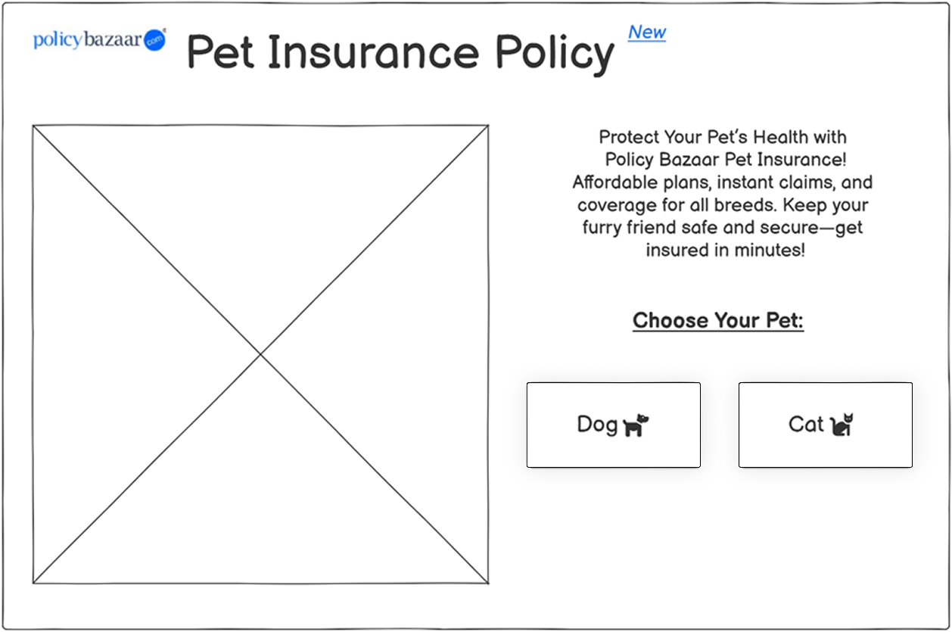

8

7

5

6

1

4

3

|  |  |  |  |  |  |  |  |
| --- | --- | --- | --- | --- | --- | --- | --- |
| **Sr. No.** | **Field Name** | **Field Type** | **Content** | **Required Field?** | **Min. Char.** | **Max Char.** | **Notes** |
| 1 | Logo | Image | policybazaar.com logo | N/A | N/A | N/A | Brand identity/logo displayed at top-left corner |
| 2 | Page Title | Label / Heading | Pet Insurance Policy | N/A | N/A | N/A | Main heading for the page |
| 3 | "New" Badge | Label | New | N/A | N/A | N/A | Blue label beside title to indicate freshness or newly launched |
| 4 | Banner Image | Image Placeholder | Promotional visual (X-marked box) | N/A | N/A | N/A | Placeholder image for pet/promo graphic |
| 5 | Description Text | Paragraph Label | Protect Your Pet’s Health... (full description text shown) | N/A | N/A | N/A | Descriptive text to inform user about benefits of insurance |
| 6 | Section Heading | Label | Choose Your Pet: | N/A | N/A | N/A | Indicates action area where user picks between pet types |
| 7 | Dog Button | Command Button | Dog 🐶 | N/A | N/A | N/A | On click, shows dog-specific plans |
| 8 | Cat Button | Command Button | Cat 🐱 | N/A | N/A | N/A | On click, shows cat-specific plans |

**6.3 Requirements: ‘Select a Plan’ Page**

**6.3.1 ‘Select a Plan’ page data fields**

System shall display the following data fields on ‘Select a Plan’ page:

Allows user to select a plan for their pets as per the desired facilities in a plan.

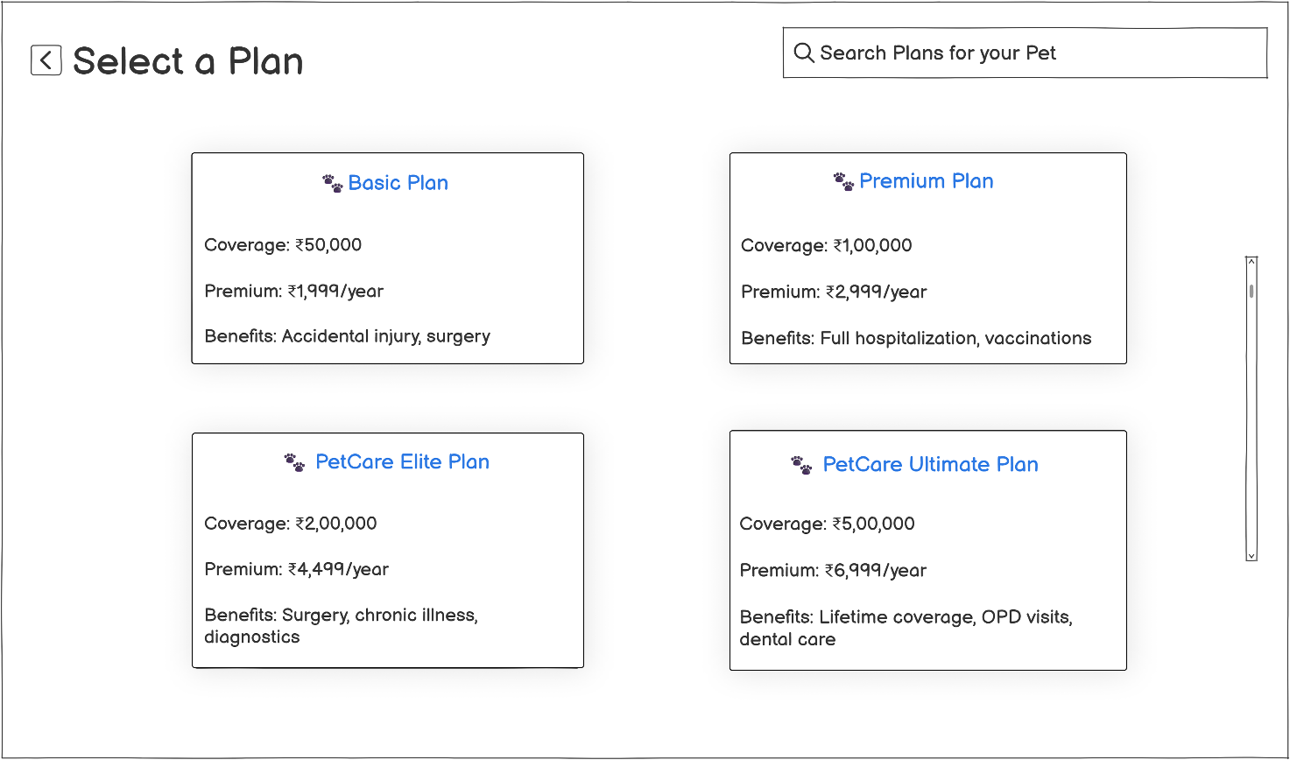

4

2

7

8

6

5

3

1

**Note:** This plan selection wireframe is reusable for both Dog and Cat policies. Plan cards dynamically load based on the pet type selected on the previous screen.

|  |  |  |  |  |  |  |  |
| --- | --- | --- | --- | --- | --- | --- | --- |
| **Sr. No.** | **Field Name** | **Field Type** | **Content** | **Required Field?** | **Min. Char.** | **Max Char.** | **Notes** |
| 1 | Back Icon Button | Command Button | ← | N/A | N/A | N/A | Navigates user back to ‘Pet Insurance Landing’ page |
| 2 | Page Title | Label / Heading | Select a Plan | N/A | N/A | N/A | Header indicating current screen |
| 3 | Search Bar | Search Input | Search Plans for your Pet | No | 1 | 100 | Allows users to search/filter plans by name or feature |
| 4 | Scrollbar | Scrollbar | Vertical Scrollbar | N/A | N/A | N/A | Allows scrolling through list of plans if content overflows |
| 5 | Basic Plan Card | Container Group | Coverage: ₹50,000; Premium: ₹1,999/year; Benefits: Accidental injury, surgery | N/A | N/A | N/A | Card layout for “Basic Plan”; content changes based on selected pet (Dog/Cat) |
| 6 | Premium Plan Card | Container Group | Coverage: ₹1,00,000; Premium: ₹2,999/year; Benefits: Full hospitalization, vaccinations | N/A | N/A | N/A | Card layout for “Premium Plan”; content changes based on selected pet (Dog/Cat) |
| 7 | PetCare Elite Plan Card | Container Group | Coverage: ₹2,00,000; Premium: ₹4,499/year; Benefits: Surgery, chronic illness, diagnostics | N/A | N/A | N/A | Card layout for “PetCare Elite Plan”; content changes based on selected pet (Dog/Cat) |
| 8 | PetCare Ultimate Plan Card | Container Group | Coverage: ₹5,00,000; Premium: ₹6,999/year; Benefits: Lifetime coverage, OPD visits, dental care | N/A | N/A | N/A | Card layout for “Ultimate Plan”; content changes based on selected pet (Dog/Cat) |

**6.4 Requirements: ‘Plan Details’ Page**

**6.4.1 ‘Plan Details’ page data fields**

System shall display the following data fields on ‘**Plan Details**’ page:

Allows user to view the full plan available with full details for their selected pet and then click on the buy now command button to procced further to the purchase and payment page.

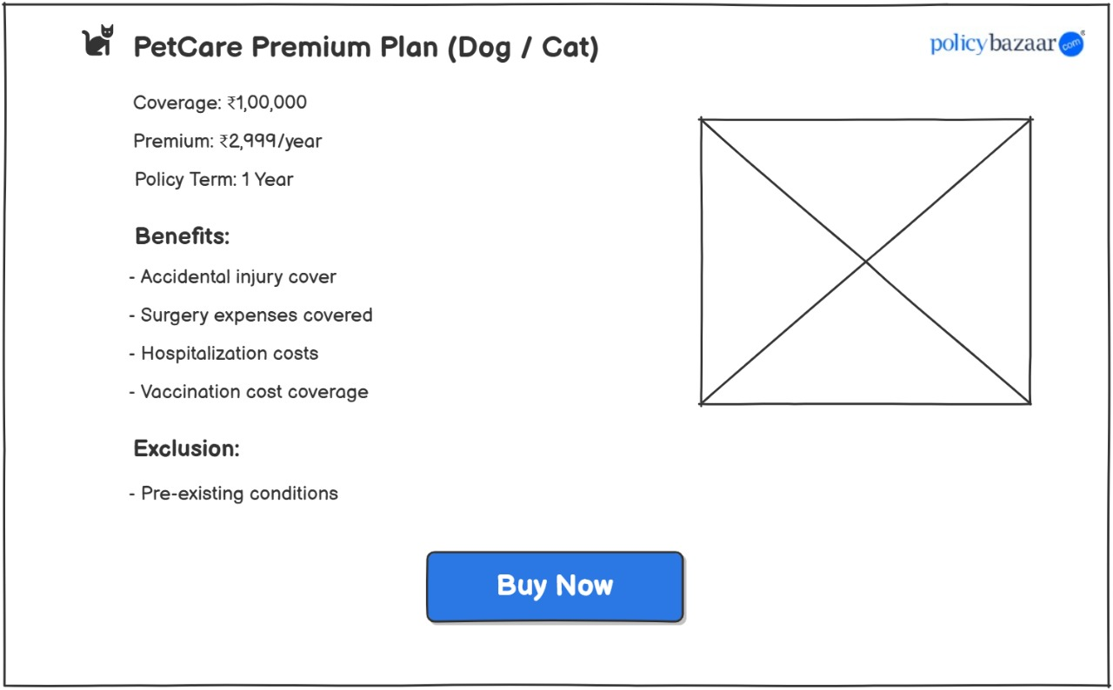

11

10

9

8

7

6

1

2

5

4

3

|  |  |  |  |  |  |  |  |
| --- | --- | --- | --- | --- | --- | --- | --- |
| **Sr. No.** | **Field Name** | **Field Type** | **Content** | **Required Field?** | **Min. Char.** | **Max Char.** | **Notes** |
| 1 | Logo | Image | policybazaar.com logo | N/A | N/A | N/A | Displayed at top-right corner for brand identity |
| 2 | Plan Title | Label / Heading | PetCare Premium Plan (Dog / Cat) | N/A | N/A | N/A | Dynamic text, changes based on pet selection |
| 3 | Coverage Amount | Text Label | Coverage: ₹1,00,000 | N/A | N/A | N/A | Indicates insurance coverage amount |
| 4 | Premium Amount | Text Label | Premium: ₹2,999/year | N/A | N/A | N/A | Yearly cost of the plan |
| 5 | Policy Term | Text Label | Policy Term: 1 Year | N/A | N/A | N/A | Duration of the policy |
| 6 | Benefits Heading | Label (Bold) | Benefits: | N/A | N/A | N/A | Section heading for list of benefits |
| 7 | Benefits List | Bullet List | - Accidental injury cover - Surgery expenses covered - Hospitalization costs - Vaccination cost coverage | N/A | N/A | N/A | Describes plan advantages |
| 8 | Exclusion Heading | Label (Bold) | Exclusion: | N/A | N/A | N/A | Section heading for exclusions |
| 9 | Exclusion Text | Bullet Point | - Pre-existing conditions | N/A | N/A | N/A | Specifies what is not covered |
| 10 | Plan Image Placeholder | Image Placeholder | X-marked box | N/A | N/A | N/A | Placeholder for pet/plan related image |
| 11 | Buy Now Button | Command Button | Buy Now | Yes | N/A | N/A | CTA to purchase policy |

**6.5 Requirements: ‘Purchase and Payment’ Page**

**6.5.1 ‘Purchase and Payment’ page data fields**

System shall display the following data fields on ‘Purchase and Payment’ page:

Allows user to fill all the valid details and then click on proceed to payment for the system to navigate the user to the payment page which is already and integrated system of the website.

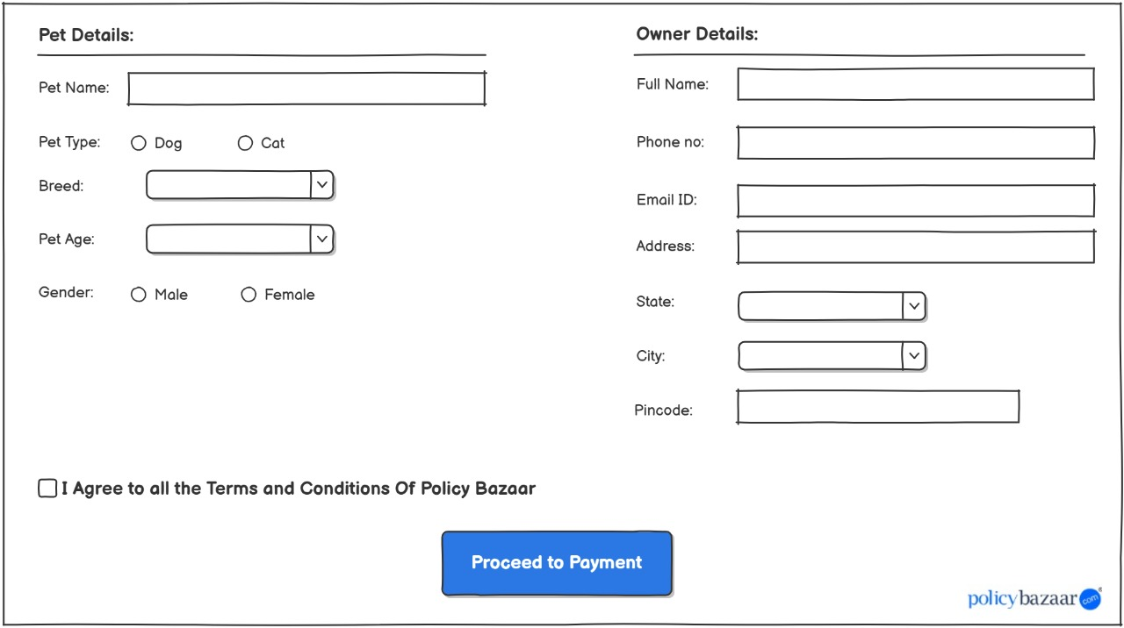

15

4

3

5

2

1

6

9

8

7

11

10

12

13

14

17

16

|  |  |  |  |  |  |  |  |
| --- | --- | --- | --- | --- | --- | --- | --- |
| **Sr. No.** | **Field Name** | **Field Type** | **Content** | **Required Field?** | **Min. Char.** | **Max Char.** | **Notes** |
| 1 | Section Heading (Pet) | Label / Section | Pet Details: | N/A | N/A | N/A | Heading for left section (pet-specific input) |
| 2 | Pet Name | Input Text Field | Pet Name: | Yes | 1 | 30 | Free text input for pet's name |
| 3 | Pet Type | Radio Buttons | Dog / Cat | Yes | N/A | N/A | Mandatory pet type selection |
| 4 | Breed Dropdown | Dropdown Menu | Breed: (dropdown) | Yes | N/A | N/A | Shows breed list based on selected type |
| 5 | Pet Age | Dropdown Menu | Pet Age: (dropdown) | Yes | N/A | N/A | Age in years, typically from 1–20 |
| 6 | Pet Gender | Radio Buttons | Male / Female | Yes | N/A | N/A | Mandatory selection |
| 7 | Section Heading (Owner) | Label / Section | Owner Details: | N/A | N/A | N/A | Heading for right section (owner-specific input) |
| 8 | Full Name | Input Text Field | Full Name: | Yes | 2 | 50 | Owner’s full name |
| 9 | Phone No | Input Text Field | Phone no: | Yes | 10 | 10 | Must be a valid Indian mobile number |
| 10 | Email ID | Input Text Field | Email ID: | Yes | 5 | 50 | Used for verification & policy receipt |
| 11 | Address | Textarea | Address: | Yes | 5 | 200 | Residential address |
| 12 | State | Dropdown Menu | State: (dropdown) | Yes | N/A | N/A | List of Indian states |
| 13 | City | Dropdown Menu | City: (dropdown) | Yes | N/A | N/A | Filtered list based on selected state |
| 14 | Pincode | Input Text Field | Pincode | Yes | 6 | 6 | Must be valid 6-digit Indian postal code |
| 15 | Terms and Conditions Checkbox | Checkbox | I Agree to all the Terms and Conditions of Policy Bazaar | Yes | N/A | N/A | Must be ticked before payment |
| 16 | Proceed to Payment Button | Call-to-Action Button | Proceed to Payment | Yes | N/A | N/A | Final action to move to payment page |
| 17 | Logo | Image | policybazaar.com logo | N/A | N/A | N/A | Bottom-right corner for brand identity |

**6.5.2 ‘Purchase and Payment’ page data validations**

On click of ‘Proceed to payment’ command button, system shall perform following validations:

1. All required data is entered
2. All the entered data is valid
3. Only one pet type is selected
4. Only one breed is selected
5. Only one age is selected
6. Only one gender type is selected
7. Phone number is 10 digit and is active
8. Email id is in valid format
9. Pincode is a 6-digit numeric value

### 6.5.2.1 ‘Purchase and Payment’ page data validation= Pass

In the event of passing of all the validations, the system navigates the user to the already integrated payment page of policy bazaar then after successful completion display ‘Confirmation’ page in the same window.

### 

### 6.5.2.2 ‘Purchase and Payment’ page data validation= Fail

In the event of the failure of one or more validations, display the error messages as shown below:

|  |  |
| --- | --- |
| **Failed Validation** | **Error Message Displayed** |
| All required data is entered | <Data Field> is a required field. Please enter a value for <Data Field> |
| All the entered data is valid | Value for <Data Field> is invalid. Please enter a valid value for <Data Field> |
| Only one pet type is selected | <Pet type> error. User can select only one pet type. |
| Only one breed is selected | Please select only one breed. |
| Only one age is selected | Please select an age. |
| Only one gender type is selected | Select Gender. |
| Phone number is 10 digit and is active | <phone number> is invalid. Enter a valid email id. |
| Email id is in valid format | <email id> is invalid. Enter a valid email id format. |
| Pincode is a 6 digit numeric value | <pincode> is invalid. Enter a valid 6 digit pincode. |

**6.6 Requirements: ‘Confirmation’ Page**

**6.6.1‘Confirmation’ page data fields**

System shall display the following data fields on ‘**Confirmation**’ page:

After successful payment and purchase of pet insurance system displays this pop-up message.

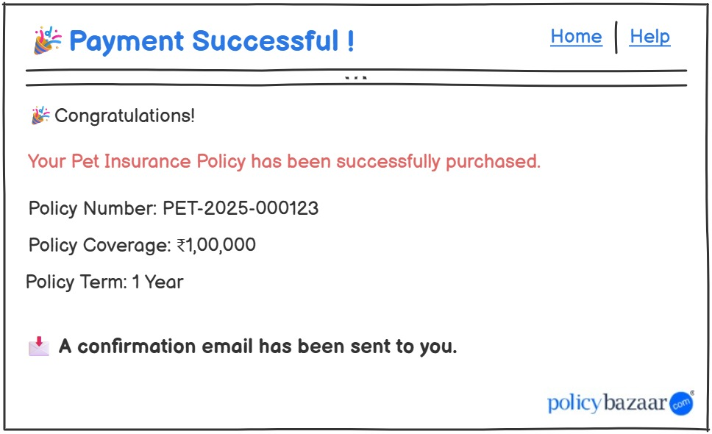

10

9

8

7

5

6

4

3

2

1

|  |  |  |  |  |  |  |  |
| --- | --- | --- | --- | --- | --- | --- | --- |
| **Sr. No.** | **Field Name** | **Field Type** | **Content** | **Required Field?** | **Min. Char.** | **Max Char.** | **Notes** |
| 1 | Page Title | Label / Heading | 🎉Payment Successful! | N/A | N/A | N/A | Main heading confirming payment status |
| 2 | Navigation Link - Home | Navigation Link | Home | No | N/A | N/A | Redirects to home page |
| 3 | Navigation Link - Help | Navigation Link | Help | No | N/A | N/A | Opens help/support documentation |
| 4 | Subheading Text | Label | 🎉 Congratulations! | N/A | N/A | N/A | Short congratulatory message |
| 5 | Confirmation Message | Paragraph Label | Your Pet Insurance Policy has been successfully purchased. | N/A | N/A | N/A | Key info text displayed in red |
| 6 | Policy Number Text | Text Label | Policy Number: PET-2025-000123 | N/A | N/A | N/A | Dynamic, system-generated policy ID |
| 7 | Policy Coverage Text | Text Label | Policy Coverage: ₹1,00,000 | N/A | N/A | N/A | Reflects user-selected plan |
| 8 | Policy Term Text | Text Label | Policy Term: 1 Year | N/A | N/A | N/A | Standard term for issued policy |
| 9 | Confirmation Note | Info Label (Bold) | 📩A confirmation email has been sent to you. | N/A | N/A | N/A | Sends email confirmation to user |
| 10 | Logo | Image | policybazaar.com logo | N/A | N/A | N/A | Placed bottom-right for brand identity |

**6.7 Requirements: Email Confirmation**

**6.7.1 Email Confirmation contents**

System automatically sends a confirmation email to the user’s mail id.

1

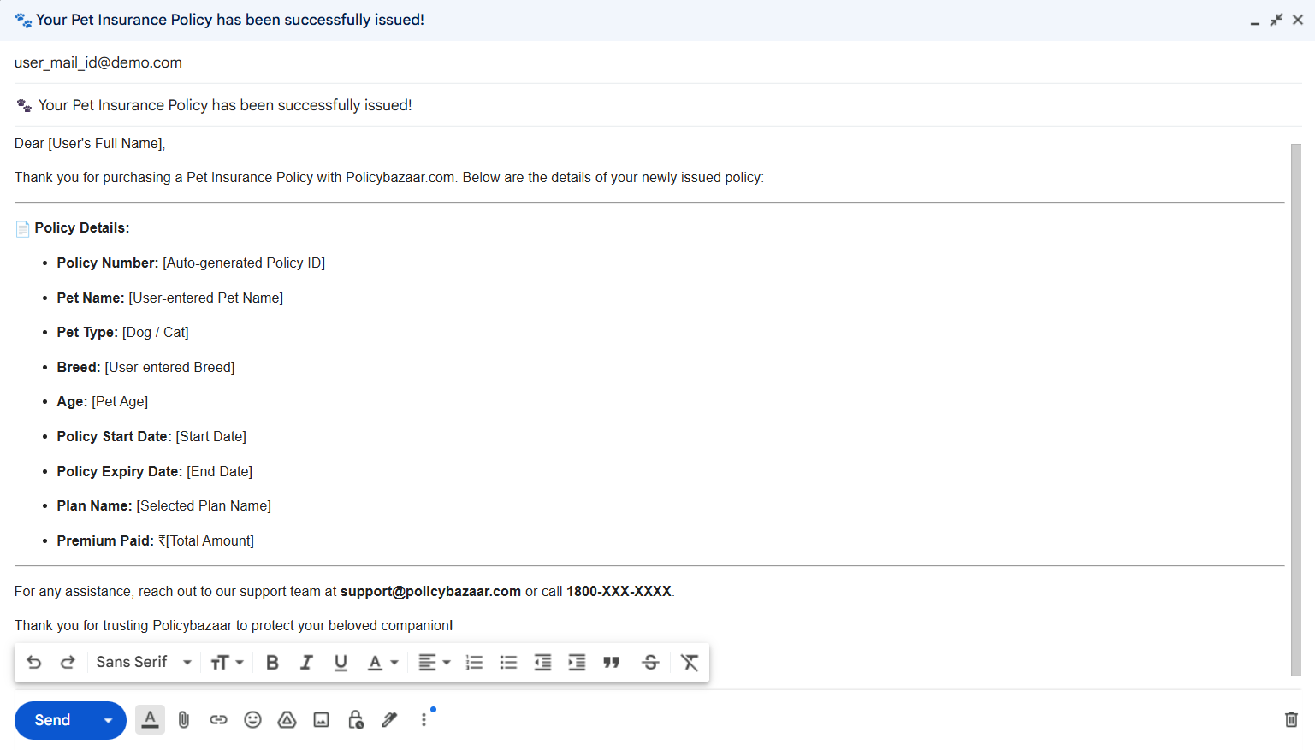

3

2

1. User’s registered mail id.
2. Subject of the mail.
3. Body of the mail including:

Dear [User's Full Name],

Thank you for purchasing a Pet Insurance Policy with Policybazaar.com.  
Below are the details of your newly issued policy:

**📄 Policy Details:**

**Policy Number:** [Auto-generated Policy ID]

**Pet Name:** [User-entered Pet Name]

**Pet Type:** [Dog / Cat]

**Breed:** [User-entered Breed]

**Age:** [Pet Age]

**Policy Start Date:** [Start Date]

**Policy Expiry Date:** [End Date]

**Plan Name:** [Selected Plan Name]

**Premium Paid:** ₹[Total Amount]

You can download your policy documents and access support by logging into your account at [www.policybazaar.com](https://www.policybazaar.com).

For any assistance, reach out to our support team at **support@policybazaar.com** or call **1800-XXX-XXXX**.

Thank you for trusting Policybazaar to protect your beloved companion!

Warm regards,  
**Team Policybazaar**

• Dynamic fields (e.g. Name, Policy Number, Pet Details) must be fetched from the user input and system-generated values.

• Email should be triggered only **after successful payment confirmation**.

**7.** Issues/Open Questions

* Who will provide and manage the dynamic list of pet breeds? Product team or development team?
* Should a digital signature be included in the generated policy document?
* Who is responsible for verifying owner contact details (phone, email) — any OTP verification planned?
* Should users be allowed to update pet details after policy purchase?
* Do we need multi-language support (like Hindi, Marathi) for Pet Insurance pages?
* Who is responsible for sending the policy document in the confirmation email — frontend application or backend system?
* Will pet insurance purchase be limited to only Dog and Cat, or will future expansion to other pets be required?